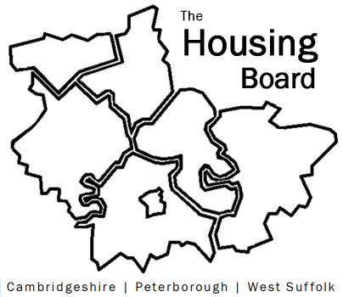
The Housing Board
Cambridgeshire | Peterborough | West Suffolk
Meeting from 10:00 to 12:00, Friday 5 July 2026
To be held online via Microsoft Teams: link can be found in the meeting invite
AGENDA
 | Item | Lead
 | Welcome/apologies  Actions of previous meeting to approve, and matters arising.  Meeting papers available at www.cambridgeshireinsight.org.uk/housingboard | Dan Horn, Chair
 | - Home-Link Annual Report 2025-2026 | Heather Wood for Home-Link (SCDC)
 | - DAHA (Domestic Abuse Housing Alliance) Update & progress on Safe Accommodation Needs Assessment 2025 (slides here) | Vickie Crompton for Peterborough
 | - Local Govt Reorganisation – any updates / discussion
 | - Updates around the table
 | - AOB
Next meetings (10am – 12 noon)
- 7 August 2026
- 4 September 2026
- 2 October 2026

