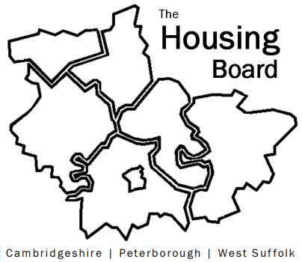
The Housing Board
Cambridgeshire | Peterborough | West Suffolk
Meeting from 10:00 to 12:00, Friday 5 June 2026
To be held online via Microsoft Teams: link can be found in the meeting invite
AGENDA
 | Item | Lead
 | Welcome/apologies  Actions of previous meeting to approve, and matters arising.  Meeting papers available at www.cambridgeshireinsight.org.uk/housingboard | Dan Horn, Chair
 | - “Sharing Well” – click here and the Local Outcomes Framework | Tom Tallon  Changing Futures Team,  Cambs County
 | - Update on Housing First funds with CPCA & quick note of CPCA’s new role on homelessness including strategy and action plan across CPCA area | CPCA / SB /  homelessness sub-group
 | - JSNA Delivery Plan update | Kate Parker,  Cambs Public Health
 | - Local Area Energy Partnership  - Feedback from 6 May LAEP workshop. (SB to attend regular group, this is an initial “link making” opportunity via Pam Scott’s team)  - Request for Housing Board rep for 23 June poverty workshop (in person, Pathfinder House, clashed with H4C&P). | Kate Parker,  Cambs Public Health and Pam Scott,  Huntingdonshire DC
- AOB
- Quick verbal update on SHROA - will just have net on 4 June
- Quick update on document circulated last meeting on the various plans and changes ahead (SB)
Next meetings (10am – 12 noon)
- 3 July 2026
- 7 August 2026
- 4 September 2026

