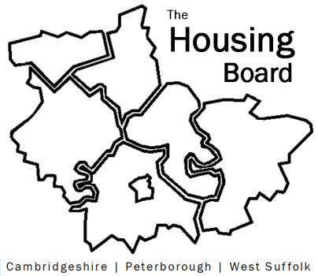
The Housing Board
Cambridgeshire | Peterborough | West Suffolk
Meeting from 10:00 to 12:00, Friday 1 May 2026
To be held online via Microsoft Teams: link can be found in the meeting invite
AGENDA
 | Item | Lead
 | Welcome/apologies  Actions of previous meeting to approve, and matters arising.  Meeting papers available at www.cambridgeshireinsight.org.uk/housingboard | Dan Horn, Chair
 | - Update on Supported Housing Act | Lisa Sparks  Sue Beecroft
 | - Homes for Cambridgeshire and Peterborough:  - Note of Planning issues raised  - Draft note about linked plans and changes | Sue Beecroft
 | - Meeting plan 2026/27 | Sue Beecroft
 | - Draft budget outline 2026/27 | Sue Beecroft
 | - AOB
Next meetings (10am – 12 noon)
- 5 June 2026
- 3 July 2026
- 7 August 2026

