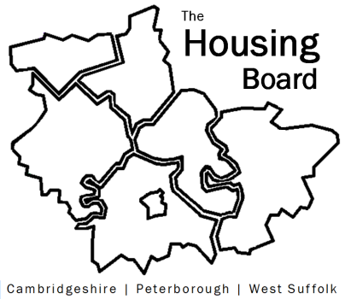
The Housing Board
Cambridgeshire | Peterborough | West Suffolk
Meeting from 10:00 to 12:00, Friday 6 March 2026
To be held online via Microsoft Teams: link can be found in the meeting invite
AGENDA
 | Item | Lead
 | Welcome/apologies  Actions of previous meeting to approve, and matters arising.  Meeting papers available at www.cambridgeshireinsight.org.uk/housingboard | Dan Horn, Chair
 | - Update on JSNA (draft JSNA and covering email circulated) | Sue B on behalf of Kate Parker, Public Health
 | - Discussion around new approach to homelessness funding, in particular Housing First for Cambs and Peterborough (note att) – scheduled for discussion at homelessness strategy group on 11th March | Sue B
 | - Planning for 2026/27: | Dan Horn to lead
 | - Review of housing board agendas in 2025 (att)
 | - Forthcoming opportunities, challenges and our plans for 2026 – all to contribute ideas
 | - Our agenda plan for 2026/27 – who do we want to speak to us / share in the coming year to help tackle the challenges – please bring your ideas
 | Note: The outputs of this meeting will be circulated for those not present to add to, and to incorporate any afterthoughts.
 | - AOB | All
Next meetings (10am – 12 noon)
- 10 April 2026 – note not 1st Friday of the month due to Easter!
- 1 May 2026
- 10 June 2026

