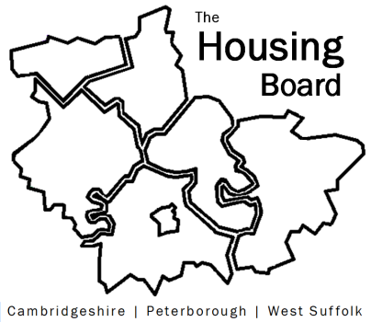
The Housing Board
Cambridgeshire | Peterborough | West Suffolk
Meeting from 10:00 to 12:00, Friday 4 July 2025
To be held online via Microsoft Teams: link can be found in the meeting invite
AGENDA
 | Item | Lead
 | Welcome/apologies / action  Meeting papers available at www.cambridgeshireinsight.org.uk/housingboard | Dan Horn  Chair
 | Home-Link update | Sharon Lock with Heather Wood
 | Domestic abuse and safe accommodation update: changes to the IDVA service and assistance with the Safe Accommodation Needs assessment (time of its 3-year review). | Danae Evans, DASV partnership
 | Local growth plan update & related | Dan Horn
 | Update on ICB/ICS changes (See Chris’ note sent 18/6/25) | Chirs Hill, ICS
 | AOB to include any updates  - new mayor at CPCA and housing  - local govt reform / reorganisation | All
Next meetings (10am – 12 noon)
- 1 August to include review of poverty commissions / actions and housing links, for both Cambs and Peterborough
- 5 September
- 3 October
Note: “new” calendar appointments have been sent by Sue. Please delete the old ones and use “NEW Housing Board” appointments from now on!

