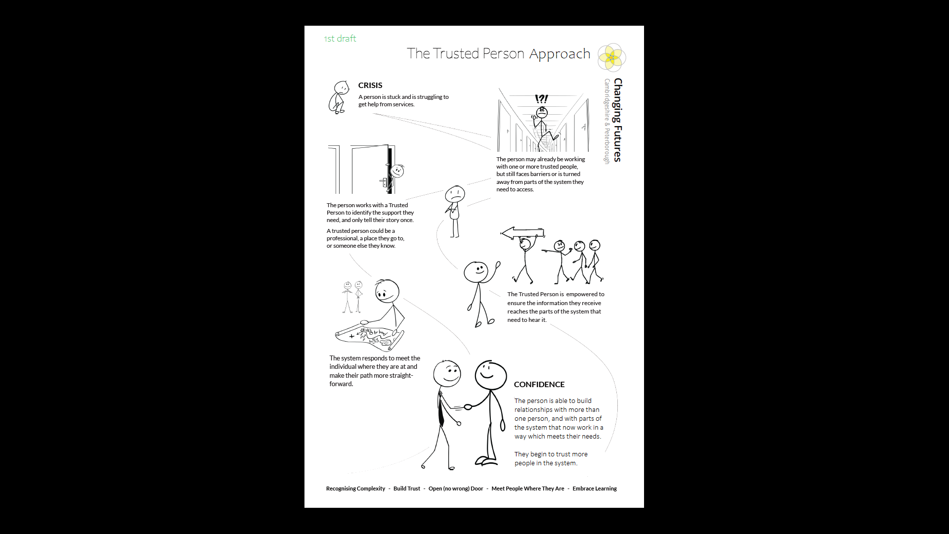
The trusted person approach

A trusted person approach
What is Changing Futures? 2
Background 2
Who is a trusted person? 2
The benefits 3
But we already do this! 4
Working in partnerships 4
Q&A on a trusted person approach 5
Find out more about Changing Futures 9

What is Changing Futures?
Changing Futures Cambridgeshire & Peterborough is a collaboration to improve outcomes for people with multiple disadvantage. Multiple disadvantage means someone experiencing three of five of homelessness, mental health issues, substance misuse, domestic abuse and offending behaviour, at any one time. Changing Futures does this by encouraging involvement of people with lived experience at all stages of our system and service design and looking at how our partnerships affect people.


Background
A trusted person approach has been developed with people with lived experience of multiple disadvantage. They described getting better outcomes by only having to tell their story, needs and wishes to a one person, a person they know and trust; someone they choose to tell their story who is empowered to share that information with the parts of the system that can act.

One person described telling their story to someone who went away and spoke to the rest of the services to get in place what they needed. They said that if they had found that person the first time around, rather than the seventh or eighth, it could have stopped ten years of addiction and homelessness.
The approach aims to reduce the time an individual spends struggling with the disadvantages they face. If the person is not getting what they need, agencies need to work together to put things right as soon as possible - not as a last resort when everything else has failed.
Many people ask for help and say what they need, but the systems to provide that help are set up in ways people find difficult to access. A trusted person approach aims to help cut through some of these barriers.


Who is a trusted person?
A trusted person is someone who has developed a relationship based on trust with a person facing multiple disadvantage. The relationship may be professional, social or voluntary. A trusted person can act on the information provided by the individual and pass it to other services who can help.
A trusted person might or might not have a role representing an individual in their dealings with supporting agencies. They may or may not provide support and hand-holding to the individual; this will vary from person to person.
A trusted person will have information and knowledge that has been communicated to them about what the person needs (or wants) to make change; and the things they need to do that. The trusted person is someone the individual is comfortable talking to.

You can find case studies showing how trusted person approaches have been put into action here.
A trusted person is not expected to take on additional responsibility, other than to communicate with services and feed back to the individual about what is happening. It can take time to build the trust, but we believe trust can grow, and hope the individual will, in time, build a bigger network of people they will trust.
The trusted person may also want to discuss with the individual the best ways to deliver any interventions. They are someone the individual can trust to be non-judgemental and to act on their behalf if needed, to help them get what they need in a better way.
Individual |   
Person feels comfortable telling someone they trust about what they need* | The trusted person helps them contact the help and support they said they need | Ideally, the person links with other support and builds a ‘trusted network’ as they begin to access the things they want and need

* Note: we have used the phrase “trusted person” in this note – however this might not be just one individual. It could also be a group of people, a place or service or an organisation where an individual feels safe and comfortable. For example, their local day centre, probation office or Job Centre. Trust can be more about the place than one specific individual. However, to keep the concept simple we found it easier to talk about a trusted person. It is what the people with lived experience who outlined it, named the approach.

The benefits
Benefits to the individual
I only have to tell my story once
I can access the treatment, care, support and housing I need
I am dealt with sensitively, because the person I deal with understands the effects of trauma in my past
Benefits to services
We communicate better with other services
We understand the limitations placed on the other services we work with
We have clear goals, set by the person we are working to help
We know & understand what other services are doing so our works can align, we don’t duplicate effort and our resources are better targeted. We can also time our actions better.
Our teams feel less isolated when dealing with an individual who has complex issues and we share responsibility.

Benefits to the system
We see fewer repeat returners
Our costs are reduced as we deal with fewer emergencies, these being replaced by a greater number of planned actions
Barriers are identified, understood, acted on and removed

But we already do this!
That’s right.
A trusted person approach is NOT a new role, and it is NOT a new team. There are organisations and people already using this or a similar approach, who have great networks and work with customers in a trauma-informed and person-centred way. Within nearly all organisations there are frontline workers who have built up trusted relationships with the people they support. When a problem arises, they use their experience to navigate the system, and their professional network for help and advice or their skills to negotiate a response. Often these workers need to be tenacious, not take ‘no’ for an answer and go the extra mile.
The aim for Changing Futures is to:
enable the approach to be spread wider, so this is the first response when an individual with multiple disadvantage approaches – not a last resort when everything else has failed, or dependent on encountering the worker who will go the extra mile
use this approach routinely and at an early stage across Cambridgeshire and Peterborough when anyone encounters someone facing multiple disadvantage - so that wherever someone approaches for help and support there is a route to find it
ensure services respond to meet a need in the most appropriate way when trusted people reach out
make sure services can act as a team in the best interests of the individual - and no one person or service is left to do everything

ensure partners across the system take responsbility when someone is asking for support.

Working in partnerships
Over the last three years, Changing Futures has been working with partnerships including people with lived experience, to continue to learn and explore how trusted person approaches can be applied systemically. These approaches cannot work in isolation within individual services. If we take that path, it leads us to the experienced, skilled and tenacious worker model – and they may still, on occasion, face unsurmoutnable barriers to accessing the support that a person needs... and may be entitled to or eligible for.
The trusted person approach is not a fixed model. It needs certain conditions to be present, but these can be flexible depending on the partnership that seeks to apply them. They include, but are not limited to, the 5 principles of Changing Futures:
1. Recognise complexity
2. Build trust
3. Open (no wrong) door
4. Meet people where they are
5. Embrace learning
We believe that any partnership should consider:
- How do we share information that we can trust (Changing Futures is working on a framework for this)
- How it will use the five Changing Futures principles.
- Who are we trying to help, especially at the outset. Although trusted person approaches can apply across the system, it may be easier to start with a smaller cohort to test the working arrangements. Hopefully this can spread across the system as time goes on
- Who is our partnership? Who needs to be informed and skilled if necessary? Some partnership mapping may help, including all sectors including the wider community - though it may not need all the partners to be equally active in applying the approach at any given time

- How do we support the trusted people? One option is to think about organisational champions who would have an in-depth knowledge and could facilitate a network of trusted people
- How do we know it is working? A mechanism to capture learning, overcome or acknowledge barriers and recycle them back to the system will be needed. Changing Futures is working on a framework for understanding impact of this approach (and other changes) in a complex system
- What resources will be needed? Trusted person approaches do not seek to create new teams but there may be resource implications that can be foreseen depending on how a partnership wishes to approach a collaboration.

Q&A on a trusted person approach
This section sets out some questions and answers around the Trusted Person approach. Please do get in touch if you have questions, you would like answered at changingfutures@cambridgeshire.gov.uk
Q | Where did the trusted person approach come from?
A | The trusted person approach has been developed locally with people with lived experience of multiple disadvantage. They described getting better outcomes by only having to tell their story, their needs and wishes to someone they know and ‘trust’ - someone they choose to tell their story. And this would mean repeating their story as few times as possible.  Trusted relationships are also highlighted in the Appreciative Enquiry - Emerging Themes for Cambridgeshire Poverty Strategy Commission held by the Cambridgeshire Appreciative Enquiry Learning Network in January 2025. Two of the emerging themes were around trusted relationships and around support to gain confidence. Feeling welcome, not judged. You can find the full report here
Q | What is a trusted person and what do they do?
A | The trusted person is empowered to act on information given by a person who faces multiple disadvantage, or to pass their story on to relevant services who are best placed to intervene.  A trusted person may - or may not - be providing support to the individual. They are a person who a person with multiple disadvantage has chosen to talk to.  A trusted person is not expected to take on additional responsibility, other than to communicate to other services.
Q | What is expected of a trusted person?
A | There is an expectation that the trusted person and the individual will get help in areas they are not responsible for, as awareness for that need becomes apparent. A trusted person may also discuss with the individual the best way to deliver any interventions.  They are someone the individual can trust to be non-judgemental and to act on their behalf if needed, to help them get what they need in a better and more timely way.  The trusted person is expected to be the conduit for information that the individual wants ‘the system’ to know to get the assistance they seek. They may also act as a bridge for services who are best placed to deliver that assistance.
Q | Who can be a trusted person?
A | The trusted person can…  Be someone the person with multiple disadvantage has chosen to talk to  Be a key worker or manager in a statutory, commissioned or voluntary organisation  Be in a paid role or a volunteer  Emerge, be found or may step forward for the task  They do not have to….  Be employed by a service provider or large organisation  Cannot be “allocated”  Be an ‘expert’  Ideally, they will be a person who…  Can receive and handle confidential information from service providers, as agreed with the individual and the service provider.  Knows or can get to know the individual’s story, building this knowledge as time goes by, so they can help avoid the individual having to repeat their story to every service provider.  Can act as a bridge between services and the individual, allowing a flow of information that might not otherwise happen.
Q | Who becomes a trusted person? Does the trusted person become someone’s advocate while retaining some form of professional accountability? In other words, this trusted person can’t be Joe Bloggs from down the pub?
A | The trusted person emerges from the person’s existing network. Simply sitting someone down and asking them ‘who it is’ does not work as they might well identify their abuser, for example. So it is a collective discussion with services which includes the opinions of the person. It’s unlikely to be Joe Bloggs from down the pub but potentially could be Mr Postie who delivers my letters or Mrs Chemist where I visit to pick my prescription, so a professional accountability remains. However, this does not mean that information coming from a friend cannot be trusted or acted upon if appropriate.  People with lived experience have described getting better outcomes by having to tell their story, their needs and wishes to as few people as necessary; people they know and trust; someone they choose to tell their story. This trusted person (or people) is empowered to act on this information or pass it on to the services which are best placed to help. A trusted person may or may not be providing support to the individual. They are a person who the individual talks to.
Q | Can I only have one trusted person?
A | No. The ambition is that a person will be able to trust and access all the services and people they need. However, often at the start of the journey there may only be one or two people they feel able to approach. This person or people become trusted as the journey continues.  The trusted person can seek help from a trusted person’s champion who helps the trusted person link the individual to other parts of the system.  It may not be an individual, but a service that is trusted. So the individual’s point of contact is a place they trust and feel safe, such as a day centre or a library. They may see a different person at the service each time but trust that organisation to tell what it is they need.
Q | What happens if the existing trusted person(s) isn’t around? For instance, if the individual has identified their trusted person, and isn’t ready to expand their trusted network and then the trusted person goes off sick? Is there scope for a back-up trusted person?
A | There will always be times when events mean that someone’s connections will change in the short or long term. In those scenarios it would be necessary to re-evaluate the network because these things can’t be helped. The goal is always to expand the number of people who are trusted within that person’s network so that in these circumstances the loss of a part of the person’s network does not impact as badly as it might do
Q | What support can a trusted person get?
A | Where a trusted person is more experienced and has a well-developed network already, they may not need much support. Where a trusted person is less experienced and has a less developed network, it’s likely a trusted person champion will need to provide a higher level of support and input to connect the individual to the support
Q | What is a trusted persons champion?
A | A trusted person champion can be anyone within an organisation with the skills and experience to support people with multiple disadvantage. They are likely to have an extensive network of contacts within other services but would still need some form of acknowledgement that they are playing this role within the system. The Changing Futures team have three coordinators who support and enable trusted people across Cambridgeshire and Peterborough. This is their dedicated role and can provide support for organisations large and small. However, to ensure Trusted Person Approaches can be used widely across the system it is necessary to have more people act in the role of a champion and are acknowledged by the system for the attributes that they brin
Q | What if I do not receive a response to the information I have shared?
A | For Trusted Person Approaches to work best, a partnership is likely to be present which agree that the need to share in the best interests of individuals is necessary. One way to do this is to provide Trusted Persons Champions a Network to explore with partners where barriers to acting on information exist, taking a systemwide view to overcoming those barriers where possible or reflecting back to the system where this may not be possible, for whatever reason. It is important to learn when things have not worked and why but also the celebrate and encourage examples of good sharing which has made a difference to someone’s life, however small. Changing Futures is a supporting a number of networks to take this approach
Q | My organisation already has trusted people?
A | That’s right. Most organisations will have many practitioners who are trusted. After all it is their job to build a relationship and trust with the people they are there to support. Trusted Person Approaches has not been developed to tell people how to be trusted but how to leverage help from the system when they have been trusted with information that it is not within their gift to help with. Often trusted people do this using their experience and networks but sometimes this does not help them overcome the barriers to accessing the help or information they need.
Q | My organisation already follows this kind of approach - how is Changing Futures helping?
A | The aim from Changing Futures is to  enable the approach to be spread wider, so this is the first response when an individual with multiple disadvantage approaches – not a last resort when everything else has failed or dependent on encountering the worker who will go the extra mile  use this approach routinely and at an early stage across Cambridgeshire and Peterborough when anyone encounters someone facing multiple disadvantage - so that wherever someone approaches for help and support there is a route to find it  ensure services respond to meet a need in the most appropriate way when trusted people reach out  make sure services can act as a team in the best interests of the individual - and no one person service is left to do everything, ensure the system takes responsibility when someone is asking for support
Q | Can I find out about some practical examples of how the approach is working?
A | Case studies have been written up to show how the model can be put into action, which you can find here https://cambridgeshireinsight.org.uk/changing-futures-cp/
Q | What if the individual needs a greater amount of support than can be offered by the trusted person?
A | The approach is intended to allow doors to be opened to treatment and services when an individual approaches any part of the Cambridgeshire and Peterborough system.  The intention is to reduce the amount of doors a person needs to knock on themselves - and to reduce the number of times those doors are closed, having been offered a signpost.  The Trusted Person approach is not intended to provide additional support or handholding to people – partners across the system still need to provide this individual specialized support.
Q | How can we be sure that the information a trusted person gives is accurate?
A | It is always difficult to know how accurate information received from a third party is. Changing Futures has developed a guide to empower practitioners to share appropriately and with confidence. It is worth remembering that Trusted Person Approaches it is aimed at reducing the times a person must repeat the same thing and ensure support needs reach the right services. Professional trust in one another is important. Our experience is that when a person does not seem to respond to services or support offered in the manner that a trusted person has outlined, then it might be that the information given does not actually represent the views of the person.
Q | Does being a trusted person go beyond a job role? What if I end in my role and was a Trusted Person?
A | If a Trusted Person leaves their role, there will be time to evaluate the current network and understand where or who the person might now talk to. The existing trusted person has a significant role to play in this and would hopefully be able to manage it before they leave.
Q | How would someone choose their trusted person?
A | Think who would you go to if you wanted some help, guidance or advice.  I might choose someone who has some expertise in the area I am thinking about – if it’s multiple disadvantage, a good person might be someone already providing advice who might be able to guide me to the support needed. For example, if a number of services are working with me, the person I share most with might be my trusted person and they might then help communicate my needs to other teams.  But again, think of it as a person choosing who they share with, not thinking who shall I choose to be my trusted person and then think about what you need to share to achieve the outcomes the individual seeks.
Q | What if there is no one the individual trusts?
A | It’s an organic thing – if someone has a trusted person that’s great. If there is no trusted person, the Changing Futures coordinators may be able to step in, perhaps temporarily.  Any organisation can help an individual identify who it is that they trust. The person might reach out at the moment when they need or want to connect and seek help. Equally, an agency might have concerns about an individual and Changing Futures gets involved to reach out to them
Q | What about sharing information and the Data Protection Act, and confidentiality issues?
A | We are working with partners to develop a guidance note about information sharing in relation to the Trusted Person approach, which will be shared here (at https://cambridgeshireinsight.org.uk/the-trusted-person-approach/)

Find out more about Changing Futures
You can e-mail the team at changing.futures@cambridgeshire.gov.uk or visit our webpage at https://cambridgeshireinsight.org.uk/changing-futures-cp/

