


January 2025
Cambridgeshire Drug and Alcohol Qualitative Needs Assessment

CONTENTS

PAGE |  | CONTENTS
Page 4 |  | 1 – EXECUTIVE SUMMARY
Page 4 |  | 1.1 Introduction
Page 7 |  | 1.2 Methodology
Page 9 |  | 1.3 Summary Findings and SWOT
Page 12  Page 12  Page 23 |  | 1.4 Recommendations  Adults  Children and Young People
 | Page 28  Page 28  Page 32 | 1.5 Additional Findings  Adults  Children and Young People
Page 35 |  | 2 – LIVED EXPERIENCE; Findings
Page 44 |  | 3 – SURVEY ANALYSIS
Page 44 |  | 3.1 Community
Page 52 |  | 3.2 CYP
Page 59 |  | 3.3 CGL Workforce

GLOSSARY
BBV | Blood Borne Virus
CAB | Citizens Advice Bureau
CASUS | Cambridgeshire Adolescent Substance Use Service
CGL | Change, Grow, Live
COSUP | Children of Substance Using Parents
CPFT | Cambridgeshire and Peterborough NHS Foundation Trust
CRIS | Clinical Record Interactive System
CRS | Cambridgeshire Recovery Service
GP | General Practitioner
HEaRT | Homeless Engagement and Recovery Team
HMP | His Majesty’s Prison
IPS | Individual Placement and Support
L&D | Liaison and Diversion
MRC | Migrant Recovery Coordinator
NHS | National Health Service
YJS | Youth Justice Service

1 – EXECUTIVE SUMMARY
1.1 - INTRODUCTION

BACKGROUND
The Council provides county-wide services to all its citizens. Its statutory responsibilities include providing education, supporting blue light services, and working in the health sector, charities, and other local authorities.
The Council’s strategic objectives are to provide a good quality of life for everyone in the county, creating thriving places for people to live and give the best start for Cambridgeshire’s children.

PURPOSE AND CONTEXT
This report supports reviewing the current Cambridgeshire specialist drug and alcohol treatment services.
The evaluation work will inform recommendations for the future recommissioning of services, aiming to improve service delivery and health outcomes for the population.
The Drug and Alcohol Needs Assessment will be delivered in two parts
- Quantitative analysis completed ‘in-house’ (by the Public Health Team)
- Qualitative evaluation
This comprehensive evaluation will ensure that future service models are informed by the lived experiences and needs of individuals and communities, supporting more effective service provision in the future.

CURRENT SERVICE CONTEXT
The current commissioned Cambridgeshire adult specialist drug and alcohol treatment service contract is provided by Change Grow Live (CGL). It commenced on the 1st of October 2018 and will end on 31st March 2026.
The Young Person’s substance use service is provided by Cambridgeshire & Peterborough NHS Foundation Trust (CPFT) and is known as CASUS. It commenced on 1st July 2019 and will end on 31st March 2026.
ADULT | YOUNG PERSON’S
  1st of October 2018 until 31st of March 2026 | 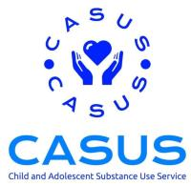  1st of July 2019 until 31st of March 2026

SERVICE PROVISION
The CGL Adult Drug and Alcohol Treatment Service (age 18 years +) provides all elements of substance misuse treatment including:
- Early intervention advice and support
- Pharmacological treatment
- Harm reduction services
- Pharmacy-delivered services (including needle and syringe programmes)
- Psychosocial support
- Recovery support
- Community/inpatient detox and residential rehabilitation
- Workforce/stakeholder training
The CGL service has specialist staff/teams, which include:
- Psychology
- Family safeguarding
- Criminal justice
- Rough sleeping/homeless treatment service (Cambridge)
- Social work/safeguarding
- Nursing/clinical
- Primary care/place-based early intervention (alcohol)
- Recovery service

The young people’s substance use treatment service- CASUS (up to 21 years) provides:
- Prevention and early intervention advice and support
- Pharmacological treatment
- Harm reduction advice
- Psychosocial support
- Interventions-co-occurring conditions (mental health and substance use)
- Workforce/stakeholder training
- Support/interventions for those in the criminal justice system
- Schools based provision

Both specialist treatment contracts provide services across the Cambridgeshire geographical footprint, which includes the following districts:
- Cambridge City Council
- East Cambridgeshire District Council
- South Cambridgeshire District Council
- Fenland District Council
- Huntingdonshire District Council

ACKNOWLEDGEMENTS
S Squared Analytics wishes to thank all the individuals and their loved ones with lived experience of drug and alcohol use and the stakeholders and professionals who generously gave their time to participate in the surveys, interviews, and focus groups, providing important information and sharing their views.
S Squared Analytics would like to thank our steering group for this project, namely Susie Talbot, Scott Davidson, and Alice Middleton, as well as staff within the specialist services, including CGL, CRS, and the SUN Network, in particular KC Cade, for their support, assistance, and guidance throughout this Drug and Alcohol Qualitative Needs Assessment.
1.2 - METHODOLOGY

OVERVIEW
The qualitative analysis for this work contained:
- THOSE WITH LIVED EXPERIENCE
  - 1-2-1 interviews
  - Stakeholder feedback provided to the Sun Network
  - Stakeholder feedback from multiple disadvantaged groups
  - Stakeholder feedback from HEaRT Team service users
  - Online survey
- TREATMENT WORKFORCE
  - Work shadowing
  - 1-2-1 Interviews
  - CGL staff focus group
  - CRS staff focus group
  - Online survey
- KEY PRACTITIONERS
  - 1-2-1 interviews
  - Focus groups
  - Children and Young Person Workshop
  - Health and Mental Health Workshop
  - Housing Workshop
  - Online survey
- CHILDREN AND YOUNG PEOPLE
  - Online survey

Figure 1.2.1: Overview of engagement completed in this assessment.
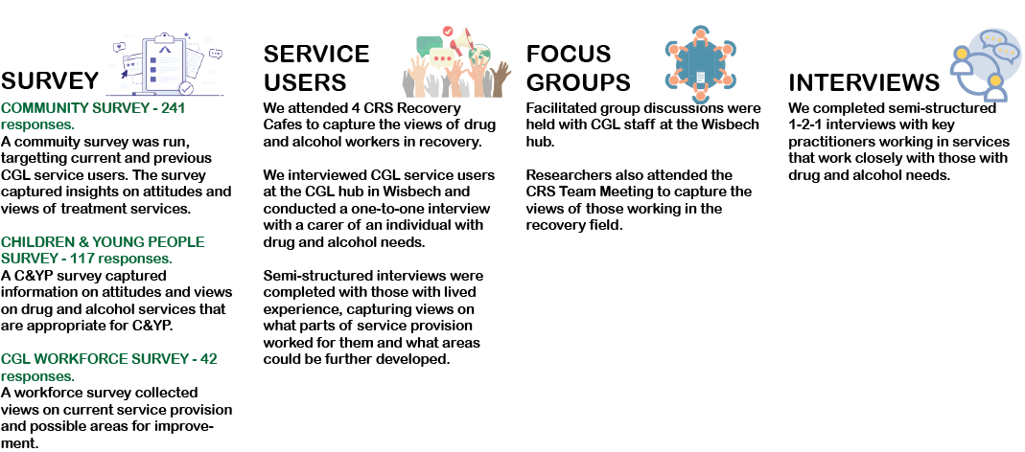
Figure 1.2.2: Organisations that participated in the needs assessment
 |  |  | 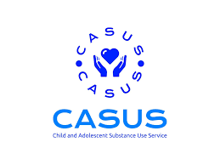
CAMBRIDGESHIRE CONSTABULARY | CAMBRIDGESHIRE AND PETERBOROUGH ICB | CAMBRIDGESHIRE COUNTY COUNCIL | CHILD AND ADOLESCENT SUBSTANCE USE SERVICE
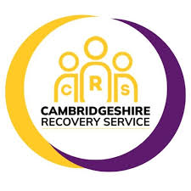 |  |  | 
CAMBRIDGESHIRE RECOVERY SERVICE | CENTRE 33 | CHANGE GROW LIVE | CHANGING FUTURES
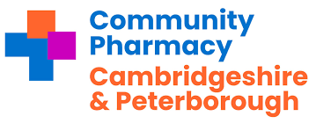 |  |  | 
LOCAL PHARMACY COMMITTEE | CAMBRIDGESHIRE AND PETERBOROUGH NHS FOUNDATION TRUST | THE EDGE CAFÉ | HEALTHY YOU
 |  |  | 
INDIVIDUAL PLACEMENT AND SUPPORT EMPLOYMENT SERVICE | NORTHAMPTON HEALTHCARE NHS FOUNDATION TRUST | HM PRISON AND PROBATION SERVICE | THE SUN NETWORK

1.3 SUMMARY FINDINGS
Figure 1.3.1: Summary of survey responses.
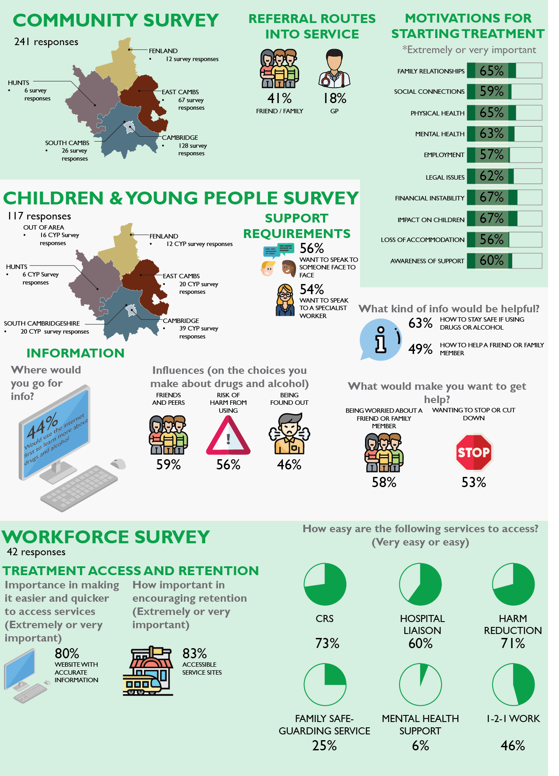

Figure 1.3.2: SWOT analysis of key findings – Adult Services
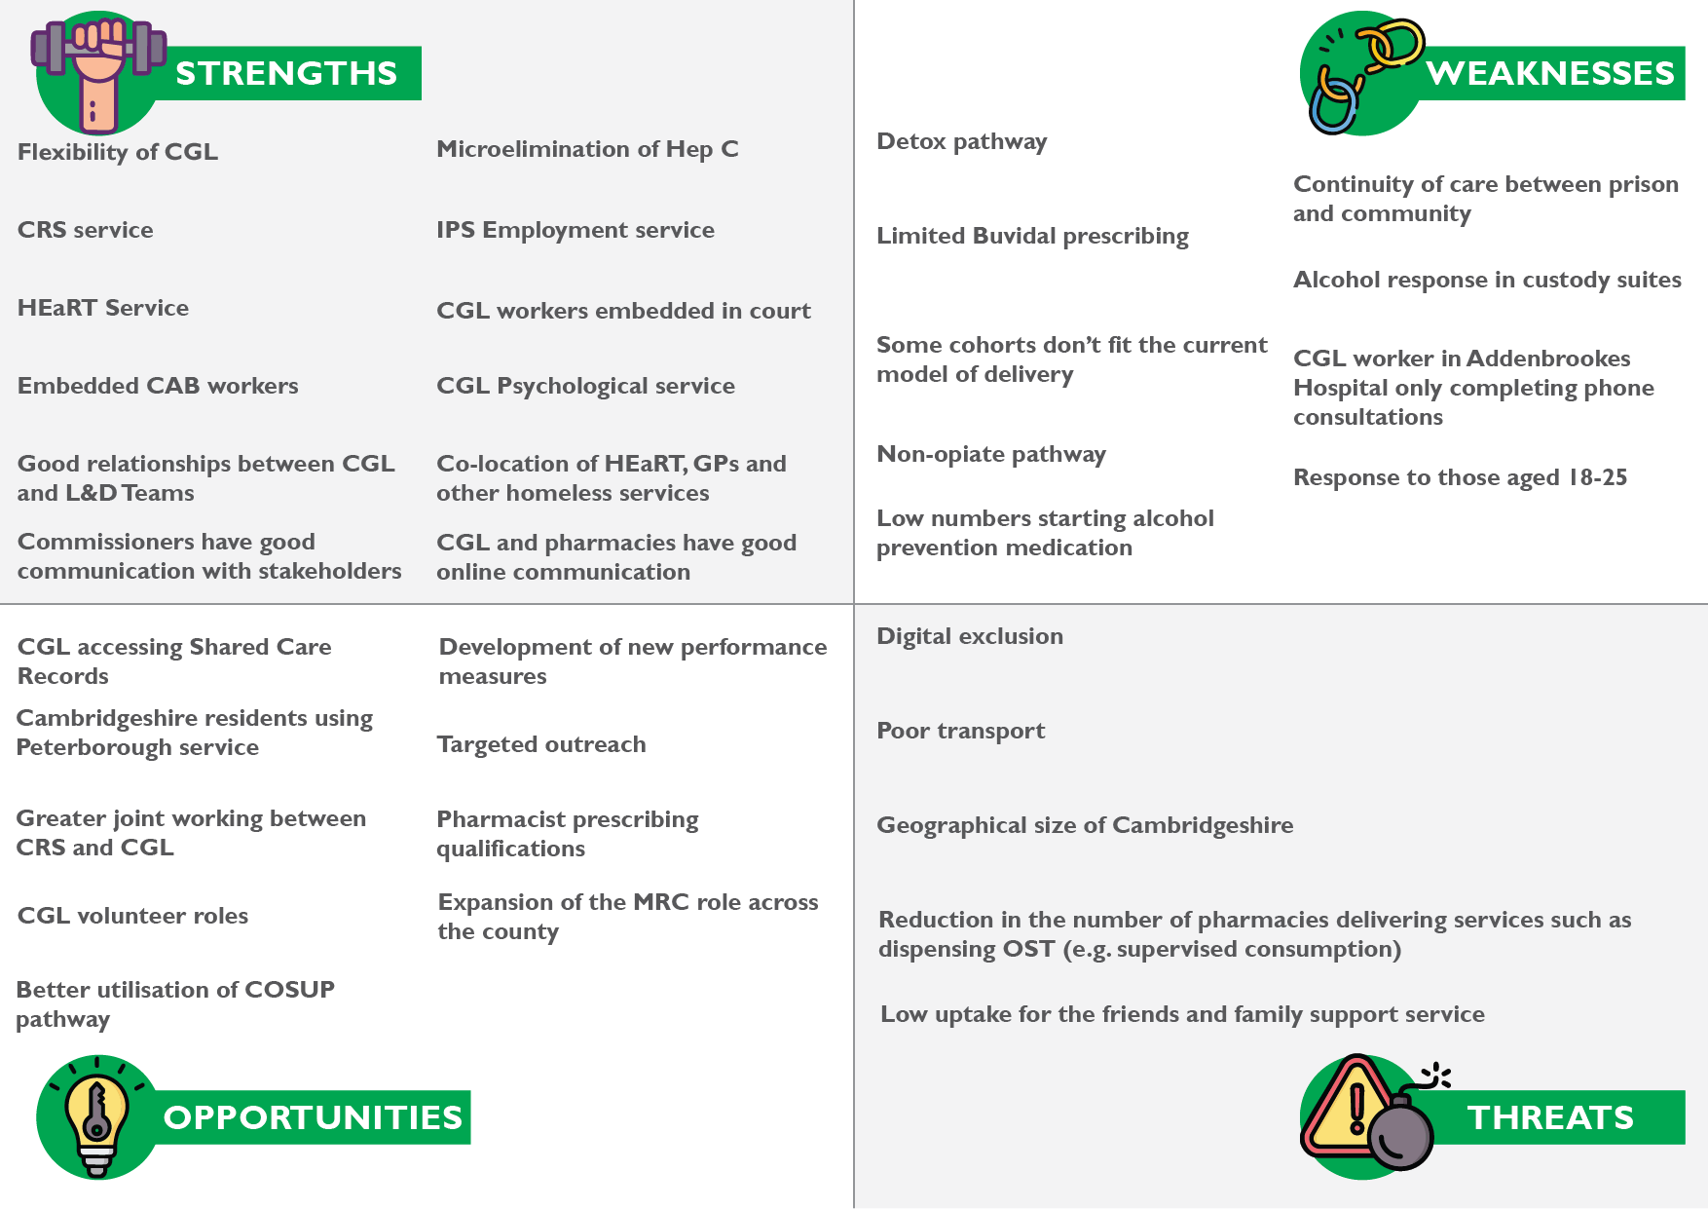
Figure 1.3.3: SWOT analysis of key findings – CYP Services
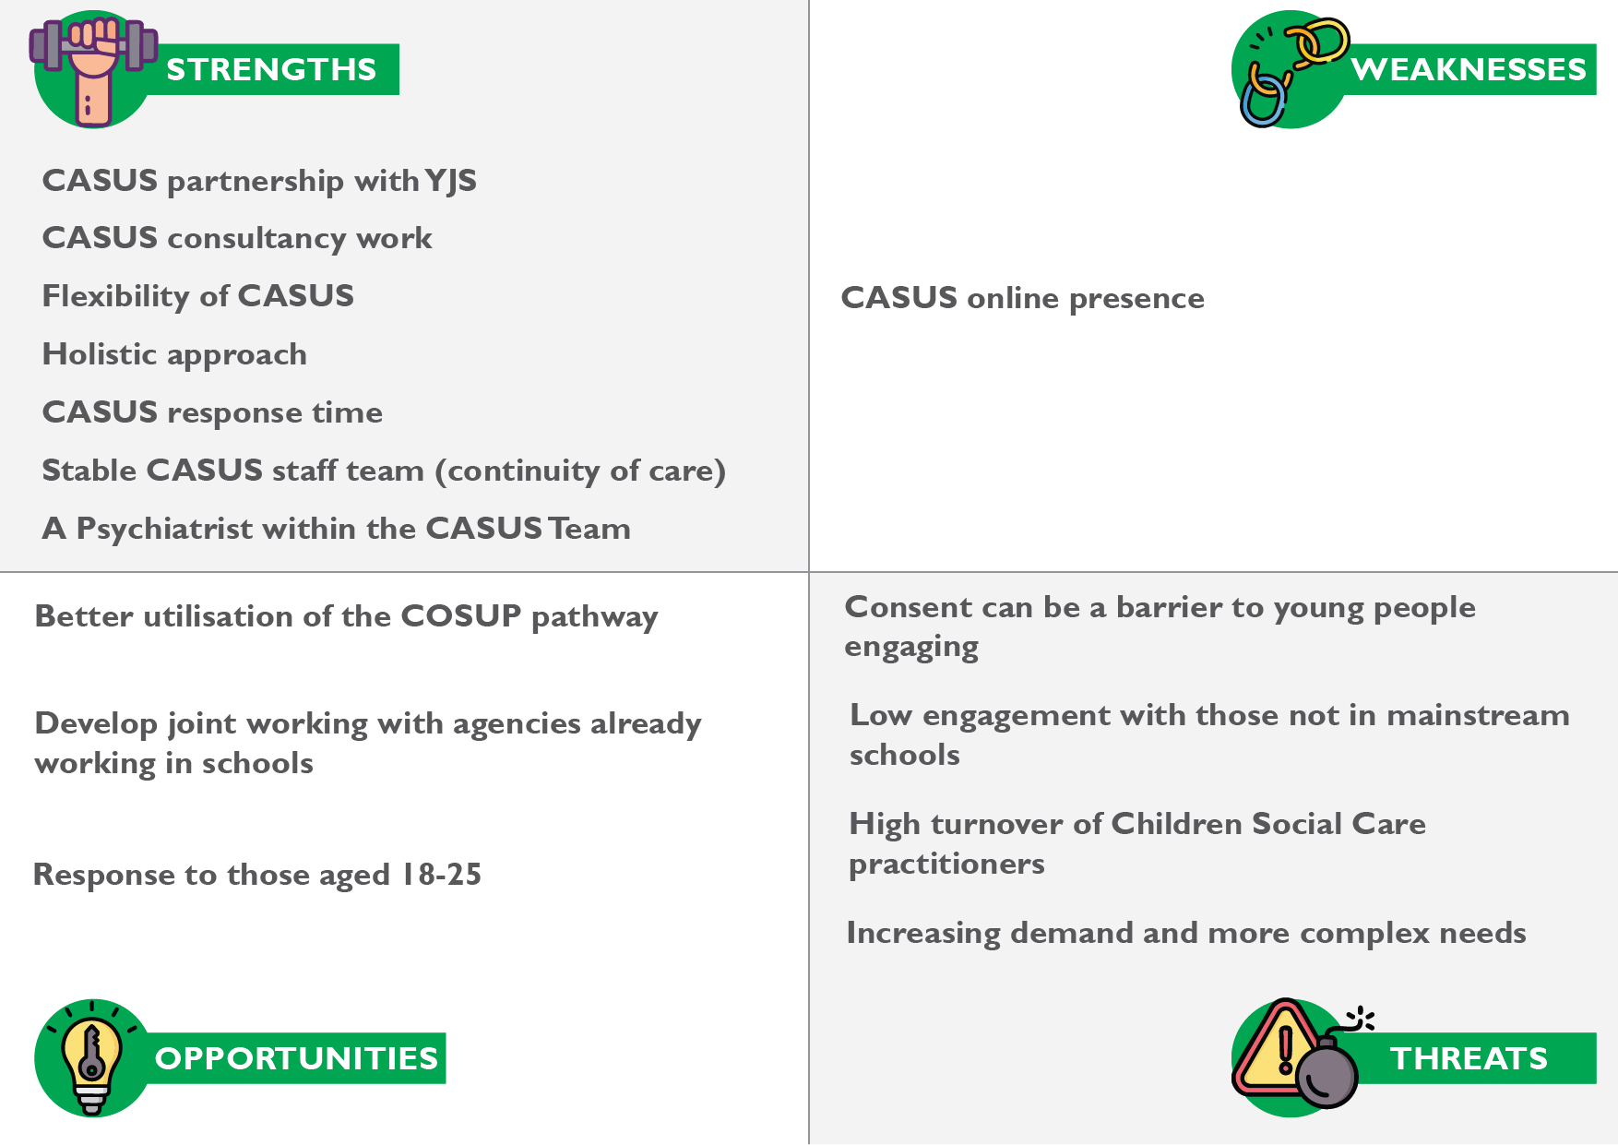

1.4 - RECOMMENDATIONS

INTRODUCTION
This section presents the recommendations developed for adult, and child and adolescent services. These recommendations are based on the evidence gathered from the qualitative research undertaken in this assessment. They reflect the insights gathered from participants’ experiences and perspectives and aim to inform improvements in service design, delivery, and accessibility across the different age groups.

ADULT SERVICE DELIVERY
RECOMMENDATION 1
TITLE: IMPROVE PATHWAYS AND DATA SHARING BETWEEN TREATMENT SERVICE PROVIDERS AND NHS SYSTEMS
 | KEY FINDING
- CGL practitioners do not have access to GP or NHS systems.
- The CGL assessment is thorough, but it is not accessible to GPs or health practitioners based in the hospital.
- It is not straightforward for GPs to make referrals to CGL. There are examples of external services being embedded on SystmOne, making the referral process easier (e.g. Healthy You).
 | RELEVANCE TO CAMBRIDGESHIRE
- The lack of data integration between CGL and primary care and hospital services could result in potential delays in referrals for individuals with a drug or alcohol need.
- The limited visibility of CGL assessments could lead to GPs not having patient histories when making clinical decisions.
 | RECOMMENDATION
- Advocate for the drug and alcohol service to have access to shared care records to enhance data sharing.
- Develop direct referral pathways within GP systems to make access to treatment services smoother.

RECOMMENDATION 2
TITLE: ENSURE THE SERVICE IS RESPONSIVE TO THE NEEDS OF SERVICE USERS CONCERNING ACCESSIBILITY
KEY FINDING
KEY FINDING 1 – SERVICE LOCATIONS ARE NOT CONVENIENT FOR SERVICE USERS IN SOME BORDER AREAS
- Yaxley and Whittlesea are 15 minutes from the Aspire Drug Treatment Service in Peterborough, making it the most geographically convenient treatment option for residents in those areas.
- Service users who are residents of Cambridgeshire must attend the nearest Cambridgeshire treatment hub rather than the closer Peterborough service, which can be challenging for those travelling by public transport.
- The number of impacted service users is currently unknown, making it difficult to quantify the scale of the issue.
KEY FINDING 2 – CAMBRIDGESHIRE COVERS A LARGE GEOGRAPHICAL AREA AND HAS LIMITED PUBLIC TRANSPORT OPTIONS
- Cambridgeshire covers a large geographical area and has a dispersed population. The financial cost and time required to travel to services may cause barriers for service users who rely on public transport.
KEY FINDING 3 – ALTERNATIVE SERVICE DELIVERY, SUCH AS VIDEO CONSULTATIONS, DOES NOT WORK FOR ALL COHORTS
- Some cohorts, such as older people, tend to be digitally excluded, so they are unlikely to utilise online CGL resources.
- An example was given of an 80-year-old patient living in sheltered accommodation in a village. He cannot make it to the CGL hub for group work.
- CGL will provide telephone support, but this is outside their normal pathway.
KEY FINDING 4 – THE WORKFORCE SURVEY HIGHLIGHTED SEVERAL FACTORS THAT WERE IMPORTANT IN MAKING IT EASIER AND QUICKER FOR INDIVIDUALS TO ACCESS SERVICES
- 63% (26) of respondents to the workforce survey thought that a website with accurate/up-to-date information was extremely important to make it easier and quicker to access the drug and alcohol service.
- 80% (33) thought ‘appointments available in local communities (place-based)’ were extremely or very important.
- 76% (31) thought a ‘mixture of online and face-to-face appointments’ was extremely or very important.
KEY FINDING 5 – SERVICE USERS MAY FACE BARRIERS DUE TO LANGUAGE
- The practitioners within the Alcohol Care Team said they see a sizeable number of patients from Eastern Europe who do not speak English. Without a specialist drug and alcohol worker who speaks relevant languages, it is harder to engage with this cohort.
- There is a Migrant Recovery Coordinator based in Wisbech. They can work with individuals from Russia, Lithuania, Poland, Latvia, and Romania, as well as those who do not speak English.
- Those areas served by the Huntingdon and Cambridge CGL hubs do not have dedicated access to a multi-lingual Migrant Recovery Coordinator.
RELEVANCE TO CAMBRIDGESHIRE
- The limited public transport options in many parts of Cambridgeshire mean that people may face long travel times and high costs to reach drug and alcohol services. This issue particularly affects residents in villages and smaller towns where bus services may be infrequent or unavailable, leading to social isolation, reduced access to opportunities, and potential disengagement from treatment.
- Many older residents, especially those in villages, face digital exclusion due to a lack of digital literacy, limited access to devices, or poor broadband connectivity in rural areas. This makes online service delivery, such as video consultations, ineffective for some cohorts.
- Drug and alcohol practitioners who can speak languages other than English make it easier for people to access services.
- In Fenland, a Migrant Recovery Coordinator is crucial for engaging individuals who might otherwise struggle to access support due to language and cultural barriers. The targeted approach increases engagement in treatment and reduces the likelihood of reoffending linked to substance misuse. Individuals who don’t speak English in Huntingdon and Cambridge may struggle to engage with treatment services, leading to unmet treatment needs and increased risks of harm.
RECOMMENDATION
- To ensure that a drug and alcohol service is responsive to the needs of service users, service providers should consider developing a place-based approach to service delivery and having a flexible transport support scheme to encourage engagement.
- To explore, at a regional level, the possibility for Cambridgeshire residents to use drug and alcohol services in other areas, thus increasing patient choice.
- Ensure equity of access to CGL support to those who do not speak English across Cambridgeshire.

RECOMMENDATION 3
TITLE: EXPAND THE USE OF VOLUNTEERS IN THE WIDER WORKFORCE
KEY FINDING
- The practitioners within the Cambridgeshire Recovery Service have reported that key workers within the CGL hubs do not complete suitable onboarding of volunteers.
- There should be an expectation that the Recovery Coordinators in the main CGL service support and upskill volunteers.
RELEVANCE TO CAMBRIDGESHIRE
- Having volunteers with lived experience in a drug and alcohol service offers several benefits, including:
  - bridging the gap between service users and professionals
  - breaking down of stigma
  - development for volunteers
  - a cost-effective way to enhance services
- Poor onboarding of volunteers may result in them being underprepared for their roles, reducing their effectiveness.
- Volunteers play a vital role in recovery support, and a structured training program would improve service user experiences.
RECOMMENDATION
- Assign Recovery Coordinators clear responsibilities for mentoring and upskilling volunteers.

RECOMMENDATION 4
TITLE: ASSERTIVE OUTREACH TO BE EXPLORED WITH KEY COHORTS AND LOCATIONS
KEY FINDING
- Mental health-supported accommodation was highlighted as a location where assertive outreach would be beneficial.
- Residents in mental health-supported accommodation may struggle with mobility, mental health symptoms, or chaotic lifestyles, making it difficult to attend scheduled treatment appointments.
- Thought should be given to training staff in supported accommodation settings, particularly concerning harm minimisation.
RELEVANCE TO CAMBRIDGESHIRE
- A lack of engagement with services could lead to worsening drug and alcohol or mental health needs.
- Targeted outreach could bring CGL and support services directly to these locations, reducing missed appointments and improving treatment accessibility.
- Harm minimisation training would ensure staff:
  - recognise early signs of drug or alcohol use
  - recognise signs and risk of relapse
  - provide basic harm reduction advice (e.g., safer substance use, overdose prevention)
  - signpost residents to appropriate drug and alcohol services
RECOMMENDATION
- The new service should explore an assertive outreach provision that ‘reaches out to cohorts’ that struggle to engage with current drug and alcohol services.
- CGL practitioners should be able to provide assertive outreach to service users who require a personalised care approach.
- To enhance the effectiveness of mental health-supported accommodation, staff should receive comprehensive training, including harm minimisation and trauma-informed care.

RECOMMENDATION 5
TITLE: TO IMPROVE THE ALCOHOL PATHWAY FOR THOSE IN CUSTODY SUITES
KEY FINDING
- Feedback from police practitioners indicated that there are gaps in identifying and supporting individuals with alcohol dependence in custody settings in Cambridgeshire.
- Resource pressures in the Liaison and Diversion service mean individuals with alcohol issues may not receive adequate screening or support whilst in custody.
- Custody staff monitor dependent drinkers mainly for withdrawal symptoms or medical risks rather than offering intervention or support referrals.
- “Those using alcohol may be the quietest individuals. They may be feeling embarrassed.”
- “If someone is drunk in custody, they tend to be given time to sober up and then released. These individuals may miss out on follow-up support.”
RELEVANCE TO CAMBRIDGESHIRE
- If alcohol-related needs go unnoticed, individuals may miss opportunities for early intervention and referral to treatment services.
RECOMMENDATION
- There should be closer working between drug and alcohol treatment services and Liaison and Diversion Services when managing those with alcohol needs in custody suites and follow-up when released.

RECOMMENDATION 6
TITLE: THERE SHOULD BE A CLEAR, FLEXIBLE OFFERING FOR THE NON-OPIATE TREATMENT PATHWAY
KEY FINDING
- Feedback from practitioners and service users was that the pathway for those using ketamine was not effective.
- Drug trends change over time, and services must be flexible to respond to new substances and patterns of use.
RELEVANCE TO CAMBRIDGESHIRE
- Ketamine misuse can lead to serious physical and mental health risks, including bladder damage (ketamine-induced cystitis) and dissociative mental health symptoms.
- If existing treatment models do not address the needs of ketamine users, individuals may disengage from services and face worsening health outcomes.
- If services remain rigid, they risk falling behind emerging drug trends, leaving gaps in support. A proactive and responsive approach would ensure early intervention and harm reduction for users of newer or less commonly treated substances.
RECOMMENDATION
- Develop flexible service models that allow rapid adaptation to new and emerging drug trends and utilise quantitative data to inform service modelling.
- Review and update ketamine treatment pathways to ensure they address both physical and psychological harms, informed with the available quantitative data.

RECOMMENDATION 7
TITLE: THE DETOX PATHWAY SHOULD BE REVIEWED
KEY FINDING
KEY FINDING 1 – SERVICE USERS ARE UNCLEAR HOW THEY CAN ACCESS COMMUNITY AND PLANNED INPATIENT DETOXES
- Service users are unclear about the CGL offer concerning community and planned inpatient detoxes. Service users would like to know their options; however, their expectations should be managed.
KEY FINDING 2 – PRACTITIONERS FROM MENTAL HEALTH SERVICES WOULD LIKE MORE INFORMATION ON ACCESS TO DETOXES
- Practitioners from mental health services said that they would like to have some guidance on how long it takes for a service user to be able to access inpatient detox provision.
KEY FINDING 3 – HOSPITAL PRACTITIONERS REPORT FEWER COMMUNITY AND INPATIENT DETOXES
- Practitioners from the Alcohol Care Team report they believe there has been a reduction in the number of community and inpatient detoxes.
- Relapse rates for emergency detoxes are high. Planned detoxes have a higher success rate. Data was not provided.
KEY FINDING 4 – SOME COHORTS CAN NOT ACCESS COMMUNITY DETOXES
- Cohorts such as the alcohol-dependent homeless population struggle to access community detoxes due to not having access to a suitable detox location or family support (patients cannot be detoxed in the street or a hostel). As such, inpatient detoxes have to be explored.
KEY FINDING 5 – INPATIENT DETOXES WERE DIFFICULT TO ACCESS
- 9 out of 21 respondents (43%) to the workforce survey believed inpatient detoxes were difficult to access.
RELEVANCE TO CAMBRIDGESHIRE
- Clear communication would help service users with their options and prepare for detox appropriately.
- Better coordination between mental health and substance misuse services would improve patient care and referral efficiency.
- Reduced detox options can lead to longer waiting times, increased health risks, and higher rates of emergency care use.
- Expanding planned detox options could improve sustained recovery rates and reduce repeated emergency interventions.
RECOMMENDATION
- The detox pathway should be reviewed to ensure it is accessible and responsive to all who require it. Clear guidance on the detox referral processes and timeframes whould be developed.
- Improve service user education on detox options, including eligibility and expected waiting times.
- Assess capacity for increasing detox provision, particularly local inpatient detox beds and increasing access to community detox through supervised support.
RECOMMENDATION 8
TITLE: THERE SHOULD BE CLEAR COMMUNICATION BETWEEN KEYWORKERS AND SERVICES USERS AND THEIR CARERS
KEY FINDING
- A carer said there was a lack of communication between keyworkers, service users, and their carers. The carer said their partner’s keyworker did not attend four appointments over nine months. No advance notice was given that the keyworker would not meet their appointment.
- Complex information about rehabilitation was not explained clearly. From the information the service user was given, there was no way they could make an educated decision on the best rehabilitation facility for them. There was no definitive list of rehabilitation facilities. The keyworker did not offer appropriate support with this.
RELEVANCE TO CAMBRIDGESHIRE
- The absence of key workers without notice and the lack of backup support highlight inconsistencies in service provision.
- A structured approach, such as assigning secondary keyworkers, could improve reliability and ensure that service users always have support.
RECOMMENDATION
- There should be a consistent approach to patient care, including when a named keyworker is absent.

RECOMMENDATION 9
TITLE: LOCAL CARE PROVIDERS SHOULD FOLLOW LOCAL PRINCIPLES IN THEIR DELIVERY OF CARE TO THOSE WITH CO-OCCURRING CONDITIONS
KEY FINDING
KEY FINDING 1 – LOCAL COMMITMENTS FOR THE CARE OF THOSE WITH CO-OCCURRING CONDITIONS HAVE BEEN CREATED
- Previous Needs Assessments highlighted the need for more integrated care to meet both mental health and substance use needs.
- These reports led to local commitments being made in 2020 to provide better care for people with co-occurring conditions based on the Public Health England guidance.
KEY FINDING 2 – CO-OCCURRING SERVICES WERE DIFFICULT TO ACCESS
- 60% (21) of respondents to the workforce survey thought mental health support (co-occurring conditions) was difficult or very difficult to access.
KEY FINDING 3 – THE SUBSTANCE MISUSE, MENTAL HEALTH AND CO-OCCURRING CONDITIONS LEAD HELPED FACILITATE JOINT WORK BETWEEN DRUG AND ALCOHOL AND MENTAL HEALTH SERVICES
- The role both championed and challenged the practices of professionals within drug and alcohol services, as well as mental health services, in their work with individuals who have co-occurring conditions.
- The role shares good practices with drug and alcohol and mental health services.
RELEVANCE TO CAMBRIDGESHIRE
- People with co-occurring conditions have co-existing substance use and mental health issues.
- The term co-occurring condition has been used instead of ‘dual diagnosis’, as people may have multiple mental health conditions or use several substances concurrently, and some may not have received formal diagnoses of these issues.
- People who have co-occurring conditions are more likely to have multiple needs than those who have either mental health conditions or use substances.
RECOMMENDATION
- The substance misuse provider is one of various organisations that meet the needs of those with co-occurring conditions.
- All organisations should follow the same principles in their delivery of care to those with co-occurring conditions:
  - Substance/alcohol misuse and/or mental health should never be a barrier to respective treatments.
  - Dual Diagnosis is a core part of all mental health, substance misuse and criminal justice professional’s work.
  - Where the person is accessing any combination of substance misuse, mental health and criminal justice services, the service providers will be expected to work collaboratively to meet the needs of the individual through effective joint working and care coordination arrangements.
  - Providers will deliver a consistent service delivery model for those with Dual Diagnosis needs.
  - Staff of all agencies will be equipped to recognise, assess and support those with Dual Diagnosis needs.
  - All staff should have access to relevant training to equip them to manage the care and support of this client group.
  - Care should reflect the views and motivations of the person.
  - Care plans should involve carers (including young carers) and family members.
  - User and carer involvement is at the forefront of service delivery.
  - Service providers are responsible for the delivery of the pathways and should escalate any evidence where the pathway is not being followed to their Commissioner.
  - Where non-compliance with pathway delivery is highlighted, the provider must provide a written action plan to remedy the issues.

CHILDREN AND YOUNG PEOPLE SERVICE DELIVERY
RECOMMENDATION 10
TITLE: COMPLEX NEEDS, INCLUDING SEXUAL ABUSE, AMONGST THE COHORT USING CASUS SHOULD BE EXPLORED FURTHER
KEY FINDING
- Anecdotal feedback from CASUS practitioners is that the number of young people who require interventions is much higher than five years ago. Feedback was also received that young people have greater complex needs.
- The number of young people receiving treatment through the CASUS service has returned to pre- COVID-19 pandemic levels.
- CASUS practitioners estimate that 90% of the female CASUS caseload had suffered some form of sexual abuse.
RELEVANCE TO CAMBRIDGESHIRE
- The statistic that 90% of female CASUS clients have experienced sexual abuse suggests a strong link between trauma and substance use in young women.
- It is increasingly recognised that substance use disorders, including substance abuse and substance dependence, are closely related to childhood trauma and post-traumatic stress disorders. Among women with substance use disorders, the majority report sexual, physical or emotional abuse, or neglect.
- This has major implications for service provision, requiring trauma-informed care, safeguarding measures, and gender-specific interventions.
RECOMMENDATION
- Further analysis should be conducted into the needs of those using the CASUS service, with a particular focus on females who have experienced sexual abuse.
- Ensure all practitioners are trained in trauma-informed care.

RECOMMENDATION 11
TITLE: EXPLORE MULTI-AGENCY APPROACHES TO ENGAGING PARENTS WITH DRUG AND ALCOHOL NEEDS WITH SPECIALIST SERVICES
KEY FINDING
- Feedback from specialist drug and alcohol practitioners and practitioners working with young people was that parents do not want to disclose any drug and alcohol needs.
- Parents are “terrified” of social workers being involved and have fears related to social services interventions with their families.
- It is common for parents with drug and alcohol needs to not consent to services contacting their children.
- There were low referrals to the COSUP service from CGL for children of the parents on their caseload.
- There are barriers to parents agreeing to referrals to the COSUP service. Parents may not want to let a service know they are struggling with drugs or alcohol.
- It tends to be a limited number of schools that refer children and young people to the COSUP pathway.
RELEVANCE TO CAMBRIDGESHIRE
- There is likely to be an unmet need concerning parental substance misuse in Cambridgeshire. This increases the risk to parents and children.
RECOMMENDATION
- Strengthen collaboration between drug and alcohol services, schools, children’s social care practitioners, and healthcare providers to identify families in need without triggering disengagement.
- There should be a focus on addressing the stigma of engaging with a drug and alcohol service and providing parental support.
- There should be a plan to improve partner engagement with the COSUP pathway.

RECOMMENDATION 12
TITLE: THERE ARE OPPORTUNITIES TO ENGAGE MORE CHILDREN AND YOUNG PEOPLE WITH DRUG AND ALCOHOL NEEDS WITH CASUS
KEY FINDING
- Feedback from CASUS practitioners highlighted the high turnover of social work practitioners and the impact that this had on promoting the service and joint working.
- There are existing health services that work with children and young people in schools with potential drug and alcohol needs who may be able to promote CASUS and refer to them—for example, Healthy You and school mental health support teams.
  - Healthy You practitioners see children and young people who may benefit from a referral to CASUS. Healthy You practitioners highlighted the importance of knowing the CASUS practitioners so that children are more likely to agree to a referral to them.
  - Mental health support teams are in approximately 50% of secondary schools and sixth-form colleges.
RELEVANCE TO CAMBRIDGESHIRE
- Social workers play a key role in referring young people to CASUS. New staff may be unaware of the service or its benefits if staff turnover is high.
- Utilising existing services working with children at risk of drug and alcohol use could help encourage engagement with specialist drug and alcohol services.
RECOMMENDATION
- Implement joint training sessions between CASUS and other agencies to improve awareness and referral pathways.
- Ensure newly recruited social workers receive training on CASUS early in their roles to maintain awareness and referral levels.
- Joint working with existing services that outreach into schools and colleges should be explored.
- Mental health support teams and Healthy You practitioners could be utilised to provide drug and alcohol information and support in schools.

RECOMMENDATION 13
TITLE: ADDRESSING THE NEEDS OF YOUNG PEOPLE WHO ARE NOT IN MAINSTREAM EDUCATION
KEY FINDING
- Practitioners working with children and young people highlighted several potential cohorts where there is likely to be unmet need due to limited professional oversight:
  - Those being homeschooled. There is limited oversight from all agencies with this cohort, with CASUS practitioners estimating that each one had someone being homeschooled on their caseload.
  - Those not in education, employment, or training (NEETs). Which agencies are seeing this cohort?
  - In addition, private schools and some Academy Trusts do not always engage well.
RELEVANCE TO CAMBRIDGESHIRE
- Without formal structures to monitor wellbeing, children not in mainstream education may miss out on opportunities for early intervention and preventative work.
- Children who are not in mainstream education face increased risks of criminal exploitation.
RECOMMENDATION
- There should be a multi-agency collaboration to identify and support children and young people with potential drug and alcohol needs.
- The drug and alcohol provider should engage directly with all educational establishments.

RECOMMENDATION 14
TITLE: EXTENDING THE AGE CRITERIA FOR THE CHILDREN AND YOUNG PERSON’S SERVICE SHOULD BE EXPLORED
KEY FINDING
- CASUS practitioners feedback that the cohort of over 18s that they work with tends to have complex needs requiring bespoke interventions that adult drug and alcohol services may not offer.
- Adult drug and alcohol services are delivered predominantly via group work. Practitioners fed back that young adults are uncomfortable sitting in a room with those older than them.
- In other areas, children and young persons drug and alcohol services work with those older than 18, with some services working with those up to 25 years of age.
- 60% of respondents to the Children and Young person survey thought the transition should happen at 21, with 4% thinking that the transition should happen at 25 years old.
RELEVANCE TO CAMBRIDGESHIRE
- Without bespoke interventions, young adults may not engage with adult services.
- Addressing the needs of this cohort could potentially impact the number of future long-term users.
RECOMMENDATION
- It is necessary to have some flexibility in the children and young person service model when working with young adults. Services should be developmentally appropriate.

1.5 - ADDITIONAL KEY FINDINGS

INTRODUCTION
The following key findings are presented without accompanying recommendations. Their inclusion offers additional context and detail regarding the delivery and experience of the service. This section provides insight into areas of practice, perception, and operational context that are significant for future consideration, ongoing monitoring, or further exploration.
Where appropriate, themes highlighted here have already been reflected in the recommendations presented earlier in the report. Additionally, the findings outlined in this section have contributed to developing and interpreting the quantitative analysis.

ADULT SERVICE DELIVERY

KEY FINDINGS
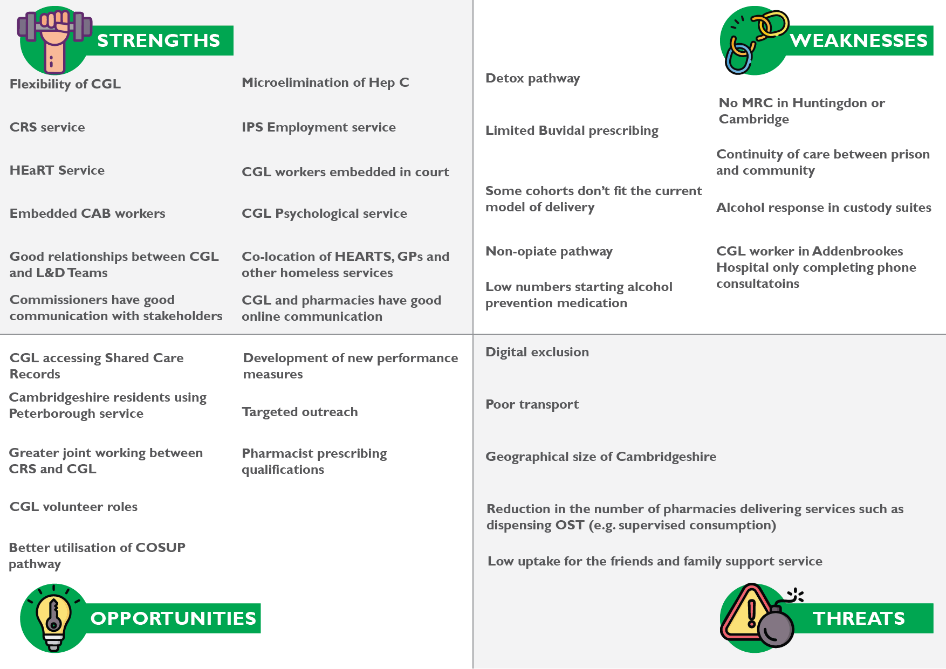

CGL ARE FLEXIBLE
- Probation practitioners said CGL was flexible when working with probation and service users.
- CGL practitioners will see service users outside of their hubs.

CAMBRIDGESHIRE RECOVERY SERVICE (CRS)
- CRS received positive feedback from those using their Recovery Café services.
- “CGL is the hospital that fixes broken legs. CRS are the physio and aftercare.”
- Arts and crafts offer a different aspect of recovery.

HOMELESS ENGAGEMENT AND RECOVERY TEAM (HEART) SERVICE
- Provide a flexible outreach service to a cohort whose needs were unmet by the mainstream CGL service.
- The rough sleeping cohort requires a bespoke approach.
- The weekly outreach van is a known hub for the street homeless in Cambridge to receive support.
- Opiate prescribing pathway for the homeless cohort in Cambridge works well.

CITIZENS ADVICE BUREAU (CAB) WORKER
- Positive feedback was received concerning the debt advice and information received by CGL service users from the embedded CAB workers.

INDIVIDUAL PLACEMENT AND SUPPORT (IPS) EMPLOYMENT SERVICE
- The IPS Employment service has a strong relationship with CGL.
- There is a simple referral pathway. IPS practitioners have access to CRIS.

CGL WORKERS EMBEDDED IN COURTS
- When a CGL practitioner is in the courts, there is better engagement with their service.
- Court staff do not have to contact CGL to refer someone, reducing the delays.
- “There is meant to be continuity between custody, courts and the prison. At the moment, we are relying on CGL [to identify individuals with a drug or alcohol need].”

CGL PSYCHOLOGICAL SERVICE IS A BENEFICIAL ADDITION TO THE PROVISION
- Service users and practitioners praised the CGL Psychological Service.
- 78% of respondents to the workforce survey thought mental health support was difficult or very difficult to access.
- 53% of respondents to the workforce survey thought psychological support was difficult or very difficult to access.

CO-LOCATION OF THE HEART SERVICE, GPs, AND OTHER HOMELESS SERVICES CONTRIBUTES TO A JOINED-UP APPROACH
- Those using the Access Surgery can have their physical health needs met as well as their drug and alcohol needs.
- The cohort seen by the HEaRT Team has high physical health needs.
- There is potential to offer joint appointments between GPs and HEaRT team practitioners.
- Co-location means that patients can receive same-day prescriptions.

GOOD RELATIONSHIPS BETWEEN CGL AND LIAISON AND DIVERSION (L&D) TEAMS
- L&D practitioners reported good relationships with CGL practitioners.

CGL AND PHARMACIES HAVE GOOD ONLINE COMMUNICATION
- Pharmacists can provide electronic information to CGL via an IT platform.

COMMISSIONERS HAVE GOOD COMMUNICATION CHANNELS WITH STAKEHOLDERS
- Various partners highlighted the good communication channels between them and the commissioning team.

CGL SERVICES HAVE MICRO-ELIMINATED HEPATITIS C
- This good work needs to continue.
- Can Blood-Borne Virus (BBV) management form part of CGL’s performance measures?

ARE THE NUMBER OF PATIENTS COMMENCING TREATMENT OF ALCOHOL RELAPSE PREVENTION MEDICATION LOW?
- Hospital practitioners highlighted that there were low numbers of patients being prescribed alcohol relapse medication by CGL. This should be explored.

BUVIDAL
- Practitioners, including prescribers, have responded that they want to start more patients on Buvidal.
- Continuity of care for those starting Buvidal in prison is disrupted as there is not always the capacity to continue prescribing Buvidal in the community. Practitioners working with the street homeless believed that the practice of starting an individual on Buvidal in prison should stop if the prescription cannot continue in the community as it is detrimental to them engaging with services.
- Practitioners have noted that the cost of Buvidal is restrictive.
- There are potential developments in NHS England funding for Buvidal to be continued in the community for a maximum of three months.

CONTINUITY OF CARE BETWEEN PRISON AND THE COMMUNITY CAN BE IMPROVED
- CGL does not visit HMP Peterborough to see prisoners before they are released.
- CGL are often not notified that a service user has been released from prison.
- Can a through-the-gate scheme be explored? Can video consultations be used in the prison?
- Is there a possibility of joint appointments between probation and drug and alcohol services?
- Those leaving prison have a lot of appointments, and it is often the drug and alcohol appointments that are missed.

CGL WORKER IN ADDENBROOKES HOSPITAL PROVIDES A LINK BETWEEN THE HOSPITAL AND THE COMMUNITY
- The Recovery Worker works with patients after they are discharged from the hospital.
- Previously, this role was a nursing post that could provide patients with an assertive primary care service.
- The CGL worker provides phone calls to patients who have been identified as having alcohol-related health needs. Practitioners said this is not the best way to engage with this high-risk group.

THERE ARE OPPORTUNITIES TO DEVELOP JOINT WORKING BETWEEN CRS AND THE MAINSTREAM CGL SERVICE
- The front door to CGL could promote CRS in a more integrated way.
- Practitioners in the CGL hubs can increase the referrals they make to CRS.
- CRS needs CGL to refer people to them. The services are intertwined.
- Could an embedded CRS team in each CGL hub work?

THERE ARE OPPORTUNITIES FOR CGL TO IDENTIFY THE CHILDREN OF PARENTS WHO USE DRUGS OR ALCOHOL AND REFER TO CASUS; CHILDREN OF SUBSTANCE USING PARENTS (COSUP)
- In most cases, parents of children seen on the COSUP pathway are not engaging with CGL.
- Centre 33 reports that their young carer scheme does not receive many referrals from CGL.

PHARMACISTS QUALIFYING WITH INDEPENDENT PRESCRIBER QUALIFICATIONS COULD BE UTILISED
- Independent pharmacist prescribing qualifications have evolved to allow pharmacists to be more active in patient care. From 2026, all newly qualified pharmacists in the UK will be trained as independent prescribers.

BUILDING PERFORMANCE MEASURES INTO THE SERVICE SPECIFICATION SHOULD BE EXPLORED
- Should CGL have performance measures related to alcohol-related deaths/admissions?

THERE IS A LACK OF PHARMACIES THAT PROVIDE OPIATE SUBSTITUTE MEDICATION
- Pharmacy practitioners fed back that fewer pharmacies in Cambridge provided opiated substitute medication. Pharmacies have fed back that they cannot manage drug-using patients due to capacity issues.

UPTAKE FOR THE FRIENDS AND FAMILY GROUP
- There has been a low uptake of the carers, friends and family groups run by CGL.

CHILDREN AND YOUNG PEOPLE SERVICE DELIVERY

CASUS PARTNERSHIP WORKING WITH THE YOUTH JUSTICE SERVICE
- Previously, this work was delivered by Youth Justice Services. CASUS have a broader understanding of drug and alcohol needs.
  - Not having this embedded worker within Youth Justice Services may mean practitioners aren’t as aware of the drug and alcohol service CASUS provide.
- CASUS have a non-stigmatising approach to young people.

CASUS CONSULTANCY WORK WITH AGENCIES WAS BENEFICIAL
- Positive feedback was received from practitioners about the information and advice that CASUS gave to professionals and practitioners working with children and young people with drug and alcohol needs.

CASUS IS A FLEXIBLE SERVICE
- A key strength of CASUS is the flexibility practitioners have in meeting children and young people in convenient and comfortable locations (e.g., their home, school, coffee shop, McDonalds).
- Practitioners can see children across the whole county.
- Practitioners can introduce themselves to young people before formally engaging with the service.
- Practitioners accompany service users to other appointments, including mental health and housing appointments. This positively impacts the young person’s drug and alcohol.

THE AMBIT APPROACH (HOLISTIC, ADOLESCENT MENTALIZATION-BASED INTEGRATIVE TREATMENT, ‘AMBIT’)
- Positive feedback was received from practitioners regarding how the AMBIT approach is beneficial to practitioners from other agencies who are working with young people who may have experienced trauma.
- CASUS have a multi-disciplinary team.
- CASUS practitioners can work jointly with other services, improving the response to the young person.

CASUS HAVE A PROMPT RESPONSE TIME TO REFERRALS
- CASUS practitioners have a quick response time.
  - “The longest time a young person can wait to see us is 4 weeks.”
  - “If an individual is open to Youth Justice, they can be seen within 5-15 working days.”
  - “If the young person is high risk, they can be seen in a matter of hours.”

CONSISTENT WORKER
- CASUS can offer a young person a consistent practitioner. This positively impacts their engagement with the service.
- Practitioners in other agencies also benefit from having a consistent practitioner to work with and refer young people to.

A PSYCHIATRIST WITHIN THE TEAM
- Service users can see a psychiatrist within six to eight weeks.
  - The psychiatrist can draft letters to courts and schools. Their interventions have changed the direction of people’s lives.
  - Children and young people can get timely diagnoses and medication.
  - The intervention of a psychiatrist improves the referral a service user has to a Child and Adolescent Mental Health Services (CAMHS) Team.
  - Practitioners, including the psychiatrist, have developed prescribing pathways that mean young people do not have to stop using cannabis before being prescribed medication.

ASKING A YOUNG PERSON TO CONSENT TO THEIR INFORMATION BEING SHARED WITH CASUS CAN BLOCK ENGAGEMENT
- Young people are more likely to engage once they have met the CASUS worker. Can initial appointments be treated as an information session?

2 - LIVED EXPERIENCE; Findings
2.1 - INTRODUCTION
This section details the findings from the fieldwork completed with those with lived experience of drug and alcohol needs completed for this needs assessment. The information contained in this section has informed the previous sections' recommendations and SWOT analysis. Information is included from:
- Members of the Changing Futures Programme
- The SUN Network
- Cambridgeshire Recovery Service
- HEaRT

2.2 - MEMBERS OF THE CHANGING FUTURES PROGRAMME

INTRODUCTION
Changing Futures is a national programme aiming to improve outcomes for adults experiencing multiple disadvantages – including combinations of homelessness, substance misuse, mental health issues, domestic abuse and contact with the criminal justice system. Changing Futures is testing new ways of bringing together public and community sector partners to help people improve their lives.
The following information summarises the feedback from facilitated groups completed in Wisbech, Ely, and Cambridge.

FEEDBACK
Figure 2.1: Changing Futures Drug & Alcohol Recommissioning Feedback
WHAT IS NEEDED?
INTERVENTIONS  - Help to stop smoking weed  - Peer-led support  - Harm reduction  - Family carers support  - Ongoing support?  - Person-centred approach  - Video calls to talk to people  - Appointments are available late this afternoon, early evenings  - More one-to-ones and more often  - More in languages such as Polish  - Fortnightly face-to-face contact with recovery workers helps both parties. It was like that 20 years ago  - Ongoing support when off drugs/alcohol  - Cambridge Recovery Services  - Siloed working systems | STAFFING  - Lower caseloads for staff  - Support tailored to the needs, e.g. specialist support staff  - Lived experience (more lived experience staff)  - Specialist workers for more complex cases  SERVICE ACCESSIBILITY  - More suitable permanent spaces in rural areas like Ely  - Pop-up locations in more rural areas so people can access the services  - More offices in locations to make it easier to access  - Transport needed.  - Do not have to go to a place to get support online or over the phone | CRIMINAL JUSTICE  - Police, court and prison support  HEALTH AND PHYSICAL HEALTH  - Mental health  - Pharmacy support  - Access to mental health whilst at CGL  HOUSING  - Drug and alcohol service involvement in housing meetings  - More integration with homeless housing services  DETOX AND REHAB  - Shorter Waiting times for community detox  - Somewhere safe to continue my recovery after detox  - Accessing detox and rehab  - More and easier access to residential rehab  - Quicker access to rehab

WHAT COULD BE IMPROVED?
INTERVENTIONS  - Working in partnership with related services  - Key worker time, i.e. more time to spend with clients  - Same-day prescribing  - Joint/ joined up working around the person  - Alternative opportunities and activities. For people to engage with instead of drinking and doing drugs  SERVICE ACCESSIBILITY  - Opening hours, i.e. afternoons and evenings  - Locations (not that easy to access in rural areas | - Waiting times (You go in wanting help, must wait, too late)  - Time for appointments later in the day  - Outreach, more resources, and staff needed, especially in rural areas  - Funding for technology, phones, etc for service users  STAFFING  - More resources for staff to reduce burnout  - More doctors and prescribers  - Incorporation of honest feedback from service users  - More staff  - Not just email communication (more face-to-face work time for staff) | - Greater transparency/ evidence of accountability  - Proof that trauma-informed training is being adhered to. (Monitoring system)  - Trauma-informed training for all staff  - Trauma-informed principles in system leadership staff on the ground/Monitoring and evidence of it working  - Lower caseloads for staff (allowing more time with each client)  - Smaller caseloads for recovery workers, they can have more contact with service users  - More time spent with a client
WHAT WORKS?
- CGL is great  - Art/craft supplies available something positive to do/keeps your hands busy  - Hot drinks and food are available to all | - Staff work well in partnership with other agencies  - Sense of community  - Welcoming  - User-led feedback groups | - CGL's well-being day should be more frequent. Is it really good  - Able to refer for specialist dentistry at no cost at all to me

2.3 - FEEDBACK COLLECTED BY THE SUN NETWORK

INTRODUCTION
The SUN Network is a lived experience organisation that works with CGL service users to gather feedback on their experiences. The summary below presents key findings from this feedback. The SUN Network conducts regular engagement exercises with service users, and the information presented here was collected from 1-2-1 interviews with individuals across Cambridgeshire between Quarter 2 of 2023 and Quarter 2 of 2024.

POSITIVE FEEDBACK (Q2 2024)

THE POWER OF LIVED EXPERIENCE
- Hearing personal stories of addiction and recovery was impactful and inspiring.
- Volunteers and trainers with lived experience helped break the stigma and offered relatable insights.
- Many found lived experience videos and testimonies crucial to their understanding and recovery.

COMMUNITY AND SUPPORT
- Services like CGL, The Edge Café, and Recovery Writing provide a sense of belonging.
- Groups and activities help combat loneliness, boredom, and isolation.
- Open-door policies and non-judgmental support make a significant difference.

RECOVERY AND PERSONAL GROWTH
- People expressed deep gratitude for the services helping them turn their lives around.
- Many reported feeling better, more hopeful, and inspired to give back in the future.
- Recovery was described as transformative, improving both mental and physical health.

HIGH-QUALITY TRAINING & EDUCATION
- Addiction training and Intro to Addiction & Recovery courses received excellent feedback.
- Training provided valuable self-reflection and professional insights.
- Suggestions included adding breakout rooms and longer breaks for accessibility.

IMPROVEMENTS IN SERVICES OVER TIME
- Some noted that services have improved significantly compared to past experiences.
- Trauma-informed care principles (safety, trust, empowerment) were appreciated.
- Services are now more inclusive, supportive, and holistic.

STIGMA REDUCTION & AWARENESS
- Police and professionals benefited from training on addiction and mental health.
- Sharing personal stories helped challenge stigma in various settings.
- Volunteers and service users actively contribute to awareness efforts.

THE IMPORTANCE OF HOLISTIC APPROACHES
- Acupuncture, group sessions, and detox programs were valued.
- Addressing underlying issues like loneliness and trauma is key to recovery.
- Mental health and addiction support need to be more integrated.

NEGATIVE FEEDBACK (Q2 2023-Q2 2024)

GAPS IN MENTAL HEALTH & DUAL DIAGNOSIS SUPPORT
- Service users with both mental health and addiction challenges struggle to access appropriate help.
- Some are passed between services without getting the support they need.
- The stigma around addiction in mental health services leads to judgment and inadequate care.

ACCESS & LOCATION BARRIERS
- Service users in areas like Cambourne and Wisbech face difficulty accessing CGL services due to distance and transport costs.
- Some are signposted to services in different locations, requiring long, expensive journeys.
- Sofa surfers are not recognised as rough sleepers, limiting their access to support.

COMMUNICATION & FOLLOW-UP ISSUES
- Calls and messages to CGL go unanswered, making it difficult to get help.
- Appointments are cancelled without notice, leading to wasted journeys and feelings of rejection.
- Promises to follow up or provide information are not always kept.

STIGMA & TREATMENT IN HEALTHCARE & SERVICES
- Some service users report feeling judged or treated poorly when disclosing addiction, especially in hospital settings.
- Addiction histories are documented in ways that lead to bias in treatment.

LACK OF VOLUNTEER & PEER SUPPORT MANAGEMENT
- Volunteers feel unsupported, with no debriefs or structure to their involvement.
- Cambridge CGL is described as feeling “cliquey” and not welcoming to new people.

INCONSISTENCIES IN SERVICE DELIVERY
- Some service users and family members feel misled or let down by inconsistent information (e.g., delayed rehab applications).
- Reports of staff saying they will take action but failing to follow through.

SOCIAL ISOLATION & POST-RECOVERY CHALLENGES
- Service users and family members express struggles with isolation after detox.
- Lack of engagement opportunities post-treatment can lead to loneliness and relapse risk.

BARRIERS FOR NON-ENGLISH SPEAKERS & VULNERABLE GROUPS
- The lack of translators in services makes access difficult for non-English speakers.
- People without settled status or stable housing face additional barriers to support.

CRISIS SUPPORT & SUICIDE PREVENTION FAILURES
- Some individuals expressing suicidal thoughts do not receive adequate support.
- Family members report loved ones being discharged from the hospital after suicide attempts without proper follow-up.

SYSTEMIC ISSUES & SERVICE USER DISEMPOWERMENT
- Many feel like they “fall through the net” and have no further options.
- People are hesitant to give feedback because they feel nothing changes.

2.4 - FEEDBACK COLLECTED AT CAMBRIDGESHIRE RECOVERY SERVICE (CRS) GROUPS

INTRODUCTION
As part of the qualitative research, researchers attended CRS groups in Cambridge, March, Huntingdon, and St Neots. Interviewers conducted 1-2-1 interviews with attendees.
Below is a summary of feedback.

POSITIVE FEEDBACK

PEER-LED SUPPORT & CRS
- Groups led by those with lived experience are highly valued.
- CRS provides essential support, helps with loneliness, and offers a sense of community.
- CRS is seen as an effective and supportive resource, often more engaging than CGL.

FAMILY & CARER SUPPORT
- The involvement of families helps reduce stigma.
- Some have benefited from carer support but weren’t always aware it was available.

MENTAL HEALTH SUPPORT
- Many acknowledge the strong link between addiction and mental health.
- Support through CRS and CGL psychology services has been beneficial.
- Trauma-informed approaches and motivational interviewing have been helpful.

KEYWORKERS (MIXED BUT POSITIVE FOR SOME)
- Some keyworkers have been supportive and helpful.
- Some service users appreciated being able to call for support when needed.

GROUP SUPPORT & SOCIAL CONNECTION
- Many found group settings beneficial, even those initially hesitant.
- Peer-led CRS groups create valuable friendships and support networks.

CGL’S ROLE IN INITIAL SUPPORT & SIGNPOSTING
- CGL was a key starting point for many seeking help.
- CGL helped connect individuals with relevant services like mental health support.

NEGATIVE FEEDBACK

ISSUES WITH KEYWORKER CONSISTENCY & WORKLOAD
- Many had multiple keyworkers, causing inconsistency in care.
- Some keyworkers had caseloads of 80+ people, making meaningful support difficult.
- Some keyworkers lacked the necessary qualifications or experience.

LIMITED MENTAL HEALTH & EMOTIONAL WELLBEING SUPPORT
- Many feel mental health services are insufficient, especially for those actively using substances.
- Emotional wellbeing support at CGL is lacking, and there is a need for dedicated roles.

DETOX & REHAB CHALLENGES
- Rehab is often promoted but not always accessible.
- Detox alone is insufficient without longer-term rehabilitation.
- Reduced funding for rehab is a concern.

BARRIERS TO ACCESSING SUPPORT
- Public transport and location make it difficult for some to attend services.
- Online courses (e.g., Foundations of Change) lacked interactive support.
- Some individuals struggled to access courses due to transport issues.

CGL’S STRUCTURED APPROACH LACKING FLEXIBILITY
- Some feel they’re in the “leftover bin” and not taken seriously.
- CGL’s rigid processes sometimes fail to account for individual needs.

CONCERNS ABOUT PHARMACY & MEDICATION MANAGEMENT
- Some service users were uncomfortable with pharmacy staff knowing about their treatment.
- Medication decisions felt inflexible despite clean tests.
2.5 - CHANGE GROW LIVE HOMELESS ENGAGEMENT AND RECOVERY TEAM (HEaRT) SERVICE USER FEEDBACK

INTRODUCTION
CGL’s HEaRT completed a service user feedback evaluation as part of the follow-up from a service evaluation completed in 2023 (Campbell Tickell).

POSITIVE FEEDBACK

SUPPORTIVE AND COMPASSIONATE STAFF
- Staff are described as lovely, helpful, reliable, and professional.
- Many service users feel listened to, respected, and encouraged in their recovery journey.
- Workers are praised for their prompt responses and flexibility in communication (texts, calls, and in-person support).

EFFECTIVE TREATMENT AND RECOVERY SUPPORT
- Several users feel they have a say in their treatment and appreciate staff involvement in decision-making.
- Detox and medication support have been highlighted as well-managed and effective.
- The service has helped some users achieve long-term recovery, with one noting being seven months clean.

ACCESSIBILITY AND OUTREACH
- On-site services and outreach support (e.g., visiting homeless individuals) are highly valued.
- The outreach van was noted to help some return to treatment.
- Many find the single-location setup helpful, but some suggested further mobile/outreach services.

HONEST AND OPEN COMMUNICATION
- Users appreciate the honest approach taken by staff.
- Apologies for past service issues have helped build trust and engagement.

NEGATIVE FEEDBACK

COMMUNICATION ISSUES
- Some users reported difficulties with communication between services, including missed referrals and delayed responses to complaints.
- Lack of follow-up after a Blood-Borne Virus (BBV) test voucher left a service user feeling ignored.

FLEXIBILITY AND ACCESSIBILITY CONCERNS
- Some feel that staff should be more accommodating in meeting locations.
- Service users with poor mental and physical health struggle to access services and prefer outreach options.

WORKER CHANGES AND INITIAL EXPERIENCE
- A service user mentioned struggling with their first worker due to difficulty keeping appointments but had a better experience after switching workers.
- Frequent staff changes could be a barrier to continuity of care.

RESPECT FOR BOUNDARIES
- One user expressed frustration that their "no" was not always respected when declining certain services.

3 - SURVEY ANALYSIS
3.1 - COMMUNITY SURVEY

DEMOGRAPHICS
- 44% (105) were aged between 25-34.
- 54% (129) were male, 45% (107) were female, and one respondent did not want to say their sex.
Figure 3.1.1: Age – Adult Survey (n=240) | Figure 3.1.2: Sex – Adult Survey (n=237)
- 42% (101) were White British. 21% (50) were White Irish. 10% (25) were Black African.
Figure 3.1.3: Ethnicity – Adult Survey (n=240)

- Most respondents were from Cambridge (128, 54%).
Figure 3.1.4: Area– Adult Survey (n=239)
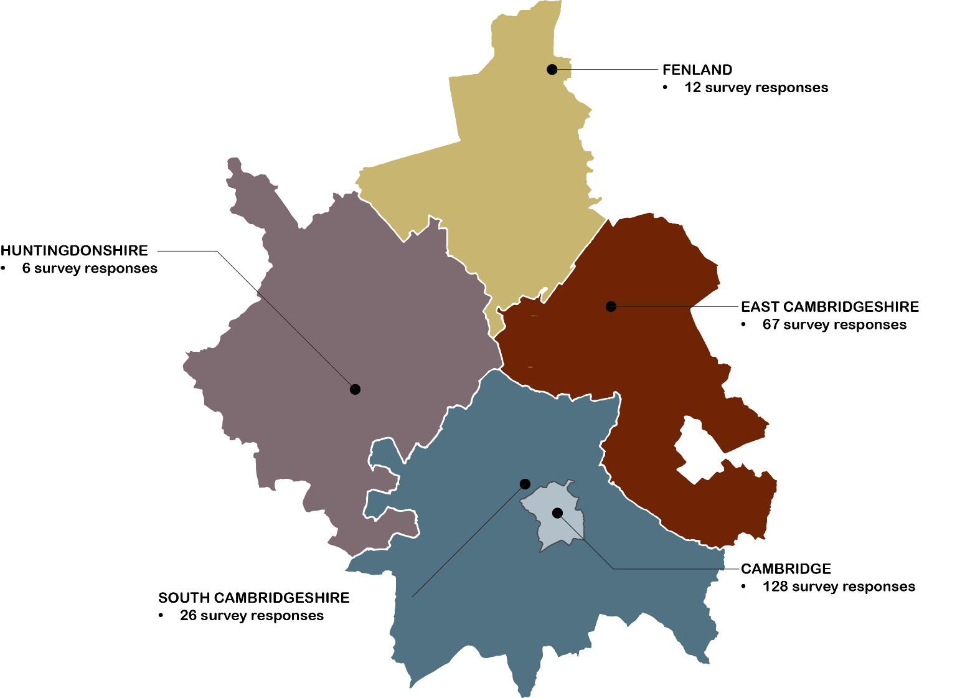

- 75% (178) were in regular employment.
Figure 3.1.5: Employment – Adult Survey (n=236)

- 44% (104) lived in a rental property.
- 59% (139) lived with children under 18.
- 46% (108) had a physical or mental health condition. 49% (115) had no physical or mental health condition.
Figure 3.1.6: Accommodation type – Adult Survey
Figure 3.1.7: Live with children under 18 – Adult Survey (n=235) | Figure 3.1.8 Physical or mental health condition lasting 12 months – Adult Survey (n=237)

REFERRAL ROUTE
- 41% (97) were signposted to services by their friends or family.
Figure 3.1.9: Referral route into services – Adult Survey (n=239)

MOTIVATIONS FOR STARTING TREATMENT
- 67% (160) stated their motivation for starting treatment was the impact their drug and alcohol use was having on their children. The same number stated that financial stability was their motivation.
- 56% (132) stated their motivation was loss of accommodation.
Figure 3.1.10: Motivations for starting treatment – Adult Survey (n=236-241)

ASSESSMENT WAIT
- 13% (32) waited 1-3 days for an assessment. 34% (82) waited for 4-6 days. 41% (98) waited for 1-2 weeks. 12% (28) waited for 2-3 weeks. One person waited more than 3 weeks.
Figure 3.1.11: Wait for an assessment – Adult Survey (n=241)

SERVICES USED
Figure 3.1.12: Which services have you used? Adult Survey (n=231-239)

SERVICE ACCESS
- 64% (154) thought online or telephone support was extremely or very important for accessing services.
Figure 3.1.13: How important are the following for accessing services? – Adult Survey (n=237-241)

SERVICES
- All services had good satisfaction ratings.
Figure 3.1.14: How satisfied are you with the following services? – Adult Survey (n=234-238)

3.2 - CHILDREN AND YOUNG PERSON SURVEY

DEMOGRAPHICS
- 85% (98) were aged between 16 and 18.
- 56% (65) were female, 36% (42) were male, and 8% (9) preferred not to say.
- 80% (93) were White British.
Figure 3.2.1: Age – CYP Survey (n=115)
Figure 3.2.2: Sex– CYP Survey (n=116) | Figure 3.2.3: Ethnicity – CYP Survey (n=116)

Figure 3.2.4: Area – CYP Survey
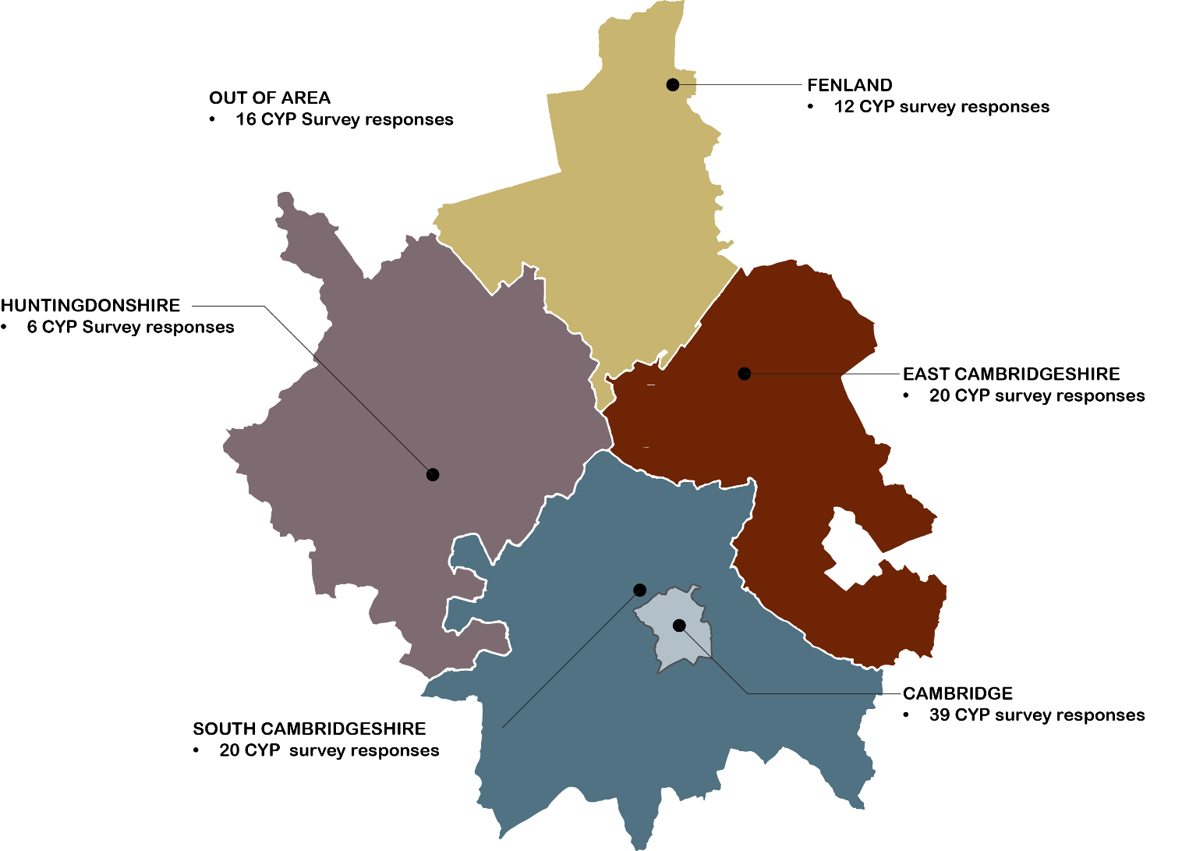

INFORMATION
- 44% (51) would use the internet to look for information on drugs or alcohol.
Figure 3.2.5: If you wanted to learn more about drugs or alcohol, where would you look for information? – CYP Survey (n=116)

- 63% (74) thought that how to stay safe if using drugs and alcohol would be the most helpful information to receive.
Figure 3.2.6: What kind of information or support about drugs and alcohol would be most helpful to you? – CYP Survey (n=117)

DRUGS USED
- Alcohol (99%, 115) and cannabis (92%, 107) were the most common drugs that respondents thought young people used.
Figure 3.2.7: What drugs do you think young people use? – CYP Survey (n=116)

INFLUENCES
- 59% (69) thought friends and peers influence their choices about drugs and alcohol.
- 56% (65) through risk of harm influences their choices about drugs and alcohol.
Figure 3.2.8: Who or what influences the choices you make about drugs and alcohol? – CYP Survey (n=117)

SERVICE KNOWLEDGE
- 90% (105) were unaware of any young person’s drug and alcohol service in Cambridgeshire.
- 26% (30) thought that schools and other children’s and young people’s services have a good knowledge of drugs and alcohol.
Figure 3.2.9: Are you aware of any drug and alcohol support services in Cambridgeshire specifically for young people? – CYP Survey (n=117) | Figure 3.2.10: Do you think that schools and other children's & young people’s services have a good knowledge of drugs and alcohol? – CYP Survey (n=117)

SUPPORT REQUIREMENTS
- 47% (55) said they would prefer to go to their GP for help with a drug or alcohol problem. 20% (23) said they would prefer to go to other young people’s services.
- 66% (75) said they would like to receive help by speaking to someone face to face. 16% (18) said they would like help via an app.
Figure 3.2.11: If you wanted help for a drug or alcohol problem, where would you prefer to go? (Tick your preferred option) – CYP Survey (n=116) | Figure 3.2.12: How would you like to receive this help? – CYP Survey (n=116)
- 54% (63) said they would feel most comfortable talking to a specialist drug and alcohol young people’s worker. 9% (11) said they feel most comfortable talking to a teacher.
Figure 3.2.13: Who would you feel most comfortable talking to? – CYP Survey (n=117)

- 58% (68) believed ‘being worried about a friend or family member’s drug or alcohol use’ would make them want to get help or talk to someone about drugs or alcohol.
- 53% (62) believed ‘wanting to stop or cut down on drug or alcohol use’ would make them want to get help or talk to someone about drugs or alcohol.
Figure 3.2.14: What would make you want to get help or talk to someone about drugs or alcohol? – CYP Survey (n=117)

- 44% (52) thought ‘not thinking my issue is serious enough’ would stop them from using a drug and alcohol service.
- 44% (51) thought ‘fear of being judged’ would stop them from using a drug and alcohol service.
Figure 3.2.15: What might stop you from using a drug and alcohol service? – CYP Survey (n=117)

TRANSITIONING
- 36% of respondents thought transitioning to adult services at 18 was right.
- 60% thought the transition should happen at 21, with 4% thinking that the transition should happen at 25.
Figure 3.2.16: If you were in treatment with drug and alcohol services for young people at age 18, we would need to start considering moving you to adult services. Do you think this is right? – CYP Survey (n=116)

3.3 - CGL WORKFORCE SURVEY

ACCESS
- 63% thought a ‘website with accurate/up-to-date information’ was extremely important in making it easier and quicker for individuals to access services.
- 80% thought ‘appointments available in local communities (place-based)’ were extremely or very important.
- 76% thought a ‘mixture of online and face-to-face appointments’ was extremely or very important.
Figure 3.3.1: In your opinion, how important are the following factors in making it easier and quicker for individuals to access the drug and alcohol service? – CGL Workforce Survey (n=40-41)

- ‘Accessible service sites’ (98% Very or somewhat helpful) and ‘face-to-face appointments in local communities’ (80% Very or somewhat helpful) were considered the most helpful factors in retaining someone in treatment.
Figure 3.3.2: Once individuals are in specialist treatment, how helpful are the following in encouraging retention?- CGL Workforce Survey (n=41)

- Perceptions of accessibility varied across the different services within CGL
Figure 3.3.3a: How easy are the following CGL services to access? – CGL Workforce Survey (n=41-42)
- Responses of ‘difficult’ or ‘very difficult’ only are shown in 3.3.3b, demonstrating that:
  - 78% thought mental health support was difficult or very difficult to access.
  - 53% thought psychological support was difficult or very difficult to access.
Figure 3.3.3b: How easy are the following CGL services to access? (Very difficult or Difficult only) – CGL Workforce Survey (n=41-42)

- 60% thought mental health support (co-occurring conditions) was difficult or very difficult to access.
Figure 3.3.4a: How easy are the following specialist services to access? CGL Workforce Survey (n=32-40) | Figure 3.3.4b: %age that stated Very difficult or Difficult only

TREATMENT QUALITY
- Over 90% of respondents believed the following factors were extremely or very important in improving the quality of treatment:
  - Training and workforce development (95%)
  - Workforce competency standards (93%)
  - Capacity and skill mix for service users with complex needs (93%)
  - Joint working with partner agencies (e.g. co-location) (95%)
  - Specialist roles (i.e. psychology, safeguarding, etc.) (98%)
Figure 3.3.5: How important are the following for improving the quality of treatment for service users/patients? – CGL Workforce Survey (n=41)
- 85% strongly agreed or agreed with the statement ‘CGL Cambridgeshire manages the risks of service users well’.
Figure 3.3.6: How much do you agree with the following statements? – CGL Workforce Survey (n=41)

END

Solutions for Public Health. (2014). Cambridgeshire Joint Strategic Needs Assessment: Autism, Personality Disorders and Dual Diagnosis
Public Health England. (2019). Mental health: population factors
Cambridgeshire and Peterborough CCG, Cambridgeshire and Peterborough Public Health Directorate, & Office of the Police and Crime Commissioner. (2020). Our commitment to better care for people with co-occurring Mental Health and Substance/Alcohol use
Public Health England. (2017). Better care for people with co-occurring mental health and alcohol/drug use conditions: A guide for commissioners and service providers
Lotzin A, Grundmann J, Hiller P, Pawils S, Schäfer I. Profiles of Childhood Trauma in Women With Substance Use Disorders and Comorbid Posttraumatic Stress Disorders. Front Psychiatry. 2019 Oct 18;10:674. doi: 10.3389/fpsyt.2019.00674. PMID: 31681026; PMCID: PMC6813657.
DLUHC, (2021), Changing Futures

