

Drug and Alcohol Needs Assessment 2024-25

Authors
Alice Middleton – Public Health Registrar
S Squared Analytics
Supported by
Susie Talbot – Public Health Commissioning Team Manager, Drugs and Alcohol
Scott Davidson – Senior Public Health Manager, Drugs and Alcohol

Contents
1 Executive Summary 1
1.1 Introduction 1
1.2 Key Challenges 1
1.3 Strengths of the Current System 2
1.4 Weaknesses in the Current System 3
1.5 Other Opportunities 3
1.6 Recommendations 5
2 Introduction 9
2.1 Why We Need a Needs Assessment 9
2.2 Why Drug & Alcohol Services Matter 9
2.3 Objectives 9
2.4 Background; Legal Context 10
2.5 Strategic Context – Local and National Policy 10
2.6 Structure of this Needs Assessment 10
2.7 Terminology 11
3 Literature Review: Summary 12
4 National Epidemiology 14
4.1 National Drug Use 14
4.1.1 General Trends in Drug Use 14
4.1.2 Substance-Specific Trends and Frequency of Use 14
4.1.3 Lifestyle Factors and Wellbeing 15
4.1.4 Demographic Patterns in Drug Use 15
4.1.5 Children and Young People 17
4.2 National Alcohol Use 18
4.2.1 General Trends in Alcohol Use 18
4.2.2 Demographic Patterns in Alcohol Use 18
4.2.3 Children and Young People 19
4.3 National Mortality 20
4.3.1 Drugs 20
4.3.2 Alcohol 21
4.4 Intersecting Vulnerabilities 22
5 Cambridgeshire 24
5.1 Demographics 24
5.1.1 Population 24
5.2 Drug Use in Cambridgeshire 28
5.2.1 Drug Use; Prevalence 28
5.2.2 Drug Use; Service User Epidemiology 35
5.2.3 Drug Use; Unmet Need 39
5.2.4 Drug Use; Key Insights and Priorities 41
5.3 Alcohol Use in Cambridgeshire 43
5.3.1 Alcohol Use; Prevalence 43
5.3.2 Alcohol Use; Service User Epidemiology 46
5.3.3 Alcohol Use; Unmet need 48
5.3.4 Alcohol Use; Key Insights and Priorities 49
5.4 Detailed Service User Demographics 51
5.4.1 Service User Demographics: Districts 51
5.4.2 Service User Demographics: Age 55
5.4.3 Service User Demographics: Protected Characteristics 56
5.4.4 Demographics; Key Insights and Priorities 60
5.5 Mortality Related to Substance Use in Cambridgeshire 62
5.5.1 Deaths from Drug Misuse 62
5.5.2 Mortality from Alcohol 65
5.5.3 Liver Disease 69
5.5.4 Substance Use and Suicide 70
5.5.5 Deaths While in Treatment 71
5.5.6 Mortality; Key Insights and Priorities 72
5.6 Health Harms 74
5.6.1 Hospital Admissions for Drugs and Alcohol 74
5.6.2 Blood-borne Viruses 77
5.6.3 Tobacco Use 78
5.6.4 Health Harms; Key Insights and Priorities 79
5.7 Intersecting Vulnerabilities 80
5.7.1 Mental Health 80
5.7.2 Women 83
5.7.3 Criminal Justice and Prison Leaver Population 84
5.7.4 Housing and Homelessness 88
5.7.5 Families and Substance Use 90
5.7.6 Employment and Individual Placement and Support (IPS) Services 94
5.7.7 Intersecting Vulnerabilities; Key Insights and Priorities 96
5.8 Services in Cambridgeshire 99
5.8.1 Current Service Model 99
5.8.2 Harm Reduction 102
5.8.3 Service Mapping 106
5.8.4 Inpatient and Residential Services 112
5.8.5 Services; Key Insights and Priorities 113
5.9 Known Challenges and Opportunities 117
5.9.1 Hospital Liaison 117
5.9.2 Engaging High-risk Populations 117
5.9.3 Adult Social Care 118
5.9.4 Primary Care 119
5.9.5 Accessibility of Services 120
5.9.6 Data Sharing 120
5.9.7 Challenges and Opportunities; Key Insights and Priorities 121
6 Qualitative Findings 123
7 Appendix 127
7.1 Acronym table 127
7.2 Priority & Recommendation Mapping 130

Executive Summary

Introduction
This needs assessment builds on the findings of the 2022-23 needs assessment, to inform the recommissioning of drug and alcohol (DA) services in Cambridgeshire for April 2026. It provides an updated picture of substance use trends and emerging needs in the local population. The assessment highlights key challenges, opportunities for improvement, and how investment can support broader public health and social outcomes to guide future commissioning decisions.
Continued investment in DA services is vital, delivering significant public health and societal benefits, including improved health, reductions in crime, and enhanced productivity through employment.

Key Challenges
Building on 2022-23 findings, the following issues pose significant challenges for treatment services and system partners:
- Rising drug- and alcohol-related mortality
  - Drug- and alcohol-related deaths are increasing locally and nationally, with a specific surge in deaths linked to cocaine use.
- Shifting substance use patterns
  - There appears to have been a decrease in opiate use, while non-opiate use is rising, including use of powdered cocaine.
  - The emerging threat of synthetic opioids (nitazenes) has not increased, but remains high-risk.
- Multiple vulnerabilities
  - Many people with need for substance use treatment face overlapping challenges, with over one-third of adults in treatment reporting at least one disability, though this likely underrepresents the full extent of co-existing health needs. In addition, almost eight in ten report mental ill health, more than one in eight report housing instability, and over six in ten are not in employment or training, so may face economic hardship.
- Children and families
  - Over one-third of adults in treatment are parents, and more children are being supported through statutory and early help pathways. Better identification and coordinated care for families and substance use is a critical part of support.
- Inequalities in treatment access
  - Specific groups appear to face disproportionate barriers in accessing treatment. Unmet DA treatment need is highest for young adults (up to 90%), and certain subgroups appear to be underrepresented in treatment numbers, such as ethnic groups from the global majority and LGBT+ individuals.
- Funding uncertainty and system changes
  - Around half of local funding relies on short-term national grants which affects stability and long-term planning, while the public health budget remains stretched.
  - NHS structural reforms and ongoing local government reorganisation add complexity and uncertainty to commissioning and service delivery.
  - While new treatments and place-based approaches offer real benefits, they are resource-intensive and involve opportunity costs in adopting or scaling them.
  - The formal split of Cambridgeshire public health team from Peterborough in 2024 allows tailored approaches but risks greater variability in service provision, reduced efficiency in some areas, and a challenges for cross-border collaboration and shared learning.
- Workforce and delivery pressures
  - Financial and workforce pressures are affecting the delivery of key services across the wider system. Pharmacies face closures, reduced staffing, and growing clinical demands, impacting delivery of services like supervised consumption and needle and syringe programmes (NSP).
  - Primary care, mental health, and social care services are also under strain, with limited capacity and rising demand affecting opportunities for integrated working.
  - Additional pressure is also reported across emergency services, criminal justice, housing, and youth services, limiting the ability of partners to engage in early intervention or support continuity of care for vulnerable individuals.

Strengths of the Current System
Cambridgeshire’s drug and alcohol services show a number of system-wide strengths that provide a strong foundation for future service development and improvement:
- Increasing treatment uptake
  - A growing number of adults are entering treatment, and there is good engagement among children and young people.
- Strong partnership working
  - Effective joint working and evidence of co-location is in place between drug and alcohol services and key partners, including the criminal justice system and acute hospitals. These collaborative relationships support more holistic responses to individuals with complex needs.
- Innovation and flexibility
  - Supplementary funding has supported successful interventions, such as Individual Placement and Support (IPS), long-acting injectables (e.g. Buvidal), and specialist homelessness initiatives.
- A strong local recovery service
  - The local recovery service is widely recognised by both service users and practitioners as a transformative and supportive resource, addressing physical, mental, and whole-life recovery needs.
  - Peer-led support is a vital component, with lived experience central to service delivery. These initiatives foster meaningful friendships, reduce isolation, and offer valuable opportunities for continuous improvement through service user feedback.
- Targeted public health improvement
  - The successful micro-elimination of hepatitis C demonstrates effective, coordinated public health practice within services and the wider system.

Weaknesses in the Current System
Despite many strengths, several challenges persist across the system. These represent key areas for improvement to support more inclusive, coordinated, and effective drug and alcohol services:
- Young adult access
  - There is significant unmet treatment need for under-25s across all substance types, with lower engagement compared to other age groups.
- Prevention and early intervention
  - Earlier identification and engagement with individuals at risk of substance-related harm is needed to prevent escalation and reduce long-term impacts.
- Inpatient and detoxification provision
  - Access to inpatient detox services is available, but the pathway can be complex and inconsistent. Beds are not always available locally, and the multi-step referral process can delay timely support, particularly for individuals with complex needs.
- Data and inclusion
  - Monitoring of access and outcomes remains limited for some underserved groups, including minority white ethnic groups, care leavers and veterans, making it harder to address inequalities.
- Communication and accessibility
  - Information about services is not consistently accessible to all users, particularly those with additional vulnerabilities or communication needs. Promotional materials and websites are not always specific to the local Cambridgeshire offer, which can make it harder for people to understand what support is available in their area and how to access it.
- Service fragmentation
  - Gaps remain in joint working between drug and alcohol services and parts of the NHS and social care, leading to missed opportunities for integrated care. Limited access to shared data constrains coordination, meaning services may lack vital information to support holistic and timely responses.
- Continuity of care and outcome measures
  - While engagement in treatment is positive, continuity of care between prison and services remains below national targets and has been slow to improve.

Other Opportunities
In addition to building on strengths and addressing weaknesses, other opportunities to enhance service impact and integration include:
- Enhanced use of data
  - The growing availability of national joint outcome dashboards, alongside robust local reporting, can support more tailored services for different population groups and needs.
- Digital infrastructure
  - The introduction of data-sharing initiatives, such as a shared care record, offers opportunities to improve care coordination, reduce duplication, and support trauma-informed practice.
- New system links
  - Recent progress in system-wide engagement, for example, improved collaboration with the ambulance service, has created opportunities to better reach high-risk and underserved groups. Lessons from ‘Project ADDER’ (see evidence review) demonstrate the value of co-ordinated, multi-agency approaches to reducing drug-related harm. These insights have directly informed several recommendations in this report, particularly those on assertive outreach, integrated care pathways, and trauma-informed practice.

Recommendations
The three parts of this needs assessment have informed 16 recommendations. These bring together 36 priorities from the literature review (Section 3) and quantitative analysis (Sections 4 and 5), and 14 priorities from qualitative analysis (Section 6).
A detailed mapping table is provided in the Appendix (Section 7.2), summarising how each recommendation aligns with quantitative and qualitative priorities, with signposting to the supporting data sections.
Recommendation 1- Children and Young People
Strengthen identification, education, and engagement pathways for children and young people (CYP), including those experimenting with substances or affected by parental use. Education should begin early, with prevention activity embedded across the system, in both universal and targeted services to reach CYP before issues escalate.
Enhance partnership working with schools, youth services, council services (such as Children’s Services and Early Help), Youth Offending Services (YOS), and the Child and Adolescent Substance Use Service (CASUS). Partner with outreach services already working in schools (such as Healthy You and mental health support teams) to improve identification and referral to specialist services.
Explore co-located services and outreach methods to reach the most vulnerable, including those not in mainstream education. Embed trauma-informed and gender-sensitive approaches to better support vulnerable groups, particularly those with complex needs such as experiences of abuse.
Recommendation 2 - Young Adults
Address the high unmet treatment needs for drug and alcohol use among younger adults by identifying barriers to access. Develop tailored outreach and messaging specifically targeting males, using age-appropriate and culturally sensitive strategies to improve engagement and intervention effectiveness.
Explore developmentally appropriate service models that extend support up to age 25, ensuring smooth transitions from young people’s to adult services for those with complex needs.
Recommendation 3 - Adults
Strengthen early intervention and proactive support for alcohol use among working-age adults. This should include routine identification and brief advice (IBA) in key settings such as primary care, workplaces, and hospitals. Local data, such as hospital admission numbers by Primary Care Network (PCN) and liver disease trends, should inform targeted efforts for specific areas and population subgroups.
Ensure access to low-threshold, flexible support options to minimise barriers to entry. Additionally, explore whether separating alcohol treatment pathways from drug services within the existing model could help reduce stigma and encourage more people to seek support.
Recommendation 4 - Tailored Local and Age-specific Approaches
Service planning should be informed by local population data, including deprivation and housing status, to address area-specific needs. Develop targeted strategies for urban populations and individuals with no fixed address (NFA), who often have distinct substance use patterns. Prioritise harm reduction and opiate-focused support for the NFA group, including outreach, naloxone provision, and low-threshold treatment.
Additionally, ensure engagement and treatment approaches reflect substance use differences across age groups, tailoring interventions accordingly and using ongoing monitoring to improve effectiveness.
Recommendation 5 - Mortality and Harm Reduction
Enhance harm reduction and work to prevent avoidable deaths by sustaining blood-borne virus (BBV) work, improving access to needle and syringe provision (NSP) and naloxone, and increasing the recording, referral, and support for smoking cessation. Conduct a drug- and alcohol-related death audit to inform targeted action. Strengthen the use of real-time data and assertive outreach, particularly by linking with ambulance services and High Impact Use (HIU) teams, to identify and support individuals and areas at highest risk.
Recommendation 6 - Inclusion and Equity of Access to Services
Improve equality monitoring and data quality by routinely collecting information on all protected characteristics. Take targeted action to ensure access and inclusion for under-represented groups (e.g. disabled people, LGBTQ+ individuals, ethnic minorities, veterans, care leavers). Use this intelligence to inform culturally competent services and outreach, including for specific needs like chemsex or learning disabilities.
Ensure that information and communication within services are fully accessible, addressing literacy, communication, and other accessibility needs identified among service users.
Invest in staff training on cultural competence, anti-racism, LGBTQ+ inclusion, and trauma-informed approaches, with a focus on understanding intersecting inequalities and systemic barriers. Actively involve people with lived experience in codesigning and reviewing services to ensure they are safe, relevant, and responsive to the communities they serve.
Recommendation 7 - Intersecting Vulnerabilities
Trauma-informed, personalised care should be embedded across all services, acknowledging the high prevalence of intersecting vulnerabilities among people with drug and alcohol needs, such as mental health conditions, housing insecurity and homelessness, unemployment, contact with the criminal justice system, and exposure to domestic violence.
This requires coordinated, system-wide working and strong communication across services. Outreach roles, co-location models, or designated responsibilities within teams should be developed to engage and support these specific groups more effectively. Implement shared care planning and records that communicate or are shared across services to prevent repeated re-telling of trauma and ensure service users feel heard and supported throughout their journey.
Recommendation 8 - NHS Integration and Continuity of Care
Maintain and develop hospital liaison roles and improve coordination between hospital and community services to enhance post-discharge engagement. Explore opportunities to expand screening and brief interventions in emergency departments. Additionally, support greater integration of drug and alcohol services within primary care to improve early identification and ongoing support.
Ensure handovers and personalised care plans are shared across teams to reduce duplication, support continuity, and avoid repeated trauma from re-telling experiences.
Recommendation 9 - Mental Health and Co-occurring Conditions
Improve care for people with co-occurring mental health and substance use needs by embedding joint working and clear referral pathways across all services.
Ensure that care plans routinely consider mental health needs and that no one is excluded from treatment based on co-occurring conditions. Strengthen links between drug and alcohol services and mental health providers through shared care records, joint assessments, and co-commissioning.
Equip the workforce across sectors with appropriate training and shared protocols to support consistent, person-centred care. Ensure local delivery aligns with the agreed Dual Diagnosis principles and that accountability for pathway delivery is clear.
Recommendation 10 - Social Care Pathways and Partnerships
Improve identification and referral pathways within both Adult Social Care (ASC) and Children’s Social Care (CSC) by enhancing data capture on substance use needs and providing targeted training for staff, including use of validated screening tools like AUDIT. Foster closer partnership working across ASC, CSC, and specialist substance use services to ensure trauma-informed, personalised support for vulnerable individuals and families, particularly those experiencing intersecting vulnerabilities such as mental health issues, housing instability, and exposure to domestic violence.
Address barriers to disclosure and fears around social care involvement, and improve engagement with existing referral pathways such as COSUP. Ensure ongoing awareness of CASUS among CSC staff, including new recruits, to strengthen referral and support for children and young people. Co-located or outreach models should be considered to better engage those most at risk, including children affected by parental substance use and adults with complex needs.
Recommendation 11 - Criminal Justice
Strengthen pathways between the criminal justice system and drug and alcohol services to improve identification, referral, and engagement. Build on existing partnerships and co-location arrangements with probation, courts, and police to ensure earlier recognition, intervention, continuity of care, and wraparound support for individuals in contact with the justice system. Ensure joint working is trauma-informed, coordinated, and addresses the complex needs of this population. Embed routine monitoring of referral and engagement data to identify gaps and drive continuous improvement across the system.
Recommendation 12 - Data Sharing and System Collaboration
Continue to develop and strengthen data-sharing agreements and access to Shared Care Records (SCR) for drug and alcohol services and partner agencies to support coordinated care and system-wide benefits.
Recommendation 13 - Inpatient and Residential Services
Expand access to residential and inpatient treatment in line with Department of Health and Social Care (DHSC) targets. Address access equity, referral pathways, and practical needs of individuals and families. Protect and sustain funding and partnerships with regional providers.
Recommendation 14 - Lived Experience Involvement
Build on the success of the local Lived Experience Recovery Organisation (LERO) model by expanding involvement of people with lived experience in service planning, peer support, and evaluation. Use national guidance to embed peer-led approaches as a core element of service delivery.
Ensure structured volunteer onboarding and ongoing support by assigning Recovery Coordinators clear mentoring responsibilities, aiming to enhance volunteer effectiveness and improve service user experiences.
Recommendation 15 - Quality and Feedback
Continue to monitor treatment drop-out and re-presentation trends for adults, with particular focus on opiate users. Explore treatment outcomes for children and young people (CYP), particularly where substance use persists at exit, to identify areas for monitoring and targeted support.
Actively seek feedback from service users, including those who disengage, to identify barriers and tailor support accordingly. Leverage established local networks, such as the SUN Network, to maintain ongoing contact and inform service improvements.
Ensure there is always reliable support for service users by assigning secondary keyworkers to cover absences, addressing feedback about missed appointments and inconsistent communication.
Recommendation 16 - System Working, Commissioning, and Sustainability
Advocate for sustainable funding to support robust commissioning and workforce retention. Monitor system-wide pressures and changes (e.g. Community pharmacies, NHS, local government) and proactively assess their potential impact on local drug and alcohol services to inform planning and mitigate disruption.

Introduction

Why We Need a Needs Assessment
This needs assessment is essential for guiding the commissioning of community-based alcohol and drug use treatment services in Cambridgeshire. A recent decoupling of public health services from Peterborough in September 2024 raises a need to reassess the landscape of substance use services to ensure they are effectively meeting the distinct needs of each area, while also acknowledging the overlap in service provision across both regions.
As trends in drug and alcohol use evolve and financial pressures in the wider system continue to strain service delivery, it is crucial to provide an evidence base that supports the development of responsive and effective treatment services. A comprehensive needs assessment is crucial to understand local trends, identify service gaps, and address health inequalities. By identifying areas of unmet need and highlighting population-specific challenges, this process will support more equitable and effective service delivery.
This updated assessment builds on the findings of the 2023 needs assessment by incorporating the latest data and addressing emerging issues that were not previously explored.

Why Drug & Alcohol Services Matter
Drug and alcohol use significantly impacts individual health, families, communities, and wider society. The cost of substance use is both financial and personal, affecting the lives and wellbeing of individuals, their loved ones, and public resources. Local authority public health teams are tasked with commissioning services that mitigate these harms, and should emphasise evidence-based practice and aim to reduce health inequalities.
Alcohol is a leading modifiable risk factor for non-communicable diseases, alongside smoking and obesity. Services that support individuals struggling with addiction play a critical role in mitigating these risks and in helping people make healthier choices. Beyond direct health consequences, drug and alcohol use are major drivers of crime and social issues. Nationally, over half of violent crimes involve alcohol or drug-related offenses and societal costs go beyond criminal justice, permeating child welfare, housing, and employment sectors.
The economic argument is compelling: over a ten-year period, every pound invested in drug treatment is estimated to save £21, whilst alcohol treatment saves £26. These substantial savings are realised across the NHS, criminal justice system, and social services.

Objectives
The key objectives of this needs assessment are:
- To review national policy and strategies that impact local drug and alcohol service delivery.
- To introduce national trends in drug and alcohol use and related harms, providing contextual background.
- To outline the demographic profile and specific needs of the Cambridgeshire population, with a focus on identifying at-risk groups.
- To describe at-risk groups and explore wider determinants, such as social and economic factors, that influence substance use outcomes.
- To review current services, identifying gaps, strengths, and areas for improvement, to ensure future service delivery is effective and responsive.
- To gather feedback from service users, the local population, and stakeholders to ensure the assessment is inclusive and comprehensive.
- To generate insights that will inform evidence-based commissioning and the development of future services.

Background; Legal Context
Key legislation, such as the Health and Social Care Act, the Care Act, and relevant provisions within the Crime and Disorder Act, mandates the provision of effective, accessible, and integrated services for those affected by substance use.

Strategic Context – Local and National Policy
The strategic context for drug and alcohol service provision is informed by both local and national policies. Nationally, documents such as the ‘From Harm to Hope’ Drug Strategy and National Institute for Health and Care Excellence (NICE) guidance on substance misuse outline a comprehensive framework for prevention, treatment, and recovery. Locally, our strategic planning must align with these national frameworks while also addressing the unique challenges faced by our communities. Although there is a clear national strategy for drugs, the absence of a dedicated alcohol strategy means that local practice will apply existing guidance and evidence to design and deliver effective alcohol services.

Structure of this Needs Assessment
The full needs assessment that follows outlines key areas of evidence and analysis. Chapter 3 summarises relevant literature, Chapter 4 presents the national picture, and Chapter 5 explores local epidemiology, treatment data, and service provision in depth. Chapter 6 outlines findings from qualitative engagement with local stakeholders and service users.
Within each major section in Chapter 5, subchapters conclude with a focused summary of ‘Key Insights and Priorities’. These draw together the emerging findings from each area and highlight considerations for local planning and service development. They served as the building blocks that shaped the above Recommendations. A detailed mapping table is provided in the Appendix (Section 7.2), summarising how the priorities and recommendations are linked.

Terminology
We have aimed to use person-first, non-stigmatising language throughout this assessment, in line with best practice and feedback from individuals with lived experience. Terms such as “people who use substances” are used to promote dignity and reduce stigma.
The term “substance use” is primarily used across this document, as it was preferred by people with lived experience and avoids language that may contribute to negative stereotypes. However, where appropriate, for example, to reflect specific clinical contexts, differentiate levels or patterns of use, or when quoting national data or policy documents, terms such as “misuse”, “dependence”, or “harmful use” have been used.
Care has been taken to apply such language sensitively and only when necessary, to ensure clarity without reinforcing stigma.

Literature Review: Summary
An evidence review was conducted to support the Drug and Alcohol Needs Assessment and is available in full here: https://cambridgeshireinsight.org.uk/health-and-socialcare-hub/published-joint-strategic-needs-assessments/. The review summarises key national guidance, research findings, and best practice recommendations. It combines rapid reviews, in-depth analyses, national guidelines, and best practice examples from the National Drug Treatment Monitoring System (NDTMS), rather than a fully systematic review.
Topics covered include drug and alcohol treatment models, recovery services, early intervention, and integrated care for co-occurring mental health conditions. It also examines specific interventions such as opioid substitution therapy and inpatient treatment, alongside guidance on service provision for children and young people.
The synthesis aims to inform local decision-making and service development, ensuring that provision aligns with best practice and meets the needs of the population. Key themes are summarised below:
- System-wide Working
  - Effective responses to drug and alcohol-related harm require strong collaboration across services, including health care, criminal justice, housing, social care, ambulance and emergency services. National guidance (e.g. Office for Health Improvement and Disparities (OHID), NICE, Advisory Council on the Misuse of Drugs (ACMD)) and evidence from ‘Project ADDER’ highlights the importance of integrated, multi-agency approaches that are trauma-informed, person-centred, and assertive in reaching underserved populations.
- Recovery Services
  - A visible recovery offer should be embedded throughout services, with co-location, community-based support, and strong system-wide links. Recovery services should incorporate peer co-designed elements and Lived Experience Recovery Organisations (LEROs). Services should emphasise cultural competence, particularly for at-risk and minority groups.
- Inpatient and Residential Rehabilitation Services
  - National standards call for a full range of options to meet varied needs, but availability remains inconsistent. A 2023-24 local review recommended sustaining funding, improving aftercare, enhancing community services, and addressing equity gaps, particularly for those with complex needs and underserved groups in Cambridgeshire.
- Mental Health
  - Closer joint working with mental health services, including coordinated care and data systems, shared training, and joint assessments, where feasible.
- Opioid Substitution Therapy (OST)
  - OST options should include long-acting Buprenorphine, but its use should be targeted, with patient selection strategies in balance with patient-centred care and shared decision-making.
- Children & Young People (CYP) Models
  - A multi-agency approach is essential, with particular focus on a gradual, coordinated, and well-supported transition to adult services. Consideration should be given to extending service provision up to age 25 where it could be beneficial for the service user.
- Reducing Unmet Need
  - Guidance highlights the use of NDTMS data to identify gaps in treatment, improve outreach and engagement (especially for underserved groups), and promote multi-agency, trauma-informed approaches.
- Criminal Justice Pathways
  - National strategy requires improved access to treatment across all points in the justice system, supported by; dedicated criminal justice drug workers, drug testing on arrest (DToA), conditional cautions and diversion schemes, Community Sentence Treatment Requirements (CSTRs) and improved continuity of care from custody to community.
- Parents with Problem Substance Use
  - Addressing parental substance use is key to safeguarding and improving outcomes for children. A whole-family, trauma-informed approach is needed, with strong links between adult treatment, children’s services, and local safeguarding partnerships.
Insights from this review are incorporated in recommendations throughout this needs assessment. The table included in the Appendix (Section 7.2) shows how the evidence is linked to each recommendation.

National Epidemiology
This section provides an overview of drug and alcohol use at the national level to establish a context for understanding local patterns in Cambridgeshire. Local data is explored in subsequent sections, where further comparisons are made.
The analysis first explores drug use trends in adults, including patterns by key demographic factors that influence substance use patterns, followed by levels of use in children. The same approach is then applied to alcohol.

National Drug Use

General Trends in Drug Use
Use of drugs in the last year
The Crime Survey for England and Wales (CSEW) 2024 reveals that 8.8% of individuals aged 16 to 59 reported using drugs in the past year, equating to approximately 2.9 million people. While this prevalence is similar to 2020, the absolute number of users has increased over time due to population growth and a previously lower prevalence. In 2013, 8.1% of people aged 16 to 59 reported drug use, around 2.7 million people.
Among younger adults (16 to 24 years), prevalence is notably higher at 16.5%, though this represents a decline from 21% in 2020.
More frequent use
Frequent use of drugs (more than once a month) is less common and CSEW demonstrated that levels in 2024 were lower than recent years; 1.8% of adults aged 16 to 59 and 2.5% of young adults (16 to 24) reported frequent drug use (2.3% and 4.7% in 2023 respectively).

Substance-Specific Trends and Frequency of Use
Understanding the different types of drugs and their associated harms is crucial for developing effective interventions.
CSEW 2024 revealed the following prevalence and trends in different substances:
- Cannabis: This remains the most commonly used drug. Among adults aged 16 to 59, 6.8% reported using it in 2024 (a decrease from 7.6% in 2023). Among young adults aged 16 to 24, prevalence was 13.8%, a decrease from 15.4% in 2023.
- Class A Drugs: Overall prevalence of Class A drug use in 2023 was 3.0% among adults aged 16 to 59 (similar to 2023) and 5.5% among young adults aged 16 to 24 (a reduction from 6.4% in 2023).
  - Powder Cocaine was the most commonly used Class A drug, with prevalence at 2.1% for adults aged 16 to 59 and 3.8% for young adults aged 16 to 24.
- Ketamine: In 2024, 0.8% of adults aged 16 to 59 reported use (up from 0.6% in 2014). Among young adults aged 16 to 24, prevalence was 2.9%, down from 3.8% in 2023, but more than a percentage point higher than 1.8% in 2014. While year-on-year change was not statistically significant, a long-term upward trend and contrasting direction to other substances raise concern.
- Hallucinogens (Class A, lysergic acid diethylamide (LSD) and magic mushrooms): Also in contrast to other substances, hallucinogens showed an increase in use among adults from 2020 to 2023, with prevalence now at 1.2%.
- Nitrous Oxide: Use of nitrous oxide has declined since 2020. In 2024, 0.9% of adults aged 16 to 59 reported using it in the last year, compared with 2.4% in 2020. Among young adults aged 16 to 24, prevalence dropped significantly from 8.7% in 2020 to 3.3% in 2024.

Lifestyle Factors and Wellbeing
Findings from the CSEW 2024 also reveal associations between substance use, lifestyle factors, and self-reported wellbeing.
Drug use prevalence increases with frequency of alcohol consumption. It is lowest among people who drink less than once a month or not at all (5.5%), and highest among those who drink three or more days a week (15.2%).
Drug use is strongly associated with clubs and pubs. Prevalence rises from 7.5% among those who hadn’t been to a nightclub in the past month to 28.3% among those who had been 4 or more times. Similarly, drug use increases with pub/bar visits; from 5.1% (none) to 31.4% for those with 9 or more visits.
Drug use is strongly associated with lower wellbeing across multiple indicators. People reporting low levels of happiness, life satisfaction, sense of life being worthwhile, or high anxiety consistently show higher rates of drug use, particularly of Class A substances. For example, Class A drug use was 5.5% among those with low life satisfaction, compared to just 1.6% among those with very high life satisfaction. For any drug use, prevalence ranged from over 20% among those with low wellbeing scores to around 5-6% among those with the highest scores.
In addition, National OHID data show that smoking prevalence among individuals in drug and alcohol treatment is significantly higher (47%) than in the general population (13.4% among men and 9.9% among women). Smoking is a major contributor to health inequalities, further negatively impacting wellbeing and increasing both morbidity and mortality risks in this population.

Demographic Patterns in Drug Use
The CSEW highlights differences in drug use across demographic groups (prevalence is reported use of any illicit drug in the past year):
- Age: Drug use is highest among younger adults (16 to 24) and decreases with age.
- Sex: Men consistently report higher use of illicit drugs compared to women (10.7% and 7.0% respectively).
- Ethnicity: Mixed/ Multiple ethnic groups report the highest prevalence (12.2%), followed by White groups (10.0%). Asian and Black ethnic groups report significantly lower prevalence (3.0% and 5.5%, respectively). Individuals in the Other ethnic group (an aggregate category) report a prevalence of 7.4%.
- Disability: Prevalence of drug use is higher among individuals with disabilities (13.3%) compared to those without (8.2%).
  - Although there is no breakdown of disabilities, it has been recognised that individuals with learning disabilities can be considered a ‘doubly disadvantaged group’, with both substance use and disability often being under-recognised by mainstream services.
- Marital Status: Single individuals report higher prevalence of drug use (14.5%) compared to married or civil-partnership individuals (3.6%).
  - Note that direct comparison does not account for variation with other demographics which may influence this pattern, such as age.
- Socioeconomic Status: Drug use is most prevalent in households earning less than £10,400 annually (12.3%), but the trend is not linear with some increases in the higher income groups (e.g., Class A drug use was most prevalent households earning £52,000 or more at 4.0%).
- Religion: The highest prevalence was observed among individuals with no religious affiliation (12.6%) and those in the 'Other religion' category (18.1%), which combines smaller faith groups. Those identifying as Muslim (1.7%) or Sikh (0.7%) report the lowest prevalence.
- Sexual Orientation: Drug use prevalence is significantly higher among individuals identifying as bisexual (25.0%), gay or lesbian (15.8%), and 'other' sexual orientation (14.0%), compared to those identifying as heterosexual (8.1%).
- Gender: those whose gender identity is different from the sex they were registered at birth were more likely to report drug use in the last year (21.0%) compared with those who identified as the same sex they were registered at birth (8.9%).
Note that these differences are in drug use and may not translate or correlate with drug dependency. Some research evidence has indicated differences to the above patterns:
- The Adult Psychiatric Morbidity Survey (APMS) in England highlighted that White ethnic groups had the highest rates of drug dependency. Black and mixed/multiple ethnic groups had higher rates of drug use and dependency compared to Asian groups, but lower than White groups. However, the most recent version of this report was published 10 years ago (2014).
Whilst other research aligns with CSEW:
- Studies show higher rates of substance use disorders among sexual minority adults. A US study found that for females, 26.5% of lesbian and 32.2% of bisexual individuals are affected by substance use disorders, compared to 13.8% of straight females. For males, 32.2% of gay and 32.4% of bisexual individuals report disorders, compared to 20.7% of straight males.
Reliable data on drug dependency for all subgroups in the UK is limited, making it challenging to fully understand the extent of use and treatment need across different groups. However, these differences demonstrate that services must be tailored to address the diverse needs of all groups effectively.

Children and Young People
Drug use among children remains a public health concern, with early exposure increasing the likelihood of long-term dependency and associated harms.
A national survey of Smoking, Drinking and Drug Use (SDD) Among Young People in England was last carried out in 2023, which surveyed secondary school pupils in England in years 7 to 11 (mostly aged 11 to 15), focusing on smoking, drinking and drug use.
For drugs, the survey found that:
- 12.6% of pupils reported they had ever taken illicit drugs. In the East of England this was higher, at 15.2%.
- This was a fall in prevalence of around 5 percentage points since 2021.
- Cannabis remains the most commonly used drug, with 3.0% of pupils reporting use in the last month. This represents a small fall in prevalence, but remains a likely key focus for intervention.
- Class A drugs, including cocaine, ecstasy and LSD, had low prevalence of use in the last month at 0.9%, similar to previous levels.
- Nitrous oxide saw a notable decline from 1.4% in 2018 to 0.5% in 2023. Similarly, new psychoactive substances ("legal highs") have reduced dramatically, from 0.9% in 2021 to 0.2% in 2023.
- Use of volatile substances (e.g., glue, gas, aerosols, or solvents) has shown some fluctuation, with 1.4% of pupils reporting use in the last month, down from a peak of 2.1% in 2016.
- Ketamine awareness and exposure have increased, with 1.1% of pupils reporting use (2.5% among 15-year-olds). Awareness has risen to 51% (from 35% before 2013), and more pupils report being offered it. Nationally, ketamine is now a growing concern in treatment services, with more young people seeking help for ketamine than for cocaine.

While overall prevalence of drug use among children has declined in recent years, the continued use of cannabis and the rise and fall of other substances, such as nitrous oxide, volatile substances and ketamine, highlight the need for ongoing vigilance. In addition to this, there is evidence of an increase in drug-related harm increasing drug-related school exclusions and suspensions, hospital presentations, and deaths.
Targeted interventions focusing on education, early prevention, and support for vulnerable young people are essential to sustain progress and address emerging trends.

National Alcohol Use
Alcohol misuse is the biggest risk factor for death, ill-health, and disability among 15–49-year-olds in the UK. It’s also the fifth biggest risk factor across all ages and is a causal factor in more than 60 medical conditions, including:
- Cancers (mouth, throat, stomach, liver and breast)
- High blood pressure
- Cirrhosis of the liver
- Depression

Current national guidance on alcohol consumption from England’s Chief Medical Officer (CMO) is that adults should not drink more than 14 units of alcohol per week, to keep health risks from alcohol to a low level.

General Trends in Alcohol Use
The Health Survey for England (HSE) monitors trends in the nation’s health and care and includes questions about alcohol. The most recent data available is from HSE 2022, which showed:
- 81% of adults reported that they had drunk alcohol in the last 12 months.
- Data since 2011 suggest a gradual decrease in alcohol consumption among adults, alongside an increase in the proportion of non-drinkers.
- The mean number of units of alcohol consumed by all adults per week has decreased from 13.4 in 2011 to 12.5 in 2022, reflecting a general decline in average alcohol intake.
- Similarly, the median number of units consumed has fallen from 6.8 in 2011 to less than 6 in 2022, indicating that more individuals are consuming lower amounts of alcohol.

Demographic Patterns in Alcohol Use
As seen in drug use, patterns of alcohol consumption also vary by demographic factors. This was demonstrated in findings in HSE 2022:
- Age: Alcohol consumption varies by age;
  - 30% of those aged 55 to 74 drank at least 14 units of alcohol per week, compared with 19-24% of other age groups.
  - Younger adults report lower levels of alcohol consumption compared to older age groups, but some patterns of drinking in younger age groups are known to present more health risks.
- Sex: Men tend to drink more than women, although the gap has reduced over time.
  - 32% of men and 15% of women drank at levels that put them at increasing or higher risk of alcohol-related harm (over 14 units in the last week).
- Ethnicity: Alcohol consumption varies significantly across ethnic groups.
  - Individuals from White backgrounds are more likely to consume alcohol compared to other ethnic groups. For instance, 91% of White British men and 86% of White British women reported drinking alcohol in the past year. In contrast, only 9% of Pakistani men and 2% of Pakistani women reported alcohol consumption in the same period.
- Socioeconomic Status: Those in higher income brackets tend to report higher alcohol use, but harmful drinking behaviours are more prevalent in lower-income groups.
- Sexual Orientation: Lesbian, gay, and bisexual adults are more likely to drink at levels which put them at increased or higher risk of alcohol-related harm.
  - 32% reported drinking more than 14 units in the last week, compared with 24% of heterosexual adults
  - Lesbian, gay and bisexual adults estimated weekly alcohol intake was 17.7 units on average, compared with 12.7 units on average amongst heterosexual
- Disability, gender, religion: No breakdown in HSE
The notable variation across demographic groups highlights the importance of understanding alcohol consumption patterns within our population, and again tailoring interventions to meet the diverse needs of different groups effectively.

Children and Young People
In addition to drug use, the national survey (SDD 2023) also collected information about alcohol use among secondary school pupils in England in years 7 to 11 (mostly aged 11 to 15). This revealed that prevalence of alcohol use rises with age in children, and levels were similar or lower than previous years:
- 37% of pupils said they had ever had an alcoholic drink.
- 5% of all pupils said they usually drank alcohol at least once per week
  - This was similar to 2021 (6%)
- The proportion of those who drink alcohol once at least a week increases with age, from 1% of 11- and 12-year-olds to 11% of 15-year-olds
- Overall, 6.8% of those aged 11-15 were found to have been drunk in the last four weeks, lower than 8.2% found in 2021.
  - This also increased with age; at 0.8% for those aged 11 and 18.7% for those aged 15.
  - The proportion was lowest amongst boys at 5.7%, then girls at 7.7%, and highest in those with another gender identity at 8.3%.

The responses from the survey were also analysed by individual measures, to explore associations with drinking. This revealed that pupil likelihood of having drunk alcohol in the last week varied according to age, gender, ethnicity, family affluence, and whether they had used illicit drugs or used e-cigarettes. This indicates that further information according to these characteristics should be explored within our local areas, and targeted prevention and intervention efforts may need to consider these demographic and behavioural factors to effectively address alcohol use among young people.

National Mortality
Nationally, mortality rates from both drugs and alcohol have risen in recent years.

Drugs
Deaths related to drug use have been increasing over the last 30 years and males have consistently had a higher mortality rate from drug use compared with females, as shown in Figure 4.3a.
‘Age-standardised mortality rates from drug misuse’ from the Office for National Statistics (ONS) are recorded and monitored as part of a broader effort to understand the public health impact of drug use, and has been given increased emphasis as deaths began to surge across England since 2012. The measure specifically captures deaths where drug use, including opioids, cannabinoids, and stimulants, were a contributing factor.
Figure 4.3a. Age-standardised mortality rate for death related to drug misuse, by sex, England and Wales, registered between 1993 and 2023.
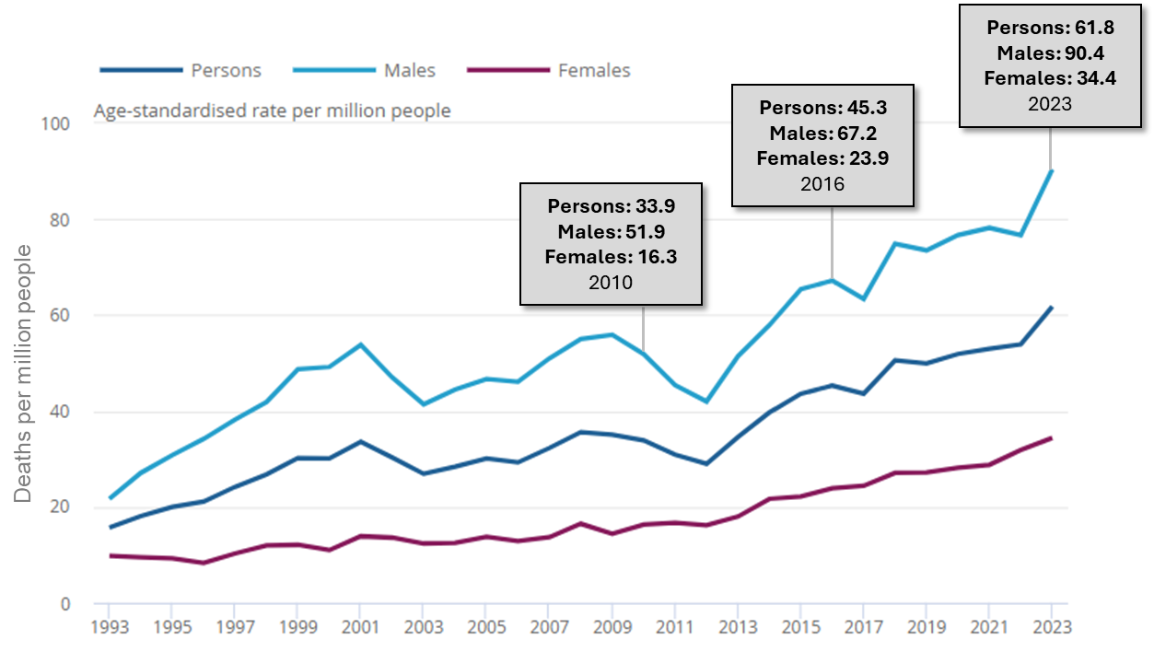
Source: Drug poisoning in England and Wales from ONS
The highest rates of drug misuse deaths are currently observed among individuals aged 40 to 49 years. The average age at death for drug misuse deaths in 2023 was 44.5 years for males and 47.5 for females, which is over 30 years younger than the average age of death from all causes in England (78.0 years).
The biggest rises in mortality have been observed since 2012, with the most significant increase in opioid-related deaths. Deaths involving new psychoactive substances have also surged in recent years, although the numbers remain much lower than for traditional substances like heroin or methadone.
Drug-related deaths show a stark disparity based on deprivation, with individuals in the most deprived areas facing significantly higher risks of fatal overdoses. Mortality rates in these areas are approximately 2.5 times higher than in the least deprived areas; the mortality rate in for the period 2020-2022 in the most deprived decile was 8.5 per 100,000, compared with 2.9 per 100,000 in the least deprived decile.
Awareness of substance-specific mortality trends is crucial, especially given the overall rise in drug-related deaths. Opiates remain the most frequently implicated substances, involved in nearly half of drug-poisoning deaths, with heroin and morphine being prominent contributors. Deaths involving cocaine have surged by over 30% in a year, while synthetic opioids such as nitazenes and fentanyls are an emerging threat due to their potency and high overdose risk. In the year ending May 2024, there were 179 deaths involving synthetic opioids nationally, with cases unevenly spread across nine regions of England. In the East of England, 33 deaths were recorded, accounting for a significant portion of the national total.

Alcohol
In England in 2023, there were 8,274 alcohol-specific deaths (wholly due to alcohol), which is a rate of 15.0 per 100,000 population in 2023. This was the highest rate for alcohol-specific mortality since the start of the data series in 2006 (5,050 deaths, 10.7 per 100,000), as shown in Figure 4.3b.
Figure 4.3b. Age-standardised alcohol-specific mortality rate per 100,000 population (all ages): single year, England 2006 to 2023
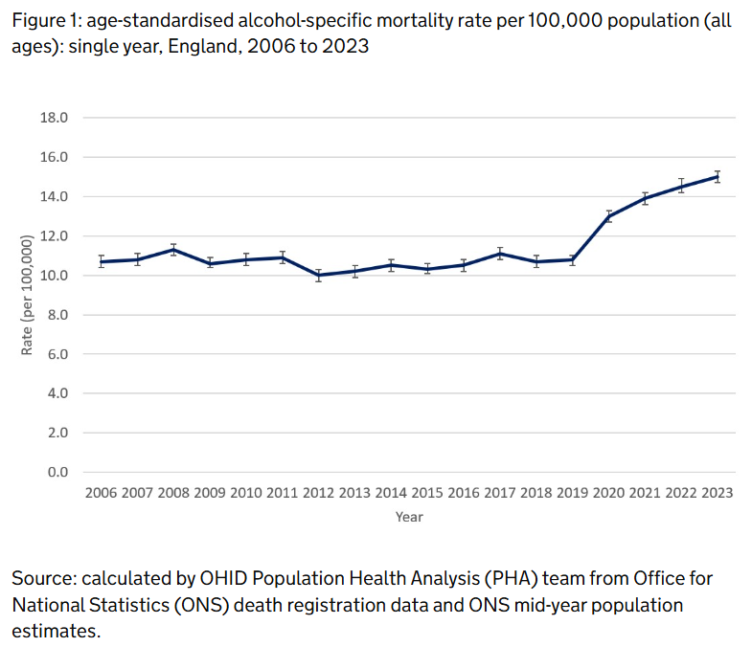
Source: calculated by OHID Population Health Analysis team from ONS death registration data and ONS mid-year population estimates.

The average (mean) age of death for alcohol-specific mortality in England in 2023 was 57.2 years, which is around 20 years younger than the average age of death from all causes in England (78.0 years).
National data shows that mortality rates are linked to levels of deprivation, with the most deprived areas experiencing around double the mortality rate compared with the least deprived areas; alcohol-specific mortality in 2023 was 20.9 per 100,000 in the most-deprived decile of local authorities, and 9.8 in the least deprived.

Intersecting Vulnerabilities
In addition to the influence of individual demographics as highlighted above, certain groups are more vulnerable to substance use due to additional factors, including housing instability, social environment, and life experiences. This needs assessment will consider potential disproportionate harm from substance use in these groups, driven by systemic inequalities and personal circumstances.
The following sub-groups have been identified as experiencing heightened vulnerability to substance use:
- People with mental health conditions: tend to have higher rates of substance use, with use of drugs or alcohol as a coping mechanism.
- Women: some women face increased vulnerabilities due to intersecting factors such as a history of domestic violence, trauma, and experiences of sex work. These factors may exacerbate their risk of both substance use and associated harms.
- Prison and prison leavers: this group is at a higher risk of substance use, often linked to past trauma, mental health conditions, and the challenges of reintegrating into society post-release.
- Individuals experiencing housing instability and homelessness: who often face high levels of substance use due to social isolation, mental health issues, and limited access to support services.
- Parents and families: parents in treatment services may be dealing with the pressures of caring for children while managing their own substance use, whilst children living in families where substance use is a concern may face increased risks, such as neglect, abuse, or involvement with social services.
- People in unstable employment: Employment status can influence substance use, with individuals in precarious or low-income jobs facing higher stressors and limited access to support, alongside additional barriers to accessing services. Data from CSEW 2024 shows that drug use is highest among unemployed people and students, and elevated among those inactive due to illness, highlighting the association between socio-economic vulnerability and substance use.

The aim of exploring these groups is to better understand how their specific needs and vulnerabilities contribute to substance use and associated harms. This analysis will help inform the development of targeted services and interventions. It aligns with the objectives outlined in the overarching Joint Strategic Needs Assessment for Cambridgeshire and Peterborough 2023, which emphasises the importance of public health initiatives in reducing unfair differences in health across our population.

Cambridgeshire

Demographics

Population
The size and distribution of the population influence the scale and nature of drug and alcohol (DA) need, as different age groups may have varying risk factors, service requirements, and levels of vulnerability.
As of the most recent census in 2021, Cambridgeshire’s population was 678,855. The age distribution of residents across the county is similar to England, as shown in Figure 5.1a.
Figure 5.1a. Resident population age profile; Cambridgeshire compared with England and East of England, 2022.
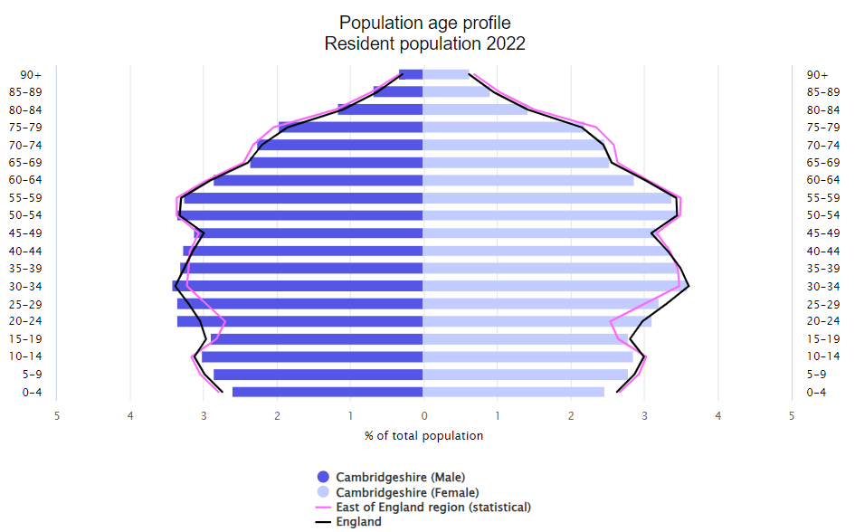
Source: Fingertips/ OHID
The county is characterised by a blend of urban and rural communities across five districts, each with unique demographic and socio-economic profiles; Cambridge, East Cambridgeshire, Fenland, Huntingdonshire, and South Cambridgeshire. Residents are unevenly distributed across the five districts in the county, as shown in Table 5.1a (using population estimates from 2023).
Table 5.1a. Resident population across Cambridgeshire districts
District | Residents (2023) | Proportion of Cambridgeshire population
Cambridge | 149,963 | 21%
East Cambridgeshire | 91,466 | 13%
Fenland | 103,537 | 15%
Huntingdonshire | 186,066 | 27%
South Cambridgeshire | 168,541 | 24%
 | 699,573 | 100%
Source: ONS, residents are mid-year estimates for 2023
Of the five districts, Cambridge has the most distinct age profile, with a notably higher proportion of young adults compared to the national average. This is largely due to the presence of a significant student population, which influences the demographic makeup and the specific needs of the area. In contrast, the other districts in Cambridgeshire tend to have older populations, with proportionally fewer young adults than seen nationally, as shown in Figure 5.2b.
Figure 5.b. Resident Population Age Profile of Cambridgeshire Districts, 2022.
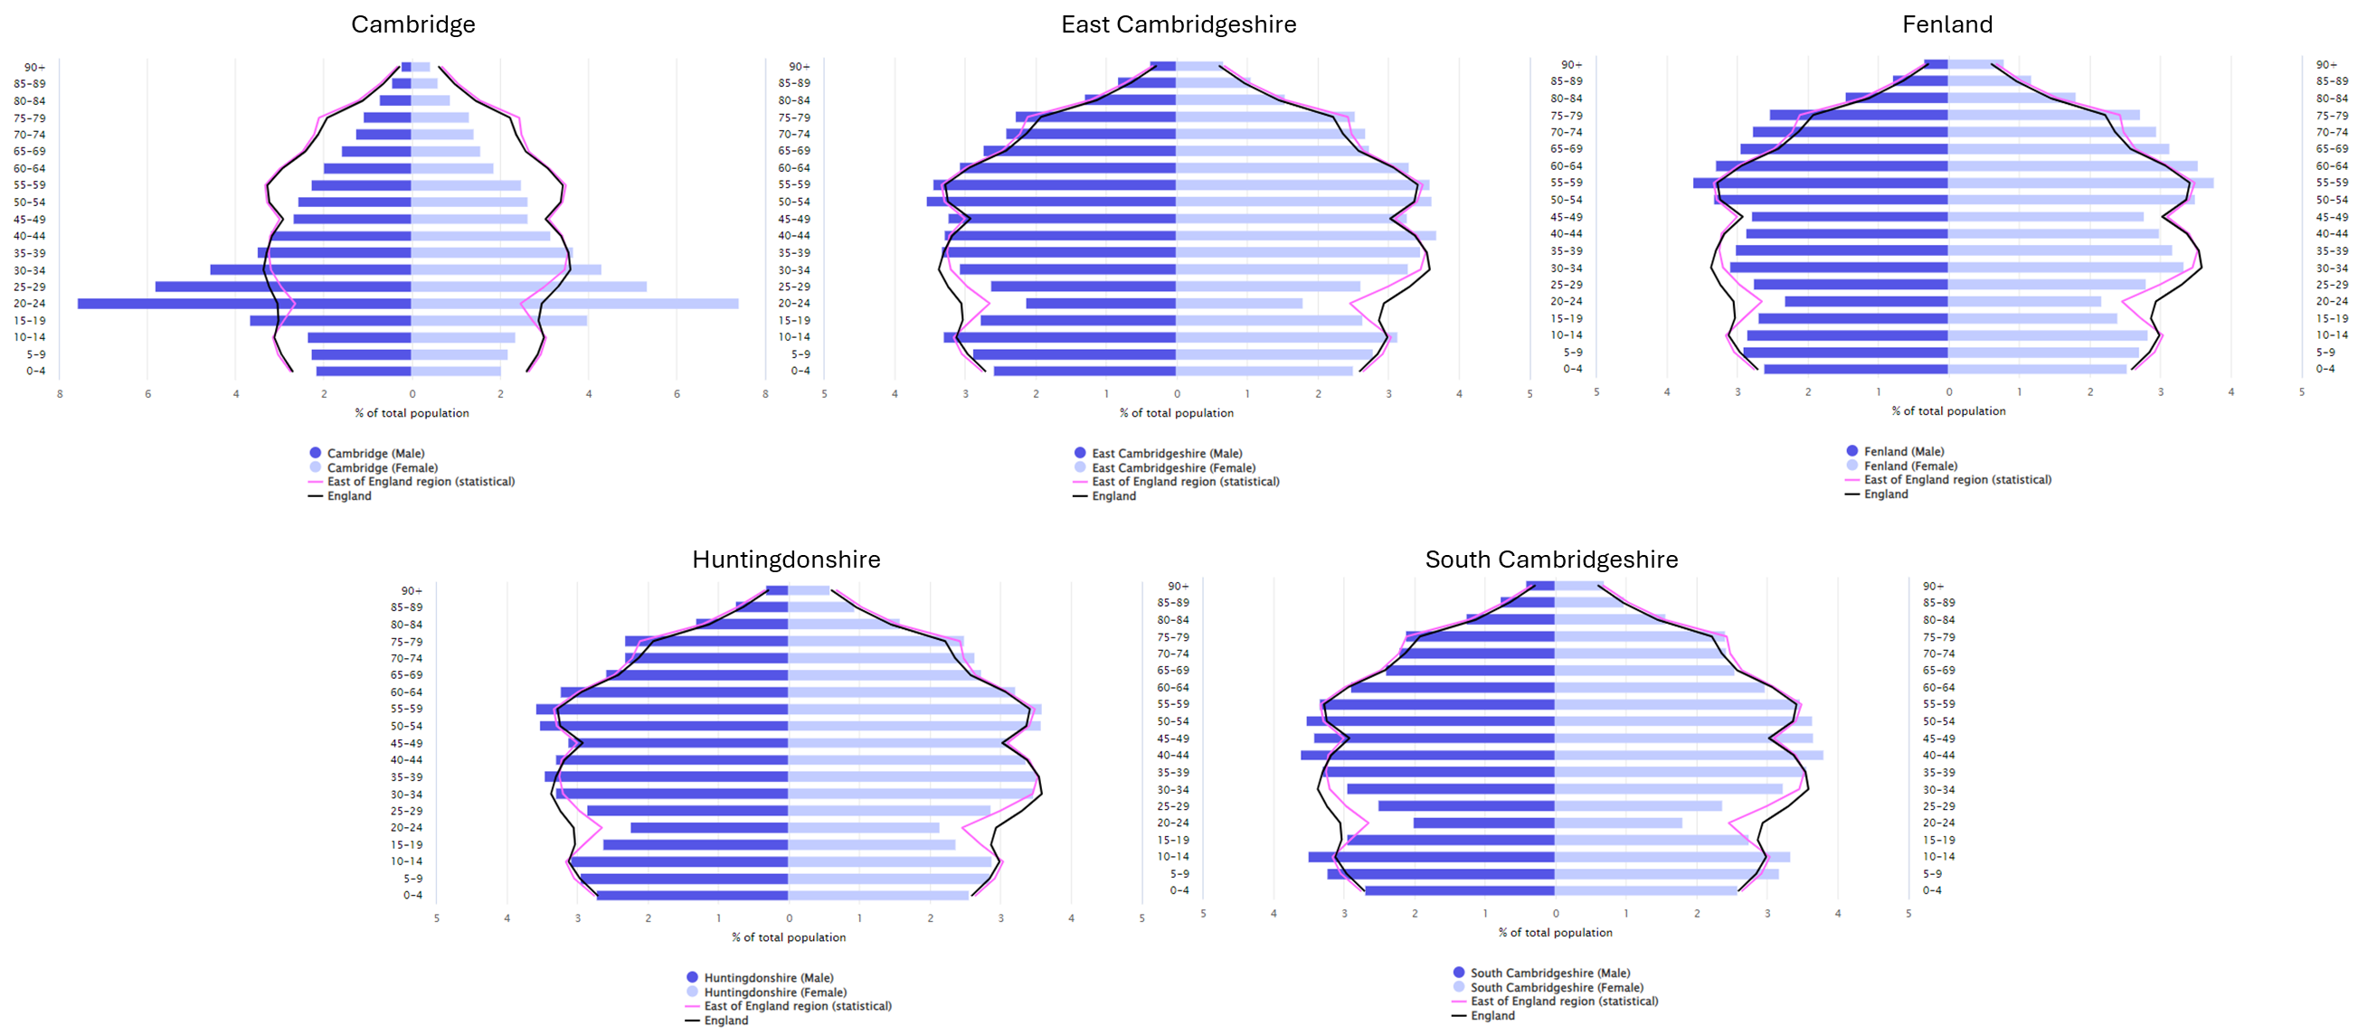
Source: Fingertips/ OHID
Between the 2011 and 2021 censuses, Cambridgeshire experienced a population increase of 9.2%, which is higher than the national growth rate of 6.6%. Cambridge city saw the most rapid growth within the county at 17%, making it one of the fastest-growing areas in the East of England. The county's age structure is shifting, with notable growth in the 0-19 and 65+ age groups, reflecting both an increase in younger families and an aging population​.
Cambridgeshire's population density varies significantly across its districts. On average, the county has a population density of 229.7 residents per square kilometre (/km²), below the national average of 434 /km². Cambridge City, the most densely populated district, contrasts sharply with rural areas such as East Cambridgeshire and Fenland, as shown in Figure 5.1c.
These geographic differences influence access to services, transport, and socio-economic conditions, all of which are important factors in addressing substance use. In particular, residents in more remote or rural areas may face greater challenges in accessing drug and alcohol support.
Figure 5.1c. Population density across districts in Cambridgeshire 2023.
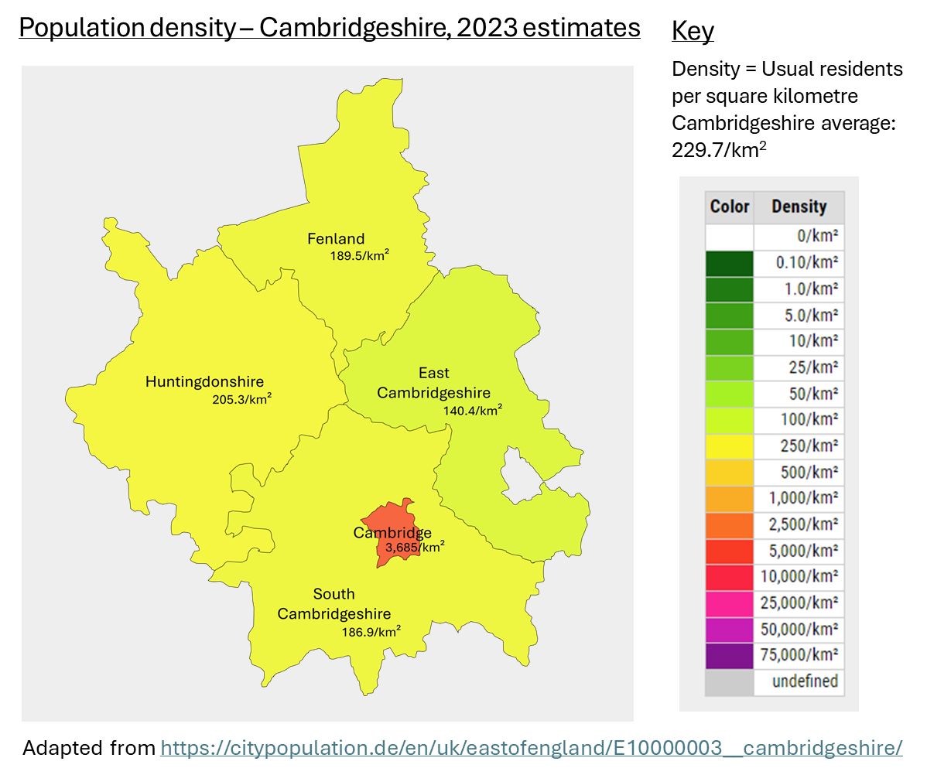
Source: Adapted from https://citypopulation.de/en/uk/eastofengland/E10000003__cambridgeshire/

Wider Determinants and Other Demographics
Deprivation and social determinants play a critical role in drug and alcohol use. According to the 2019 Index of Multiple Deprivation (IMD), the districts in Cambridgeshire span a wide range of deprivation levels, ranking from the second to the tenth decile nationally, as demonstrated in Figure 5.1d. Levels of deprivation are higher in Fenland than in the more affluent districts of South and East Cambridgeshire. There are also pockets of significant deprivation in Cambridge City, Huntingdonshire, and other areas that may be obscured by overall district-level averages.
Figure 5.1d. Deprivation levels across Cambridgeshire districts.
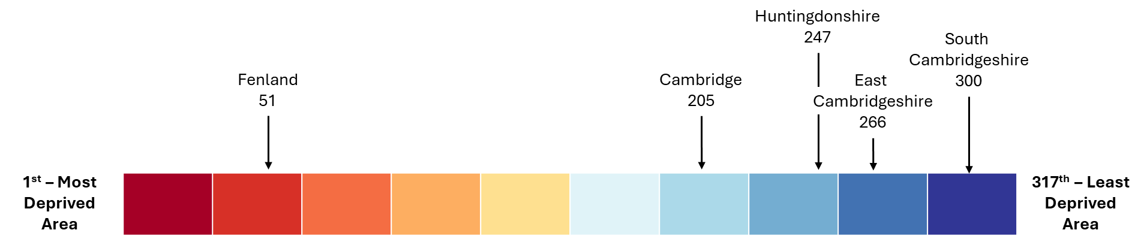
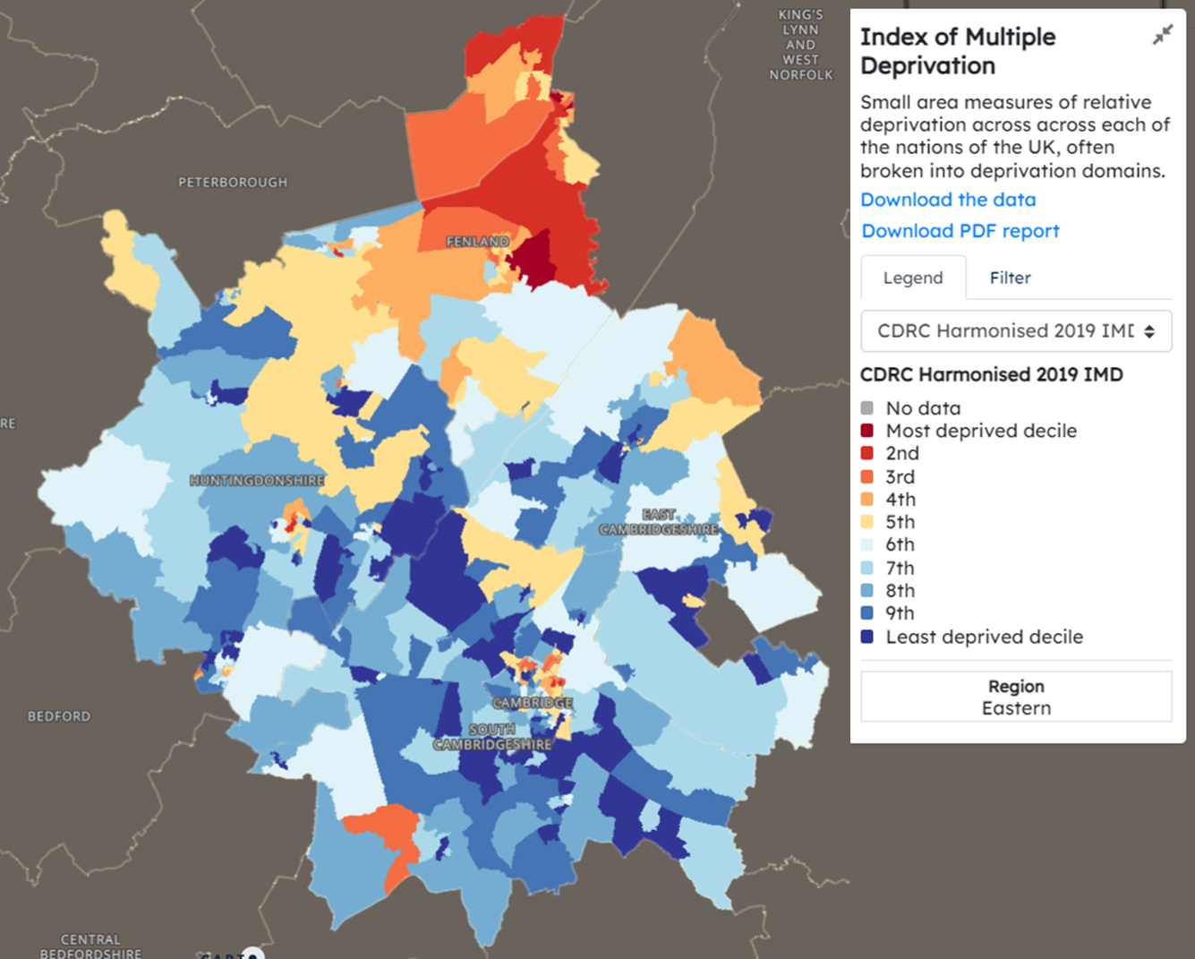
Source: Adapted from https://data.cdrc.ac.uk/dataset/index-multiple-deprivation-imd

The number of residents born outside England has grown significantly in areas like Cambridge where 40.9% of residents were born outside England, a higher proportion than in 2011 (33.1%) and higher than the national average of 19.7%. This proportion was lower or similar to the national average in the other districts in the region (East Cambridgeshire 14.4%, Fenland 14.3%, Huntingdonshire 15.4%, South Cambridgeshire 19.2%).
91.4% in Cambridgeshire of residents reported English as their main language in 2021, while 8.6% primarily spoke other languages, reflecting the area’s growing diversity. Polish is the most commonly spoken non-English language (2.2%), followed by Lithuanian (1.6%) and Romanian (1%). These figures emphasise the need for language-sensitive services, particularly in urban centres like Cambridge, which attract diverse international populations.
Cambridgeshire has become increasingly ethnically diverse in recent years, though the picture varies significantly between districts. In Cambridge city, 74.6% of residents identified as White in the 2021 Census, meaning about 25.4% belong to other ethnic groups, which is higher than the national average (81.7% of the population England and Wales identify as White). Cambridge has notably higher proportions of Asian (14.8%) and mixed ethnic groups (5.1%) compared to national figures. In contrast, more rural districts like South Cambridgeshire and Fenland have predominantly White populations (89.0% and 94.5% respectively), and smaller proportions from minority ethnic groups.
Residents in Cambridgeshire demonstrate a diversity of religious affiliation, with Christianity being the predominant faith, a significant representation of Islam, Hinduism, and Buddhism, and a growing number of people identify as having no religion.
According to the 2021 Census, 7.6% of Cambridgeshire residents reported being ‘disabled and limited a lot’, which is very similar to the national average of 7.5%. An additional 10.2% of residents reported being ‘disabled and limited a little’, while the majority, 82.2%, were not disabled.
The 2021 Census data for Cambridgeshire indicates that the vast majority of residents, 88.3%, identify as straight or heterosexual. Among other sexual orientations, 1.5% identify as gay or lesbian, 1.8% as bisexual, 0.3% as pansexual, 0.1% as asexual, and 0.1% as queer. Some data sources aggregate these categories without further breakdown, so the overall proportion can be a useful reference point, which was 4.2%. It’s important to note that social and privacy concerns, as well as survey methodology, may lead to under-reporting of minority identities. Approximately 8% of respondents did not disclose their sexual orientation.
In Cambridgeshire, the 2021 Census data shows that 93.2% of residents identify with the same gender as their sex registered at birth. Around 1% of the population identifies as a different gender, including transgender individuals, while 6.2% chose not to answer. The Office for National Statistics (ONS) advises caution in interpreting this data, noting that this was a new and sensitive question which may have affected how people responded. As with sexual orientation data, self-reported gender identity can be influenced by stigma and privacy concerns, potentially leading to under-representation of diverse gender identities.

Drug Use in Cambridgeshire
This section includes prevalence, treatment numbers and unmet need for drug use in Cambridgeshire.

Drug Use; Prevalence
Key National Figure: The most recent comprehensive data on drug dependence is over 10 years old (2014) but reported that 3.1% of people aged 16 years or over showed signs of drug dependence. This included 2.3% who were dependent on cannabis only, and 0.8% who were dependent on other drugs.

This section presents available data on the prevalence of drug use in Cambridgeshire, covering both adults and young people. It explores treatment engagement and service user characteristics, highlighting areas of unmet need. Where possible, data is disaggregated by demographic characteristics and compared with national benchmarks to contextualise local patterns.
A significant portion of this data is sourced from the National Drug Treatment Monitoring System (NDTMS), which tracks individuals in treatment for drug use. Most figures included are from the year ending March 2024, as more recent data remains restricted until its formal release.
Trends over time provide insights into changes in prevalence, and comparison with national figures are made to offer a clearer picture of substance use patterns within our local context in Cambridgeshire.
Many illicit substances lack reliable prevalence estimates so cannot be included here.

Adults
Unless otherwise stated, the following data refers to adults aged 18 or older.
Opiates and Crack Cocaine
Opiate and crack cocaine use (OCU) is closely monitored due to the significant public health and societal impacts of their use. Key data sources in England include DA treatment services, hospital episode statistics, and criminal justice records. NDTMS use this data to derive prevalence estimates; the most recent estimates are from 2019-20, and are presented as a total (‘OCU’) and also categorised in three groups; users of both substances, users of opiate-only and users of crack-only.
Cambridgeshire was estimated to have a lower overall OCU (6.1 per 1,000) compared to England (9.5 per 1,000). The prevalence rates were highest for opiate-only users, followed by those using both substances, with crack-only users being the smallest group. Cambridgeshire had a relatively high proportion of crack-only users within its overall cohort compared to national average proportions, as shown in Figure 5.2a.
Figure 5.2a. OCU prevalence rates per 1000 population, by substance type in Cambridgeshire and England 2016-17 to 2019-20
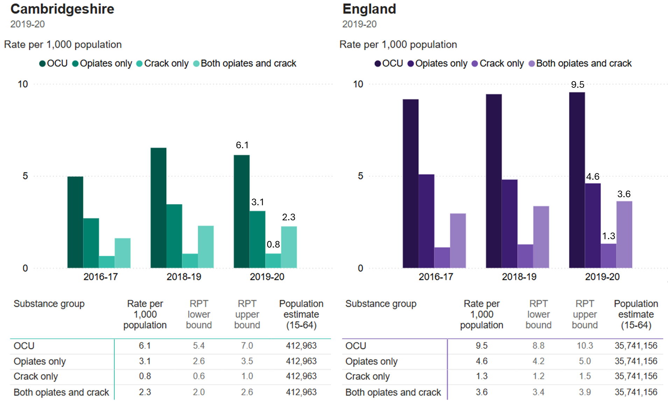
Source: NDTMS.
From 2016 to 2020, opiate and crack use increased both locally and nationally. Cambridgeshire saw a greater rise (1.2 per 1,000) compared to England (0.4 per 1,000), equating to nearly 500 additional users. Users of both substances have increased as a proportion, while opiate-only use has declined slightly.
Applying 2019-20 prevalence rates to 2023 population estimates suggests an 8.6% rise in service demand due to population growth, as shown in Figure 5.2b.
Figure 5.2b. Predicted increase in OCU due to population growth in Cambridgeshire.
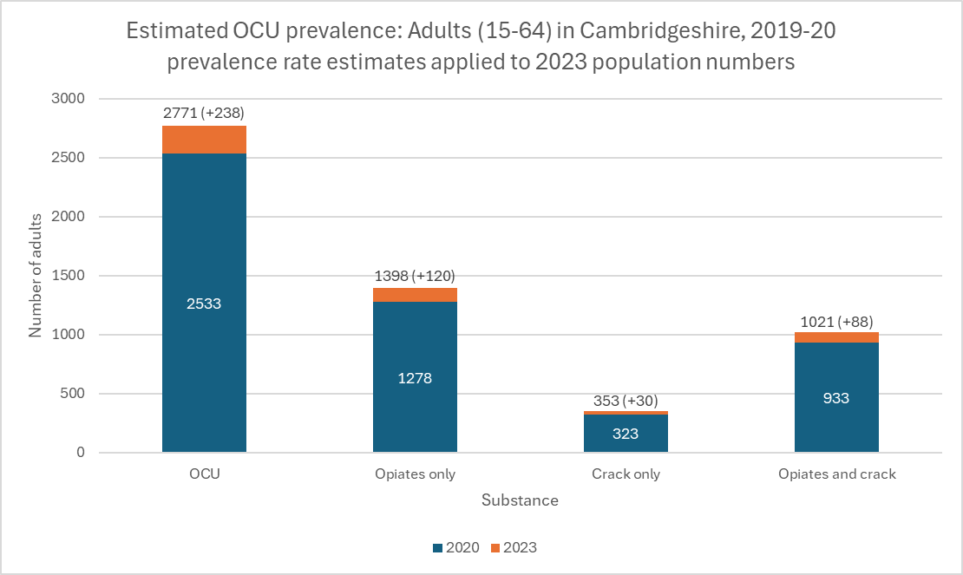
Source: NDTMS data, population estimates from ONS.
This modelling should be considered with caution, as it does not account for any change in prevalence.
Injecting drug use poses risks like blood-borne viruses and overdose. In 2019-20, prevalence estimates in Cambridgeshire predicted a higher proportion of current injectors (29.5%) compared to England (18.9%), with fewer who had never injected (47.5% vs. 56.8%). Estimates based on these rates predict there to be around 800 injecting OCU in 2023, underscoring the need for harm-reduction services like needle exchange and naloxone provision.

Demographic Breakdown
Age
In Cambridgeshire, the highest prevalence of opiate and crack use is estimated to be in people aged 25-34, differing from the national trend where 35-64-year-olds have the highest prevalence, as shown in Table 5.1b.
Table 5.1b. OCU prevalence by age groups in Cambridgeshire and England.
 | Cambridgeshire |  |  |  |  | England
Group (years)* | Rate per 1000 (RPT) population | RPT lower bound | RPT upper bound | Population estimate† | Estimated users (OCU) | Rate per 1000 (RPT) population
15-24 | 2.4 | 1.9 | 3.0 | 85,800 | 206 | 3.8
25-34 | 7.9 | 6.6 | 9.2 | 94,848 | 749 | 10.3
35-64 | 6.8 | 6.0 | 7.7 | 271,130 | 1844 | 11.0
Source: NDTMS. * Note that the oldest age band spans a broader age range, and no additional breakdown is available to examine subgroup prevalence within this range. † 2023 Mid-year estimate from ONS.
Among young users (15–24), opiates are the most commonly used substance, as seen in other age groups, but the proportional number of those who only use crack is larger compared to other age groups. Numerically, the 35-64 age group has more users due to its larger population size, despite slightly lower rates.
Sex
Note that data presented here as ‘sex’ is from NDTMS and is self-reported, it may reflect ‘gender’ for some, but male and female are the only options and are referred to as ‘sex’ in national data.
Rates of opiate and crack use are consistently over 3.5 times higher in males than females, both locally and nationally, with minimal variation over time, as shown in Figure 5.2c.
Figure 5.2c. OCU prevalence among adults (aged 15-64) by sex in Cambridgeshire and England.
 | Cambridgeshire |  |  |  |  | England
Sex | Rate per 1000 (RPT) population | RPT lower bound | RPT upper bound | Population estimate† | Estimated users (OCU) | Rate per 1000 (RPT) population
Female | 2.7 | 2.4 | 3.0 | 227,069 | 613 | 4.0
Male | 9.5 | 8.3 | 10.9 | 224,709 | 2135 | 15.1

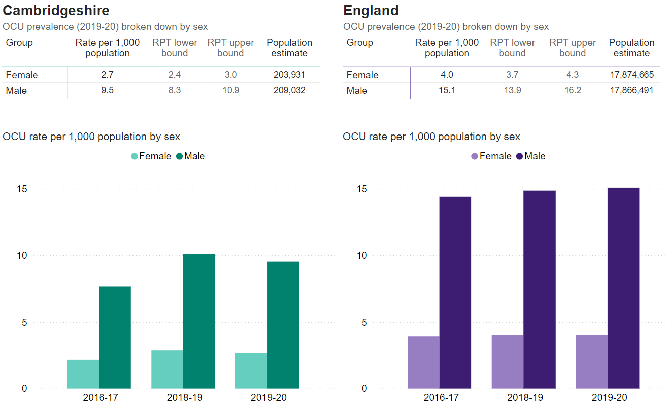
Source: NDTMS. † 2023 Mid-year estimate from ONS.
Other Substances
Prevalence estimates for other substances are not available, patterns of use and trends may be monitored through service user reports, national surveys, and routine data. Substances reported by adult service users as their ‘top three’ problem substances provide some insight into local trends as is available on NDTMS, grouped as ‘non-opiates’. It is important to note that this data reflects only those in treatment and doesn't represent the wider population. Additionally, substances used in combination may be underrepresented due to the ‘top-three’ rule, and the percentages should not be interpreted as prevalence rates.
The ‘non-opiate’ category includes crack (already covered under OCU in the previous section) along with a range of other substances. The most commonly cited substances are cannabis (53.3% of citations), powdered cocaine (41.1%), and crack (14.9%). Notable other trends in Cambridgeshire include:
- A narrower range of substances reported locally (15 substances) compared to England (29 substances).
- Amphetamine and benzodiazepine are more commonly cited in Cambridgeshire than nationally; 5.7% and 5.4% respectively, compared with 3.6% and 4.9% nationally.
- Proportional reporting of prescription drug use was higher locally; 1.3% vs. 0.5% nationally.
See section 5.4 for further consideration of substance use trends.

Children
There are no prevalence estimates for all those aged under 18 on NDTMS, although the data above includes some children in groups that start at age 15.
A local survey, the Health-Related Behaviours Survey (HRBS), is conducted biennially in Cambridgeshire for students in year 8 and year 10 (aged 12-15) and provides valuable insights about substance use in this area. This data can be utilised to understand current behaviours, identify trends over time, and inform targeted health interventions for the youth in the community.
The most recent HRBS was conducted in 2024 in Cambridgeshire. It should be noted that this survey included 6,955 young people and was conducted through schools. As such, the findings may not be fully representative of all young people in the area; it excludes those not attending school and may not capture the diversity of experiences across different communities. Data by gender here is only broken down into male and female as lower numbers in other genders have been suppressed to maintain confidentiality.
Among year 8 and year 10 students surveyed, the likelihood of being offered drugs increased significantly with age. While 7% of year 8 respondents reported being offered cannabis or other drugs to get high, this rose to 24.5% of year 10 respondents. A slightly higher proportion of females reported being offered drugs, but this was not statistically significant. Overall, the proportion of pupils who were offered drugs was around 2 percentage points lower than in previous surveys (in 2021 and 2022).
Actual drug use was lower than the figures for being offered drugs, with 6.4% of respondents across both year groups and all genders stating that they had taken any drugs to get high.
- Year 10s reported higher levels of use compared to their year 8 counterparts (11.6% versus 2.1%).
- The most commonly used substance was cannabis, with 2.6% of all respondents reporting use in the last month.
  - This proportion was significantly higher for year 10s (5.2%) compared with year 8s (0.4%).
- There was no statistically significant difference between females and males reporting having taken drugs to get high.
- 6.4% is similar to levels in recent years, but lower than 2018 when the level was around 9%.
Other substances were less likely to have been taken; synthetic cannabinoids were taken by 0.7% of respondents, hallucinogens, solvents and ketamine, were each reported by 0.3-0.4% of respondents, ecstasy and nitrous by 0.2% each.
Most students denied knowing anyone who they believed took drugs to get high (70.9%), but the proportion of students in year 10 who are aware of drug use is significant, specifically:
- 16.9% of year 10s were certain that they knew someone who used drugs (the proportion was slightly higher for females, but was not statistically significantly different to males)
- In year 8s, 4.6% of respondents were certain they knew someone who used drugs.
When broken down by district, the rates of being offered drugs were slightly higher in East Cambridgeshire by 3 to 4 percentage points, while the proportion of respondents who had actually taken drugs was similar across all five areas.
A significant level of uncertainty about drug use among respondents (10.5% reported ‘not sure’) may point to the need for initiatives that reduce stigma and encourage open conversations, enabling young people to seek help and make informed decisions about drug-related risks.
Finally, the survey explored coping behaviours among respondents, revealing that some use drugs, smoking, vaping, and alcohol in response to problems. When asked what they do when they have a problem, 6.3% of respondents reported that they "usually" or "always" engage in one or more of these behaviours. Including those who answered "sometimes", this figure rises to 16.2%. As with previous findings, the proportion was higher among older students (9.6% in year 8, rising to 24.2% in year 10) and was also higher for females compared with males (18.6% vs. 13.4%).
Among these behaviours, vaping emerged as the most commonly reported substance, followed by alcohol. Notable gender differences were observed, as shown in Figure 5.2d. Note that these proportions illustrate the relative frequency of each substance among those engaging in coping-related substance use, rather than overall prevalence, and that respondents could report more than one substance.
Figure 5.2d.
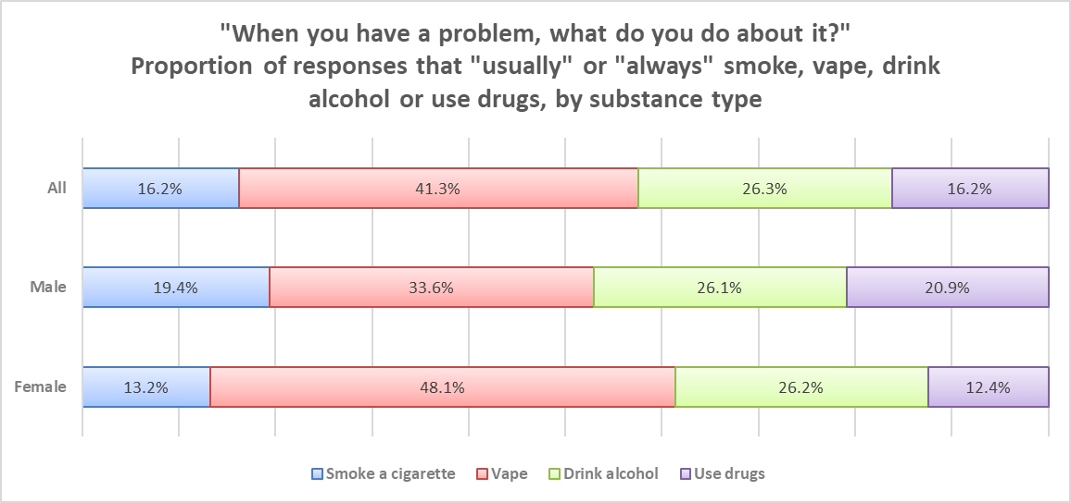
Source: HRBS data. Note this is a subgroup of all respondents, example interpretation: “among responses indicating substance use or vaping as a coping mechanism, for females, 13% reported smoking, 48% vaping, 26% alcohol and 12% drug use.”
(Further breakdown of use of alcohol is included in section 5.3.1.2.)
Drug exposure and use patterns identified in this data can inform timing and targeting of prevention programs, which should consider the increasing exposure in older students and tailor interventions to address gender-specific risks and peer dynamics.

Drug Use; Service User Epidemiology

Adults
This section presents analysis of people in community-based treatment for drugs, including those in treatment for opiates and non-opiates both with and without additional use of alcohol. Those in treatment for alcohol-only are discussed later.
In the year ending March 2024, there were 1,885 adults (18 years and above) in treatment for drugs in Cambridgeshire. This marks a significant increase of 11.7% (from 1,687) in the year ending March 2023. This rise is in the context of uncertain prevalence trends but suggests that additional funding and concerted local efforts to engage more individuals in need of support have had an impact. Nationally, treatment numbers have increased by a smaller amount over the same time period (6.4%). The proportion of people in treatment that were new presentations in the year ending March 2024 was 43.3%, similar to the national level of 42.9%.
Analysis of treatment numbers by substance type reveals that the increase in the number of people in treatment is not equally spread across all substances. This is analysed and presented here in substance groups as categorised by NDTMS.
The number of people in treatment for opiates (with and without crack) is only slightly, 5%, higher than in previous years (up by 51 since 2022, from 1,096 to 1,147). Meanwhile, the number of people in treatment for non-opiates (with and without alcohol) increased by 29% in the same time period (up by 166, from 572 to 738). Individuals tend to remain in treatment for opiates for longer, so the difference becomes more pronounced when considering only new presentations, as shown in Figure 5.2e.
Figure 5.2e. Number of adults (18 years +) newly presenting for treatment for drugs in Cambridgeshire between March 2022 and March 2024, by substance type:
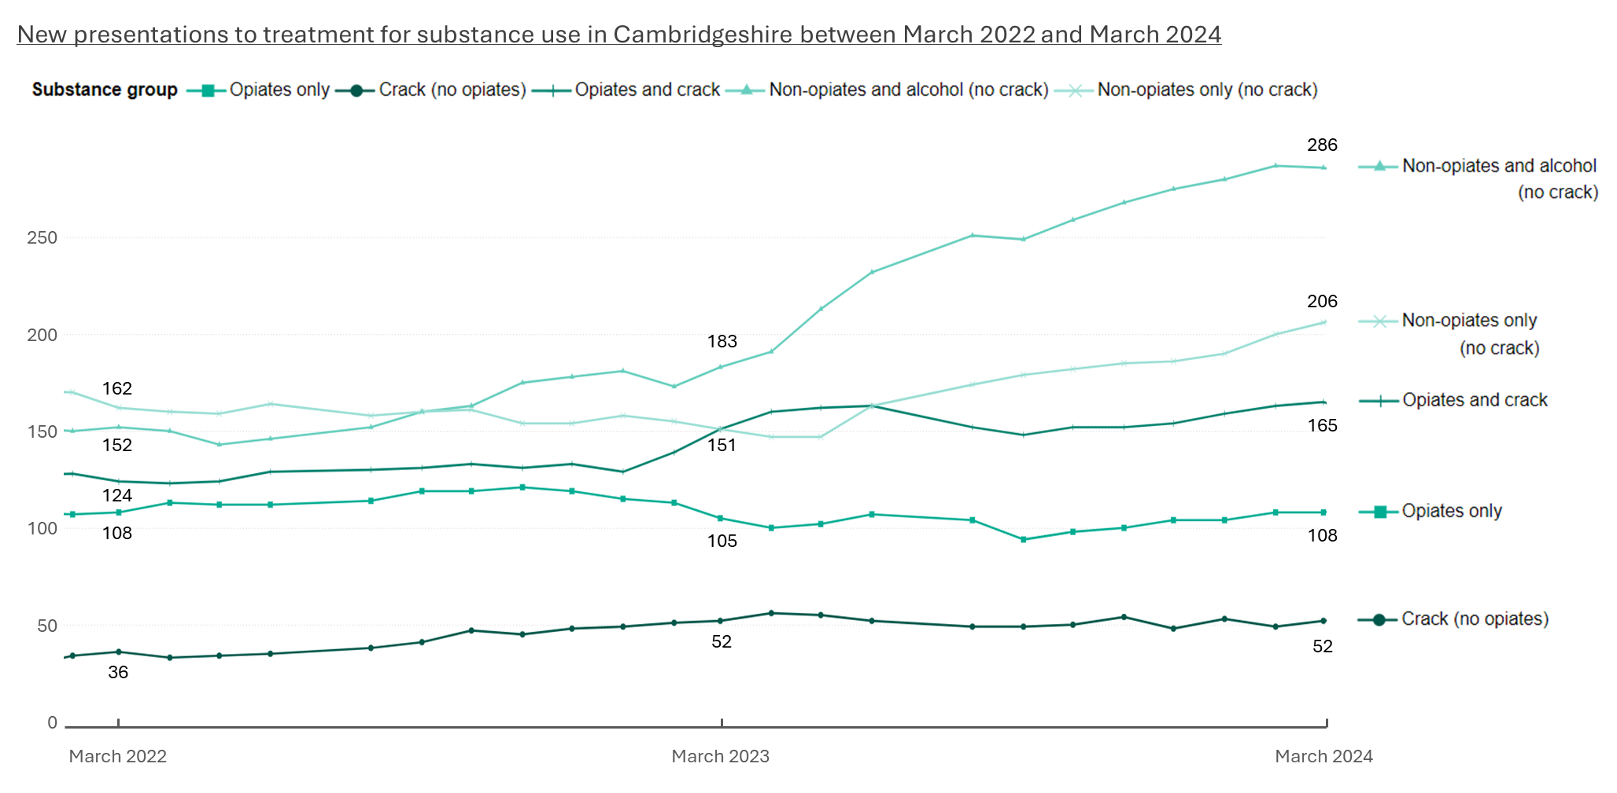
Source: Adapted from NDTMS.
Service User Demographics: Age
The majority of service users in Cambridgeshire are aged 30-49, accounting for 1,160 individuals in the year ending March 2024. 315 were younger adults aged 18–29, and 410 were aged over 50.
The overall increase in number of service users described above was not in all age groups, for all substance types. This is demonstrated in Table 5.2a, which shows:
- Treatment numbers declined among adults aged 18–29 overall,
- Among adults aged 30-49, overall numbers rose, although numbers in treatment for opiates decreased by about 10%,
- Adults aged 50+ saw the largest increase, with numbers rising across all substance groups.
Table 5.2a. Adult Drug Treatment Numbers by Substance Type Group and Age Band. 12-Month Rolling Total for years ending March 2021-2024.
‘Change’ is from average over 2-year periods 2020-22 to 2022-24.
18-29
 | 2021 | 2022 | 2023 | 2024 | Change 20-22  to 22-24 (%)†
Crack (no opiates) | 11 | * | 12 | 16 | +7 | +86.7%
Non-opiates and alcohol (no crack) | 107 | 101 | 86 | 117 | -3 | -2.4%
Non-opiates only (no crack) | 145 | 128 | 98 | 112 | -32 | -23.1%
Opiates and crack | 36 | 34 | 34 | 33 | -2 | -4.3%
Opiates only | 43 | 34 | 29 | 37 | -6 | -14.3%
Total | 342 | 301 | 259 | 315 | -35 | -10.7%
30-49
 | 2021 | 2022 | 2023 | 2024 | Change 20-22  to 22-24 (%)†
Crack (no opiates) | 47 | 49 | 52 | 63 | +10 | +19.8%
Non-opiates and alcohol (no crack) | 147 | 121 | 154 | 231 | +59 | +43.7%
Non-opiates only (no crack) | 102 | 124 | 118 | 138 | +15 | +13.3%
Opiates and crack | 397 | 375 | 392 | 397 | +9 | +2.2%
Opiates only | 368 | 363 | 351 | 331 | -25 | -6.7%
Total | 1061 | 1032 | 1067 | 1160 | +67 | +6.4%
50+
 | 2021 | 2022 | 2023 | 2024 | Change 20-22  to 22-24 (%)†
Crack (no opiates) | * | 6 | 9 | 7 | +5 | +128.6%
Non-opiates and alcohol (no crack) | 22 | 32 | 31 | 35 | +6 | +22.2%
Non-opiates only (no crack) | 9 | 7 | 11 | 19 | +7 | +87.5%
Opiates and crack | 110 | 111 | 117 | 140 | +18 | +16.3%
Opiates only | 165 | 179 | 193 | 209 | +29 | +16.9%
Total | 307 | 335 | 361 | 410 | +65 | +20.1%
Source: NDTMS data. * Suppressed due to small numbers. † Average yearly numbers taken over two-year periods April 2020 to March 2022 and April 2022 to March 2024 to reduce the effect of fluctuations due to small numbers.

Service User Demographics: Sex
In the year ending March 2024, there were more males in treatment services for drug use than females across all substance types in Cambridgeshire (1347 vs. 528). On average, the number of females in treatment is around one-third of the number of males and proportional numbers by substance type are similar. This has been consistent over time and is in line with national patterns.
See section 5.2.3 for analysis of these numbers in the context of prevalence estimates (‘unmet need’).

Children
NDTMS data for service users aged under 18 is recorded as all substances, so this section includes numbers for children and young people (CYP) in treatment for alcohol, as well as drugs.
In Cambridgeshire, in March 2024, there were 152 young people aged 0-17 receiving treatment for substance use. This represents 0.23% of the population aged 10-17 in this area. Nationally there are a similar proportion of 10-17-year-olds in treatment, 0.24%. Without prevalence estimates for this age group, it is difficult to understand how this proportion compares to the level of need in this population.
- This number in treatment for substance use in Cambridgeshire in 2024 demonstrates an increase of over 50% since a low of 100 in early 2022.
- There were higher numbers of service users previously; in February 2020 there were 205 CYP in treatment, a number which has not been matched since.
- This suggests either lower need or higher unmet need, especially in the context of population increases (by an average 1% a year from 2020 to 2023).
- Nationally, numbers have recently rebounded to nearly match highest levels at a similar time, as shown in Figure 5.2f.
Figure 5.2f. Total number of under 18-year-olds in treatment for any substance, rolling 12m numbers for Cambridgeshire and England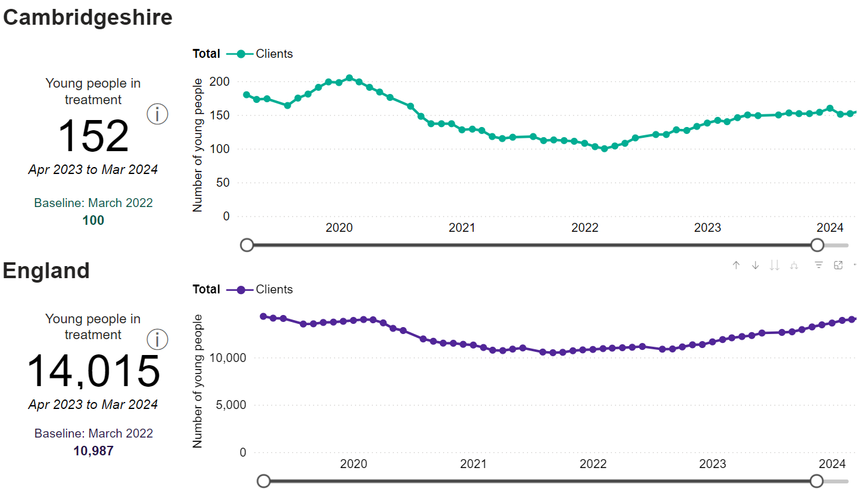
Source: NDTMS.
Of 152 young people in treatment in Cambridgeshire in the year ending March 2024, 92 were male (60.5%) and 60 were female (39.5%). This was consistent with proportions in adults, but has not always been the distribution; there were similar numbers of males and females in treatment between June 2022 and June 2023. From autumn 2023, male numbers increased while female numbers plateaued and slightly declined, as shown in Figure 5.2g. Fluctuations are more pronounced than national patterns, which is expected given the smaller cohort sizes at local level.
Figure 5.2g. Number of children and young people (under age 18) in treatment for drugs and or alcohol in Cambridgeshire and England over time, by sex.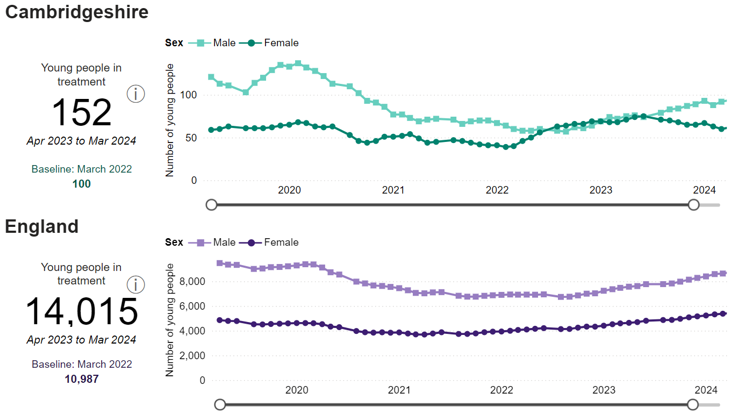
Source: NDTMS.
The age distribution of under-18s in treatment has fluctuated, which is expected given the relatively low numbers. However, recent patterns do not show an increase in service users with increasing age, despite substance use insights indicating higher prevalence among older adolescents, as shown in Table 5.2b.
Table 5.2b. Age distribution of CYP in Cambridgeshire in 2021 and 2021.
Age | March 2021 |  | March 2024
Under 15 | 15 | 16.5% | 31 | 20.4%
15 | 21 | 23.1% | 45 | 29.6%
16 | 22 | 24.2% | 33 | 21.7%
17 | 33 | 36.3% | 43 | 28.3%
Total | 91 | 100% | 152 | 100%
Source: NDTMS data.
This suggests a potential gap in access or engagement that may need further investigation. suggests a need for targeted efforts to reach 16- and 17-year-olds. While these findings should be interpreted with caution due to small numbers, a similar pattern is seen nationally, indicating a broader trend that may require further investigation and action.

Drug Use; Unmet Need
Unmet refers to individuals who are not currently receiving treatment for drug and/or alcohol problems but could benefit from it. They may have never accessed treatment or may have been in treatment before but are not currently. Formal estimates for unmet need on NDTMS are based on prevalence estimates, so are only available for opiate and crack users (OCU). The unmet need figure is established by subtracting the number of individuals receiving treatment from the estimated prevalence of substance use.
Unmet need for OCU in Cambridgeshire in the year ending March 2024 was 52.5%, 4.9 percentage points lower than the national average of 57.4%, as shown in Figure 5.2h.
Figure 5.2h.
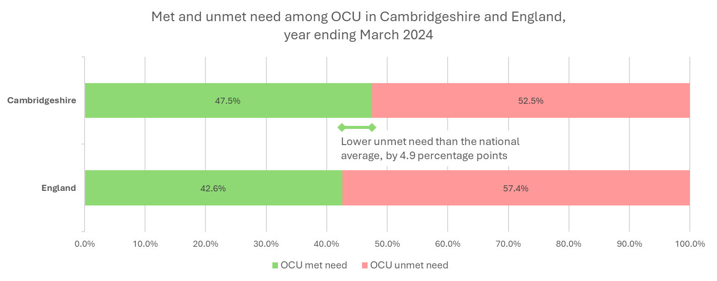
Source: NDTMS data.
This was not evenly spread across subgroups within OCU. The highest unmet need is seen for those requiring treatment for crack only at 73.4% in Cambridgeshire, followed by 56.2% unmet need for opiates only, and 39.4% unmet need for opiates and crack. This is shown in Table 5.2c.
Table 5.2c. Summary table of unmet treatment need for OCU, England and Cambridgeshire in year ending March 2024:
 | Cambridgeshire  Estimated proportion with unmet need | Estimated number of people with unmet need* | England | Difference; Cambridgeshire vs. England (percentage points)
OCU | 52.5% | 1323 | 57.4% | - 4.9
Opiates only | 56.2% | 719 | 60.6% | - 4.4
Crack only | 73.4% | 237 | 78.3% | - 4.9
Both opiates and crack | 39.4% | 368 | 45.8% | - 6.4
Source: NDTMS data. * 2019-20 prevalence estimates compared with numbers in treatment.

OCU Unmet Need: Trend over time
Unmet need for OCU in Cambridgeshire reduced between years ending March 2022 to 2024 by 2.6 percentage points, from 54.8% to 52.2%. The biggest substance-specific reduction in unmet need was seen for users of crack only (by 8 percentage points from 81.4% to 73.4%).
Unmet Need Demographics: Sex
Since 2020, unmet need in Cambridgeshire has been consistently around 22 percentage points higher for males than females (57.1% vs. 34.5% in the year ending March 2024). Nationally, the gap is slightly smaller at 17-18 percentage points (60.9% vs. 44.3%).

Unmet Need Demographics: Age
Analysis by age group reveals that proportional unmet OCU need is significantly higher among young adults compared to older adults, both in Cambridgeshire and nationally. In Cambridgeshire, in the year ending March 2024, unmet need was 87.0% for those aged 15–24, 73.3% for 25-34-year-olds, and 40.6% 35-64-year-olds. The gap in unmet need between age groups has widened over time as shown in Figure 5.2i. Note that the absolute number of people with unmet need is highest in the 35-64 age group, which spans a broader age range. The high percentage of unmet need among younger adults is a pressing concern, but older adults continue to account for a larger share of total unmet demand.

Figure 5.2i. OCU unmet need in Cambridgeshire and England by age group, over time.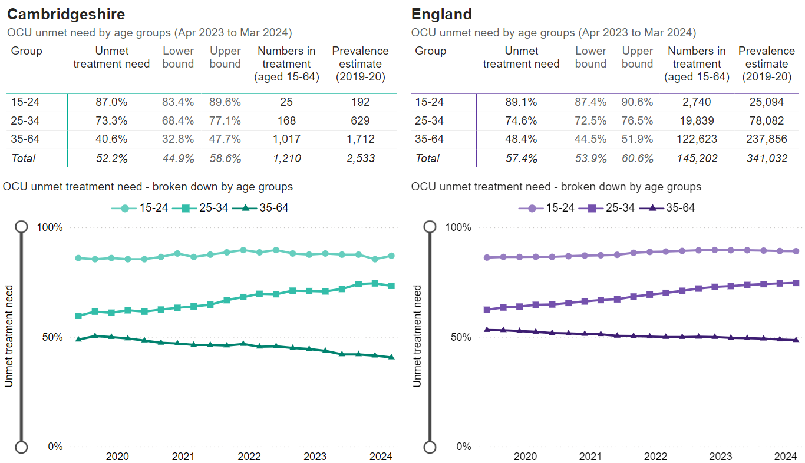
Source: NDTMS.

Drug Use; Key Insights and Priorities
Key Insight Summary: Children and Young People (CYP)
Survey data indicates that by Year 10, one in four young people have been offered cannabis, and one in ten have used drugs to get high. While the number of CYP in treatment have increased recently, levels remain below previous years. Older adolescents (ages 16-18) are likely to be underrepresented in treatment.
Priority 1:
Services should explore approaches to engage CYP not currently in contact with structured support for drug or alcohol use, particularly those experimenting with substances or at risk of escalation. This could include closer partnership working with schools, youth services, and online platforms to strengthen early identification and referral pathways.
See also Priority 3 around targeted education for CYP.

Key Insight Summary: Disproportionate Unmet Need
Local efforts have successfully increased the number of adults aged over 30 accessing treatment, particularly for non-opiate drug use. However, unmet need remains highest among males and younger adults using opiates and/or crack. Those using crack only represent a group with particularly high unmet need.
Limited data on non-opiate drug prevalence poses a significant challenge to accurately assessing need and service provision.
Priority 2:
Services should prioritise reducing barriers and improving access for younger adults (under 30), males, and those who use crack-only. This may involve tailored community outreach, age- and gender-informed messaging, and stronger partnerships with organisations that engage with these populations.

Key Insight Summary: Injecting Drug Users
There is a relatively high proportion of injectors amongst OCU in Cambridgeshire. This is further explored in section 5.6.3.

Alcohol Use in Cambridgeshire
This section includes prevalence, treatment numbers and unmet need for alcohol use in Cambridgeshire.
Understanding alcohol consumption patterns is essential for assessing public health risks and identifying areas for intervention. Alcohol use in the UK is categorised by levels of risk:
- Low risk: Drinking within recommended limits; no more than 14 units per week for adults, with consumption spread over three or more days and several alcohol-free days each week (CMO Guidelines5).
- Increasing risk: Regularly exceeding these limits, raising the likelihood of alcohol-related harm (defined by NICE as 15–34 units per week for women, 15–49 units per week for men).
- High risk: Heavy drinking associated with serious health and social consequences (NICE definitions 35+ units for women, 50+ units for men).

Alcohol Use; Prevalence
Key National Figure: Around 1.4% of the adult population in England were estimated to be alcohol dependent in 2019/20, defined as having an AUDIT score of 20 or more.

Adults
Previous prevalence estimates from 2019 Health Survey for England indicate that levels of drinking in Cambridgeshire are higher than national levels, with fewer people abstaining from alcohol, and more drinking above low risk levels,
- Abstaining from alcohol: Lower locally (9.3%) compared to England overall (16.2%).
- Drinking above low-risk levels: Higher locally (28.7%) compared to England (22.8%).
- Binge drinking: Statistically similar locally (17.7%) compared to the national average (15.4%).

A more recent edition of the survey conducted in 2022 does not provide local area breakdowns. For the overall population there has been a slight trend toward more polarised drinking over the last five years, with more people either abstaining or drinking at harmful levels. Overall, the proportion of people reporting either increasing or higher risk drinking in 2022 was around 2.4 percentage points higher than in 2017.
A more recent local survey (conducted in 2024) showed that 52.4% of residents in Cambridgeshire consume alcohol, with 11.1% reporting that they exceed recommended weekly limits of 14 units. However, when adults in Cambridgeshire were assessed using the AUDIT-C tool, 21.8% were categorised as higher-risk drinkers (AUDIT-C score 5 or higher). This suggests that self-reported consumption may underestimate levels of alcohol-related risks compared to validated screening tools, although this may also reflect limitations in representativeness of the survey sample.
If these proportions reflect the wider adult population, over 55,000 adults in Cambridgeshire are at risk of health harms from alcohol (11-22% of those aged 18-75 population equates to 55,000-110,000 adults, based on 2023 mid-year estimates).
Significant differences in the prevalence of drinking above recommended levels were identified across demographic groups in the local surveys:
- Age: Prevalence increases with age, from 8.6% in 18–34-year-olds, to 11.3% aged 35-54, and 12.7% in those aged 55 and older.
- Gender: Higher in men (15.8%) compared to women (6.5%), (other genders suppressed due to low numbers).
- Ethnicity: Highest among White residents (11.5%) and Mixed ethnic groups (15.4%), while lower among Black (6.1%), Asian (5.4%) and Other ethnic groups (1.3%).
- Disability: Higher in those without a disability (11.9%) compared to those with a disability (8.7%).

Data on the prevalence of alcohol dependency from NDTMS can provide further insight for assessing the need for targeted support services. The most recent NDTMS prevalence estimates of alcohol dependency are from 2019-20 and are applied to current population figures here to estimate need in Cambridgeshire, however, this assumes that there has been no change in prevalence of alcohol use. Alongside HSE findings above, research indicates that the COVID-19 pandemic significantly altered alcohol consumption patterns, which necessitates caution in interpreting these estimates. Estimates should be treated with caution, and there is a need for more up-to-date prevalence information.
The estimated overall prevalence rate of alcohol dependence for adults (18+) in Cambridgeshire is 10.75 people per 1000. This is lower than the national rate of 13.75 people per 1000 and equates to 6024 adults, based on 2023 population estimates from ONS.
The prevalence rate across the population differs when broken down by age and sex. Males have a higher rate of alcohol dependence, and the highest rate of alcohol dependence is in those aged 18-24 and 25-34 years old, as shown in Table 5.3a.
Table 5.3a. Estimated prevalence rates of alcohol dependency in Cambridgeshire 2019-20, by sex and by age, adults per 1,000 population.
Sex: | Female | Male
Prevalence | 5.1 | 16.5

Age (years): | 18-24 | 25-34 | 35-54 | 55+
Prevalence | 17.7 | 17.5 | 13.6 | 3.7
Source: NDTMS data.
When applied to the recent population estimates, prevalence differences result in numbers that are unequally spread across demographic groups, with three (3.1) times more males than females with alcohol dependence. The age categories used for estimates vary in size, which, along with differing prevalence rates, results in the highest proportion of individuals with alcohol dependence being aged 35 to 54. This is followed by those aged 25 to 34, then individuals aged 18 to 24, with the smallest proportion among those aged 55 and over, as shown in Figure 5.3a.
Figure 5.3a. Estimated numbers of alcohol dependent adults in Cambridgeshire.
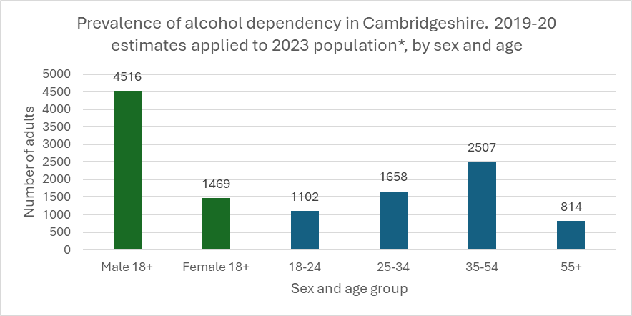
Source: NDTMS data. *Mid-year population estimates from ONS.

Children
As for drug use, formal estimates for alcohol use prevalence in CYP is not available. The Health-Related Behaviour Survey (HRBS) includes local insights regarding alcohol use amongst children in Cambridgeshire. Amongst those who answered HRBS in 2024 (6.955 individuals):
Prevalence of alcohol use increases with age. When asked about drinking in the last seven days:
- 11.8% of year 8 respondents (aged 12-13) reported drinking, compared to 26.7% of year 10 respondents (aged 14-15).
- Overall, this equated to 18.6% of respondents consuming alcohol in the past seven days, with minimal differences between male and female genders (19.0% of males and 18.0% of females).
- When broken down by district, alcohol consumption rates were similar across most areas, except for Cambridge, where the rate was around 7 percentage points lower.
Harmful patterns of alcohol use are generally less common, but tend to increase with age and are more prevalent among females than males. Among the 18.6% of pupils who reported drinking in the past week:
- Drinking frequency: 70.5% drank on one day, 16.0% on two days, and 13.5% on three or more days.
- Episodes of intoxication:
Among males, 76.2% did not get drunk, 15.8% got drunk once, and 8.0% got drunk on multiple occasions.
For females, 67.8% did not get drunk, 23.7% got drunk once, and 8.5% got drunk on multiple occasions.
As a proportion of the whole sample, these figures equate to 5.5% of all respondents drinking alcohol more than once in the last seven days, and 5.1% got drunk at least once in the last seven days.
Although binge drinking remains rare at this stage, these behaviours indicate early exposure to potentially harmful patterns of alcohol use, underscoring the need for targeted education and support to reduce risks associated with underage drinking.

Alcohol Use; Service User Epidemiology

Adults
This section provides an analysis of individuals in community-based treatment for alcohol use, including those receiving treatment solely for alcohol and those receiving treatment for both alcohol and non-opiate substances. Individuals in treatment for opiate use, who may also be using alcohol, are included in the figures above and not here.
The number of adults (18+) in treatment for alcohol in Cambridgeshire has fluctuated since 2021, but in the year ending March 2024 there were 1333 adults in treatment, higher numbers than any previous year, as shown in Table 5.3b. 67.1% of these service users were new presentations (895 of 1333), similar to the proportion seen nationally (69.1%).
Table 5.3b. Number of adults in treatment for alcohol-only and non-opiates and alcohol from March 2021 to March 2024 in Cambridgeshire.
Year ending March: | 2021 | 2022 | 2023 | 2024
Total adults in treatment | 1215 | 1141 | 1099 | 1333
Yearly change | +167 | -74 | -42 | +234
Number in treatment compared to previous year | +15.9% | -6.1% | -3.7% | +21.3%
Source: NDTMS data.
Between March 2020 and March 2024, national treatment numbers increased more, and more consistently. Cambridgeshire saw an overall increase of 27.2%, whilst the national increase was 31.1%.
These increases far exceed what population growth alone would predict. While evidence suggests that prevalence rates may have risen¹⁹, the magnitude of the change implies that increased service investment and changes in patterns of access also play a role. This is explored further through unmet need below (Section 5.3.3).

Service User Demographics: Age
In the year ending March 2024, the majority of adults in treatment for alcohol (both alcohol only and alcohol and non-opiates) were male (63.8%) and most service users were aged 30-49 (52.3%). Figure 5.3b shows the age and sex breakdown of service users, and demonstrates that the number of new presentations amongst treatment numbers were fairly evenly distributed across demographic groups.
Figure 5.3b. Service users for alcohol and non-opiates and alcohol by age and sex in the year ending March 2024, in Cambridgeshire:
Sex | Female | Male
Number in treatment | 482 | 851
Proportion (%) | 36.16% | 63.84%

Adults in treatment for alcohol, year ending March 2024 in Cambridgeshire by age and sex. Number of adults in treatment and how many of those were new presentations.
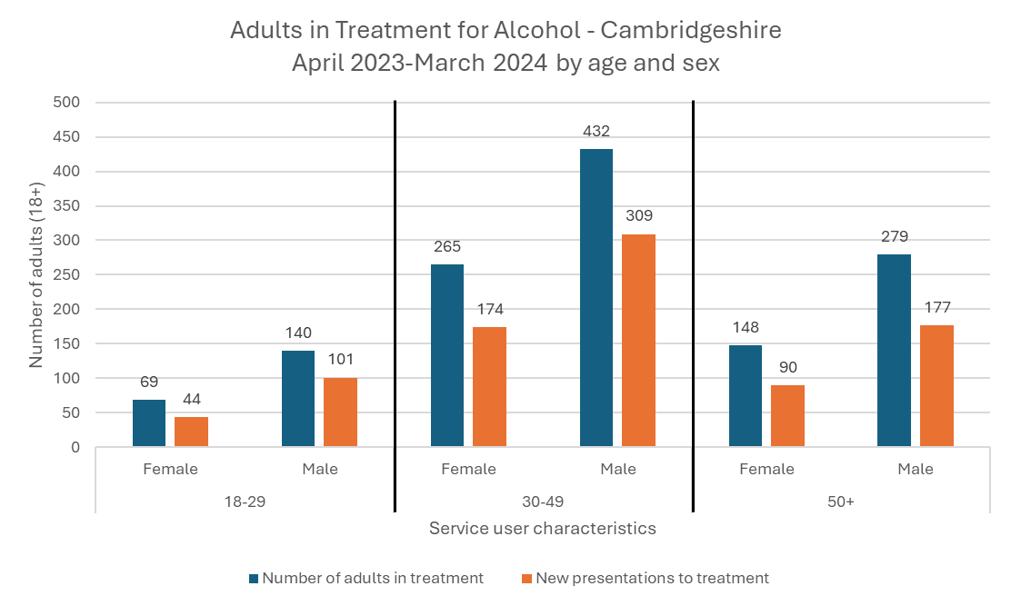
Source: NDTMS data.
A comparison between the distribution of service users is made to prevalence estimates under ‘unmet need’ below.
To note, an additional local behaviour change service, ‘Healthy You’, also sees adults in Cambridgeshire who are at risk of harm from alcohol, separately for dedicated drug and alcohol services. Adults can access this via self-referral or through a referral from a health professional for various lifestyle improvements (including weight management and smoking cessation). This service engaged an average of 63 people a year for support with alcohol use in Cambridgeshire between 2021-22 and 2024-25 Although this support functions similarly to structured treatment, it is not captured in NDTMS data. As a result, the number of service users reported in NDTMS may underrepresent actual engagement levels. This may also lead to a slight overestimation of adult unmet need (figures in section 5.3.3 may be around one percentage point above the true value).

Children
The number of CYP in treatment for alcohol is part of the overall numbers of CYP in treatment in Section 5.2.2.2.

Alcohol Use; Unmet need
Unmet need is estimated for alcohol on NDTMS by subtracting the number of individuals receiving treatment from the estimated prevalence of alcohol dependency. The national average for unmet need for alcohol in the year ending March 2024 was high at 77.8%, and it is similar in Cambridgeshire at 75.3%. Applied to a prevalence estimate of 6024 alcohol dependent adults in Cambridgeshire, this equates to 4,536 adults not receiving treatment.
Unmet need by this measure reduced both nationally and locally in the two years prior to March 2024. The decrease in Cambridgeshire was 3.8 percentage points, which is slightly bigger than the national decrease of 2.9 percentage points, as shown in Figure 5.3c.
Figure 5.3c. Alcohol unmet need
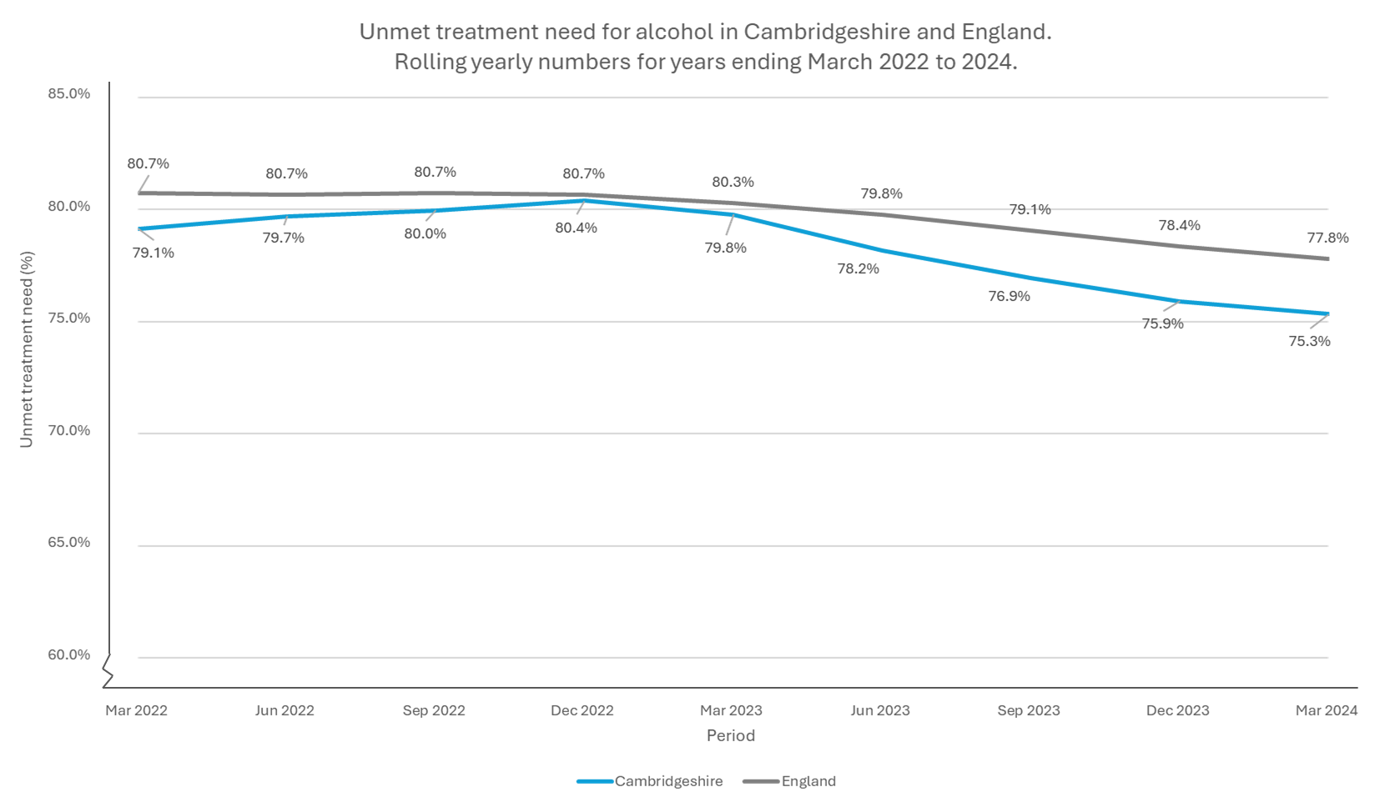
Source: NDTMS data.
Unmet Need Demographics: Age
Unmet need for alcohol treatment in Cambridgeshire is estimated to be highest among young adults, with 91% of those aged 18-24 who would benefit not accessing treatment. This decreases with age, dropping to 64% for individuals aged 55 and older. A similar pattern is observed nationally, as shown in Figure 5.3d.
Figure 5.3d. Unmet need for treatment for alcohol in Cambridgeshire and England, by age group.
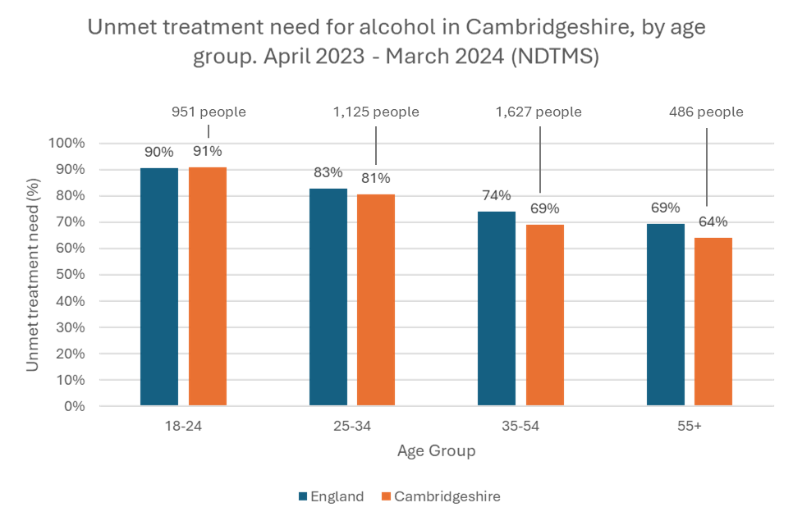
Source: NDTMS data.
This disparity has increased over time as the decrease in unmet alcohol need described above (from 2022 to 2024) was smaller amongst younger adults (2-4 percentage point reduction) compared with older adults (5-7 percentage point reduction).
Unmet Need Demographics: Sex
Unmet need for alcohol is estimated to be higher for males than females, by 16.4 percentage points both nationally and locally, as shown in Table 5.3c.
Table 5.3c. Unmet need, year ending March 2024
Area | Male | Female | Overall
England | 81.6% | 65.2% | 77.8%
Cambridgeshire | 79.3%, 3347 people | 62.9%, 842 people | 75.3%, 4189 people
Source: NDTMS data.

Alcohol Use; Key Insights and Priorities
Key Insight Summary: Children and Young People (CYP)
Alcohol use begins early among young people. By ages 12–13, just over 1 in 10 reported drinking alcohol in the past week; by 14–15, this rose to over 1 in 4. Around 1 in 20 young people reported drinking more than once in the previous seven days.
Priority 3:
Alcohol education and early intervention should be targeted at young teenagers, this age group represents a critical window for prevention. Interventions should also include information about drug use and signposting to support services.
See also Priority 1 on improving access to treatment services for young people.

Key Insight Summary: Adults
More than 55,000 adults in Cambridgeshire are estimated to be at increasing or higher risk of alcohol-related health harms.
Priority 4:
A more proactive and preventative approach is needed to support people with alcohol use. This may include raising awareness of alcohol-related harms, embedding routine identification and brief advice (IBA) in key settings (e.g. primary care, workplaces), and linking individuals to support at an earlier stage.

Key Insight Summary: Unmet Need
Unmet treatment need remains high, with over 60% of dependent adults not in treatment. Younger adults and males are particularly affected.
Priority 5:
Services should enhance early identification and engagement efforts for people with high alcohol use, particularly among younger adults. This could involve community engagement, targeted outreach and partnership working with higher education settings and community networks.
Access to low-threshold, flexible support options should be available to reduce barriers to entry. The service model should also explore whether alcohol treatment or aspects of the service could be structured separately from drug services within the existing system to help remove the potential barrier of stigma.

Detailed Service User Demographics
Analysis of additional demographics of service users is presented in this section, for both drugs and/ or alcohol use. This aims to inform an understanding of how different groups access services, to allow better targeting of resources where they are most needed.

Service User Demographics: Districts
Different areas within Cambridgeshire vary in terms of geography, levels of deprivation, and demographic composition. These factors influence both the prevalence of substance use and the level of need for treatment services. A broad understanding of where service users are from allows us to begin assessing how accessible services are across the county, and whether provision aligns with local need.
In the year ending March 2024, service users came from all five districts, with an additional 2.5% recorded as having no fixed abode (NFA) and 1.1% from out of area (OOA). However, the distribution of service users across districts was not equal. The largest proportion of service users were from Huntingdonshire, while the smallest proportion were from East Cambridgeshire.
Service user rates per 1,000 population (as opposed to raw numbers) provides a better measure of access relative to local population size. This analysis shows that Fenland had the highest rate of service users, while South Cambridgeshire had the lowest. This broadly reflects patterns of deprivation which are associated with higher levels of drug and alcohol use, although it is not possible to determine whether access is proportionate to need.
Table 5.4a illustrates this pattern of access, which is similar to the year ending March 2023. Index of multiple deprivation (IMD) deciles are included in the table to help contextualise need across districts (1 = most deprived, 10 = least deprived).
Table 5.4a. Number, proportion and rate of service users across districts in Cambridgeshire in the year ending March 2024.
District | Number of service users* | Proportion of service users | Service users in 2024; rate per 1000 population† | Service users in 2023; rate per 1000 population† | National IMD decile
Cambridge | 697 | 26.6% | 4.6 | 4.3 | 7
East Cambridgeshire | 234 | 8.9% | 2.6 | 2.1 | 9
Fenland | 523 | 19.9% | 5.1 | 5.0 | 2
Huntingdonshire | 787 | 30.0% | 4.2 | 3.7 | 8
South Cambridgeshire | 381 | 14.5% | 2.3 | 2.2 | 10
Total | 2622 | 100% | 3.7 | 3.4
* Not including service users of NFA, OOA or with missing data. † Based on 2023 population estimates. The rate serves as a relative measure only, as it is calculated for the whole population (including all age groups).
IMD decile: The Index of Multiple Deprivation (IMD) ranks areas in England from most to least deprived with the most deprived 10% of areas nationally in decile 1 and the least deprived 10% in decile 10. Areas with lower decile scores typically face greater socioeconomic disadvantage, which can be associated with higher levels of need.
While deprivation is a significant factor, other local demographic and service availability differences may also contribute to variations in access. For example, Cambridge has a relatively high service user rate for its average IMD decile (7), which may reflect the urban setting, localised areas of greater deprivation, the presence of a distinct homeless population, and a distinct demographic profile compared to rural areas. Additionally, the complexity of cases can vary across areas, for example, some districts may have a higher proportion of service users experiencing homelessness, mental ill health, or contact with the criminal justice system, which increases the level of support needed. This means that areas with fewer service users may still experience high demand in terms of staff time and resources needed per person.
Figure 5.4a, provides a visual representation of these patterns. Note that the areas highlighted outside of Cambridgeshire reflect out-of-area service users, but are limited to the six-month time period shown. A longer time frame would capture more areas, as just one or two service users will result in an area being highlighted.
Figure 5.4a. Proportional Representation of Drug and Alcohol Service Users Across Cambridgeshire Postcode Areas. Six-month period ending March 2024.
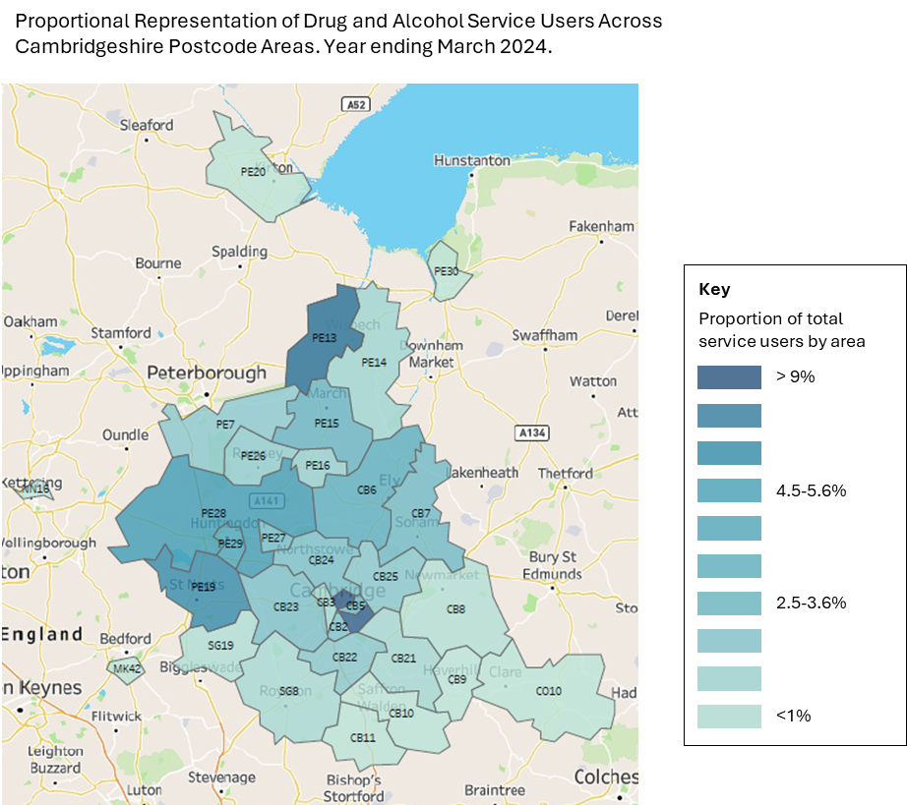
Service User Demographics: Substances across districts
Analysis of service users by area of residence shows some variation in the profile of primary substances used, although it is important to note that the primary substance reported will not represent the full extent of substance use in the population. Many individuals use a combination of substances, including alcohol and other drugs, which are not captured in this data.
The most notable variation is observed among individuals with no fixed address (NFA), where a significantly higher proportion (62.5%) report illicit opiates as their primary substance, substantially higher than in any other district. In contrast, alcohol is the most commonly reported primary substance among individuals with a fixed residence, particularly in South Cambridgeshire and Huntingdonshire, where it accounts for 56.2% and 55.0% of cases, respectively. Among those with NFA, alcohol accounts for just 20.8%.
Further interpretation of patterns should be done with caution due to small numbers in some group, but are shown in Figure 5.4b below. Additionally, it should be noted that these proportions reflect access to services rather than actual need or prevalence in the wider population.
Cambridge City demonstrates a slightly different pattern from surrounding areas, in part reflecting a wider range of substances in use. For example, although Cambridge appears to have a lower proportion of users reporting crack cocaine and other cocaine use, it had the highest total number of service users (26 and 33 respectively). Differing patterns may reflect the more urban nature of the city, as well as a younger and more mobile population.

Figure 5.4b. Primary substances cited as problem by service users by district/ NFA in Cambridgeshire, year ending March 2024.
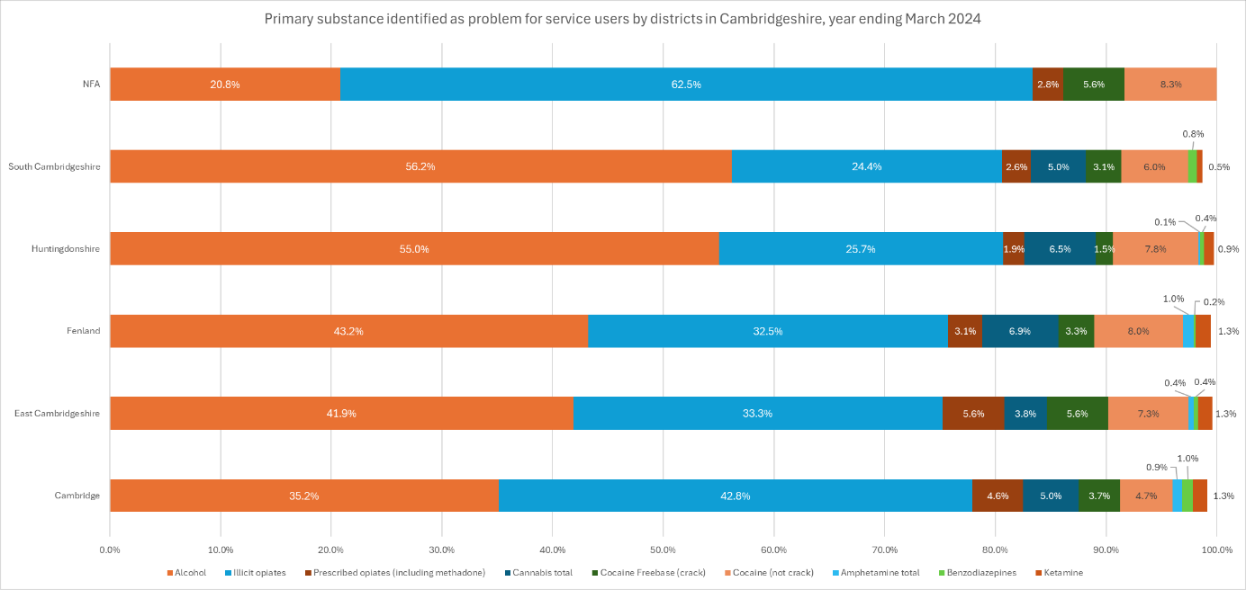
Data source: Service user statistics from Change Grow Live (CGL) Cambridgeshire data team.

Service User Demographics: Age
The distribution of service users by age reveals distinct patterns in the substances they report. In the year ending March 2024:
- Adults over 50: most commonly received treatment for alcohol, followed by opiates, and then a combination of opiates and crack.
- Adults aged 30-49: were more evenly spread across substance groups.
- Young adults aged 18-29: were most often in treatment for non-opiate substances, with or without alcohol.
This is shown in Figure 5.4c.
Figure 5.4c. Substances use profile of service users in Cambridgeshire
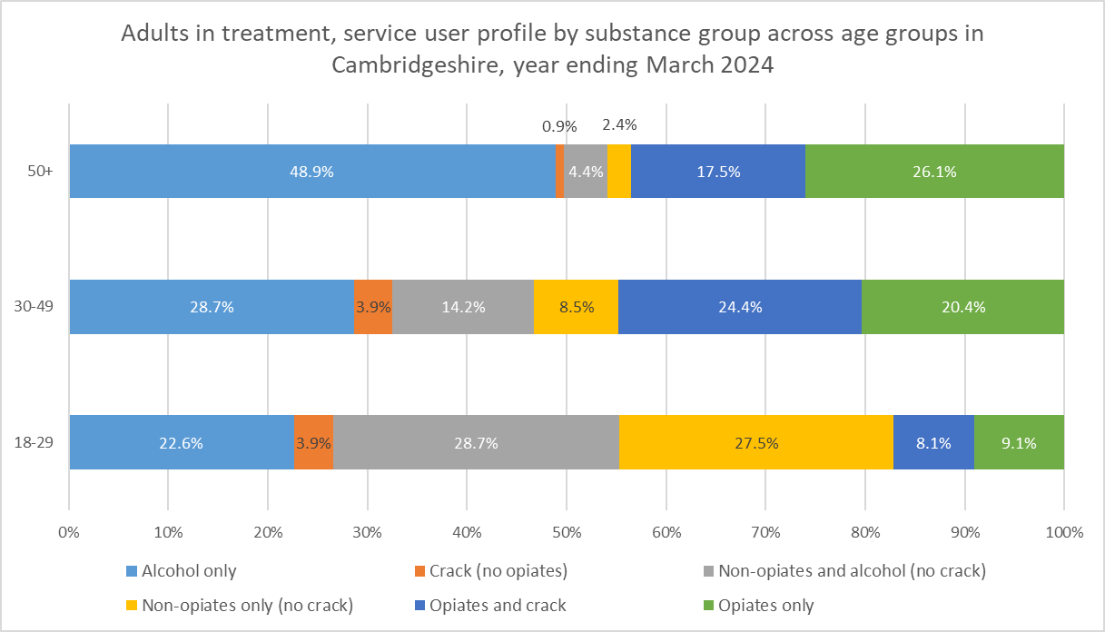
Source: NDTMS data.
Substance Use Trends by Age: Non-opiates
Further analysis of the ‘top three’ non-opiate substances cited by service users in Cambridgeshire reveals distinct age-related trends:
- Cannabis was most common among younger adults, accounting for 40.1% of citations in the 18–24 age group, declining to 29.8% in those aged 55 and over.
- Powdered cocaine was similarly concentrated in younger groups (around 30% in ages 18–34), falling to just 10.6% in over-55s.
- Crack cocaine shows the opposite pattern, with citations rising from 5% among 18–24-year-olds to over 35% in older age groups.
- Ketamine and Ecstasy use was mostly cited by the youngest adults. Ketamine is cited by 8.9% of 18-24-year-olds and 6.0% of 25-34-year-olds, but use is minimal in older age groups (1-2.5%). Ecstasy follows a similar trend, with 3.8% of citations in the 18-24 group and less than 1% in all others.
- Benzodiazepines were reported across all age groups, but more often by over-55s (7.6%).
- Amphetamines were slightly more commonly cited with increasing age, from 1.8 to 3.8%.
While small numbers require caution in over-interpreting trends over time, the data indicate relative increases in the citation of cannabis, powdered cocaine and ketamine among service users in treatment. Although GABA (gamma-aminobutyric acid) drugs make up a small proportion of cited substances overall (around 0.8%), this represents a notable increase from previous years, warranting continued monitoring.
These trends highlight the importance of age-specific approaches. Among younger adults, rising use of substances like powdered cocaine, ketamine, and ecstasy is concerning given their links to harm, including drug-related deaths. Among older adults, increasing citations of crack and cocaine use call for continued monitoring and tailored harm reduction. Awareness of age-related trends will ensure interventions are both relevant and responsive.
Current NDTMS data for substance use groups older adults into broad age categories (e.g., 50 or 55+, or 35-64), without further sub-categorisation. This limits the ability to identify differences in substance use patterns and treatment needs among older age subgroups, potentially masking important variations and hindering targeted service planning for these populations.

Service User Demographics: Protected Characteristics
The completeness of sexual orientation, religion, ethnicity, and disability data for service users in Cambridgeshire is shown in Figure 5.4d. This shows fairly robust data collection for ethnicity but indicates missing data for 23% of service users’ sexual orientation, 28% for religion, and 14% for disability.
Figure 5.4d. Proportion of service user records with complete data by characteristics, Cambridgeshire year ending March 2024.
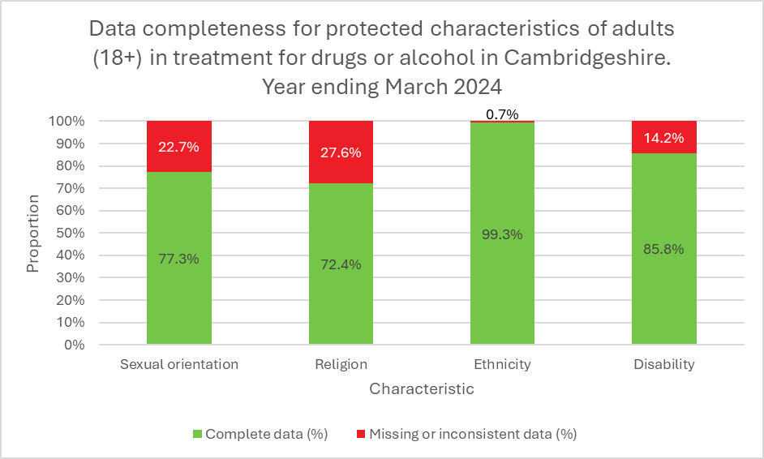
Source: NDTMS data.
Improved data collection for sexual orientation, religion and disability will provide a clearer understanding of the diverse needs of service users, helping to identify and address gaps in care.
Service User Demographics: Disability
In the year ending March 2024, of the adults in drug and/or alcohol treatment in Cambridgeshire who reported their disability status, around 36% of reported having at least one disability, while 64% reported no disabilities.
Although we found no local or national data directly linking disability status with substance dependency or treatment need, the CSEW 2024 reported that disabled individuals were more likely to have used illicit drugs in the past year (13.3%) compared to those without disabilities (8.2%).
While this does not directly indicate higher treatment need, it highlights the importance of ensuring that treatment services are accessible and responsive to the diverse needs of disabled people. Disability encompasses a wide range of conditions, which may affect how individuals experience substance use, seek help, and engage with services. Addressing potential barriers, such as physical accessibility, communication needs, or stigma, is essential to support equitable access to treatment.
People with learning disabilities (LD) face well-documented risks related to substance use and may have specific support needs. NDTMS data shows that 2.7% of new presentations to treatment in Cambridgeshire in the year ending March 2024 reported a learning disability.
This figure reflects those who disclosed an LD, which may not fully capture the true prevalence, as learning disabilities can be under-recognised or under-reported in treatment settings. A local LD needs assessment has outlined recommendations for improving access and tailored support for this group, including staff training on LD that complies with national legislation and treatment outcome monitoring for patients with LD. It also highlighted the potential value of access to shared care records and of links with specialist LD services, and recommended that commissioners should consider inpatient detox options for those with LD.

Service User Demographics: Ethnicity
For adults in treatment for drugs in Cambridgeshire in the year ending March 2024, of those who stated their ethnicity, the significant majority were from White British (87.2%) and White Other (8.8%) ethnic backgrounds. People from other ethnic backgrounds made up 4% of service users, as shown in Table 5.4b.
Table 5.4b. Number of adults in treatment for drugs (with or without alcohol) in Cambridgeshire in the year ending March 2024, by ethnic group.
Ethnicity* | Number | Proportion
Asian | 14 | 0.8%
Black | 19 | 1.0%
Mixed and Other Ethnic Groups | 41 | 2.2%
White British | 1633 | 87.2%
White Other | 165 | 8.8%
Source: NDTMS data. *See below regarding aggregated ethnic groups.
This indicates a potential underrepresentation of ethnic groups from the global majority in local treatment services when compared to their expected numbers, based on drug dependence prevalence estimates from the 2014 Adult Psychiatric Morbidity Survey (APMS) and local demographics. While this approach provides a rough estimate of service accessibility across ethnic groups, it relies on outdated data and several assumptions, so findings should be interpreted with caution.
National data reveals similar patterns of underrepresentation, particularly among Asian and Black ethnic groups, highlighting systemic barriers and potential inequities in access to drug dependency services.
It is important to note that analysis by aggregated ethnic groups may mask important differences in access and needs. For example, the ‘White Other’ category includes diverse populations such as White Irish, White Roma or Gypsy, and White Eastern European, each of which may face unique barriers to treatment and require tailored support strategies. Developing nuanced approaches to engage all ethnic groups is essential for effectively addressing disparities in service access.
Service User Demographics: Religion
In the year ending March 2024, the largest group of service users in Cambridgeshire by religious affiliation identified as having no religion, at 71.3% of the total. The next largest group were Christian, making up 20% of service users, while 1.8% stated Muslim, Jewish, Hindu and Buddhist as their religion, 5.4% stated Other and 1.5% declined to disclosed, as shown in Table 5.4c.
Table 5.4c. Proportion of service users in Cambridgeshire by religion in the year ending March 2024, for those who declared a religion, no religion, or declined to disclose.
Religion | Number of service users | Proportion of service users | Cambridgeshire residents (%) in census 2021*
Other religion | 74 | 5.4% | 0.8%
Sikh | * | <0.5% | 0.2%
Muslim | 10 | 0.7% | 5.1%
Sikh | * | <0.5% | 0.7%
Hindu | * | <0.5% | 2.3%
Buddhist | 11 | 0.8% | 1.1%
Christian | 273 | 20.0% | 35.2%
No religion | 973 | 71.3% | 44.7%
Declined to disclose | 20 | 1.5% | 9.8%
 | 1365 | 100%
Source: NDTMS Data. *Supressed due to low numbers. Note that the final column is for reference and should not be directly compared with the proportion of services users as there are known differences in substance use by religion.
There is currently no national prevalence data on drug dependence categorised by religion. However, the CSEW 2024 indicates illicit drug use prevalence varies by up to 17.4 percentage points across religious groups. While this does not directly equate to dependence, it may suggest differing service needs.
Given the religious composition of Cambridgeshire alongside this national prevalence data on drug use, it is not surprising that the largest number of service users report having no religious affiliation. However, this could still indicate an overrepresentation of non-religious individuals within the service user population, particularly given the large proportional size of this group among treatment numbers (over 70% of service users).
The absence of detailed data on dependence prevalence among different religious groups, coupled with the relatively small sample sizes, limits this analysis. Nonetheless, these factors may suggest a broader underrepresentation of individuals with religious beliefs in the context of substance use services.
People from religious backgrounds may face unique challenges when accessing drug and alcohol services. These can include:
- Heightened stigma: Substance use can carry significant stigma in many communities, and this may be especially pronounced in some religious or faith-based contexts, making it harder for individuals to seek help.
- Cultural or religious prohibitions: In some faiths, the use of alcohol or drugs is strictly forbidden. Individuals who do use substances may feel shame or fear of judgment, leading them to conceal use and difficulties, or avoid services altogether.
- Culturally responsive services: If services are not designed with cultural or religious needs in mind (such as gender-sensitive support, dietary considerations, or understanding of faith-based values), they may feel less welcoming or appropriate to potential service users.

Service User Demographics: Sexual orientation
The majority of service users in treatment for drugs in Cambridgeshire are heterosexual. In the year ending March 2024, 93% reported heterosexual sexuality, 2.1% reported being gay or lesbian, 3.9% reported bisexuality and less than 1% reported other. Note these figures exclude service users with missing information on sexuality.
If the need for treatment were evenly distributed across all sexual orientations, we would expect service user numbers to reflect the general population distribution in Cambridgeshire, where 88.3% identified as heterosexual in the 2021 Census. However, this group appears to be overrepresented in treatment services. National data from the CSEW further suggests that people from sexual minorities may be underrepresented, as they report significantly higher rates of illicit drug use, 8% of heterosexuals used drugs in the past year, compared to 14% to 25% for other sexual orientations.
A specific area of concern is the use of illicit drugs to enhance or facilitate sexual activity, particularly among some sexual minority groups, including gay, bisexual, and other men who have sex with men. Known as ‘chemsex,’ this practice commonly involves substances such as methamphetamine, mephedrone, and GHB/GBL. While chemsex can foster social bonding and intimacy, it is also linked to significant public health risks, including higher HIV transmission rates, mental health concerns, and overdose.
The complex relationship between drug use and sexual behaviour highlights the need for targeted harm reduction strategies and culturally competent support services. Given the potential underrepresentation of people from sexual minority groups in treatment, it is also critical to identify and remove barriers to access. This may include addressing stigma, ensuring inclusive service provision, and improving outreach to groups at higher risk.
Understanding local prevalence of chemsex is challenging. Individuals may travel outside the area, for example to London, to attend parties or seek support, and they may engage with sexual health services rather than local drug and alcohol services. These patterns of mobility and cross-service engagement complicate needs assessment, service planning, and data interpretation, and may result in underrepresentation within local treatment datasets.
Sexual health services therefore play a vital role in identifying and supporting individuals at risk. Those presenting with substance use issues may be more likely to do so in sexual health settings than in drug and alcohol services. It is essential that sexual health professionals are trained to recognise signs of substance dependency and understand related risks. These services also offer an opportunity to provide harm reduction advice and distribute safer sex and drug use kits, acting as a key point of contact for intervention and support.
To ensure individuals receive holistic care regardless of their point of entry into the system, strong collaboration between drug and alcohol services and sexual health teams is essential. This includes shared training, coordinated referral pathways, and joint approaches to outreach and harm reduction.

Demographics; Key Insights and Priorities
Key Insight Summary: Differential need and access across Cambridgeshire
Service access and substance use patterns vary across Cambridgeshire. Fenland has the highest rate relative to population, while Huntingdonshire has the most users overall. Cambridge City shows a broader substance mix, and illicit opiate use is highest among those with no fixed address.
Priority 6
Service planning should account for local variations in need by using population-based rates and contextual data such as deprivation and housing status. Tailored approaches should be developed for urban areas and for individuals with no fixed address (NFA), where substance use patterns differ.
Given the high prevalence of illicit opiate use among the NFA group, targeted harm reduction and opiate-focused support, such as outreach, naloxone provision, and low-threshold treatment, should be prioritised.

Key Insight Summary: Differential substance use by age groups
Substance use patterns vary significantly by age group. Younger adults are more likely to report cannabis, powdered cocaine, ketamine and ecstasy, while older adults are more commonly in treatment for alcohol, opiates, and crack cocaine. These trends highlight the need for targeted approaches. The absence of prevalence estimates for non-opiate substances noted in section 5.2 risks under-prioritisation of those who use non-opiates, which may affect different age groups in distinct ways.
Priority 7
Services should ensure that engagement strategies and treatment approaches are informed by the distinct substance use patterns observed across different age groups. Tailoring access initiatives and interventions to these variations can improve accessibility and effectiveness, while ongoing monitoring can guide tailored approaches.

Key Insight Summary: Access and protected characteristics
There are gaps in protected characteristic data for service users, including gender identity, sexual orientation, religion, and disability. This limits the ability to assess whether services are truly inclusive and meeting the needs of all communities.
Available data suggest under-representation of key groups, including ethnic groups from the global majority, disabled individuals, religious minorities, and people from sexual minorities.
Priority 8
Improve equality monitoring and data quality by routinely collecting sexual orientation, religion, disability status, and gender (not just sex) of service users, to better understand and respond to the needs of diverse groups.
Priority 9
Take targeted equality action to improve access and inclusion for under-represented groups including ethnic groups from the global majority, disabled individuals, religious minorities, and people from sexual minorities. This should include building on culturally competent models, considering specialist interventions with partners (e.g. involvement of sexual health team around chemsex) and tailored support for people with learning disabilities.

Mortality Related to Substance Use in Cambridgeshire
Deaths related to alcohol and drug misuse have been increasing in recent years (see section 4.3). This concerning trend is recognised both nationally and locally, with efforts underway to address the issue through targeted interventions and preventive measures.
In Cambridgeshire, monitoring drug- and alcohol-related deaths is a critical component of the local approach to enable timely identification of emerging risks. The local processes follow national recommendations for drug alerts and local drug information systems (LDIS). This system relies on close collaboration between partners, including health and ambulance services, the police, and other key stakeholders, to ensure a coordinated and effective response to these challenges.

Deaths from Drug Misuse
In Cambridgeshire, the rate of deaths from drug misuse in the most recently reported data (2023) was 3.5 per 100,000, which was below the national average of 5.5 per 100,000. This lower rate suggests that, while Cambridgeshire is affected by drug-related mortality, it has a lower burden than other local authorities.
Table 5.5a and Figure 5.5a below show that deaths relating to substance use has risen in recent years (since 2013-2015) across all areas. Cambridgeshire has had a statistically significantly lower mortality rate than seen nationally since 2017-19.
Table 5.5a. Deaths from drug misuse in three-year periods from 2018, in England, East of England region and Cambridgeshire.
Directly Age-Standardised Rate (DASR) - per 100,000
Area | 2018-2020 | 2019-2021 | 2020-2022 | 2021-2023
England | 5.0 | 5.1 | 5.2 | 5.5
East of England | 3.7 | 3.2 | 3.4 | 3.6
Cambridgeshire | 3.0 | 2.6 | 3.2 | 3.5
Number of Cases
Area | 2018-2020 | 2019-2021 | 2020-2022 | 2021-2023
England | 8,185 | 8,361 | 8,582 | 9,105
East of England | 669 | 590 | 618 | 664
Cambridgeshire | 60 | 52 | 63 | 70
Source: ONS data. Directly Age-Standardised Rate (DASR) - per 100,000 and absolute numbers.
Figure 5.5a. Deaths from drug misuse, trend across three-year periods since 2001 in Cambridgeshire and England.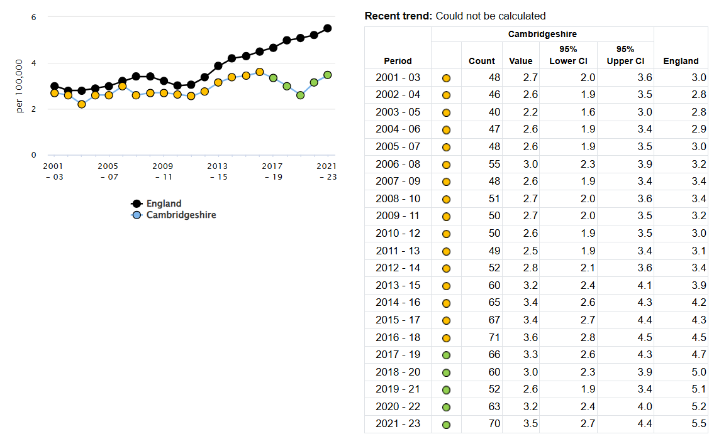
Source: OHID, based on Office for National Statistics data.
A mortality rate from drug misuse of 3.5 per 100,000 in Cambridgeshire is similar to statistical neighbours (NHS England), where the average is 4.2 per 100,000, with a range of 2.5 to 7.4 per 100,000, as shown in Table 5.5b.
Table 5.5b. Deaths from drug misuse, age standardised mortality rate from drug misuse per 100,000 population, directly standardised rate – per 100,000. 2020-23 (most recent available):
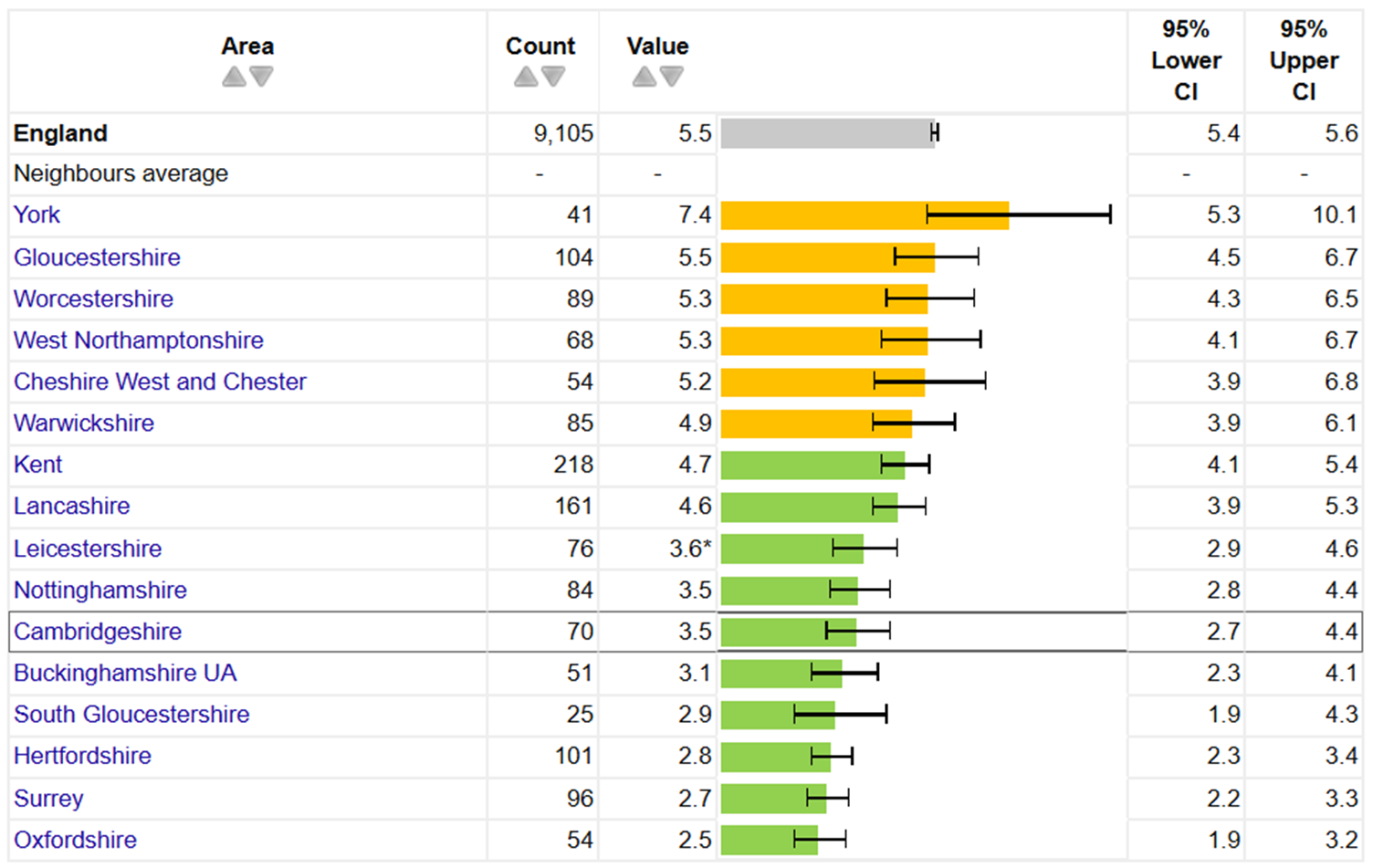
Source: OHID, based on ONS data, statistical neighbours (NHS England30).
The mortality rate from drug misuse remains higher for males than females, both locally and nationally, as shown below in Figure 5.5b. In Cambridgeshire, the male mortality rate was 4.4 per 100,000 in 2021-2023, similar to previous years and statistically significantly lower than the rising national rate. For females, the rate increased from 1.2–2.2 per 100,000 (2018–2022) to 2.6 per 100,000, a return to levels seen in 2019–2020 (2.5 per 100,000) and becoming statistically similar to the national rate of 3.1 per 100,000 (2021–2023). Note that fluctuations are more likely in female rates due to lower overall numbers.
Figure 5.5b. Deaths from drug misuse in males and females, in Cambridgeshire and England, three-year periods since 2001.
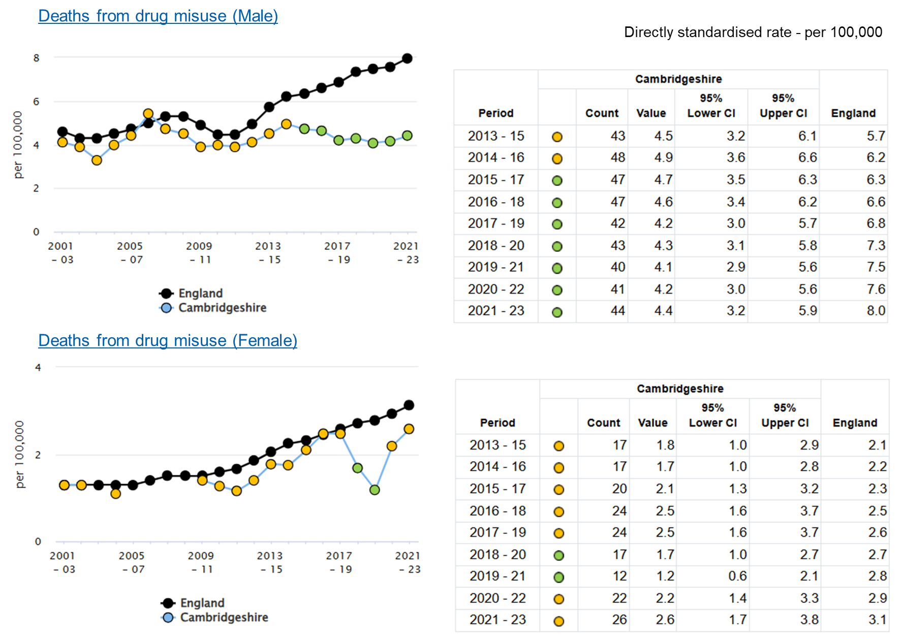
Source: OHID, based on ONS data.

Drug Mortality by District
District-level data reveals variation in rates and case numbers between areas within Cambridgeshire (see Table 5.5c). However, the relatively small number of cases in each district introduces uncertainty, meaning that some of the observed variation may reflect natural fluctuations rather than true differences in underlying rates.
Table 5.5c. Deaths from substance misuse in districts of Cambridgeshire in three-year periods from 2018. Directly Age-Standardised Rate (DASR) - per 100,000 and absolute numbers.
Directly Age-Standardised Rate (DASR) - per 100,000
Area | 2018-2020 | 2019-2021 | 2020-2022 | 2021-2023
England | 5.0 | 5.1 | 5.2 | 5.5
Cambridgeshire | 3.0 | 2.6 | 3.2 | 3.5
Cambridge | 3.6 | 4.7 | 6.1 | 6.5
East Cambridgeshire | * | * | * | *
Fenland | 5.4 | 3.3 | 3.9 | 4.6
Huntingdonshire | 3.2 | 2.1 | 2.8 | 3.5
South Cambridgeshire | * | * | 2.1 | 2.3
Number of Cases
Area | 2018-2020 | 2019-2021 | 2020-2022 | 2021-2023
England | 8,185 | 8,361 | 8,582 | 9,105
Cambridgeshire | 60 | 52 | 63 | 70
Cambridge | 15 | 17 | 21 | 22
East Cambridgeshire | * | * | * | *
Fenland | 16 | 10 | 12 | 14
Huntingdonshire | 17 | 11 | 15 | 19
South Cambridgeshire | * | * | 10 | 11
Source: ONS data. * Supressed due to low numbers.

Mortality from Alcohol
Alcohol-related harms often develop over time, with a lag between changes in consumption patterns and observable health impacts. Many alcohol-related conditions progress chronically so immediate changes are hard to detect, however, monitoring these trends remains essential to understand and address the impact of alcohol use on public health.
Overall, mortality from alcohol in Cambridgeshire was similar or lower than England in 2023 by a number of measures. Some measures show recent worsening trends, particularly those associated with harms from dependent drinking (as opposed to broader alcohol-related mortality, which can be influenced by general population drinking patterns). This is shown in Figure 5.5c.
Figure 5.5c. ‘Alcohol profile’ indicators from OHID, Cambridgeshire compared with England.
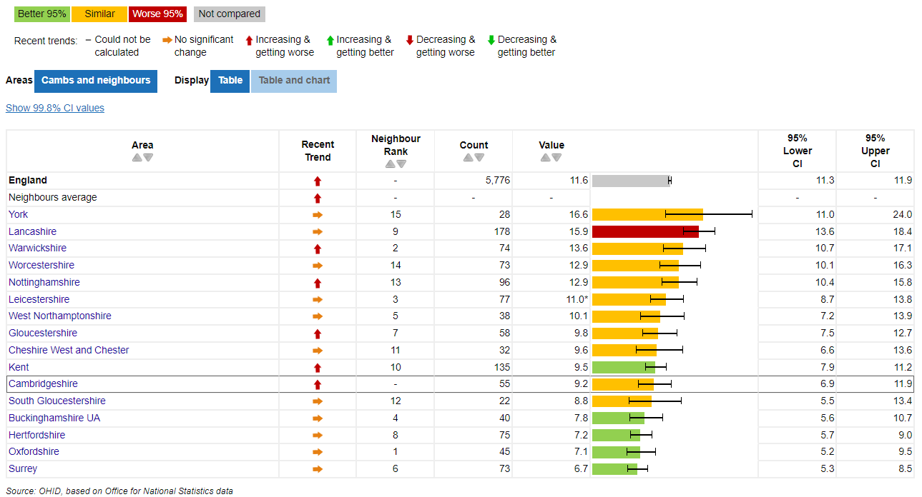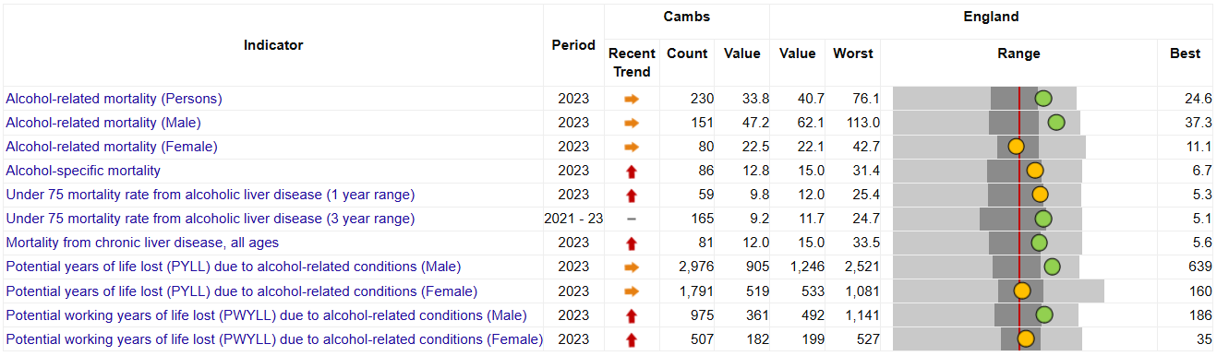
Source: OHID, based on Office for National Statistics data.

Alcohol-specific Mortality
Deaths which have been wholly caused by alcohol consumption are monitored by OHID and ONS, in order to provide an evidence base for activities to reduce the harmful use of alcohol. The rate of these deaths, referred to as ‘alcohol-specific mortality’, has increased since 2019 in both Cambridgeshire and nationally.
The most recent annual mortality rate from 2023 for Cambridgeshire was 12.8 per 100 000, which is a significant increase from the year before and brought Cambridgeshire closer to the national rate (15 per 100 000) where it had previously been significantly lower. This is demonstrated in Figure 5.5d.
Figure 5.5d. Alcohol-specific mortality in Cambridgeshire and England 2006 to 2023.
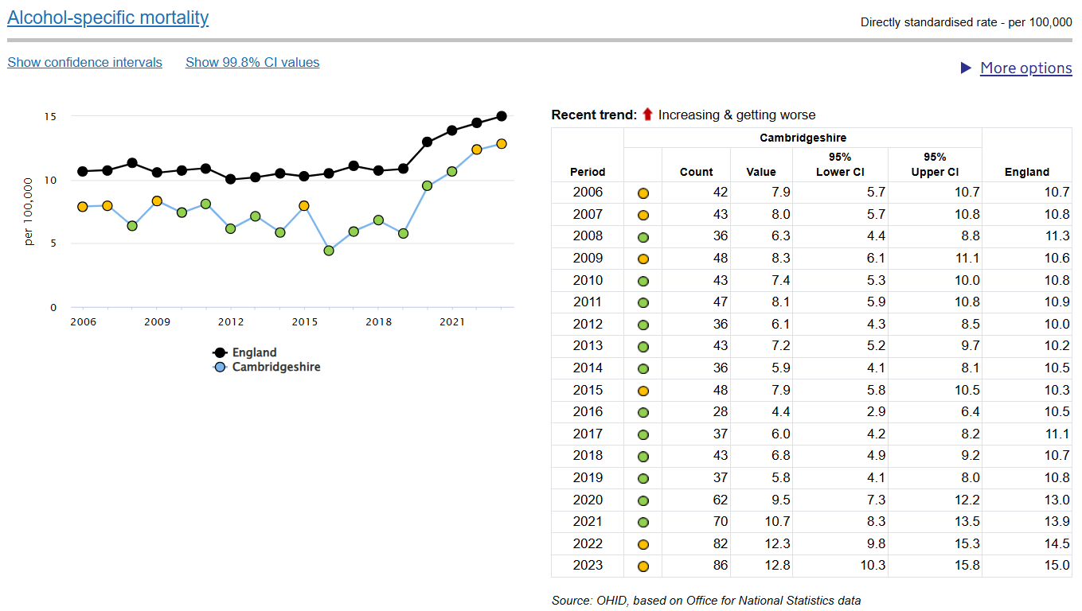
Source: OHID, based on Office for National Statistics data.

Alcohol-related mortality rates in Cambridgeshire were similar to the average rate amongst statistical neighbours29 in 2023, but not all similar areas saw trend of recent increase, as shown in Figure 5.5e.

Figure 5.5e. Alcohol specific mortality rates (DASR per 100,000) in Cambridgeshire and nearest statistical neighbours (NHS England30) in 2023.

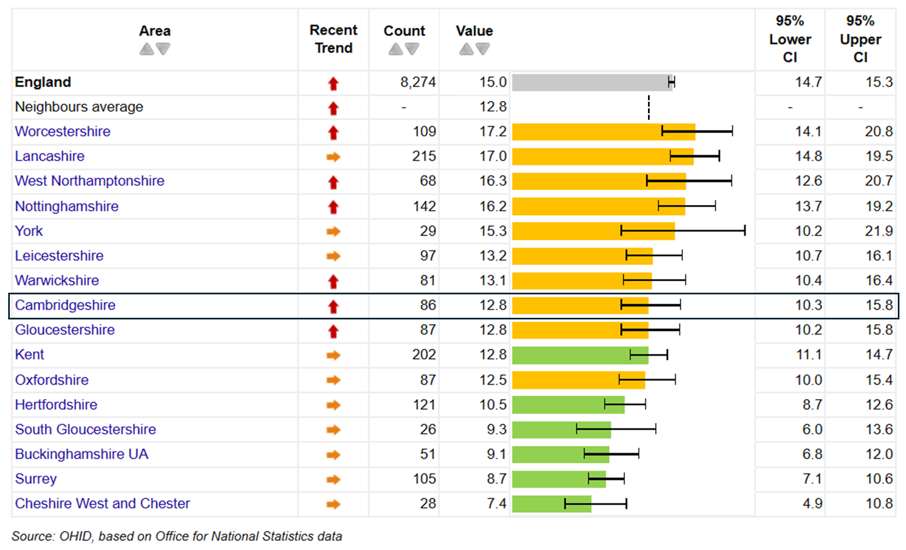
Source: OHID, based on ONS data. There is no district breakdown for this measure.

Alcohol-related Mortality
Alcohol-related mortality refers to deaths where alcohol is a contributing factor, but not necessarily the direct cause. This measure captures a broader range of diseases and conditions that are partly attributable to alcohol consumption, such as cancers, liver disease, and heart conditions. To calculate alcohol-related mortality, a specific fraction of deaths from these diseases is attributed to alcohol based on how common drinking is in the population, along with age, sex, and disease-specific risks.
This measure is broader than alcohol-specific mortality, it is available by sex and at district level, so is included here to allow further understanding of our local population.
Alcohol-related mortality rate in Cambridgeshire was 33.8 per 100 000 in 2023 (most recent data available). This is lower than the national rate of 40.7 per 100 000, as seen with trends in alcohol-specific mortality. Mortality by this measure is not significantly increasing in Cambridgeshire, as shown in Figure 5.5f.

Figure 5.5f, alcohol-related mortality in Cambridgeshire and England 2016-2023.
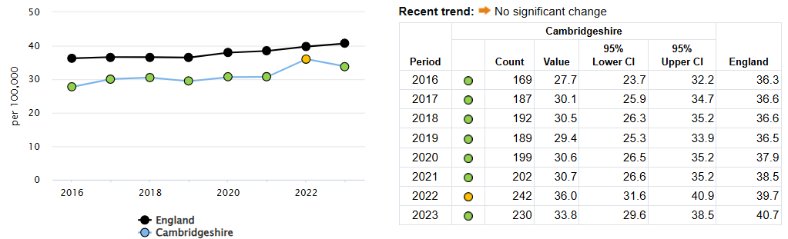
Source: OHID, based on ONS data.

By Sex
There is a marked sex difference in alcohol-related mortality both locally and nationally. For males in Cambridgeshire in 2023, the rate was 47.1 per 100,000 compared with 22.5 per 100,000 for females. For males, this rate is significantly lower than England, but for females the rate is similar, as shown in Figure 5.5g.
Figure 5.5g. Alcohol-related mortality in Cambridgeshire and England 2016-2023, directly standardised rates per 100,000 population, by sex.
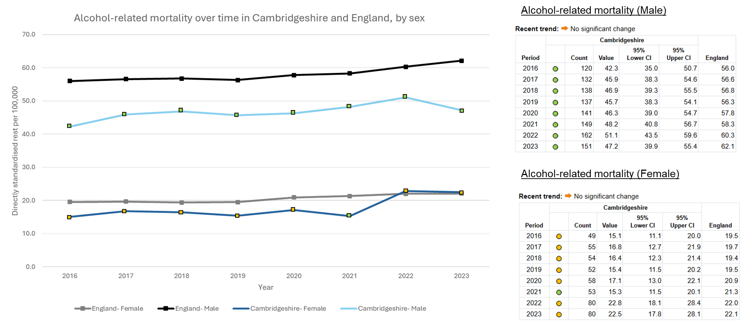
Source: Adapted from OHID, based on ONS data.

By District
Alcohol related mortality varies across districts in Cambridgeshire. Cambridge, Fenland and Huntingdonshire were statistically similar to the national rate in 2023, while East and South Cambridgeshire were lower, as shown in Figure 5.5h.

Figure 5.5h. Alcohol-related mortality in districts of Cambridgeshire (DASR)
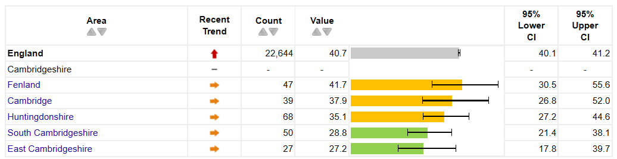
Source: OHID, based on Office for National Statistics data.
Differences in mortality rates between districts may, in part, reflect underlying deprivation levels, as socio-economic disadvantage is strongly associated with poorer health outcomes. A correlation between deprivation level and mortality rate can be seen in Figure 5.5i.
Figure 5.5i. Alcohol-related mortality (deaths per 100 000) in 2023 in England by IMD (2019)
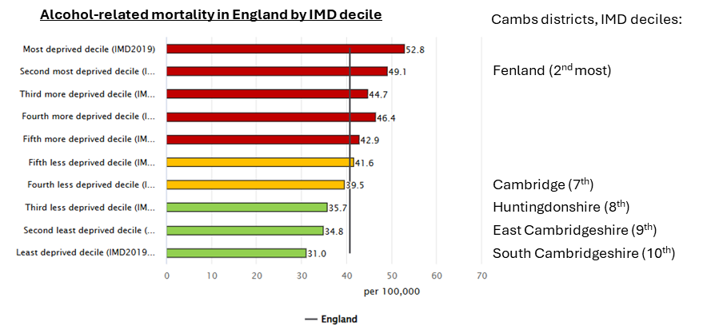
Source: OHID, based on ONS data.

Liver Disease
Both drug and alcohol use are leading causes of liver disease, which is a significant and preventable health burden. Chronic alcohol consumption and the use of certain drugs, including opioids, can cause severe liver damage. Risky behaviours associated with substance use, such as injecting drugs or unsafe use habits, further exacerbate the risk of liver conditions like alcoholic hepatitis, cirrhosis, and liver failure.
Indicators that used by OHID to monitor health impacts of liver disease are shown in Figure 5.6b. This demonstrates that Cambridgeshire has similar or ‘better’ values compared with England.

Figure 5.6b. Liver disease profile for Cambridgeshire, compared with England
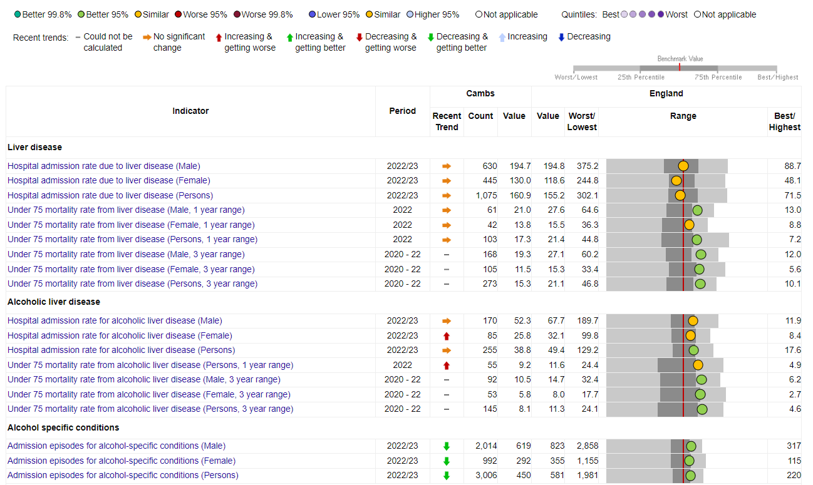
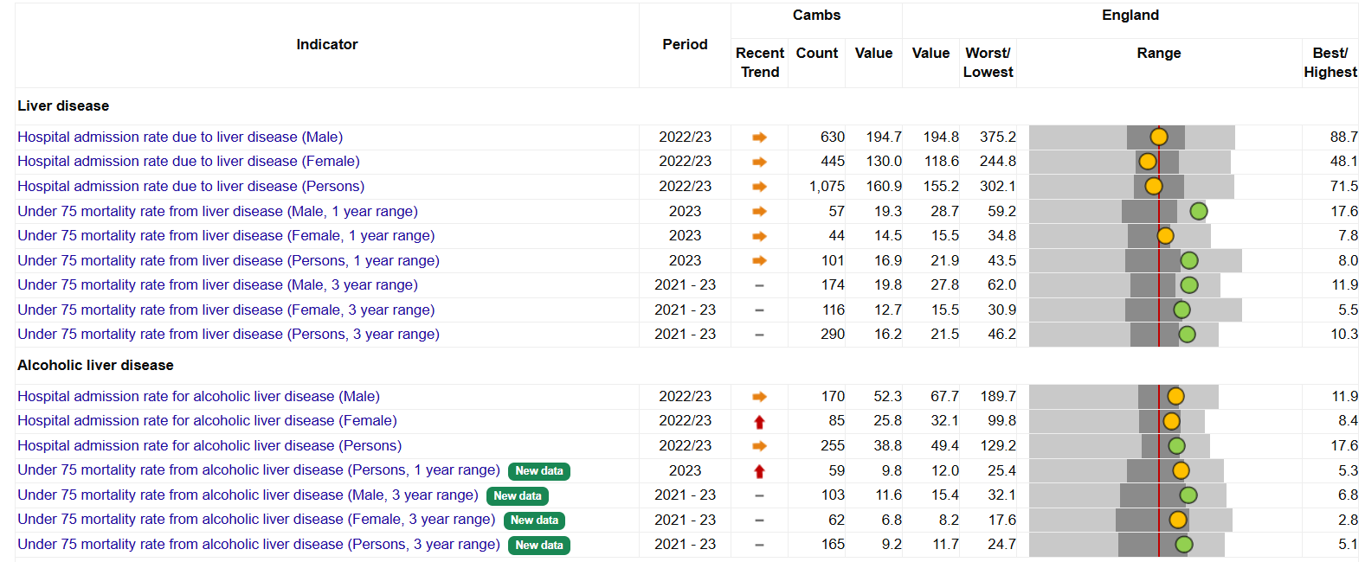
Two indicators are increasing and getting worse in Cambridgeshire; female admissions for alcoholic liver disease, and under 75 mortality rate from alcoholic liver disease. These measures are also increasing nationally and in some of Cambridgeshire’s statistical neighbours, although not all.
There trends highlight the need to continue monitoring liver disease locally and strengthen preventative action as part of efforts to address wider unmet need.

Substance Use and Suicide
A local suicide audit conducted in 2023 sought to better understand the diverse and complex risk factors that can lead to somebody taking their own life, in order to focus efforts and ensure that those with greatest need are adequately supported.
It looked at suicides registered by Cambridgeshire and Peterborough’s Coroner’s Office between 2019 and 2021 and found that approximately 14.6% of people who died by suicide had an identified alcohol use issue, and approximately 12.2% of people had an identified drug dependence issue. Compared with national estimates of dependence of 1.4% and 3.1% of the population respectively, the proportion of people dying by suicide with drug and alcohol dependence issues is much greater than the proportion of the general population.
Amongst those who died from suicide and had identified substance use issues, less than one third were known to substance use services but most were known to mental health services, as shown in Figure 5.5j. The audit recommended strengthening referral pathways from secondary mental health services to drug and alcohol services.

Figure 5.5j. Engagement with Drug and Alcohol and Mental Health Services among those who died by suicide.
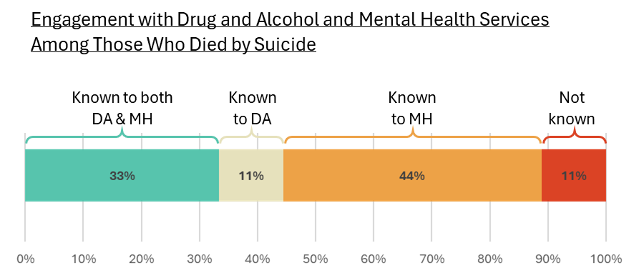
Source: Local audit31.

Deaths While in Treatment
Every year, people die while they are in an alcohol and drug treatment programme, and these deaths may or may not be alcohol or drug related. Data here demonstrates mortality rates among individuals whilst receiving treatment for drug and alcohol use in Cambridgeshire in order to understand risks faced by this population. This may highlight areas for potential intervention and can inform strategies for improving health outcomes.
Overall, the number of deaths in treatment in Cambridgeshire were stable over the 3 years ending March 2024, with a rate of 1.2% most recently, an average of 32 deaths. This was similar to the mortality rate for England, 1.3%. The number and proportion of deaths in treatment has increased over the last 15 years, both locally and nationally, as shown in Figure 5.5k.
Figure 5.5k. Deaths whilst in DA treatment.
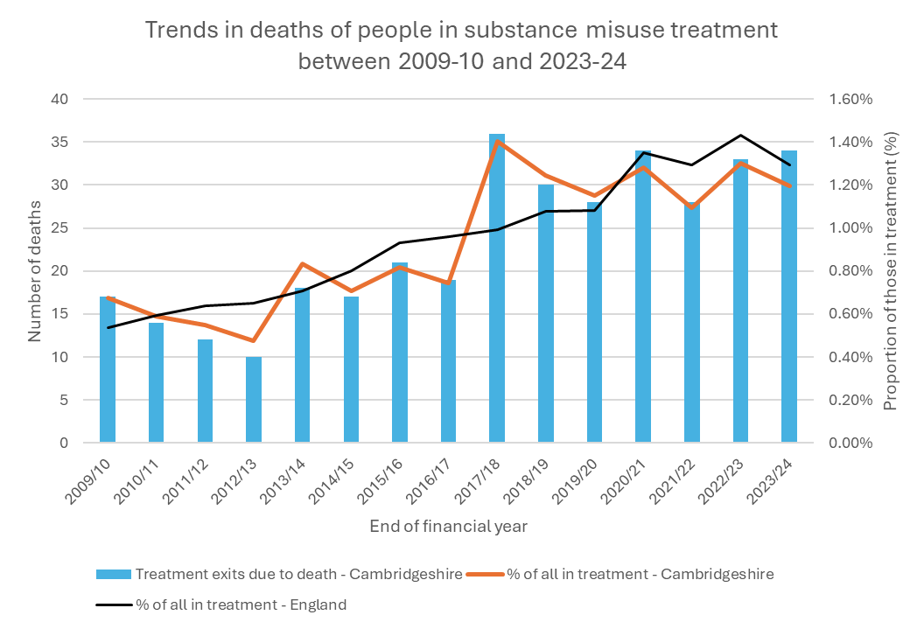
Source: NDTMS data.
There is no consistent pattern of sex distribution of mortality whilst in treatment for drugs, with neither sex disproportionately represented in mortality numbers.
Deaths in treatment from drugs and alcohol is not evenly spread across substance types. People who use opiates have the highest mortality rate, making up around half of total deaths in treatment. Around a third are of those using alcohol only, with the remainder occurring in those using non-opiates with or without alcohol.

Mortality; Key Insights and Priorities
Key Insight Summary: Mortality
Mortality rates related to alcohol and drugs are increasing locally and nationally. Mortality is higher among males. Just over 1% of those in treatment for substance use die annually.
Priority 10
A local Drug and Alcohol-Related Deaths (DARD) audit or case review should be considered to help to identify trends, risk factors, and opportunities for intervention. This can provide valuable insights into areas for action; findings should inform local harm reduction strategies, service improvements, and targeted outreach for high-risk groups to help prevent future deaths.

Key Insight Summary: Emerging liver disease risk
Liver disease is a major, preventable health burden linked to both alcohol and drug use, with injecting behaviours increasing risk. While Cambridgeshire performs similarly or better than England on many liver-related indicators, recent rises in female admissions and under-75 mortality from alcoholic liver disease mirror national trends and highlight the need for earlier intervention.
Priority 11
Continue to monitor liver disease trends locally and work with hepatology colleagues to strengthen preventative efforts. This may include exploring screening pathways, collaboration with hospital alcohol care teams and liver specialists, and embedding routine alcohol identification and brief advice, as also noted in priority 4. Use of tests for fibrosis could also be explored to support earlier detection of liver damage in at-risk groups.

Key Insight Summary: Mortality and mental health
People who die from suicide have a significantly higher prevalence of substance use than the general population, and many are known to mental health services but not to substance use services.
Priority 12
Strengthen joint working between mental health and substance use services, including exploring joint commissioning, integrated assessments, and shared care records. This aims to reduce barriers to access, and support individuals with co-occurring conditions more effectively, with more care continuity.

Health Harms

Hospital Admissions for Drugs and Alcohol
In 2021, nearly 6% of all hospital admissions in England were alcohol related. Analysis of hospital admission episode data for both drug and alcohol poisoning allows an understanding of harm from substance use amongst our population and can inform strategies for harm reduction.
Data shows reductions in admissions for drug and alcohol poisoning between 2020 and 2024, both locally and nationally. The cause of this is unclear, however, and may reflect changes in recording practice or system pressures, rather than a reduction in actual overdoses and poisoning.
Rates by substance type are shown in Table 5.6a and Figure 5.6a, which demonstrate that the most marked reduction in rates of admissions have been seen for alcohol and opiates.

Figure 5.6a. Admissions for drug and alcohol poisoning by type, in Cambridgeshire and England from 2019 to 2024, Directly Standardised Rate (DSR) per 100,000.
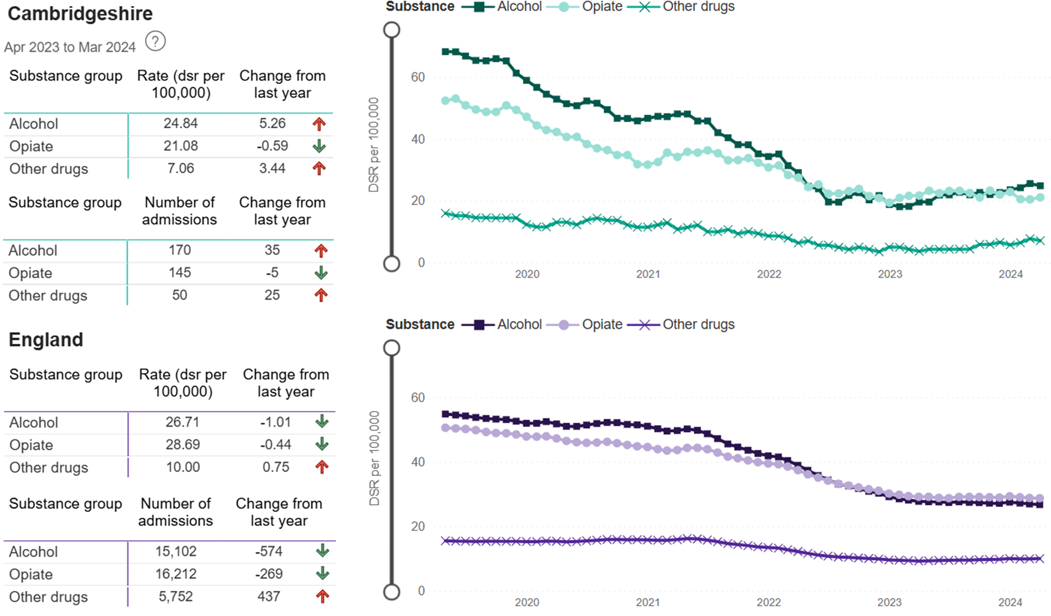
Source: NDTMS.
Table 5.6a. Admissions for drug and alcohol poisoning by type, in Cambridgeshire from 2019 to 2024, DSR per 100,000.
Year ending March: | 2019 | 2020 | 2021 | 2022 | 2023 | 2024
Alcohol | 65.0 | 50.4 | 42.5 | 24.0 | 21.2 | 24.7
Opiates | 50.1 | 38.0 | 34.0 | 24.2 | 22.4 | 20.3
Other drugs | 14.5 | 12.7 | 10.6 | 5.7 | 4.9 | 7.4
Total | 43.2 | 33.7 | 29.0 | 18.0 | 16.2 | 17.5
Source: NDTMS data.
Higher admission rates are associated with increasing deprivation. In Cambridgeshire, rates were in line with the average for areas in the least deprived quintile nationally (IMD 2019), as shown in Table 5.6b.
Table 5.6b. DSR per 100,000 across quintiles of deprivation for substances in England and in Cambridgeshire
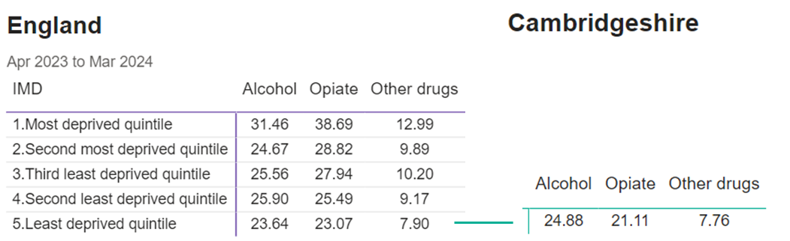
Source: NDTMS.
This pattern of higher admission rates in more deprived areas may also be reflected at district level within Cambridgeshire, where deprivation ranges from Fenland (most deprived quintile) to South Cambridgeshire (least deprived). NDTMS does not have district level data, but data for alcohol-related non-elective hospital admissions does demonstrate significant variation in admission rates across the county.
This is available at Primary Care Network (PCN) level; over the eight-month period ending November 2024, an average PCN population of 42,243 would be expected to have 92 admissions if rates were evenly distributed. However, applying actual PCN admission rates to this population results in a variation from 37 admissions in the PCN with the fewest admissions, to 154 in the PCN with the most; a range of 62 admissions, as shown in Table 5.6c and Figure 5.6c.
Table 5.6c. Modelling of alcohol-related admission rates by PCN, 8-month period ending November 2024.
PCN Name | Modelled admissions over eight months* | Actual admission number | PCN Population
Cambridge City PCN | 154 | 185 | 50,594
Huntingdon PCN | 147 | 147 | 42,205
St Neots PCN | 134 | 99 | 31,118
St Ives PCN | 118 | 126 | 45,154
Ely North PCN | 115 | 100 | 36,664
A1 Network PCN | 106 | 107 | 42,578
Fenland PCN | 93 | 72 | 32,829
Cambs Northern Villages PCN | 91 | 97 | 44,931
South Fenland PCN | 86 | 62 | 30,514
Cambridge City 4 PCN | 78 | 94 | 51,016
Wisbech PCN | 75 | 101 | 57,128
Meridian PCN | 71 | 78 | 46,153
Granta PCN | 66 | 66 | 42,168
Ely South PCN | 59 | 50 | 35,509
CAM Medical PCN | 43 | 42 | 41,018
Cantab PCN | 37 | 41 | 46,302
* Actual admission rate in the area multiplied by average PCN population (42,243) to allow comparison.
Figure 5.6c. Alcohol-related admission rates by PCN (8-month period ending November 2024), mapped by dominant LSOA*
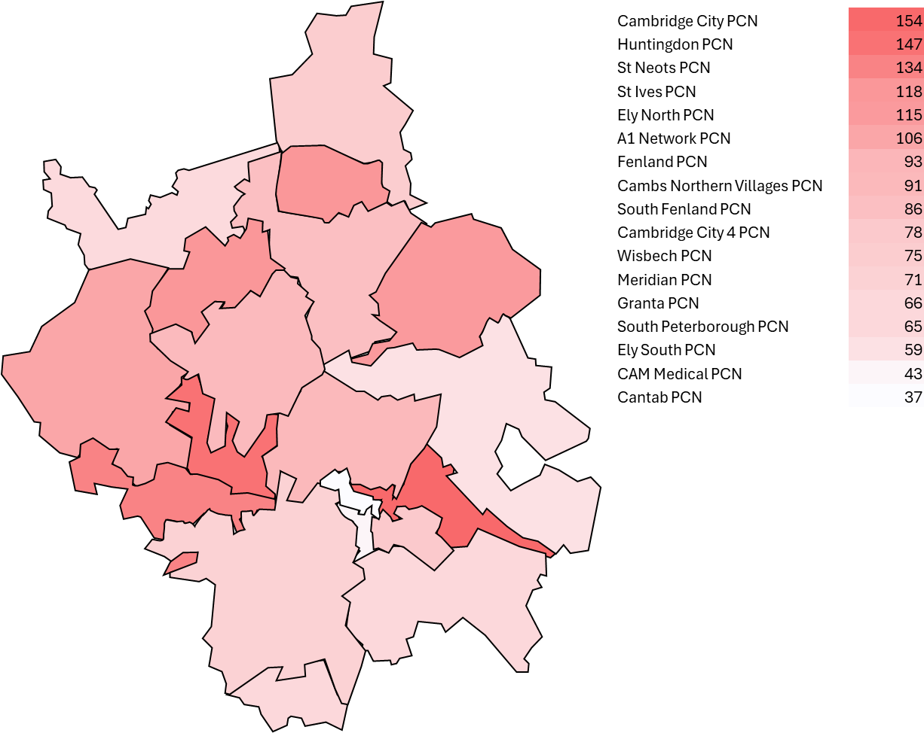
* based on the majority of registered residents in 2019. Colour scale reflects admission rates assigned at PCN level. Darker red represents highest admission rates, white represents lowest admission rates.
This variation suggests that some PCNs experience a disproportionately higher burden of alcohol-related harm, which may be influenced by differences in demographics, deprivation levels, service provision, and patterns of alcohol use. Further investigation into these disparities can help inform targeted interventions to reduce alcohol-related hospitalisations and improve outcomes across the area.

Blood-borne Viruses
Blood-borne viruses (BBVs), including hepatitis B (HBV), hepatitis C (HCV), and HIV, are significant health harms associated with drug use, particularly among people who inject drugs (PWID). The UK Government is committed to the World Health Organization (WHO) goal of eliminating viral hepatitis as a major public health threat by 2030 and has also pledged to end new HIV transmissions by the same year.
Monitoring BBV-related interventions through drug and alcohol treatment providers is crucial to tracking progress. While diagnosis and treatment rates for HIV are improving in the general population, PWID experience higher rates of late diagnosis, delayed treatment, and co-infection with HCV, leading to poorer outcomes. In 2021, an estimated 18% of PWID in the UK were chronically infected with HCV, and 0.2% were infected with HBV.
As noted in section 5.2.1, injecting drug use accounts for a higher proportion of opiate and crack users (OCUs) in Cambridgeshire than nationally, with estimates suggesting around 800 current and 650 former injectors. Not all of these people are engaged in treatment, reflecting levels of unmet need.
In the year ending March 2024, there were 819 service users who were either currently injecting, or had previously injected in Cambridgeshire (28.9% of 2835). Data among this group shows that BBV screening, testing, and treatment rates are higher than national averages; however, there remains room for improvement.
Understanding and accurately recording HIV status is essential for providing timely treatment, preventing transmission, and ensuring appropriate health interventions. In the year ending March 2024, 72.6% of service users in Cambridgeshire had a recorded HIV status, compared with 59.5% in England overall. For injecting service users (current or previous), recorded HIV status rises to 91.9% in Cambridgeshire and 74.3% nationally.
For hepatitis, among injecting service users, 5.5% did not have an HCV test recorded or were not offered one, and 1.6% did not have HBV treatment recorded or offered, as shown in Figure 5.6c.

Figure 5.6c. HCV testing and HBV treatment in Cambridgeshire compared with England 2024.
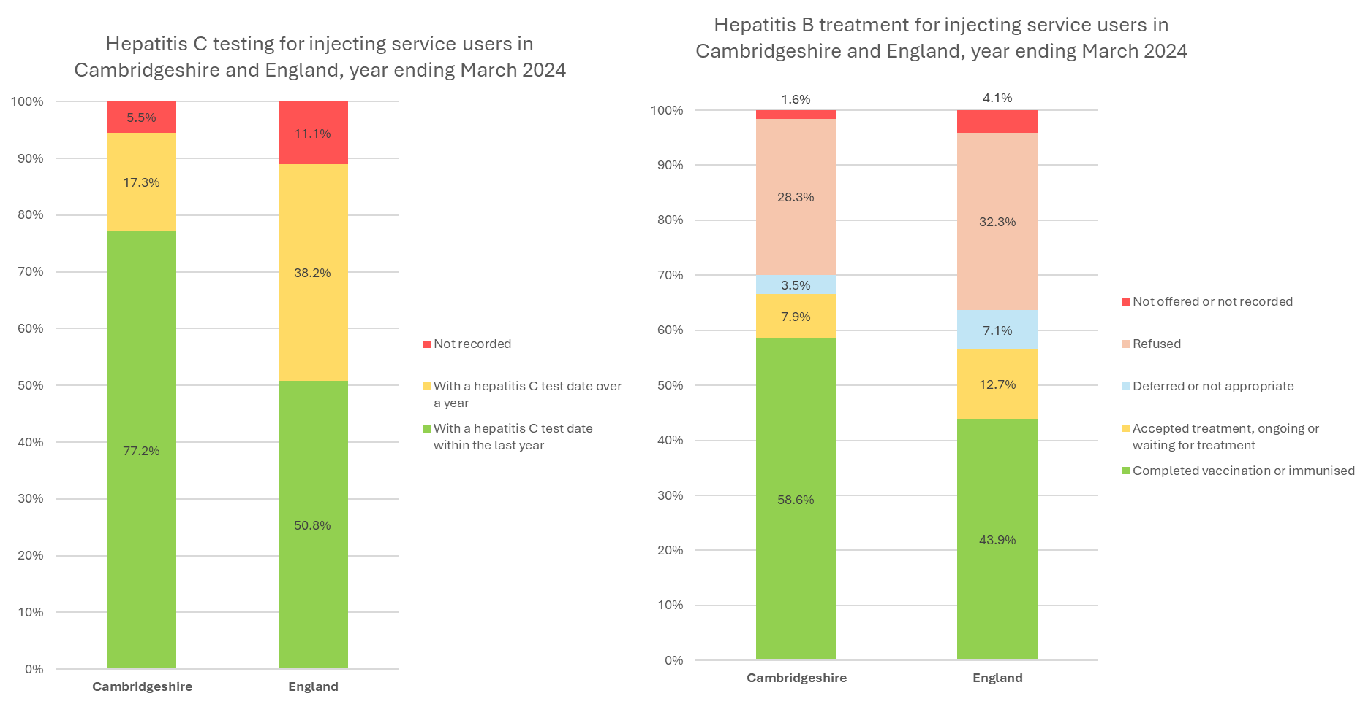
Source: NDTMS Data. Note that ‘injecting service users’ includes services users who are currently injecting, and those that have previously injected.
Another key target for BBV prevention is ‘microelimination’ of hepatitis C within specific populations or regions, contributing to the broader aim of eliminating viral hepatitis.
To achieve microelimination, the following targets must be met:
- 100% of individuals using the service are offered a hepatitis C test.
- 90% of those offered a test go on to be tested.
- 75% of individuals diagnosed with hepatitis C start treatment.
Local drug and alcohol services have actively supported efforts through targeted initiatives to engage people in HCV treatment, raise awareness, and facilitate testing. Notably, CGL Cambridgeshire achieved microelimination in December 2024, in partnership with the local hepatology team and the Hepatitis C Trust. This success was underpinned by consistent messaging, team-wide commitment, and a sustained focus on HCV elimination.

Tobacco Use
National evidence shows that smoking remains highly prevalent among people in drug and alcohol treatment, and contributes substantially to avoidable morbidity and premature mortality. Smoking prevalence among treatment service users is 47% nationally, compared with 13.4 % of men and 9.9 % of women in the general population. Despite this, nationally, only 4% of people in treatment were recorded as having been offered a referral for smoking cessation support in 2023/243.
In Cambridgeshire, smoking status is not routinely reported in NDTMS returns for all adults in treatment, making it difficult to quantify local prevalence precisely. However, treatment outcome data and practitioner insights suggest that smoking rates among the treatment population are similarly high, if not higher, than the above national averages.
Referrals to smoking cessation support from local drug and alcohol services have increased from 21 in 2023/24 to 50 in 2024/25. While this is a positive shift, referral numbers remain low relative to the overall number of people in treatment, suggesting a significant missed opportunity to address a major health risk.

Health Harms; Key Insights and Priorities
Key Insight Summary: Differential health impacts across Cambridgeshire
Primary Care Networks (PCNs) vary in levels of substance-related hospital admissions, indicating potential to target high-admission areas for more intensive primary care support.
Priority 13
Consider conducting deeper analysis of Primary Care Networks (PCNs) with higher rates of substance-related admissions to hospital, to allow an understanding of drivers of demand and identification of opportunities for enhanced support or integrated care pathways in these settings.

Key Insight Summary: Injecting drug use and Blood-Borne Viruses (BBV)
Cambridgeshire has a relatively high number of current and former injecting drug users. High levels of BBV screening and treatment have contributed to successful outcomes, including Hepatitis C virus (HCV) microelimination in local services.
Priority 14
Sustain and share the good practice underpinning BBV successes, particularly on HCV microelimination. Maintain momentum through ongoing outreach, testing, and linkage to care for current injectors and other high-risk groups.

Key Insight Summary: Tobacco Use
Smoking prevalence remains high among people in drug and alcohol treatment, contributing significantly to preventable illness and early death. Despite this, very few individuals are offered cessation support, both nationally and locally. While Cambridgeshire has seen a small rise in referrals, overall numbers remain low, suggesting a missed opportunity to address a major health risk.
Priority 15
Strengthen the focus on smoking cessation within drug and alcohol services. Improve routine recording of smoking status, increase referrals to stop smoking support, and embed tobacco harm reduction into care pathways.

Intersecting Vulnerabilities
As highlighted above (section 4.4) some people are disproportionately affected by drug and alcohol-related harms due to systemic inequalities and personal circumstances. This section presents local data to increase understanding of any disparities amongst these groups to inform intervention targeting and allocation of resources.

Mental Health
People who have both mental illness and substance use are at risk of poorer outcomes compared with people who have either severe mental illness or substance use alone. National Institute for Health and Care Excellence (NICE) guidance advises that substance misuse must be identified in people attending mental health services in order for effective tailored care and treatment plans to be put in place. Similarly, attendance to substance use services present an opportunity to identify and address underlying mental health conditions.
Coordinated care between mental health and substance use services is essential to improve outcomes, as untreated mental health issues can exacerbate substance use, and vice versa. Effective collaboration ensures that individuals receive comprehensive, person-centred support tailored to their complex needs, as confirmed across guidance and research in the evidence review for this needs assessment.
A high proportion of people in treatment for substance use in Cambridgeshire have co-occurring mental health needs. In the year up to March 2024, 2,213 of 2,835 service users (aged 18+) had mental health need. This is 78.1% of those in treatment, which is higher than the national average of 73.5%.
‘Unmet’ mental health need refers to individuals who are recorded as not receiving or having declined mental health treatment. This indicates a gap in access to or engagement with appropriate mental health support. In the year ending March 2024, unmet mental health need for those in treatment was 18.6% in Cambridgeshire. This is slightly higher than the national average of 16.1%.
The demographic breakdown of mental health need and unmet need is shown in Figure 5.7a, demonstrating that females have a higher relative mental health need, whilst males have higher unmet need. Both need and unmet mental health need is higher in younger adults.

Figure 5.7a. Mental health of service users in Cambridgeshire by demographics.
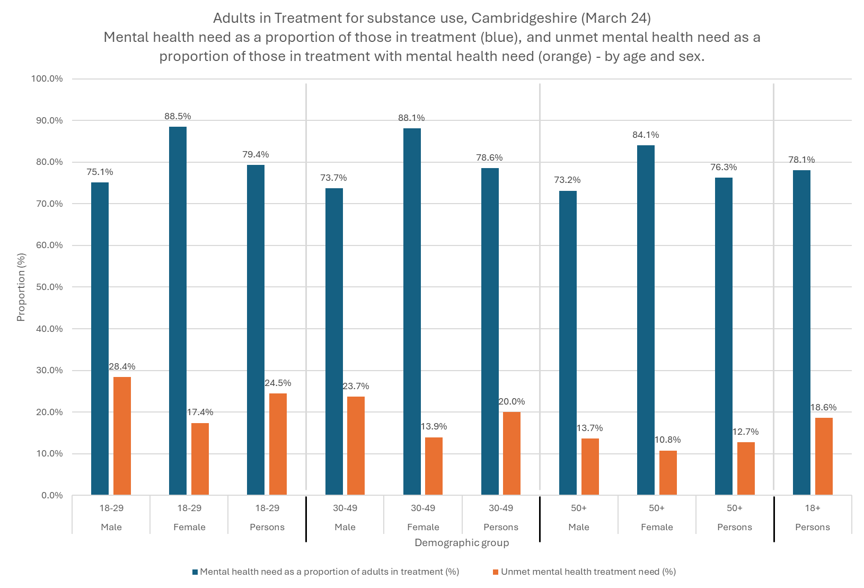
Source: NDTMS data.
Need and unmet need also vary according to substance used:
- The highest levels of mental health need was for those using crack at 88.4%.
- The highest unmet mental health need was for those using non-opiates and alcohol, at 30.9%.
- Unmet need is lowest for those in treatment for opiate use, at 9.1%.
This is shown in Figure 5.7b.
Figure 5.7b. Service user mental health by substance group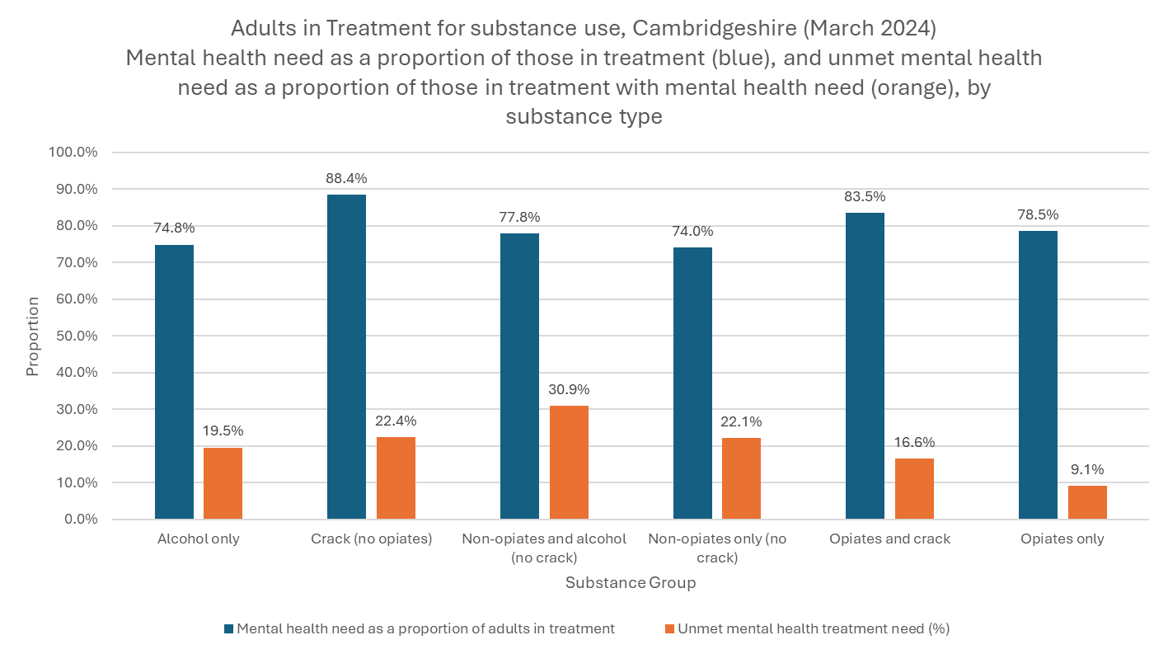
Source: NDTMS data.
Mental health need and unmet need has been recorded on NDTMS since 2022. Trends over time show that mental health need in Cambridgeshire service users in 2024 (78.1%) was a slight increase from 76.0% in June 2022. The proportion of unmet need has increased more significantly; 18.6% in March 2024 is a 5.7 percentage point rise compared with 12.9% in June 2022.
The high prevalence of mental health conditions among service users, alongside known unmet need and the significant challenges posed by co-occurring mental health and substance use, highlights the need for targeted action. Recent local work identified best practice and assessed current provision in this area, leading to key recommendations. These include joint commissioning of mental health and drug and alcohol services, integrated training and workforce development, inclusive and trauma-informed care, and personalised care planning. These areas are reinforced in the recent Cambridgeshire and Peterborough Mental Health Joint Strategic Needs Assessment (JSNA). Implementation of these recommendations should remain a priority to improve outcomes for individuals with co-occurring needs.

Children and Young People
There is limited data on the prevalence of mental health needs among CYP accessing local drug and alcohol services locally, but nationally, around half (49%) starting substance use treatment in the year ending March 2024 year said they had a mental health treatment need. Mental health is consistently highlighted as a priority in both the Cambridgeshire and Peterborough Mental Health JSNA and the CYP JSNA.
The current service model includes embedded psychiatry (see section 5.8.1), recognising the importance of integrating mental health support. However, the Mental Health JSNA³⁰ recommends developing a system-wide roadmap to extend services for young people up to age 25, which should be considered in the context of drug and alcohol services. For mental health, this means ensuring support spans both CYP and adult services aligning with NHS Long Term Plan commitments.

Women
Some women face increased vulnerabilities due to intersecting factors such as a history of domestic violence, trauma, and experiences of sex work. These factors may exacerbate substance use risk and create additional barriers to accessing support.
In the current service model, an outreach worker based in the homelessness team (see section 5.7.4) focuses on identifying and supporting women facing these challenges. This role is instrumental in facilitating access to appropriate services and addressing the unique needs of this population.
Drug and alcohol services also aim to identify any clients at risk of domestic violence and refer them for support. Since 2018, between 4 and 16 people have been referred or signposted to relevant services through this process each year. This remains an important pathway to support, and efforts should continue to ensure referrals are responsive to demand and effectively meet the needs of those at risk.
Additionally, services track the number of victims of domestic violence whose cases are discussed at the Domestic Violence Perpetrator Panel. This helps to understand the extent of victim involvement in risk management and intervention efforts. This number has increased from less than 30 a year prior to 2023, to around 70 in years ending March 2023 and 2024. This may be due to a number of factors including increased treatment numbers, a growing recognition of victims within the panel process, improved identification and recording practices, or a rise in high-risk cases requiring multi-agency intervention.
The number of perpetrators involved in panel discussions are also tracked, which has demonstrated an increase in the same time period. This has important implications for service planning, particularly for group-based interventions. Careful consideration is needed to ensure that perpetrators and victims are not in the same support groups, which could compromise safety and the effectiveness of interventions.
Services should seek to understand what these rising numbers indicate, ensuring resources and group structures are appropriately aligned to meet both the victim and perpetrator support needs.

Criminal Justice and Prison Leaver Population

Adults
Service provision and addressing need in the criminal justice system are key parts of the national drug strategy. Around half of prisoners are thought to have substance misuse issues and offenders who are supported to abstain from drug use are 19 percentage points less likely to reoffend.
There are three prisons in Cambridgeshire, HMP Littlehey, HMP Whitemoor, and HMP Highpoint, along with HMP Peterborough, which accounts for most prison referrals and releases into the local community. The commissioning of Substance Misuse Services in prisons and probation services is the responsibility of NHS England, not Cambridgeshire County Council. Substance Misuse Service provision is delivered by the Northamptonshire Healthcare NHS Foundation Trust (NHFT) in partnership with Phoenix Futures and The Forward Trust.
Strong links between prison-based and community services are essential to ensure continuity of care. Drug and alcohol services in Cambridgeshire work closely with criminal justice teams, including:
- Dedicated dependency and recovery coordinators, funded by probation, based in probation offices in Cambridge, Huntingdon, and Wisbech
- The Criminal Justice Admin Service Point of Contact (SPOC), which facilitates communication between the police, prison, probation services, and mental health services
People leaving prison after accessing drug treatment are at heightened risk of relapse, overdose, and disengagement from health services. Ensuring timely access to ongoing community support is critical. Maintaining engagement in treatment during this transition requires effective coordination between NHS-commissioned prison services and local authority-commissioned community services.
Strong referral pathways have been developed to ensure effective coordination between CGL (Change Grow Live) community services and prison recovery teams, with clear communication processes in place. Individuals serving community sentences are also referred to CGL via structured referral processes designed to capture essential information.
Work with two local police forces (Cambridgeshire and Norfolk constabularies) ensures drug and alcohol service representatives are present in local police stations and team meetings, helping to bridge the gap between prison, police custody suites and community services. These contact points also present valuable opportunities to identify drug and alcohol use early, deliver brief interventions or harm reduction advice, and support timely referral into specialist treatment where needed. This integrated approach strengthens both prevention and recovery pathways, aiming to reduce reoffending and to support individuals in maintaining recovery post-release.

Continuity of Care
One way to assess how well this system is working is by monitoring the proportion of prison leavers with a continued treatment need who engage with community services within three weeks. This serves as an indicator of continuity of care and is provided by NDTMS. The national target is 75% as this supports wider efforts to prevent premature mortality and levels of crime in the community.
Figure 5.7c below illustrates engagement trends among prison leavers requiring continued treatment between 2022 and 2024 in Cambridgeshire. Notably, the overall number of prison leavers in Cambridgeshire has doubled during this period, which increases pressure on existing services. The engagement rate during this time has reduced by 4.8 percentage points, from 51.3% to 46.5%. This local trend contrasts with national data which saw an increase in engagement over the same time period, from 36.1% in 2022 to 52.9% in March 2024. This increase was also in the context of increasing numbers of prison leavers.
Figure 5.7c. Continuity of care in Cambridgeshire and England over time.
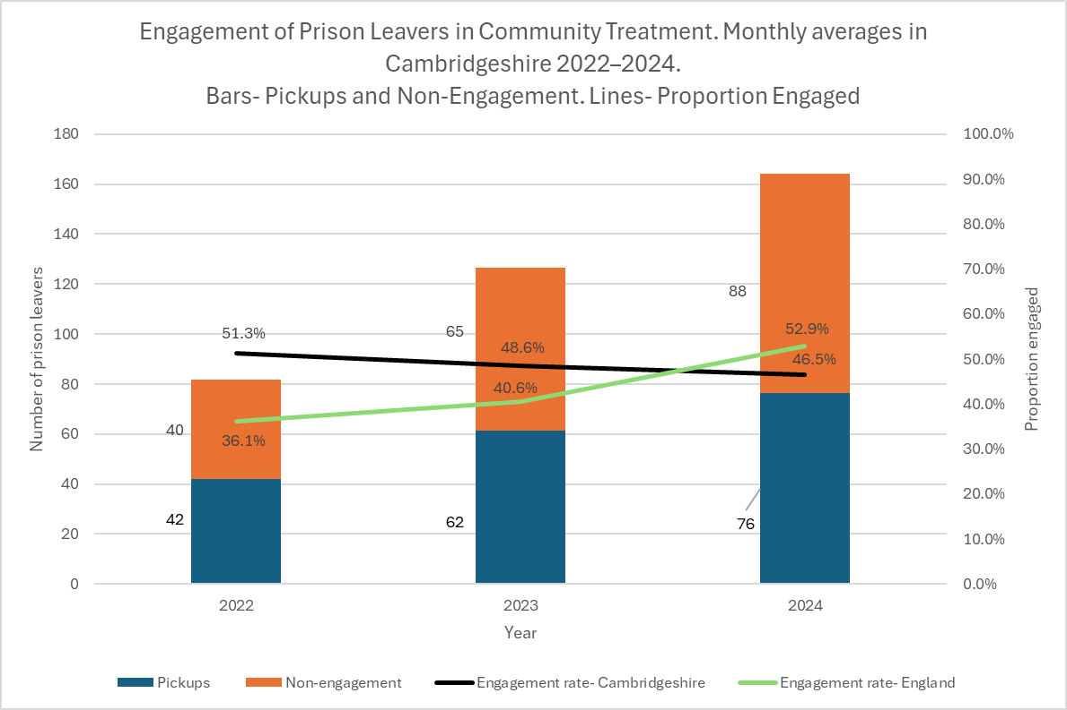
Source: NDTMS data.
The recent increase in the number of prison leavers is expected to continue, compounded by early release measures introduced in late 2024 to alleviate prison overcrowding. These measures are likely to further strain efforts to engage prisoners upon release and present new challenges in ensuring continuity of care.
Referral Pathways
Data around referral routes into DA services can also help assess the effectiveness of collaboration and system links, ensuring that individuals in contact with law enforcement in any setting receive appropriate support for substance use issues where needed.
Between 2023 and 2024, the number of referrals from criminal justice routes increased by 36% to 221 (58 extra referrals). Of the referrals, 66 referrals came from prison (a 16% increase), while 155 were from other criminal justice routes (a 46% increase). This is shown in Table 5.7a which demonstrates particularly marked increases in court-ordered referrals and in "arrest referrals/DIP" (Drug Interventions Programme). This rise is likely driven by increased investment through the national drug strategy, which has enabled initiatives such as drug testing on arrest, where a positive test automatically results in referral to treatment services.
Table 5.7a. Number of referrals into DA services across criminal justice pathways over time.
 | 2022 | 2023 | 2024 | Change 2023 to 2024 (%)
Prison | 45 | 57 | 66 | +9 (+16%)
Probation | 53 | 57 | 70 | +13 (+23%)
Arrest referral/DIP | 0 | 15 | 28 | +13 (+87%)
Court-ordered referrals | 6 | 22 | 41 | +19 (+86%)
Liaison and diversion | 5 | 12 | 16 | +4 (+33%)
Other criminal justice | 23 | 0 | 0 | n/a
Total CJ referrals | 132 | 163 | 221 | +58 (+36%)

Although the data shows that individuals involved in the criminal justice system can be referred into treatment through a range of pathways, there remain missed opportunities to identify and engage individuals in this group. In the year ending March 2024, the Liaison and Diversion Service (LaDS) saw 231 individuals across Cambridgeshire and Peterborough. Within this cohort, only around one in ten were recorded as having alcohol or substance misuse needs on LaDS data systems. There were 16 successful referrals to Cambridgeshire DA services in this time period (as shown in table 5.7a), and 14 to Peterborough; a total of 30 referrals into treatment, or 13% of those seen by LaDS. The low proportion of identified need and referrals suggests opportunities to strengthen recognition and referral pathways, highlighting a gap in the system where vulnerable individuals could be better reached.

Children and Young People (CYP)
Substance use is similarly prevalent among CYP involved in the criminal justice system. The Cambridgeshire Youth Offending Service (YOS) is a multi-agency partnership involving the police, local authority, health, education, and other partners. It works to assess risk, support rehabilitation, and coordinate tailored interventions to address the underlying causes of offending among CYP aged 10 to 17 in Cambridgeshire.
Each year from 2021 to 2024, between 230 and 290 children and young people received structured support through YOS following a criminal justice outcome. This includes both statutory interventions (such as court-ordered supervision) and voluntary or diversionary programmes, delivered to help prevent reoffending and support wider wellbeing needs.
Local data indicates that each year, 90 to 100 young people supported by YOS have identified evidence of substance use, representing between 30% and 40% of the YOS caseload. On average, around 32 of these individuals receive substance use treatment through YOS each year. This suggests that successful engagement of those with identified substance misuse needs is between 18% and 38%, as shown in Table 5.7b.
Young people under YOS account for approximately 22% of all children and young people (CYP) in treatment with CASUS. This proportion varies year-on-year with no consistent trend over time.
Table 5.7b. Young People in Substance Use Treatment Through YOS and CASUS (2019-2024)
 | 2019-20 | 2020-21 | 2021-22 | 2022-23 | 2023-24
CYP in Treatment via YOS (CASUS-YOS cases) | 51 | 35 | 23 | 17 | 33
CYP in YOS with Identified Substance Misuse | - | - | 90 | 96 | 88
Proportion of CYP with Identified Substance Misuse Engaged in Treatment | - | - | 25.6% | 17.8% | 37.5%
Total CYP in CASUS Treatment | 199 | 127 | 100 | 140 | 152
CASUS-YOS Cases as a Proportion of Total CASUS Clients | 25.6% | 27.6% | 23.0% | 12.1% | 21.7%
Source: NDTMS and local data.

County Lines and Vulnerable People
Another important consideration is exploitation of vulnerable individuals, particularly CYP, through County Lines drug networks. County Lines refers to the practice of drug gangs expanding their operations from urban centres into smaller towns and rural areas, often using coercion, violence, and exploitation to recruit young people to transport and sell drugs.
This has significant implications for substance use services, as young people drawn into County Lines activity may have complex needs, including substance use, trauma, and safeguarding concerns. Engagement with support services can be challenging due to fear of repercussions from gangs, criminalisation, or mistrust of authorities.
Although data reporting and availability is limited, local intelligence offers some insight into the scale of County Lines activity. Over the eight-month period to January 2025, there were intelligence reports concerning approximately 377 county lines across Cambridgeshire and Peterborough (with Peterborough included as it falls under Cambridgeshire Constabulary). Of these, 49 were linked to the trafficking children and 201 involved vulnerable adults. By area, the highest number of active lines was recorded in Peterborough, followed by Cambridge City.
Initiatives across Cambridgeshire have recently been recognised nationally as best practice, with successful disruption of County Lines activity. This work requires strong regional collaboration through the Eastern Region Special Operations Unit (ERSOU) and coordination with multiple police forces, including the Metropolitan Police due to Cambridgeshire’s proximity to London; a key factor which drives local case numbers.
Well-established partnerships with internal teams, neighbouring areas, and drug and alcohol services are vital to ensure that those affected are identified and supported appropriately.

Housing and Homelessness
Housing stability underpins effective substance use treatment strategies. Between 2022 and 2024, 12 to 14% of individuals in substance use treatment in Cambridgeshire were recorded not to be living in suitable accommodation, according to NDTMS data. This mirrors national averages over the same period. Around 2.5% of service users in Cambridgeshire were recorded as having no fixed abode in the year ending March 2024, equating to 72 people.
There is evidence that engagement with DA treatment services improves housing stability. In Cambridgeshire, the number of clients with acute housing risk at the start of treatment reduced from 36 to 17 people on average per quarter by treatment exit, a reduction of 52.5%. Similarly, those at risk of eviction reduced from 26 to 11 people, a 58.3% drop. While national data shows greater average reductions (63.5% for acute housing issues and 62.3% for eviction risk), this still reflects positive local outcomes.
People who are homeless and use substances have particularly complex circumstances and additional risks which require specific support. There is a higher rate of drug-related death and morbidities among homeless people who use drugs and alcohol, and needs are not well met by mainstream benefit, healthcare, social care and some drug services. In response, two services in Cambridgeshire look to address this need, Housing First and the Homelessness Engagement and Recovery Team (HEaRT).
Housing First is a council-led service supporting people experiencing homelessness and multiple disadvantages to live in their own homes with personalised support.
- In the year ending 2023/24, Housing First Cambridgeshire County Council (CCC) had a caseload of 54 individuals, 13 of which were new referrals that year. Over 95% of clients have substance dependency.
- Half of the caseload (28 individuals) were in stable Housing First accommodation in March 2024, the remainder were receiving tailored support to overcome barriers to secure housing through Housing First’s navigators.
- The majority of the caseload was in Cambridge City (31 people, 57%), with others in Fenland (14 people, 26%) and Huntingdonshire (9 people, 17%).
Housing First is linked into the local strategic delivery board and recovery coordinators supporting service users are able to liaise with the service, offering opportunities to strengthen alignment between housing and substance use support.
The Rough Sleeping Drug and Alcohol Treatment Grant (RSDATG) is a national Government funding programme, aiming to contribute to the government’s ambition to end rough sleeping by the end of 2025. The grant is awarded to fund specialist support for individuals to access and engage with drug and alcohol treatment and move towards longer-term accommodation. CCC was awarded funding from 2021 for Cambridge City. This funding is used to provide specific support through a dedicated team, the Homelessness Engagement and Recovery Team (HEaRT).
In Cambridge City during 2023-24, estimates predicted there to be 390-560 individuals in need as follows:
- 60-130 people rough sleeping and using substances each quarter
- 335-430 individuals considered at risk of rough sleeping and using substances
The total number of unique individuals engaged with the service in the year ending March 2024 was 299; 72 who were rough sleeping and 227 at risk of rough sleeping. Engagement through RSDAT represents a key point of contact and an opportunity to address substance use and associated vulnerabilities, though it may not always lead to structured treatment.
The number of adults formally engaged in DA treatment through RSDAT in Cambridgeshire was 174 in 2024, a 31% increase from 133 in 2023. This increase exceeded the 13% rise in the overall number of adults in treatment. Adults engaged through RSDAT accounted for 6.1% of adults in treatment in Cambridgeshire, compared to a national average of 3.2%.
A 2023 evaluation of HEaRT found:
- A very high proportion of people (93%) were retained in treatment for more than 12 weeks and 75% sustained engagement for at least 12 months.
- 5.1% of the cohort who engaged during 2022/23 successfully completed treatment. Around two-thirds (118 people) had treatment ongoing, and one-third (50 people) disengaged from treatment.
- 93% of the cohort were registered with a GP, and 49% reported improved quality of life.
- The number of people at risk of homelessness reduced by 26% (from 84 to 62), and those in unsuitable housing reduced by 33% (from 39 to 26).
Overall, the HEaRT service was found to be effective in delivering immediate, multi-agency support to individuals experiencing homelessness and substance use issues in Cambridge.
Key strengths include:
- A low-threshold outreach-based model,
- Strong multi-agency partnerships,
- Embedded trauma-informed psychological support,
- Effective engagement of female clients.
- Dedicated doctor and quick access to opiate substitute treatment
Areas for further development:
- Improving reach to hidden homeless women,
- Expanding peer support,
- Addressing barriers to detox and rehab access,
- Strengthening integration with statutory mental health services,
- Overcoming structural challenges caused by fragmented commissioning,
- Ongoing system development to enhance coordinated care and housing support.
This development will support improved treatment engagement and better overall outcomes.

Families and Substance Use

Parents in Treatment for Substance Use
Caring for children while managing substance use can impact both a parent and their children. This section presents the number of parents receiving treatment for drug and alcohol use in Cambridgeshire and highlights the proportion who access parental support services.
In the year ending March 2024, 38% of adults in in treatment for drugs and alcohol in Cambridgeshire were parents (1,084 of 2841). Of these, 39% (659) were living with children. A further 64 adults in treatment were living with children, although not parents themselves.
Parental support services are a critical component of treatment, offering assistance tailored to the unique challenges faced by parents. While not all parents in treatment require additional support, 18.6% (202 of 1084) received parental support in Cambridgeshire in 2024. This marked an increase from 141 (13.5% of parents) in the year ending September 2023 and is above the national average of 15.0%.
There is a marked difference in the provision of support services by sex. In 2024, 29.5% of female parents in treatment received support, compared with 12.9% of male parents, a 16.6 percentage point difference. This gap is notably larger than the national difference of 6.6 percentage points during the same period and is shown in Figure 5.7d. While we do not have data on levels of need by sex, the difference in uptake or provision may reflect differing patterns of help-seeking, perceptions of parenting roles, or how services identify and offer support. There is no consistent or significant variation in support provision by parental age group.

Figure 5.7d. Parental support for those in DA services.
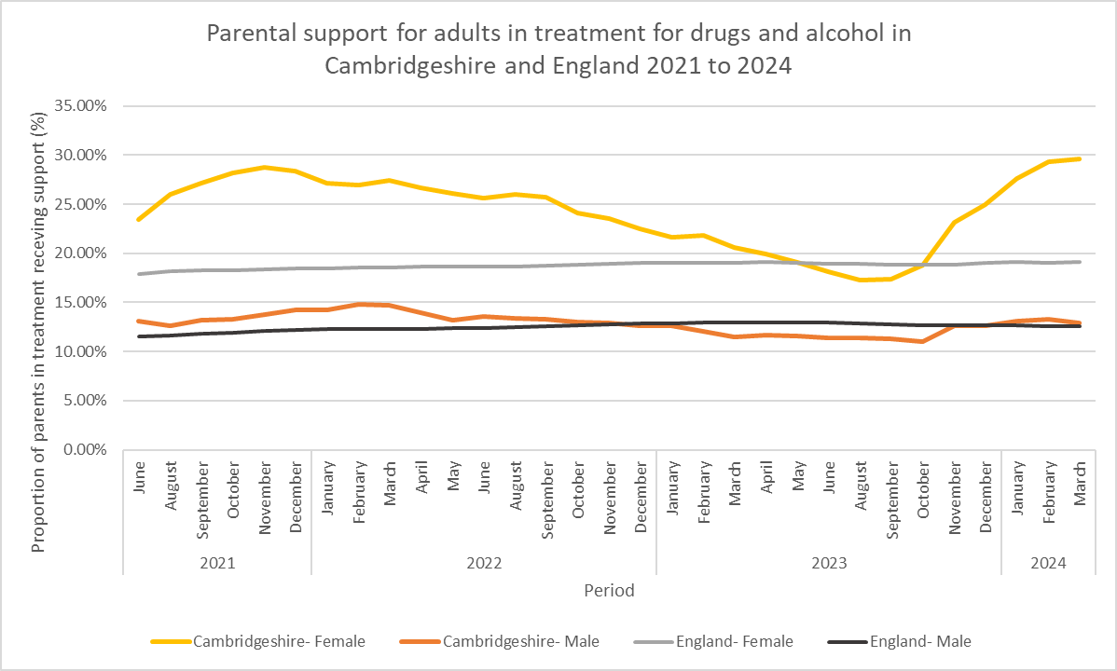
Source: NDTMS data.

Children of Parents with Substance Use
Children growing up in families where parents use alcohol or drugs are at greater risk of adverse outcomes. Although not all children will experience significant harm, previous research identified that parental alcohol or drug use was recorded in over a third (36%) of serious case reviews carried out when a child died or was seriously harmed. The increased risk can stem from the impact of substance use, which may make it harder to consistently meet children’s needs.
The Child and Adolescent Substance Use Service (CASUS) can provide information, support, and specialist interventions for young people (under 18s living in Cambridgeshire) that are affected by another’s substance use such as parents, carers, siblings, partners. This is the through ‘Child of Substance Using Parent’, COSUP pathway. This includes a dedicated worker who delivers tailored support and interventions to help young people understand and cope with the impact of a family member’s substance use. Referrals into the service can come from a range of professionals, including schools, social workers, health visitors, GPs, and adult drug and alcohol services.
In 2024/25, the COSUP pathway supported a caseload of between 14 and 18 young people. On average, the service received 8 referrals per quarter, resulting in approximately 6 assessments each quarter. While this reflects important targeted support, the relatively low referral numbers suggest a level of unmet need. This may be influenced by several factors, including low referral rates from adult drug and alcohol services, barriers related to parental consent, and stigma or fear of repercussions among families. These challenges may prevent young people from being identified or supported early, despite evidence that parental substance use can have significant and lasting impacts on children’s wellbeing.
Data from Children’s Services provide valuable insights into how frequently substance use is identified in families in Cambridgeshire, helping indicate whether pathways into appropriate support are being utilised.
‘Children in Need’ (CiN) are a legally defined group, identified by local authorities as requiring services to achieve or maintain a reasonable standard of health or development, or to prevent significant harm. In the year ending March 2024, 3,236 children were recorded as being in need in Cambridgeshire, a rate of 232.5 per 10,000 under-18s. This is higher than the 2023 rate of 209.1 per 10,000 but remains below the national average of 332.9 per 10,000.
When a child is referred to children’s services, one or more ‘factors’ from a list of 39 categories may be recorded to reflect their assessed needs. These categories include parental or child drug or alcohol misuse. In 2024, an average of 3.5 factors were recorded per child in need episode. This data is published by the Department for Education by episode and factor allowing and understanding of the range and complexity of children’s assessed needs. Note that the number of episodes is higher than the number of individual children, as some children may be referred or assessed multiple times.
Concerns about parental alcohol misuse have consistently represented a major proportion of episodes. In 2024, 811 episodes included this as a factor, accounting for 16.6% of the 4,890 episodes where assessment factor information was recorded. This proportion fluctuated between 15 and 23% between 2018 and 2024.
Parental drug misuse was identified in 896 episodes in 2024, 18.3% of episodes, with the proportion fluctuating between 16 and 24% over the same period, as shown in Figure 5.7e.
Figure 5.7e. Children in Need (CiN) and Substance Abuse.
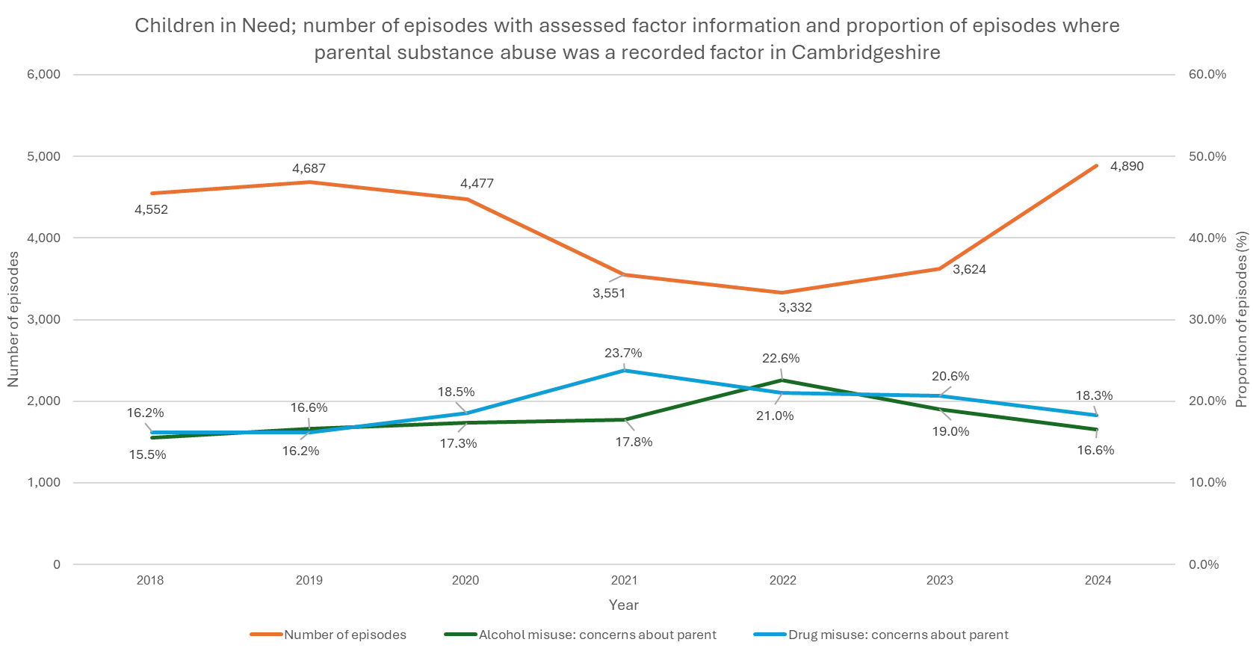
Source: Department for Education data.
There were also 169 episodes in 2024 where the child’s own alcohol misuse was recorded (3.5%) and 311 where the child’s own drug misuse was identified (6.4%), both broadly in line with averages seen between 2018 and 2024.
This data highlights the ongoing presence of substance use concerns, both parental and child, in CiN cases, underscoring the persistent nature of these issues over time.

The Early Help Hub (EHH) in CCC is a multi-agency service that supports children, young people and families who do not meet statutory thresholds for social care involvement but require coordinated support to prevent issues from escalating. It sits below the level of Children’s Social Care involvement, including CiN, and plays a vital role in delivering preventative, early intervention.
Early Help is intended for families where emerging concerns, such as parenting capacity, school attendance, emotional wellbeing, or substance use, could be addressed before they become more serious.
The service has experienced a marked increase in demand in recent years, with the number of Early Help Assessments rising from 1,582 in 2022–23 to 3,112 in 2024-25, almost doubling in just two years.
Alongside this overall rise in assessments, there has also been a notable increase in the number and proportion of assessments identifying drug and alcohol (DA) needs in both children and their parents or carers, as shown in Figure 5.7f. In 2024–25, DA needs were identified in 188 children (6.0% of assessments) and 105 parents or carers (3.4% of assessments).
Figure 5.7f. Early Help Hub Assessments and DA needs.
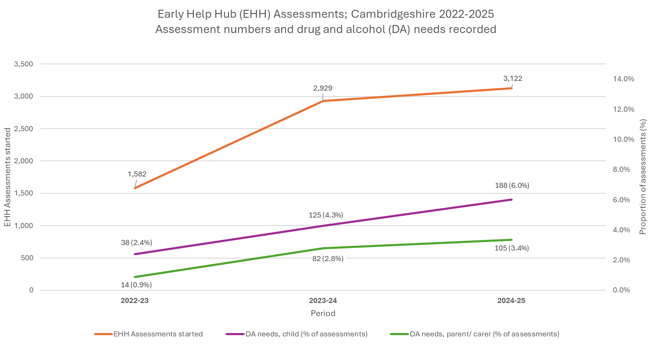
Source: Council data, EHH Assessments dataflow.
These figures indicate that DA-related needs are being recognised more frequently. However, it is not yet clear whether this reflects improved identification or a genuine increase in prevalence within families supported by Early Help. The trend nonetheless highlights the importance of well-integrated referral pathways into DA support services and ensuring Early Help teams are equipped to respond to complex, often multi-generational needs.
Of note, the lower proportion of DA needs identified in parents/carers (3.4%) compared to children (6.0%) contrasts with the pattern seen in CiN assessments. This discrepancy may reflect challenges in identifying adult need within Early Help processes, potentially due to stigma, underreporting, differences in assessment focus, or a more child-centred lens. It could suggest opportunities to strengthen adult need identification within Early Help, ensuring that support is provided across the whole family system.

The COSUP pathway supported fewer than 20 young people in 2024–25. The data shown here around Children in Need and Early Help suggest a potential gap between the level of identified need and engagement with this specialist offer. Although some needs may be addressed through direct involvement in DA treatment (children or parents/ carers receiving structured support), there appears to be an opportunity to strengthen pathways between Early Help, Children’s Social Care, and treatment services. In particular, there is scope to improve referral mechanisms and ensure COSUP and related support offers are accessible to children who are not already in treatment.

A further consideration is the heightened risk of relapse and harm among parents whose children have been removed by social care. Review panel findings have highlighted cases where the withdrawal of support following child removal left parents more vulnerable, isolated, and at increased risk of escalating substance use, sometimes with fatal consequences. This group requires particular attention to ensure availability of trauma-informed support beyond the point of removal, recognising the ongoing risks to their wellbeing and recovery.

Employment and Individual Placement and Support (IPS) Services
Employment status is a significant factor influencing vulnerability to substance use and is identified as a key risk factor for developing substance use-related problems and harms. Analysis of employment and education data for individuals in drug and alcohol treatment in Cambridgeshire reveals socio-economic challenges faced by service users and can guide targeted areas for intervention.
NDTMS data shows that in the year ending March 2024:
- 58.6% of adults entering treatment for substance use in Cambridgeshire were not engaged in formal education, employment, or training.
  - This proportion was slightly higher among all those in treatment (63.5%).
- The proportion for those entering treatment was higher nationally, at 68.7%.
- Figures in Cambridgeshire have fluctuated around these levels since 2020, with no clear trend or directional change.
For comparison, 12.5-28.1% of the working-age (16-64 years) population across districts in Cambridgeshire were not recorded to be in employment as of May 2024, highlighting a significant disparity in employment levels between the treatment-seeking population and the general population.
A closer examination of employment outcomes for those with planned exits from treatment in the year ending March 2024 demonstrates clients making progress during recovery journeys:
- Between 15% and 22% of those not working at the start gained employment by the end of treatment; a trend that met or exceeded national averages.
- The proportion of clients working regularly (at least 10 days a month) rose by about 5 percentage points, outperforming national improvements.
- Most clients (70-75%) maintained stable work patterns throughout.
However, a small minority (around 3-4%) experienced a decline in work engagement which was in line with national trends. The average number of working days for clients also slightly decreased between start and exit, from 19.6 to 18.9 days, while previous years and national averages saw slight increases of 0.5-1.4 days.
Overall, the employment landscape for DA service users is complex, but data from 2021 to 2024 highlights strong, consistent progress in employment outcomes for clients exiting treatment, with Cambridgeshire generally outperforming national trends.

Individual Placement and Support
Individual Placement and Support (IPS) is an evidence-based employment support approach initially developed for individuals with mental health conditions and later adapted for those with substance use disorders. IPS focuses on rapid job searches tailored to individual preferences, integrating employment services with clinical treatment to enhance recovery outcomes.
In the UK, the IPS-Alcohol and Drug (IPS-AD) trial was the first to evaluate IPS for adults in treatment for alcohol and drug dependence. The study found that IPS participants achieved higher rates of employment in the open job market compared to those receiving standard employment support.
Building on these findings, the UK government has expanded funding for IPS services within drug and alcohol treatment settings. In January 2024, Cambridgeshire received a grant to enhance IPS provision within drug and alcohol services, aiming to improve employment outcomes for service users. This initiative is part of a broader strategy to integrate employment support with substance use treatment, recognising that stable employment is a key factor in sustained recovery.
In the year ending March 2025, local data shows:
- 174 service users were referred for IPS,
- 120 of these were successfully engaged in the service; 70.0% of those referred,
- This resulted in 38 successful job outcomes; 31.7% of those engaged, 21.8% of those referred.
By combining personalised employment support with substance use recovery services, IPS models align with evidence-based strategies to promote recovery, improve self-sufficiency, and reduce the likelihood of relapse.

Intersecting Vulnerabilities; Key Insights and Priorities
Key Insight Summary: Mental health need
The majority of service users have mental health need, and around one in five of these individuals are not receiving mental health care.
Priority 16
Drug and alcohol services should ensure that mental health support is embedded within care planning and delivery, with strong referral pathways and collaborative working to meet service users' needs. This includes strengthening links with mental health services and ensuring access to appropriate support. Local and national recommendations to extend CYP mental health support up to age 25 should be considered in the context of DA services.
See also Priority 11 for related actions.

Key Insight Summary: Women and domestic violence
There has been a rise in recognition of victims and perpetrators of domestic violence in DA services.
Priority 17
Ensure that domestic violence (DV) support structures within DA services prioritise safety and effectiveness. Processes should be in place to prevent victims and perpetrators from being placed in the same support groups, safeguarding the well-being of those affected. The increase in DV referrals should be reviewed to determine whether this reflects changing demographics, rising deprivation, or improved engagement with services.
Efforts to deliver trauma-informed care, strengthen referral pathways for victims, and provide specialised outreach for women with multiple vulnerabilities should continue and be further developed.

Key Insight Summary: Service users with criminal justice experience
Continuity of care from prison to community DA services has reduced and remains below national targets, at a time when the number of individuals released from prison is rising. At the same time, referrals into DA services from multiple points across the criminal justice (CJ) system have increased, though further opportunities to strengthen these pathways remain.
A significant proportion of children and young people (CYP) with recognised substance use issues are not engaging with treatment, up to around 38% are engaged with CASUS.
Priority 18
Build on the positive momentum of increasing referrals from across the criminal justice (CJ) system by monitoring referral sources and conversion from contact to treatment engagement, ensuring opportunities are not missed. Strengthen identification and referral processes within existing CJ touchpoints, particularly in custody suites, by enhancing collaboration with services such as the Liaison and Diversion Service (LaDS), and ensuring consistent pathways into support.
Strengthen pathways between prison healthcare and community drug and alcohol services to work towards the national target of 75% continuity of care. This should include:
- Increasing co-location and presence of DA services within probation, court and in reach into prison settings, and vice-versa, if possible.
- Ensuring consistent engagement with prison and probation pre-release resettlement panels.
- Developing shared harm reduction approaches between prison and community services.
- Integrating clinical continuity tools (such as ‘FP10’ prescriptions on release) into community treatment plans to reduce treatment gaps and improve engagement post-release.
Priority 19
Work collaboratively across youth offending services (YOS), education, and the Child and Adolescent Substance Use Service (CASUS) to improve identification, referral, and engagement of CYP with substance use issues. This may include:
- Strengthening referral pathways and data sharing between services.
- Using co-location, outreach, and trauma-informed approaches to improve accessibility.
- Review barriers to engagement, particularly for vulnerable or marginalised CYP.

Key Insight Summary: Housing needs
Housing First and Homelessness Engagement and Recovery Team (HEaRT) are vital in responding to the complex needs of people experiencing homelessness and substance use. Both services adopt low-barrier, person-centred approaches and benefit from strong multi-agency working. These services have contributed to increased treatment engagement, improved housing outcomes, and a better quality of life for clients. A rise in treatment uptake through HEaRT and reductions in housing risk illustrate the importance of tailored, trauma-informed support.
Priority 20
Sustain and scale targeted housing-linked drug and alcohol support services, such as Housing First and HEaRT. This may include:
- Ensuring ongoing investment beyond current grant funding cycles,
- Strengthening pathways between DA treatment, housing, and mental health services,
- Expanding coverage to under-served areas and groups, particularly hidden homeless women,
- Embedding learning from HEaRT into mainstream practice.

Key Insight Summary: Families and substance use
Substance use among parents remains a significant and persistent concern in Cambridgeshire. In 2024, over a third of adults in drug and alcohol treatment were parents. Children affected by parental substance use continue to be identified in both statutory Children in Need (CiN) cases and Early Help assessments. While identification of drug and alcohol-related needs is increasing, the relatively low uptake of specialist support (e.g. COSUP) suggests potential gaps in referral pathways and family-focused interventions, particularly at the early intervention stage. Additionally, parents whose children have been removed by social care represent a high-risk group, with evidence showing increased risk of relapse and serious harm when support is withdrawn.
Priority 21
Strengthen identification and referral pathways between Early Help, Children’s Services, and specialist substance use support (including Child of Substance Using Parent pathway ‘COSUP’), with a particular focus on improving access for children and young people affected by parental substance use and ensuring whole-family support is embedded in service delivery.

Key Insight Summary: Employment
Employment is a key vulnerability factor for substance use. In Cambridgeshire, 58.6% of new treatment entrants were not economically active, reflecting underlying socio-economic disadvantage. However, drug and alcohol treatment appears to support improved employment outcomes, with local clients showing progress during their recovery journeys. The rollout of Individual Placement and Support (IPS) in Cambridgeshire is also showing early promise in helping more people into work through tailored, recovery-focused employment support.
Priority 22
Build on existing progress to further improve employment outcomes for people in drug and alcohol treatment. This may include continued investment in IPS, with ongoing monitoring of its impact, and more system links between DA services and other council-led employment schemes to ensure more joined-up support for recovery and self-sufficiency.

Services in Cambridgeshire

Current Service Model
Cambridgeshire County Council commissions an integrated drug and alcohol treatment service for adults, currently delivered by Change Grow Live (CGL), a large third-sector provider with extensive national experience. The model is designed to offer flexible, accessible, and person-centred care, delivered through a combination of central hubs and community-based settings.
For under-18s, a dedicated specialist service, the Child and Adolescent Substance Use Service (CASUS), is commissioned separately through Cambridgeshire & Peterborough NHS Foundation Trust (CPFT).
The adult service is structured around three main service hubs, supplemented by a network of community delivery locations across the county, as shown in Figure 5.8a.
Figure 5.8a. Drug and Alcohol Services across Cambridgeshire
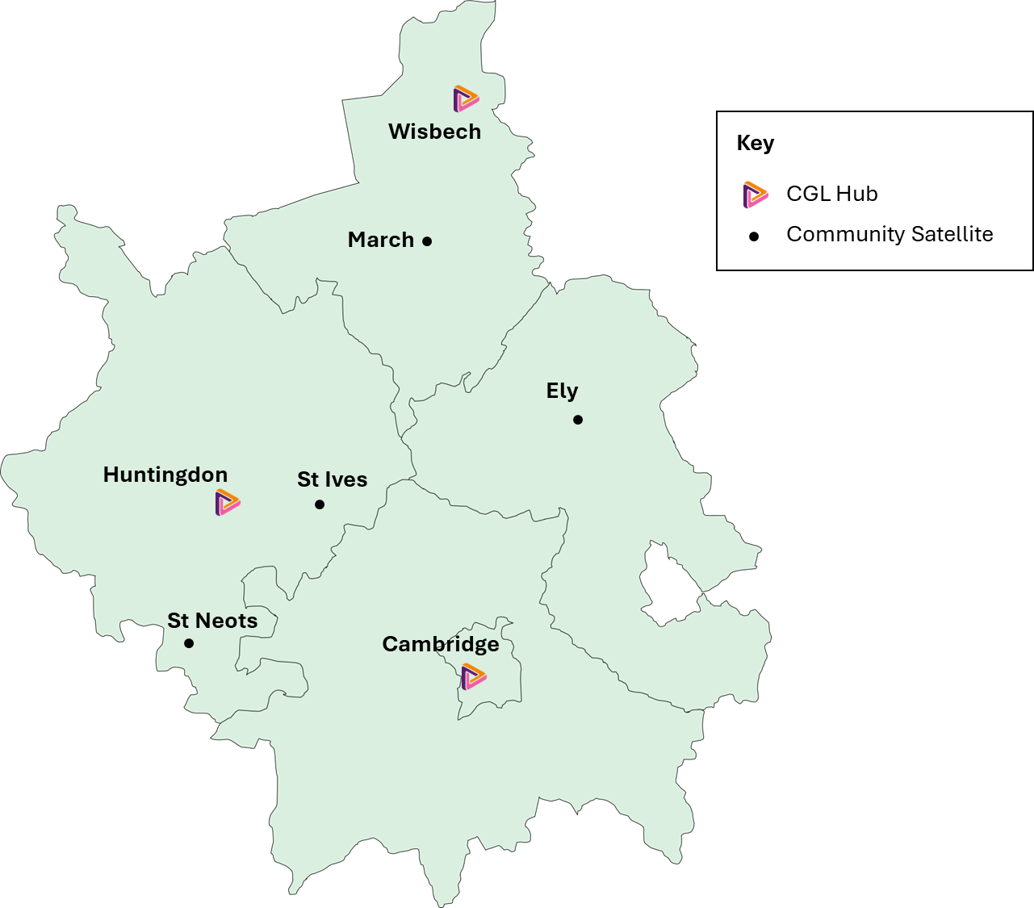

Services are provided for adults, including those in contact with the criminal justice system, with some family and children’s support embedded. Delivery of care is through a combination of in-person and digital delivery, allowing service users to access support in ways that suit their circumstances.
Core interventions provided by CGL:
- Structured treatment including assessment, recovery planning, and personalised support pathways.
- Pharmacological interventions, including opioid substitution therapy and medically assisted alcohol detoxification.
- Psychosocial interventions delivered 1:1 or in groups, addressing motivation, relapse prevention, and trauma.
- Mental health support, led by an in-house psychology team integrating psychological interventions into treatment.
- Residential and inpatient pathways, including access to detox and rehab where clinically appropriate.
- Harm reduction services, including needle exchange and naloxone distribution.
- Children and family support.
- Specialist pathways for priority populations, including rough sleepers and those in the criminal justice system.
Services are offered remotely where suitable (digital/ online or phone support).
The service is multidisciplinary, with a mix of clinical and non-clinical staff. Roles include:
- Psychologists, psychiatrist, nurses, non-medical prescribers
- Recovery coordinators, social workers, outreach workers
- Peer mentors, recovery coaches, volunteers
- Pharmacists and GP partners
- Data and quality assurance teams
Peer mentors and experts by experience are embedded in service delivery and recovery support. A dedicated recovery service, Cambridge Recovery Service (CRS) is a community-based hub offering support groups, well-being classes, and weekly Recovery Cafés across Cambridgeshire, including in Huntingdon, Ely, March, Wisbech, St. Neots, and Cambridge. CRS helps individuals in recovery to build confidence, strengthen social networks, and access employment or training. Support is also available for friends and family.
Further specialist work includes:
- A dedicated criminal justice team works closely with police, probation, courts, and prisons. The service provides support through custody suites, courts, and post-release pathways.
- Outreach and prevention teams engage with people not in treatment, including through rough sleeper initiatives (HEaRT) and hospital liaison posts (see 5.9.1).
- Primary care: alcohol interventions and brief advice are provided in partnership with GPs (see 5.9.4).
- Pharmacy services: supervised Opioid Substitution Therapy (OST) dispensing, harm reduction, and naloxone provision (see 5.8.2.4).
Housing, safeguarding, and social care links support holistic care planning.
Services aim to continually improve and adapt through collaboration with The SUN Network, an independent organisation facilitating feedback and co-production with people who have lived experience of mental health and substance use.
The service works in partnership with a range of community-based recovery organisations, including The Edge Café, a Lived Experience Recovery Organisation (LERO) in Cambridge. The Edge provides a welcoming, substance-free space for people in recovery, offering peer-led support groups, volunteering opportunities, and social connection. These partnerships help bridge the gap between structured treatment and long-term recovery in the community.
CASUS provides specialist assessment and treatment for children and young people using drugs or alcohol. This is available for under-18s, and can be provided for those aged 18-21 depending on complexity and need. Services also include:
- Early intervention and targeted prevention work, often in partnership with schools, youth services, and social care.
- Support for young people affected by parental substance use.
  - This is through a specific pathway ‘Child of Substance Using Parent’, COSUP pathway.
- Mental health support through an embedded psychiatrist in the CASUS team.
  - The services uses the Adolescent Mentalization-Based Integrative Treatment ‘AMBIT’ model, a team-based, evidence-informed approach that supports work with hard-to-reach young people. It combines mentalization, multi-agency collaboration, and continuous team learning to improve outcomes.
- Close working with Child and Adolescent Mental Health Services (CAMHS), safeguarding teams, and wider health and care services.
CASUS operates across Cambridgeshire, offering both community-based and school-linked provision.

Finances/ affordability
The current funding model for drug and alcohol services in Cambridgeshire is made up of:
- The ‘core contract’ from public health funding
- Supplementary funds from central government
  - Drug and Alcohol Treatment and Recovery Innovation Grant (DATRIG) from April 2025, this combines previous funding streams:
    - Supplementary Substance Misuse and Treatment Recovery Grant (SSMTRG)
    - Rough Sleeper Drug and Alcohol Treatment Grant (RSDATG)
    - and Individual Placement and Support (IPS)
- Local grants:
  - National Probation Service
  - Office of the Police and Crime Commissioner
  - Adult social care funding for residential rehab placements
The supplementary grants have been transformative, allowing an expansion of service capacity, improving the quality of prevention work, and enhancing recovery and support services such as housing, employment support, and inpatient detoxification.
There is ongoing uncertainty about longer‐term funding beyond the current cycle (announced for 2025–26) however, with future allocations pending departmental and Treasury approval. Uncertainty complicates service planning and hampers the ability to commit to sustainable, high‐quality service models without a clear multi-year funding commitment. Services may face disruptions once supplemental funds expire or if future allocations are lower than expected.

Harm Reduction
Harm reduction refers to a range of strategies aimed at minimising the health risks associated with substance use, particularly through approaches that focus on preventing harm and reducing fatalities. The goal is not necessarily to reduce or eliminate drug use, but to reduce the negative consequences associated with it.
This section highlights data relating to harm reduction services in Cambridgeshire, including medications, needle exchange, and peer-support.
There is a relatively high proportion of OCU who inject in Cambridgeshire, who are at increased risk of harms including being at risk of blood-borne viruses (BBV, like HIV and hepatitis), infections, vein damage, and overdose. BBV monitoring and treatment is an important method of harm reduction and a high proportion of service users in Cambridgeshire receive this care (see section 5.6.3).

Needle and Syringe Provision
Sterile needle and syringe provision (NSP) reduces the transmission of blood-borne viruses among people who inject drugs, and can decrease the incidence of skin infections. In Cambridgeshire, this is offered at CGL fixed sites, through community pharmacies and via an online CGL service. In the year ending March 2024, CGL distributed over 57,000 needles and associated equipment in Cambridgeshire.
When this figure is compared with the estimated 800 injecting users in the area, this amounts to around 70 needles per person annually. Although this is a rough estimate, it provides a useful benchmark against significantly higher national and international harm reduction targets, which aim for 300 needles per person per year.

Medication-Assisted Treatment (MAT)
Opioid Substitution Therapy (OST) is a key intervention for people dependent on opioids, typically delivered through daily supervised medication at pharmacies. Since 2022, long-acting injectable OST has also been available, administered monthly by specialist teams. This approach emerged partly in response to its growing use in prisons, to ensure consistent and stable care upon release.
NDTMS data shows that in Cambridgeshire, long-acting OST accounted for 3.3% of all OST provision in 2023-24 (46 interventions of 1381). This was a proportional increase from 0.7% of OST provision in 2022-2023 (9 of 1317). The most commonly used long-acting medication is buprenorphine, trade name ‘Buvidal’. Its increased use is currently funded through supplemental grants. Nationally, a similar proportion of OST provision was long-acting, at 3.5% 2023-24.
Long-acting OST offers several advantages, including reduced diversion (sharing, selling or misuse of prescribed medication), a reduced burden of daily pharmacy visits, and improved treatment retention and abstinence for some users. However, it incurs significantly higher costs and is less cost-effective compared with traditional formulations, so any expansion should be approached with caution. Additionally, while long-acting OST provides stability for prison leavers on release, there is a risk that these clients may be less inclined to engage with drug and alcohol services if they do not need to attend for shorter-term formulations.
Given these factors and findings of the evidence review in this needs assessment (see Section 3), future provision of long-acting OST should involve careful case selection to ensure that only those most likely to benefit are offered this option.

Naloxone
Naloxone is a lifesaving medication that reverses life-threatening depression of the central nervous and respiratory systems caused by opiate overdoses. While all opiate use carries some risk, injecting drug users face a particularly high risk due to the rapid delivery of the drug into the bloodstream, making them a priority group for naloxone interventions. Naloxone does not counteract overdoses related to other substances.
In Cambridgeshire, naloxone is distributed through CGL and community pharmacies to service users, family members, and professionals. Distribution numbers are monitored quarterly, aiming for ongoing expansion in provision. In the year ending March 2024, 683 kits were distributed through CGL, a 42% increase from 2022-23 where 479 were distributed. In 2025, distribution remained high, with 681 kits issued through CGL.
Pharmacy distribution has also seen significant expansion. In the year ending March 2023, 22 kits were distributed; this rose to 197 in 2024 and 754 in 2025. The increase was primarily due to more issues to those in structured treatment (rising from 8 to 744 over the same period). This growth has been supported by work from CGL pharmacy liaison staff, who have worked to encourage and support naloxone provision across settings.
NDTMS data includes proportions of service user groups who were issued with naloxone in the last year. This demonstrates high levels of provision in Cambridgeshire, with prioritisation of those who use opiates. 87% of service users in treatment for opiates were issued with naloxone in the year ending March 2024 (compared with proportions ranging from 2% to 10% for other substances). This was an increase of 2.5 percentage points from the year ending March 2023. The increase was smaller than the national increase, but naloxone provision in Cambridgeshire remains 11 percentage points higher than for England overall, as shown in Table 5.8a.
Table 5.8a. Naloxone provision for opiate-only clients 2023 to 2024.
 | Cambridgeshire |  | England
 | Proportion | Annual Change | Proportion | Annual Change
Opiate only | 87% | +2.5 percentage points | 76% | +6 percentage points
Source NDTMS data.
The proportion of service users issued with naloxone was similar for males and females. It was slightly lower among younger users (63% of 18-24 years), although numbers in this group are small and should be interpreted with caution. This should continue to be monitored to assess whether this represents a fluctuation or an emerging trend.

CGL & Pharmacies
A number of the described harm reduction services are provided by pharmacies through CGL in Cambridgeshire. This approach leverages existing pharmacy locations to provide broad geographical coverage and convenient access for residents across the community.
As of October 2024, 91 pharmacies across Cambridgeshire were delivering CGL-commissioned services. Of these, 87 provided supervised consumption, where clients take prescribed opioid substitution therapy (OST) such as methadone or buprenorphine under the supervision of a pharmacist to ensure correct dosage and reduce the risk of diversion or overdose. In addition, 44 pharmacies supplied injecting equipment through the needle and syringe programme (NSP), and 44 dispensed naloxone. The distribution of services is shown in Figure 5.8b.
Figure 5.8b. Pharmacies offering harm reduction services in Cambridgeshire.
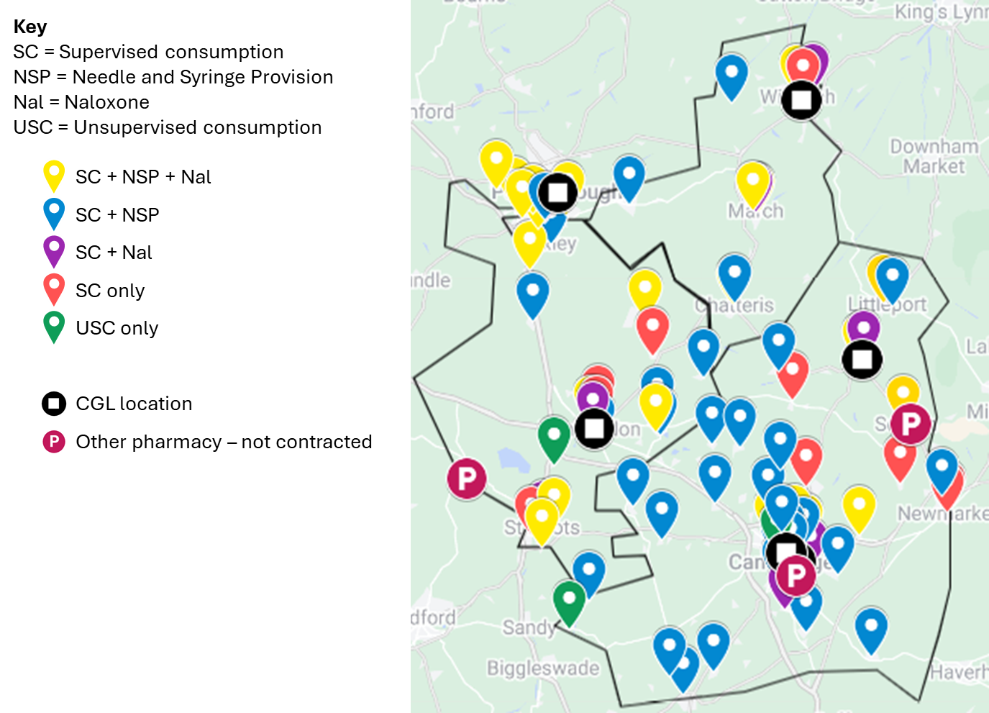
The last Pharmaceutical Needs Assessment (PNA) for Cambridgeshire and Peterborough, published in 2022, concluded that there was sufficient pharmaceutical provision across the area. However, a supplementary statement issued in January 2024 highlighted ongoing national pressures, including workforce shortages, a reduction in pharmacy opening hours, and the closure of 10 community pharmacies, seven of which had been delivering supervised consumption.
These changes have contributed to capacity issues, particularly affecting clients on OST. Some pharmacies have introduced restrictions, such as ‘one in, one out’ models, limiting the availability of supervised slots and potentially requiring clients to travel further to access treatment. This poses particular risks for vulnerable groups such as rough sleepers and prison leavers, and may undermine efforts to expand structured treatment in line with national drug strategy ambitions. A full update to the PNA is currently underway and is expected to be published in October 2025.

Nitazene Testing
A potent group of synthetic opioids linked to overdose risk, nitazenes, can be tested for using point-of-care ‘nitazene test strips’. People who use drugs can use them to check for contamination in substances they intend to take, reducing the risk of unintended opioid exposure. These strips are distributed through CGL services in Cambridgeshire. During a 10-month period ending in January 2025, clients were given test strips on 173 occasions, along with guidance on their use and other harm reduction measures. Further test strips are also distributed to partner agencies, such as pharmacies, and upcoming expansion of this service will include test strips for other drugs with associated overdose risk, such as fentanyl and xylazine.
Although these tests may influence safer use decisions, they have significant limitations. Importantly, their distribution offers an opportunity to provide advice on safer practices, including not using drugs alone, having naloxone available, and ensuring someone remains sober to seek help if needed.

Peer Support
Peer support is a vital component of harm reduction and recovery, leveraging the lived experience of individuals who have navigated substance use challenges. It fosters trust, reduces stigma, and empowers service users through relatable guidance and practical strategies.
Within the current service model, peer support is embedded through:
- Mutual aid groups and recovery cafés facilitated by Cambridge Recovery Service (CRS), which operates across the county.
- Peer mentors and recovery coaches who support individuals through treatment and into sustained recovery.
- Friends and family groups offering peer-led emotional support and shared learning.
The service also collaborates with The SUN Network, which facilitates co-production and feedback from people with lived experience, ensuring services remain responsive and person-centred.
Importantly, Cambridgeshire benefits from a strong recovery community, including The Edge Café, a LERO that provides a safe, inclusive space for recovery-focused activities, peer support, and community reintegration. This aligns with national guidance on recovery support services and LEROs, which emphasises the importance of lived experience in shaping and delivering effective recovery pathways.

Service Mapping
This section draws on data from the National Drug Treatment Monitoring System (NDTMS) to assess service efficiency and client outcomes. Many of these measures are continuously monitored by both the provider and the public health drug and alcohol team, ensuring a responsive and evidence-driven approach to service delivery.
Sections 5.8.3.1 to 5.8.3.4 present data relating to adult services, which is followed by data for CYP services in section 5.8.3.5.

Unmet Need
As detailed above (sections 5.2.3 and 5.3.3), unmet need for adult drug and alcohol treatment (based on 2020-21 prevalence estimates) varies according to substance type and user demographics. In year ending March 2024, the overall unmet need for OCU was 52.2% and for alcohol was 75.3%. In both groups, unmet need was highest in young adults by 26.9 to 46.4 percentage points.
When compared to national figures for England, approximate unmet need in Cambridgeshire was 5.2 percentage points lower for OCU treatment, and 2.5 percentage points lower for alcohol treatment in the same time period.

Referral Sources
Adults
The most frequent route into treatment for adults in Cambridgeshire in year ending March 2024 was via self-referrals (which may be following advice from a healthcare professional), making up 72.7% of new presentations. This is a higher proportion than national averages, as shown in Figure 5.8c. The next most common source was the criminal justice system, making up 15.4% of referrals.
Figure 5.8c. Referral sources into DA services in Cambridgeshire, year ending March 2024.
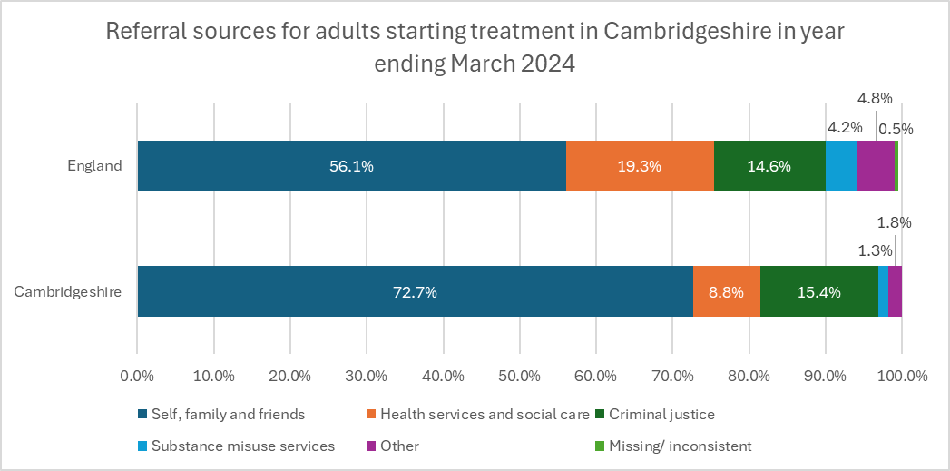
 | Self | Health services & social care | Criminal justice | Substance misuse service | Other (inc. family & friends) | Missing/ inconsistent
Number | 1036 | 120 | 221 | 18 | 31 | 0
Proportion | 72.7% | 8.4% | 15.5% | 1.3% | 2.1% | 0.0%
England | 56.1% | 19.4% | 14.6% | 4.2% | 4.8% | 0.5%
Source: NDTMS data.
As shown, referrals from health services and social care make up a significantly lower proportion of all treatment referrals in Cambridgeshire compared to the national average. The breakdown of these sources is shown in Table 5.8b, demonstrating lower referral rates from GPs, hospitals, and social services.
Table 5.8b. Health services and social care referrals in Cambridgeshire and England year ending March 2024.
 | Cambridgeshire
Referral subgroups | Number | Proportion | England | Comparison
GP | 24 | 1.7% | 5.4% | -3.70%
Hospital | 44 | 3.1% | 5.0% | -1.90%
Social Services | <5 | 0.2% | 1.8% | -1.60%
Other health services and social care | 49 | 3.4% | 7.2% | -3.80%
 | 120 | 8.4% | 19.4% | -11.00%
Source: NDTMS data.
Of note, some ‘self’ referrals may have been a result of signposting from a health professional and would therefore not be captured. Further investigation is needed to understand potential gaps in referral pathways and ensure people in need are effectively directed to treatment services.

Waiting Times
The waiting times for adults starting their first treatment after being referred have seen marked improvements in Cambridgeshire. In 2024, nearly all new presentations were seen within three weeks (99%, or 1,601 individuals). Only nine individuals (0.6%) waited between three and six weeks, and just two people (0.1%) had to wait more than six weeks. This represents a significant improvement compared to 2017, when 178 individuals waited longer than three weeks. Since 2019, fewer than 11 individuals each year, have experienced waits exceeding three weeks (less than 1% of those referred), demonstrating consistent progress.
Nationally, 98.6% of new presentations were seen within three weeks, 0.83% waited between three and six weeks, and 0.54% waited over six weeks.

Treatment Retention, Progress and Outcomes
Monitoring individuals during treatment is crucial to understanding individual journeys and service provision. This includes data on treatment retention and treatment progress.
Individuals who stay in treatment for 12 weeks or more show significantly better recovery prospects. In the year ending March 2024, 87.0% of adults starting treatment in Cambridgeshire were retained for at least 12 weeks (1,236 people), slightly above the national average of 83.2%.
Early unplanned exits, defined as leaving before 12 weeks, made up 13.0% (184 people). Most early exits involved people disengaging or not starting an intervention (154 people, 83.7% of unplanned exits), or being transferred to another service (30 people, 16.4%).
While in treatment, individuals are supported to make progress across multiple domains, including reduced substance use, improved physical and mental health, and personal recovery goals. In Cambridgeshire in the year ending March 2024, 41.1% of clients showed substantial progress against treatment goals, compared with 37.9% nationally. This figure has remained relatively stable between 2022 and 2024 (local range: 39.8%-42.1%), despite an 11% increase in treatment numbers during that period (from 2,555 to 2,835). This is shown in Figure 5.8d.
Figure 5.8d. Treatment progress for adults in treatment in Cambridgeshire, yearly rolling numbers from 2022 to 2024
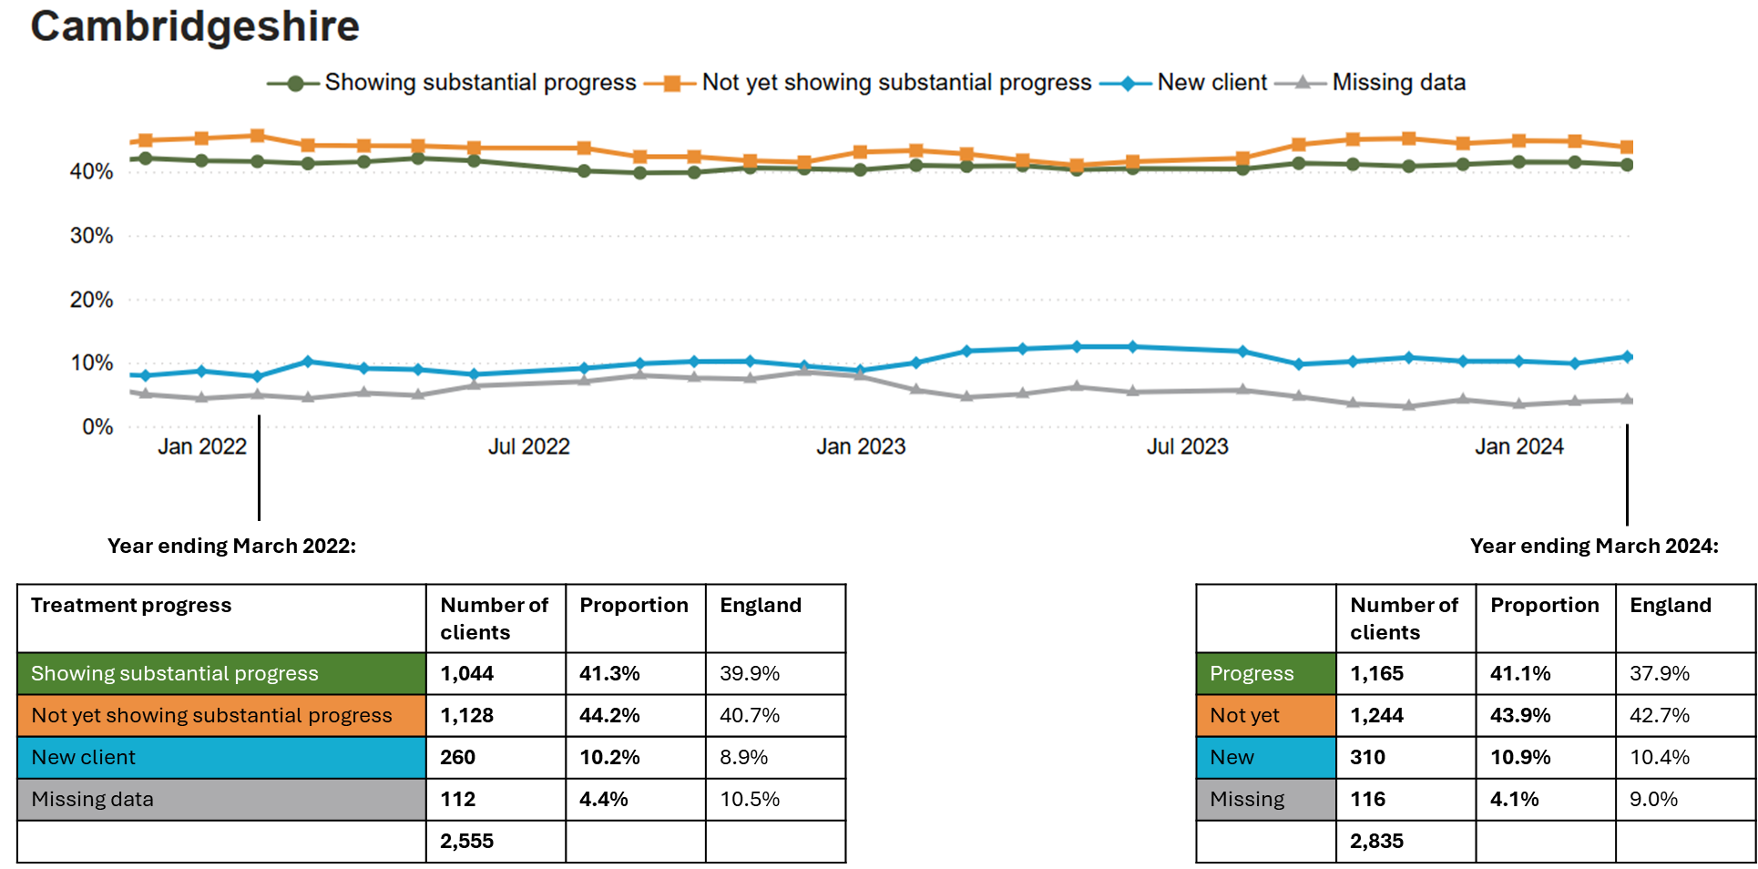
Source: NDTMS data.

There were 1190 adults (18+) who exited the community drug and alcohol treatment system in Cambridgeshire during the year ending March 2024. 48.7% of those that left had successfully completed their treatment, free from dependence. This is similar to the proportion of people who have successfully completed treatment each year since 2021 (range 48.6-51.8%) and is higher than the national successful completion rate of 45.6%.
Over a third (38.1%) of people dropped out or left treatment without completing it. The National drop-out rate was slightly lower at 37%. The remaining exits included people leaving due to transfers to other services, people who declined treatment and people who died in treatment.

By Substance Type
Of the people who left treatment, completion rates differed by substance type; the alcohol only and non-opiate groups had the highest rates of completion at 56.6% and 56.1% respectively, followed by the non-opiate and alcohol group at 51.1%. The opiate only group had a much lower completion rate of 28.8%, with a significant proportion being transferred to other services (both in the community and in a custodial setting).
Time in Treatment
Over half of the people who completed treatment successfully did so within six months of starting treatment (339 of 581, 58.3%), and most completed within a year (482 of 581, 83.0%). When broken down by substance groups, time for completion for opiates was longer than other substances:
- Around half completed treatment within a year (34 of 69),
- Around one third of those in treatment for opiates completed in one to six years (24 of 69),
- 16% took more than 6 years (11 of 69).

Re-presentations
Re-presentations to services can occur for various reasons; for some, it may indicate that treatment exit was premature, while for others, it could be due to changes in circumstances or ongoing challenges in maintaining recovery. Ideally no one would re-present as they would no longer require treatment services, but the reality of drug and alcohol needs and recovery is rarely linear. The accessibility of services and the openness for re-engagement plays a crucial role in supporting long-term outcomes.
As such, the number of repeat presentations to services is a useful marker of treatment effectiveness but also requires deeper exploration to fully understand how services can learn from client journeys.
As higher numbers of people are coming through treatment in Cambridgeshire, and higher numbers are successfully exiting treatment, the number of people representing to services has slightly increased. In the year ending March 2024, 48 adults who had successfully exited treatment re-presented to services, 7.8% of exits. The rate was 6.4% in year ending 2023 and 5.4% in 2022. The national re-presentation rate in 2024 was 1.4 percentage points lower than Cambridgeshire, at 6.4%.
When broken down by substance groups, the highest proportion of clients representing were in treatment for opiates, at 15% (12 of 80 completions). This was also the group with the highest re-presentation rate nationally at 11.9%.

Overall, DA services in Cambridgeshire show strong retention and good levels of progress, with successful completion rates consistently above national averages. However, outcomes remain uneven across substance groups, with opiate users experiencing longer treatment durations and higher rates of re-presentation. These patterns reflect the complex and often non-linear nature of recovery, underlining the importance of flexible, accessible services that support people throughout their treatment and beyond. Understanding these trends is essential for improving service effectiveness and planning for future demand.

Children and Young People (CYP)
Data in this section relates to all CYP in treatment, under both Child and Adolescent Substance Use Service (CASUS) and CASUS-Youth Offending Service (YOS).
Referral sources for CYP in substance use treatment differ in Cambridgeshire compared to the national picture. Table 5.8c shows the average proportion of referrals by source over the three-year period 2021–2024 for both Cambridgeshire and England. A three-year average has been used to provide a more meaningful comparison, due to small numbers.
In Cambridgeshire, a greater proportion of referrals come from youth and criminal justice services and education settings, while referrals from social care are notably lower than the national average (13.9% locally vs 23.1% nationally). Although this is a proportional comparison and may reflect stronger engagement routes elsewhere. The actual number of referrals from social care is low, just seven in the year ending March 2024 and fewer than 20 in each of the last three years. This may indicate a gap in identification or referral processes for vulnerable children and young people known to social care.
Table 5.8c. Referral sources for CYP in Cambridgeshire and England, 2021-2024*.
 | Self, family, friends | Health services | Social care | Education | Youth/ Criminal justice | Substance misuse service | Other
Number | 11 | 15 | 13 | 28 | 23 | 0 | 5
Proportion | 11.5% | 16.0% | 13.9% | 28.8% | 24.0% | 0.3% | 5.6%
England | 11.3% | 12.6% | 23.1% | 31.6% | 17.1% | 2.0% | 2.2%
Source: NDTMS data. * Average over three-year-period used due to low numbers
The high proportion of referrals from education settings suggests strong engagement with schools, but may also indicate gaps elsewhere. Young people in alternative provision or not in education may be under-identified, despite facing higher risks. The low number of referrals from social care reinforces the need to review pathways for more vulnerable or hidden cohorts.
Waiting Times
In the year ending March 2024, all CYP receiving treatment in Cambridgeshire had their first intervention within 3 weeks of referral.
Time in Treatment
Most CYP in Cambridgeshire are in treatment for under six months, though some remain for longer, including over a year. Compared to national data, there may be fewer short episodes and more extended stays locally, however, small numbers mean these patterns should be interpreted with caution.
Treatment Exits
An average of 75 CYP exited treatment yearly between 2021 and 2024 in Cambridgeshire and the majority (79.6%) left having successfully competing treatment. This is slightly lower than the national rate, however, at 83.3%.
15.1% of CYP exits in Cambridgeshire were due to dropping out or leaving, which is higher than the national drop-out rate of 11.4%. A further 2.7% declined further treatment. The remaining 2.6% were referred to other services.
Treatment Outcomes
Outcome data from NDTMS allows analysis of substance-specific outcomes among CYP with planned treatment exits, where full data is available. Three-year averages have been used below, but all figures should be interpreted with caution due to small numbers in substance sub-groups. The data does not show any consistent directional trend over the period.
Across the three years to March 2024, planned treatment exits were associated with improvements in substance-related outcomes. High-risk alcohol use was substantially reduced, with no CYP recorded as using at high-risk levels at treatment exit in 2023 or 2024.
Across the three years, the proportion of CYP with cannabis use decreased by an average of 16 percentage points through treatment; 64% reported use at treatment start, and 48% were still using at exit. This means that 75% of those who entered treatment using cannabis at treatment exit. Nationally, this proportion was 67% in March 2024.
Among those still using cannabis in Cambridgeshire, the average number of use days per month fell from an average of 17.3 to 15.8, a reduction of 1.6 days, but further information on any changes in quantity is not available. OHID guidance does not require abstinence from cannabis as a treatment outcome, acknowledging its complex role in young people’s lives. However, given that nearly half of those exiting treatment have ongoing use, further exploration of local data may be useful to ensure this is not associated with a heightened risk of harm or relapse.
Problematic use of substances other than cannabis was reported by 21% of CYP at treatment start, reducing to 6% at exit. This represents positive progress, although it falls short of OHID’s ambition of abstinence from all non-cannabis drug use at discharge45. This equates to 27% of those who entered treatment with other drug use still using at exit, compared to 30% nationally in March 2024.
Mental health needs among CYP in treatment also appear to reduce over the course of support. In 2022–23, 12.1% (14 of 116) had unmet mental health needs at the start of treatment. By the time of planned exit, this had reduced to 2.6% (3 people). In 2023-24, a similar pattern was observed; 13.6% (12 out of 88) started treatment with unmet mental health needs, falling to just 1.1% (1 person) at exit.

Re-presentations
The re-presentation rate for CYP in Cambridgeshire was 4.4% on average in 2024, compared to 4.0% nationally in 2023. This rate fluctuates for Cambridgeshire due to small numbers, but has been 4.1% on average since 2021, similar to the national rate of 4.0% in the same time period.

Inpatient and Residential Services
Detoxification is the medically-assisted withdrawal from either alcohol or drugs, aiming to minimise the clinical risk and impact of withdrawal. Detoxification can be performed either in the community (Tier 3) or as an inpatient with medical supervision (Tier 4).
Rehabilitation is the holistic rebuilding of a person following detoxification process, using medical and/or psychotherapeutic treatments to overcome drug or alcohol dependency. Residential rehabilitation is typically a version of this treatment in a medical facility (for up to 12 weeks).
Residential treatment uptake in Cambridgeshire has increased since 2019–20, to just under 1% of all adults in treatment. This remains slightly below the national average, and both figures fall below the Department of Health and Social Care’s (DHSC) ambition for at least 2% of individuals in treatment to access residential care as part of their recovery.
Inpatient treatment uptake in Cambridgeshire is lower than the national average. In the year ending March 2024, around 0.8% of those in treatment received inpatient care for substance use, compared to 2% nationally. While this represents a slight increase in numbers since 2019-20, uptake in Cambridgeshire was relatively low.
Residential and inpatient treatment numbers are demonstrated in Figure 5.8e and Figure 5.8f.
Figure 5.8e. Residential rehabilitation uptake.
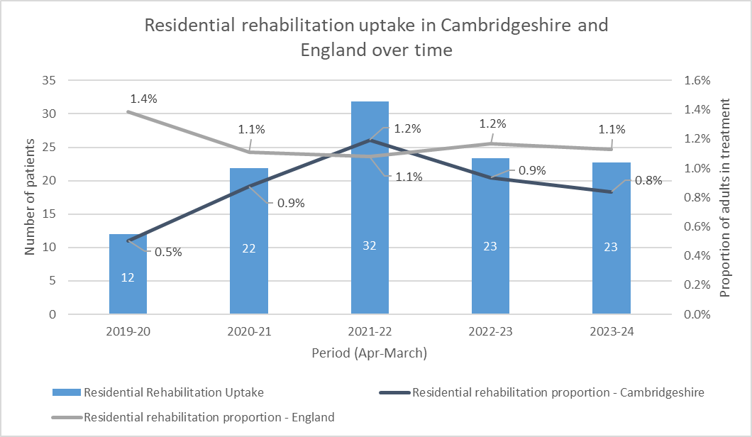
Source: NDTMS data.
Figure 5.8f. Inpatient treatment uptake.
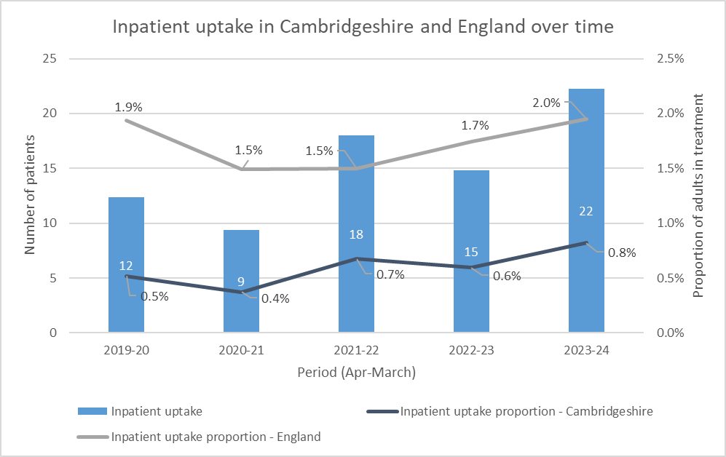
Source: NDTMS data.
As outlined in a local evaluation of Inpatient and Residential Rehabilitation Services (see Section 3, Literature Review), improvements to the rehabilitation and inpatient service offer will strengthen support for individuals with complex needs who benefit from more intensive, structured treatment than community services alone can offer.

Services; Key Insights and Priorities
Key Insight Summary: Funding and sustainability
Persistent funding uncertainty hampers long-term planning, creates instability for staff, and limits the ability to take a preventative approach. Innovation and commitment to changes is undermined when future funding is unclear.
Priority 23
Advocate for longer-term, sustainable funding arrangements to support workforce retention and strategic planning. Strengthen collaboration with regional and national representatives to amplify the local case for stability and build influence in funding discussions.

Key Insight Summary: Harm reduction
Harm reduction work is a strength. Naloxone provision has risen by 42%, and 87% of opiate service users were issued with naloxone in 2024. Use of long-acting opiate substitution therapy (LA-OST) (‘Buvidal’) has increased in line with national targets and use in prison settings. However, needle and syringe provision (NSP) falls below targets and long-acting buprenorphine is not the most cost-effective option.
Pharmacy closures and reduced opening hours have strained OST service capacity across Cambridgeshire, posing access challenges for vulnerable clients and risking disruption to treatment.
Priority 24
Work to increase needle and syringe provision (NSP), in conjunction with addressing unmet need for opiate and crack users and injecting populations (see also priority 14). Long-acting opiate substitution therapy (OST) should be part of the OST offer but its use should be targeted, with patient selection strategies in balance with patient-centred care and shared decision-making. Maximise the opportunity presented by updated legislation on naloxone distribution to build partnerships with local services and expand the reach of harm reduction advice, which may include training of partners. Ensure this considers that provision for younger users is currently slightly lower than other populations.
Priority 25
Monitor the impact of reduced community pharmacy capacity on harm reduction and treatment access, particularly for opioid substitution therapy (OST). Proactively assess risks to care, especially for vulnerable groups, and escalate issues through local, regional, and national forums as needed.

Key Insight Summary: Recovery services
The Lived Experience Recovery Organisation (LERO) in Cambridgeshire is an important local asset, offering culturally competent support that reaches at-risk and marginalised groups.
Priority 26
Build on the success of the local LERO model, using national guidance to strengthen lived experience involvement in planning, peer support, and service evaluation.

Key Insight Summary: Referral routes
For adults, gaps may exist in how health and social care services identify and refer individuals into treatment. For children and young people, those outside of mainstream education may be less likely to be referred and may have additional risk factors or involvement with other services.
Priority 27
Strengthen cross-sector system links with DA services, particularly with non-mainstream education providers and services such as children’s social care (see priority 21). Consider targeted approaches to identify and engage young people at risk of falling through the gaps.
NB see Priority 32 and 33 around adult social care and primary care.

Key Insight Summary: Treatment quality
Data indicates good treatment outcomes for DA services in Cambridgeshire, but over a third (38.1%) of adults leave without completing treatment. Re-presentation rates have increased slightly and are highest among opiate users. Treatment outcomes for CYP are mixed, with persistent cannabis use and some continued use of other drugs at treatment exit.
Priority 28
Continue to monitor trends in drop-out and re-presentation, with particular attention to opiate users and monitor outcomes for treatment, particularly for CYP. For CYP, consider in-depth exploration of ongoing substance use at treatment exit.
Gather feedback from service users, including those who disengage, to inform service development and tailor support to better meet their needs. In light of high non-completion and re-presentation rates, consider exploring the acceptability, feasibility, and potential effectiveness of recovery check-ins following treatment exit. These may offer a way to maintain engagement and identify support needs post-discharge. Use existing systems and local relationships, such as the SUN Network, to support this work.

Key Insight Summary: Inpatient and residential treatment
Uptake of residential and inpatient treatment has increased but remains below national levels and Department of Health and Social Care (DHSC) targets. In 2023–24, just under 1% accessed residential treatment (nationally 1.2%), and 0.8% received inpatient care (nationally 2%). While inpatient detoxification is being delivered, most placements are outside the local area. Community detoxification is underused, despite evidence that it can be a viable and more cost-effective option for some individuals.
Priority 29
Expand and diversify detoxification and rehabilitation pathways to improve access, personalisation, and equity. This should include continued efforts to increase residential and inpatient capacity while strengthening options for community-based detox and tailored care. Potential actions include:
- Assessing the feasibility and cost implications of commissioning closer inpatient facilities or security capacity through regional partnerships.
- Maintain clear, robust referral pathways and funding mechanisms to maximise use of available inpatient and residential beds.
- Explore block-purchasing of inpatient beds as a mechanism to stabilise access, particularly for time-sensitive cases.
- Increase access to community detoxification for suitable individuals, ensuring adequate support is in place to avoid defaulting to inpatient settings where not clinically required.
- Consider intensive, community-based models for individuals who request alternatives to residential or inpatient detox, building on learning from existing pilots (e.g. care agency support model with CGL).
- Improve communication with service users about detox and rehabilitation pathways, including what to expect, eligibility, and steps involved.
- Continue to develop person-centred approaches to rehabilitation, such as identifying placements that meet practical and family needs or adapting provision for carers.
Efforts to enhance access should be matched by a commitment to protecting existing funding for residential rehabilitation. Equity should be a guiding principle, with improvements actively addressing the needs of vulnerable groups and including appropriate support for families of those in treatment.

Known Challenges and Opportunities

Hospital Liaison
Hospitals play a critical role in identifying people at high risk of alcohol and drug-related harm and connecting them with longer-term support. In Cambridgeshire, this is supported by dedicated hospital-based roles and referral links with community drug and alcohol services.
Both Addenbrooke’s & Rosie Hospitals in Cambridge and Hinchingbrooke Hospital in Huntingdon host Change Grow Live (CGL) liaison workers who are embedded in hospital teams. Their role is to identify patients with substance use needs and support onward referral. In 2023/24, liaison workers supported 180 patients at Addenbrooke’s and 184 at Hinchingbrooke. Of these, 42 and 34 patients respectively engaged with structured community treatment.
In total, there were 1,736 referrals to drug and alcohol (DA) treatment from Addenbrooke’s and 359 from Hinchingbrooke during this period. However, this only resulted in 120 formal engagements in structured treatment (section 5.8.3.3), suggesting barriers to follow-through.
A particularly strong local model is the Alcohol Care Team (ACT) at Addenbrooke’s, a multidisciplinary team supporting alcohol-dependent inpatients. In 2023/24, the ACT engaged 1,469 patients. The hospital liaison worker in Cambridge is embedded within this team, strengthening continuity between acute care and community support.
Despite these structures, there remains scope to improve early identification. Local data suggests that only around 10% of emergency department (ED) patients in Cambridge are screened for alcohol use (via the FAST tool). Time pressures and limited staff capacity are likely barriers to wider implementation of screening and brief interventions.
The ACT also presents an opportunity to build capacity in ED through joint training in Identification and Brief Advice (IBA). However, the future of the ACT is uncertain, posing a risk to one of the most effective models of hospital-to-community care.

Engaging High-risk Populations
‘Assertive outreach’ is a proactive approach where specialist teams actively seek out and engage individuals who would benefit from treatment but are hard to reach through conventional service channels. The hospital liaison teams are an example of this, and patients encountered through emergency services represent high-risk presentations with elevated mortality rates.
The local DA team aims to expand these efforts through links with the ambulance service. Currently, the team have access to case numbers and codes of substance use related call-outs, allowing surveillance of emerging patterns of harm and risk. Ongoing efforts are focused not only on improving the quality of this data but also exploring additional ways to enhance reach and strengthen harm reduction. Key areas for identified for development include naloxone provision by ambulance crews, facilitation of direct referrals to DA services, and exploring how individuals identified through emergency call-outs could receive appropriate support.
Additionally, a ‘High Impact Use’ Service launched by the council in October 2024 supports individuals who frequently rely on emergency services. This population often faces complex challenges, with substance use potentially being a significant factor. Establishing strong links with this team aims to improve access to support for another high-risk group while also providing valuable insights into the barriers their service users face in engaging with DA treatment. This understanding will help inform strategies to improve service accessibility and effectiveness.
In addition to these high-risk groups, there may be further opportunity to strengthen identification and engagement of vulnerable groups as aligned with council ambitions, such as care leavers and veterans. Data and reporting on substance use in these populations is currently limited, but evidence suggests higher risk profiles, and poorer access to timely support,. Aligning drug and alcohol services to improve inclusion and outcomes for these groups could support earlier identification, tailored interventions, and more equitable access to care.

Adult Social Care
Adult Social Care (ASC) plays a critical role in supporting individuals with complex needs, including those related to aging, disability, mental health, and recovery. ASC is often a key point of contact for vulnerable individuals, yet substance use, whether involving drugs, alcohol, or both, can remain hidden or under-acknowledged within this population. Recognising and addressing substance use at this interface is essential for providing holistic care and maximising opportunities for early intervention.
As explored in section 5.8.3.3, Social Services led to <5 people engaging in DA services in the year ending March 2024, 0.2% of all entries to treatment, although note that some may be recorded under ‘Other health services and social care’ (there were 49 referrals from this ‘other’ category in the same time period).
ASC services in Cambridgeshire engaged with a large number of individuals in 2022–23, including 22,602 contacts for support or advice (up from 21,450 the previous year) and 7,891 individuals receiving long-term care (up from 7,760). Despite this substantial engagement, the data reveals low numbers of individuals identified under the secondary support category of “Substance Misuse Support”; fewer than 50 individuals in 2023-24. Although this may be interpreted to represent low need, it is more likely that drug and alcohol issues are under-reported, given known prevalence in the general population. The absence of “Substance Misuse Support” as a primary category, combined with the lack of obligation to record additional support needs underestimates the extent of substance use treatment need in the ASC population.
Substance use often exacerbates other vulnerabilities, such as mental health or physical disability, and vice-versa. Individuals with drug and alcohol needs may be categorised with these other support needs, but may be at risk without support for substance use. This under-identification highlights a critical challenge in understanding drug and alcohol needs for those interacting with ASC, which may stem from gaps in data systems, staff awareness or in standardised reporting practices.

Primary Care

NHS Health Checks
Data from NHS Health Checks, offered to individuals aged 40-74 through their GP, provide an opportunity to understand other alcohol use patterns in the population. In Cambridgeshire during 2023-24, 15,340 people attended a health check, 62.4% of these (9,573 people) had a coded alcohol screening using an AUDIT score.
Although the screening rate of 62.4% was significantly higher than the national average of 38.3% (1,952,091 out of 5,102,758), this still means an opportunity to detect cases and offer support was missed for 37.6% of NHS Health Check attendees (5,767 individuals).
Key findings from health checks in Cambridgeshire where an AUDIT score was completed include:
- 96.8% (9,267 individuals) were categorised as low-risk.
- 2.9% (273 individuals) were identified to be at an increasing-risk from drinking.
- 0.3% (33 individuals) were identified to be at a higher risk or to have possible alcohol dependence.
For the 306 individuals who were identified to be at an increasing or higher risk from alcohol use, or with possible dependence:
- 130 people, 42.5%, were offered a brief intervention (108 people received intervention, 22 declined); 176 were not offered this
- 33 people, 10.8%, were offered a referral for support (4 were referred, 29 declined); 273 were not offered this
These results, while only a snapshot and not representative of the wider population, highlight key areas for improvement in identifying and addressing alcohol-related risks. Over half of patients at risk were not offered any intervention, indicating significant scope to enhance the reach and impact of brief interventions and referral pathways.

Short Term Alcohol Recovery Service (STARS)
STARS is a relatively new project within CGL targeting primary care as a key setting for early intervention around alcohol use. The initiative focuses on using screening and brief interventions to promote healthier lifestyles and provide support to individuals who may not meet the threshold for structured drug and alcohol services.
A specialist recovery worker is embedded within primary care settings across Cambridgeshire to identify and support individuals at risk of alcohol-related harm. This approach helps break down barriers to early treatment, particularly for non-dependent drinkers, and aims to reach under-represented groups who may not otherwise access services. The project also seeks to raise awareness of CGL within primary care and strengthen referral pathways from GPs into treatment.
As of April 2025, STARS has received 193 referrals (since project initiation in March 2024). Of these:
- 16 (8%) were referred on to structured drug and alcohol services
- 40 (21%) have completed STARS treatment
- 55 (28%) remain in treatment
- 74 individuals (38%) were discharged before assessment or declined support
- 8 (4%) are awaiting an assessment
Among those who completed treatment, there was an average reduction in alcohol use by 64%.

Accessibility of Services
Recent work stemming from the local learning disability needs assessment has identified that current services are non-complaint with Accessibility Information Standards, which ensure that information is offered in accessible formats and necessary communication support is provided to ensure equal participation.
An audit has informed an ongoing action plan from the current service provider, CGL, which includes:
- Enhancing the process of documenting communication needs.
- Providing targeted staff training.
- Ensuring that key documents are made available in accessible formats.
- Ensuring that correct procedures for supporting individuals with communication needs are in place.

Data Sharing
The need for increased continuity of care between services has been highlighted throughout this needs assessment, particularly in the integration of care between DA treatment, children and adult services, mental health services, and social care.
Recent progress has been made in providing DA services access to the Shared Care Record (SCR), facilitating smoother information sharing across services and enhancing the ability to make timely and appropriate referrals.
This development not only enhances coordination but also reduces the need for service users to repeatedly recount their stories to different providers, improving their experience and reducing any barriers to effective care. Access to the SCR ensures that healthcare professionals have a comprehensive view of an individual's care, leading to more informed, timely, and holistic support for those facing substance use challenges.

Challenges and Opportunities; Key Insights and Priorities
Key Insight Summary: Hospital liaison
Hospitals are key points of contact for identifying substance use, supported locally by embedded liaison workers and a strong Alcohol Care Team (ACT) at Addenbrooke’s. However, despite high referral numbers, few patients go on to engage in structured treatment, suggesting follow-through challenges. Screening in emergency departments remains limited, and the future of the ACT is uncertain despite its value for the population.
Priority 30
Hospital liaison roles should be retained regardless of potential funding shifts, with ongoing strengthening of links and partner working throughout hospitals. Reasons for low conversion from hospital referral to structured treatment should be explored, and any identified barriers to engagement should be addressed post-discharge. The feasibility of screening and brief intervention (IBA) coverage in emergency departments should be considered, such as through joint training with ACT staff and emergency department teams.

Key Insight Summary: High-risk populations
Assertive outreach through hospitals, ambulance data, and the new High Impact Use (HIU) service offers opportunities to connect with people at greatest risk. However, opportunities are missed due to underdeveloped data sharing and referral mechanisms across emergency and community services.
Priority 31
Continue to build system links with ambulance services and the HIU team in the council. Strengthen real-time data use and referral pathways between services with clear protocols for directly referring or signposting individuals to drug and alcohol services.

There is limited available data on substance use and treatment engagement for certain vulnerable groups, including those in contact with adult social care, as well as groups specifically prioritised by Cambridgeshire County Council, such as care leavers and veterans.
This limits our understanding of the scale and nature of need within these populations and may mask important disparities in access, outcomes, or support needs.
Priority 32
Improve monitoring and data collection on vulnerable populations underrepresented in current reporting (including care leavers and veterans) and explore opportunities to align drug and alcohol service delivery with wider council strategies aimed at increasing inclusion and access to support for these groups.

Key Insight Summary: Social and primary care
Adult Social Care (ASC) and Primary Care regularly engage with individuals who may have unmet or early-stage substance use needs, yet referrals remain low. The Short-Term Alcohol Recovery Service (STARS) shows promise and highlights the need to improve early intervention and retention.
Priority 33
Enhance data capture of substance use needs in ASC systems and explore training for ASC staff to boost identification and referrals considering the use of the AUDIT screening tool. Learn from and collaborate with measures taken in Children’s Social Care (CSC) (see Priority 21).
Priority 34
Support the continuation and scaling of embedding DA service presence in primary care (as seen in STARS), with a focus on increasing engagement.
See also Priority 5 for related work around prevention and early intervention.

Key Insight Summary: Information accessibility
Not all information in DA services is available in accessible formats.
Priority 35
Information throughout DA services should be fully accessible, and this should be standard practice. This includes meeting the communication, literacy, and accessibility needs of all service users, which should be identified and recorded by the service.

Key Insight Summary: Data sharing
Shared Care Records (SCR) provide an opportunity for enhanced care coordination and improved service user outcomes.
Priority 36
Work should continue to strengthen data-sharing agreements or establish access to SCRs for DA services and relevant partners. This Priority has wider benefits across the system and is related to other areas of this assessment (see Priorities 4, 12, 27, 31, 32, 33).

Qualitative Findings
The qualitative part of this needs assessment was carried out by S Squared analytics between March and May 2025. It involved surveys, interviews, focus groups and workshops with service users, drug and alcohol practitioners, partnership stakeholders and members of the public.
The qualitative report includes:
- A SWOT (strengths, weaknesses, opportunities and threats) analysis of adult services and CYP services,
- Fourteen recommendations for improving service design, delivery, and accessibility,
- Further ‘key findings’ from each element of the consultation.
Findings from the qualitative work have directly informed the overarching recommendations set out in Section 1.6 of this needs assessment. This is mapped in Table 7.2 in the Appendix (Section 7). Additionally, Table 6 below shows how the recommendations from the qualitative work correspond to the priorities identified through the quantitative analysis, highlighting where they reinforce, add to, or expand upon the quantitative findings.
The full report can be found here: https://cambridgeshireinsight.org.uk/health-and-socialcare-hub/published-joint-strategic-needs-assessments/

Table 6. Qualitative work alignment with the wider needs assessment
Qualitative Priorities* | Links to other findings in this needs assessment
1. Improve data sharing via shared care records and develop direct referral routes within GP systems to streamline access to treatment services. | Supports Priority 36 on improving system-wide data sharing to enhance service user experience.  Also aligns with Priority 34 on improving access from primary care, including embedding services in GP practices.
2. Ensure services are responsive and accessible, using place-based approaches, flexible transport options, and consider arrangements that allow Cambridgeshire residents to access services in other areas if that is more suitable for them. Ensure equitable access to CGL services for people who do not speak English. | Expands on quantitative findings around tailoring services by geography, need, and population group (also see Priorities 6 and 7).  Supports Priority 35 on improving accessibility of service information.  Adds further qualitative depth on transport, language barriers, and flexibility.
3. Expand the role of volunteers within the wider workforce, with clear responsibilities and support from recovery coordinators for mentoring and upskilling. | Adds specific direction on implementing Quant Priority 26 (on expansion of the LERO model).  Qualitative insights highlight benefits such as reduced stigma and improved cost-effectiveness, not covered in quant data.
4. Strengthen assertive outreach models to better engage people who struggle to access existing services. Use a personalised care approach and ensure staff are trained in harm minimisation, trauma-informed care, and mental health support. | Supports Priority 31 which highlights potential options for assertive outreach.  Reinforces Priorities 11 and 16 addressing co-occurring mental health needs and trauma-informed practice.  Adds qualitative emphasis on personalised care and workforce training.
5. Continue to strengthen criminal justice (CJ) pathways, especially through improved joint working between treatment services and Liaison and Diversion teams for individuals with alcohol needs in custody and after release. | Directly reinforces Priority 18 and section 5.7.3 on gaps in CJ-alcohol pathways.  Adds specific insight around collaboration with Liaison and Diversion teams.
6. Ensure service models are flexible and up-to-date using quantitative data to monitor emerging trends. Review and update the ketamine treatment pathway to ensure it addresses both physical and psychological harms. | Further supports implementation of data in this needs assessment, builds on Priorities 6 and 7 by highlighting need for real-time data use and substance-specific service updates.  Adds qualitative insight on ketamine-related harms, supplementing age-group specific approaches in Priority 7.
7. Review the detox pathway to improve clarity, accessibility, and capacity. Provide better information on eligibility and wait times, and explore expanding inpatient and community detox options. | Directly supports Priority 29 on improving access to detox and inpatient care.  Adds qualitative emphasis on clarity of pathway, wait time transparency, and service expansion.
8. Ensure consistent communication between keyworkers, service users, and carers. There should be clear plans for maintaining continuity when a keyworker is absent. | Adds new insight into quality-of-care challenges. This could relate to service drop-out (see section 5.8.5) and could be a contributing factor to retention.
9. All providers supporting people with co-occurring conditions should follow shared principles, including that neither substance misuse nor mental health issues should block access to care. Care should be joined-up, person-centred, trauma-informed, and involve families where appropriate. Training and accountability mechanisms should support this. | Strengthens Priorities 11 and 16, adding detailed expectations for shared principles, training, and accountability.  Reinforces person-centred and trauma-informed care approaches.
10. Explore complex needs within the CASUS cohort, including sexual abuse and gender-specific issues. All staff should be trained in trauma-informed care. | Adds new qualitative insight specific to CYP services, including emerging concerns in this cohort.
11. Use multi-agency approaches to support parents with drug and alcohol needs. Reduce stigma, improve engagement through schools and social care, and strengthen partner involvement in the COSUP pathway. | Supports Priority 21 and Section 5.7.5.2 (children of substance-using parents).  Provides actionable suggestions on stigma, engagement through schools/social care, and COSUP pathway integration.
12. Expand engagement with children and young people: provide joint training across agencies, embed CASUS training in social worker inductions, and collaborate with schools, colleges, and mental health support teams for in-school provision. Consider use of existing providers to provide drug and alcohol information and support in schools (e.g. Mental Health Support Teams (MHST) and Healthy You practitioners). | Enhances Priority 27 on cross-sector system working.  Provides implementation suggestions (joint training, school partnerships, leveraging of existing resources).
13. Improve support for young people outside mainstream education by working with a range of educational providers and using multi-agency approaches to identify and meet their needs. | Directly supports Priority 27 and CYP engagement strategies.  Emphasises alternative education provision and early identification via multi-agency working.
14. Explore extending the age range for children and young people’s services to improve access and allow more developmentally appropriate support for young adults. | Aligns with findings in evidence review. Adds qualitative rationale for developmentally appropriate transitions between CYP and adult services.  May contribute to addressing need for improved access for young adults, as highlighted in Sections 5.2.3 and 5.3.3, Priorities 1-3
* NB: These priorities are presented as ‘Recommendations’ in the full Qualitative Report. They have been relabelled here for clarity and to allow integration of findings with the wider needs assessment.

Appendix

Acronym Table
Acronym | Definition
ACMD | Advisory Council on the Misuse of Drugs
ACT | Alcohol Care Team
ADDER | ‘Project ADDER’ is a Home Office-led programme; Addiction, Diversion, Disruption, Enforcement and Recovery
AMBIT | Adolescent Mentalization-Based Integrative Treatment
APMS | Adult Psychiatric Morbidity Survey
ASC | Adult Social Care
AUDIT | Alcohol Use Disorders Identification Test
AUDIT-C | Alcohol Use Disorders Identification Test Consumption
BBV | Blood-Borne Viruses
CASUS | Child and Adolescent Substance Use Service
CAMHS | Child and Adolescent Mental Health Services
CCC | Cambridgeshire County Council
CGL | Change Grow Live
CiN | Children in Need
CJ | Criminal Justice
CMO | Chief Medical Officer
COVID-19 | Coronavirus Disease 2019
COSUP | Child of Substance Using Parent
CPFT | Cambridgeshire & Peterborough NHS Foundation Trust
CSC | Children’s Social Care
CSEW | Crime Survey for England and Wales
CSTRs | Community Sentence Treatment Requirements
CRS | Cambridge Recovery Service
CYP | Children & Young People
DA | Drug & Alcohol
DARD | Drug & Alcohol-Related Deaths
DASR | Directly Age-Standardised Rate
DATRIG | Drug and Alcohol Treatment and Recovery Innovation Grant
DHSC | Department of Health and Social Care
DIP | Drug Interventions Programme
DSR | Directly Standardised Rate
DToA | Drug testing on arrest
DV | Domestic Violence
ED | Emergency Department
EHH | Early Help Hub
ERSOU | Eastern Region Special Operations Unit
FAST | Fast Alcohol Screening Test
FP10 | Prescription Form used in the NHS
GABA | Gamma-Aminobutyric Acid
GHB/GBL | Gamma-Hydroxybutyrate/ Gamma-Butyrolactone
GP | General Practitioner
HBV | Hepatitis B Virus
HCV | Hepatitis C Virus
HEaRT | Homelessness Engagement and Recovery Team
HIU | High Impact Use
HIV | Human Immunodeficiency Virus
HMP | His Majesty's Prison
HRBS | Health-Related Behaviour Survey
HSE | Health Survey for England
IBA | Identification and Brief Advice
IMD | Index of Multiple Deprivation
IPS | Individual Placement and Support
IPS-AD | IPS-Alcohol and Drug
JSNA | Joint Strategic Needs Assessment
LaDS | Liaison and Diversion Service
LD | Learning Disabilities
LDIS | Local Drug Information System
LERO | Lived Experience Recovery Organisation
LGBTQ+ | Lesbian, Gay, Bisexual, Transgender, Queer (+ including Questioning, Intersex and Ace)
LSD | Lysergic Acid Diethylamide
MAT | Medication-Assisted Treatment
NDTMS | National Drug Treatment Monitoring System
NFA | No fixed address
NHFT | Northamptonshire Healthcare NHS Foundation Trust
NHS | National Health Service
NICE | National Institute for Health and Care Excellence
NSP | Needle and Syringe Programme/ Provision
OCU | Opiate and Crack Use/ Users
OHID | Office for Health Improvement and Disparities
ONS | Office for National Statistics
OOA | Out of Area
OST | Opioid Substitution Therapy
PCN | Primary Care Network
PHE | Public Health England
PNA | Pharmaceutical Needs Assessment
PWID | People Who Inject Drugs
RPT | Rate per 1000
RSDAT | Rough Sleeper Drug and Alcohol Treatment
SCR | Shared Care Record
SDD | Smoking, Drinking and Drug (use survey among young people in England)
SPOC | Service Point of Contact (within Criminal Justice)
SSMTRG | Supplementary Substance Misuse Treatment and Recovery Grant
STARS | Short Term Alcohol Recovery Service
SUN Network | Service User Network
UK | United Kingdom
WHO | World Health Organization
YOS | Youth Offending Service

Priority & Recommendation Mapping
Table 7.2; Recommendations Mapped to Supporting Evidence across Quantitative, Qualitative and Evidence Review Findings
Recommendation | Quantitative Priority Links | Relevant Section(s) (Data and Findings)* | Qualitative Priority† Links and section(s) ‡
- Children and Young People (CYP); Early education, outreach, and trauma-informed support to better identify and engage vulnerable CYP. | 1, 3, 19, 21, 27  Sections  5.2.4  5.3.4  5.7.7  5.8.5 | 4.1.5 National Drug Use; CYP  5.2.1.2 Drug Use: Prevalence in CYP  5.2.2.2 CYP Service Users, Drugs and Alcohol  5.3.1.2 Alcohol Use: Prevalence in CYP  5.7.3.2 Criminal Justice; CYP  5.7.5. Families and Substance Use  5.8.3.5 CYP Service Mapping  Evidence Review Sections  Ai. Drugs; NICE Guidance, Other Reports,  Aii. Alcohol; NICE Guidance,  G: Service Models for CYP, Section  H.iii. Parents with Problem Substance Use | Priorities: 10, 11, 12, 13  Pages 23-26
- Young Adults; Tailored outreach and flexible services to address high unmet need and improve engagement among younger adults, especially men. | 2, 5, 16  Sections  5.2.4  5.3.4  5.7.1 | 5.2.3 Drug Use: Unmet Need  5.3.3 Alcohol Use: Unmet Need  Evidence Review Sections  Hi. NDTMS Guidance on Reducing Unmet Need,  G: Service Models for CYP | Priority 14  Page 27
- Adults; Proactive, accessible alcohol support through early intervention and stigma reduction in mainstream adult services. | 4, 11, 13  Sections  5.3.4  5.5.6  5.6.3 | 5.1.1.1 Alcohol Use: Prevalence, Adults  5.5.3 Liver Disease  5.6.1 Hospital Admissions for Drugs and Alcohol  Evidence Review Sections  D. Early Intervention, Section  Hi. NDTMS Guidance on Reducing Unmet Need
- Tailored Local and Age-Specific Approaches; Targeted planning based on local data and age to address diverse needs, especially for people without stable housing. | 6, 7  Section  5.4.4 | 5.4 Detailed Service User Demographics | Priorities: 2, 6  Pages 13-14, 18
- Mortality and Harm Reduction; Strengthen harm reduction and real-time interventions to address rising drug- and alcohol-related deaths. | 10, 14, 15, 24, 31  Sections  5.5.6  5.6.4  5.8.5  5.9.7 | 5.5 Mortality Related to Substance Use  5.6.2 Blood-borne Viruses  5.6.3 Tobacco Use  5.8.2 Harm Reduction  5.9.2 Engaging High Risk Populations  Evidence Review Section  Aiii. Drug and Alcohol Related Deaths | Priority 4  Page 16
- Inclusion and Equity of Access; Improve inclusion through better data, culturally competent care, and co-designed services that reflect diverse needs. | 8, 9, 32, 35  Sections  5.4.4  5.9.7 | 5.4.3 Service User Demographics: Protected Characteristics  5.9.2 Engaging High-risk Populations | Priority 2  Page 13-14
- Intersecting Vulnerabilities; Embed trauma-informed, personalised care for people with multiple vulnerabilities through coordinated system-wide action. | 16, 17, 18, 20, 22  Section  5.7.7 | 5.7 Intersecting Vulnerabilities  Evidence Review Sections  E. Substance Use and Mental Health,  H.ii. NDTMS, Enhancing Criminal Justice Pathways | Priority 4  Page 16
- NHS Integration and Continuity of Care; Improve hospital-to-community transitions and integrate drug and alcohol care within primary care. | 30, 34  Section  5.9.7 | 5.9.1 Hospital Liaison  5.9.4 Primary Care | Priorities: 1, 4  Pages 12,16
- Mental Health and Co-occurring Conditions; Ensure integrated, non-exclusionary care for people with co-occurring mental health and substance use needs. | 12, 16  Sections  5.5.6  5.7.7 | 5.5.4 Substance Use and Suicide  5.7.1 Mental Health/ Co-occurring Conditions  Evidence Review Section  E. Substance Use and Mental Health | Priorities: 4, 9  Pages 16, 21-22
- Social Care Pathways and Partnerships; Enhance identification, referral, and partnership working across social care to support families and individuals with complex needs. | 21, 33  Sections  5.7.7  5.9.7 | 5.7.4 Families and Substance Use  5.9.3 Adult Social Care  Evidence Review Section  H.iii. Parents with Problem Substance Use | Priorities: 11, 12  Pages 24-25
- Criminal Justice; Strengthen trauma-informed pathways and partnerships between criminal justice and substance use services for early and sustained support. | 17, 18  Section  5.7.7 | 5.7.3 Criminal Justice and Prison Leaver Population  Evidence Review Section  H.ii. NDTMS, Enhancing Criminal Justice Pathways | Priority 5  Page 17
- Data Sharing and System Collaboration; Expand data sharing and use of Shared Care Records to enable joined-up, effective support across the system. | 36  Section  5.9.7 | 5.9.6 Data Sharing  Evidence Review Section  G. Service Models for CYP | Priority 1  Page 12
- Inpatient and Residential Services; Increase and protect access to residential and inpatient treatment to meet demand and ensure equitable provision. | 29  Section  5.8.5 | 5.8.4 Inpatient and Residential Services  Evidence Review Section  C. Inpatient and Residential Treatment | Priority 7  Page 19-20
- Lived Experience Involvement; Embed lived experience in planning, delivery, with structured support for volunteers. | 26  Section  5.8.5 | 5.8.2.6 Peer Support  Evidence Review Section  B. Recovery Services | Priority 3  Page 15
- Quality and Feedback; Use service user feedback and outcome monitoring to improve retention, reduce disengagement, and strengthen reliability of care. | 28  Section  5.8.5 | 5.8.3 Service Mapping  Evidence Review Section  B. Recovery Services | Priority 8  Page 20
- System Working, Commissioning, and Sustainability; Advocate for sustainable funding and monitor system-wide pressures to protect and future-proof local drug and alcohol services. | 12, 23, 25  Sections  5.5.6  5.8.5 | 5.8.1 Current Service Model  5.8.2.4 CGL & Pharmacies  Evidence Review Section A, subsections; OHID Guidance, Commissioning and Service Improvement and NHS England Workforce Strategy
* Note that Section A of the evidence review refers to broad national guidance for DA services, and includes work of relevance to all recommendations. † These priorities are presented as ‘Recommendations’ in the full Qualitative Report. They have been relabelled here for clarity and to allow integration of findings with the wider needs assessment. ‡ ‘Sections’ referred to as pages in the full qualitative report.

The National Treatment Agency for Substance Misuse (2012). Estimating the crime reduction benefits of drug treatment and recovery. Available at: https://webarchive.nationalarchives.gov.uk/ukgwa/20170807150623/http://www.nta.nhs.uk/uploads/vfm2012.pdf
Public Health England (PHE) (2018). Alcohol and drug prevention, treatment and recovery: why invest? Available at: https://www.gov.uk/government/publications/alcohol-and-drug-prevention-treatment-and-recovery-why-invest
OHID (2024). Adult substance misuse treatment statistics 2023 to 2024: report. Available at: https://www.gov.uk/government/statistics/substance-misuse-treatment-for-adults-statistics-2023-to-2024/adult-substance-misuse-treatment-statistics-2023-to-2024-report
PHE (2016). Substance misuse in people with learning disabilities: reasonable adjustments guidance. Available at: https://www.gov.uk/government/publications/substance-misuse-and-people-with-learning-disabilities/substance-misuse-in-people-with-learning-disabilities-reasonable-adjustments-guidance
NHS England (2023). Smoking, Drinking and Drug Use among Young People in England (SDD). Available at: https://digital.nhs.uk/data-and-information/publications/statistical/smoking-drinking-and-drug-use-among-young-people-in-england
OHID (2024). Children and young people's substance misuse treatment statistics 2023 to 2024: report. Available at: https://www.gov.uk/government/statistics/substance-misuse-treatment-for-young-people-2023-to-2024/children-and-young-peoples-substance-misuse-treatment-statistics-2023-to-2024-report?utm_source=chatgpt.com#background-and-policy-context
ACMD (2025). A whole-system response to drug prevention in the UK. Available at: https://www.gov.uk/government/publications/a-whole-system-response-to-drug-prevention-in-the-uk/a-whole-system-response-to-drug-prevention-in-the-uk-accessible
PHE (2017). Chapter 2: major causes of death and how they have changed. Available at: https://www.gov.uk/government/publications/health-profile-for-england/chapter-2-major-causes-of-death-and-how-they-have-changed
UK Chief Medical Officers’ Low Risk Drinking Guidelines (2016). Available at: https://assets.publishing.service.gov.uk/government/uploads/system/uploads/attachment_data/file/545937/UK_CMOs__report.pdf
ONS (2024). Deaths related to drug poisoning in England and Wales: 2023 registrations. Available at: https://www.ons.gov.uk/peoplepopulationandcommunity/birthsdeathsandmarriages/deaths/bulletins/deathsrelatedtodrugpoisoninginenglandandwales/2023registrations
Office for Health Improvement and Disparities (OHID) (2024). Deaths linked to potent synthetic opioids. Available at: https://www.gov.uk/government/publications/deaths-linked-to-potent-synthetic-opioids/deaths-linked-to-potent-synthetic-opioids
OHID (2024). Alcohol profile: short statistical commentary, December 2024. Available at: https://www.gov.uk/government/statistics/alcohol-profiles-for-england-december-2024-update/alcohol-profiles-for-england-short-statistical-commentary-december-2024
OHID (2025). Public health profiles. https://fingertips.phe.org.uk/ © Crown copyright 2025. Alcohol Profile; Inequalities; Available from: https://fingertips.phe.org.uk/profile/local-alcohol-profiles/data#page/7/gid/1938132984/pat/6/par/E12000006/ati/402/are/E10000003/iid/91380/age/1/sex/4/cat/-1/ctp/-1/yrr/1/cid/4/tbm/1/page-options/car-do-0_ine-ao-1_ine-yo-1:2023:-1:-1_ine-pt-0_ine-ct-160
Cambridgeshire Insights (2023). Joint Strategic Needs Assessment (JSNA). Available at: https://cambridgeshireinsight.org.uk/jsna-2023/
OHID. (2025) Public health profiles. Available at: https://fingertips.phe.org.uk/profile/child-health-profiles/data#page/12/gid/1938133228/pat/6/ati/402/are/E10000003/iid/90811/age/244/sex/2/cat/-1/ctp/-1/yrr/1/cid/4/tbm/1/page-options/car-do-0
Cambridgeshire Insights (2023). Cambridgeshire and Peterborough Demography, ethnicity and languages. Available at: https://cambridgeshireinsight.org.uk/jsna-2023/demography/ethnicity-and-languages/
ONS (2025). Sexual orientation. Quality and methodology information. Available at: https://www.ons.gov.uk/peoplepopulationandcommunity/culturalidentity/sexuality/methodologies/sexualidentityukqmi
ONS (2025). Census 2021 gender identity estimates for England and Wales, additional guidance on uncertainty and appropriate use. Available at: https://www.ons.gov.uk/peoplepopulationandcommunity/culturalidentity/genderidentity/articles/census2021genderidentityestimatesforenglandandwalesadditionalguidanceonuncertaintyandappropriateuse/2025-03-26
ONS (2024). Drug misuse in England and Wales: year ending March 2024. Available at: https://www.ons.gov.uk/peoplepopulationandcommunity/crimeandjustice/articles/drugmisuseinenglandandwales/yearendingmarch2024
OHID (2023). Adult substance misuse treatment statistics 2022 to 2023: report. Available at: https://www.gov.uk/government/statistics/substance-misuse-treatment-for-adults-statistics-2022-to-2023/adult-substance-misuse-treatment-statistics-2022-to-2023-report
OHID (2024). Estimates of alcohol dependent adults in England: summary. Available at: https://www.gov.uk/government/publications/alcohol-dependence-prevalence-in-england/estimates-of-alcohol-dependent-adults-in-england-summary
Alcohol use disorders identification test (AUDIT). Available at: https://assets.publishing.service.gov.uk/government/uploads/system/uploads/attachment_data/file/1113175/Alcohol-use-disorders-identification-test-AUDIT_for-print.pdf
Cambridgeshire Quality of Life survey; information available at: https://www.cambridgeshire.gov.uk/council/quality-of-life-survey-2024#read-the-quality-of-life-survey-reports-31-0
Alcohol Use Disorders Identification Test Consumption, this alcohol harm assessment tool consists of the consumption questions from the full alcohol use disorders identification test (AUDIT).
Sheffield Hallam University (2024). Survey of 1,037 representative adults in Cambridgeshire. Coordinated by Sheffield Hallam University. Report available at: https://cambridgeshireinsight.org.uk/wp-content/uploads/2025/06/Behavioural-Insights-Research-Phase-1-report-ALCOHOL-CONSUMPTION.pdf
Drinkaware (2021). Drinkaware Monitor 2021. Available at: https://www.drinkaware.co.uk/research/drinkaware-monitors/drinkaware-monitor-2021
PHE (2016). Health inequalities: Substance misuse. Available at: https://fingertips.phe.org.uk/documents/Health_inequalities_substance_misuse.pdf
A shared care record is a secure way of bringing electronic records from different health and care organisations together digitally in one place. It joins up information based on the individual rather than the organisation. Shared care records facilitate sharing of patient data and information across organisations in line with the NHS Long Term Plan. https://digital.nhs.uk/services/connecting-care-records
Maxwell, S., et al. (2019). Chemsex behaviours among men who have sex with men: a systematic review of the literature. International Journal of Drug Policy, 63, pp.74-89. Available at: Chemsex%20behaviours%20among%20men%20who%20have%20sex%20with%20men:%20A%20systematic%20review%20of%20the%20literature
PHE (2016). Drug alerts and local drug information systems. Available at: https://assets.publishing.service.gov.uk/media/5a7483b440f0b616bcb1717c/Drug_alerts_and_local_drug_information_systems_guidance.pdf
NHS England Adult Social Care Statistics Team. https://github.com/NHSDigital/ASC_LA_Peer_Groups
J. Davies (2023). Suicide Audit for Cambridgeshire and Peterborough 2020-2022.
Institute for Alcohol Studies (2025). Spending Review submission 2025. Available at: https://www.ias.org.uk/wp-content/uploads/2025/01/Spending-Review-submission-2025-Institute-of-Alcohol-Studies.pdf
OHID definition: Alcohol-related admissions include cases of accidental poisoning, intentional self-harm (suicide), and poisoning of undetermined intent. For drugs, opiate-related admissions encompass numerous substances. The measure includes the number of instances in which a person has been admitted for drug or alcohol poisoning within the past 12 months (rather than counting the individuals themselves).
Ramya Ravindrane; Clare Oliver-Williams; Kathryn Faulkner. (2024) Dual Diagnosis Services Across Cambridgeshire and Peterborough. A summary of the various models of dual diagnosis care across Cambridgeshire and Peterborough with strengths and weaknesses of each. Recommendations for next steps. See local Mental Health Needs Assessment for related work at https://cambridgeshireinsight.org.uk/mentalhealthneedsassessment/mental-health-needs-assessment-chapter-two/substance-use/co-occurring-conditions/
Cambridgeshire and Peterborough Mental Health JSNA (2022-2024). Available at: https://cambridgeshireinsight.org.uk/mentalhealthneedsassessment/mental-health-jsna-2025/
OHID. Young people's substance misuse treatment statistics 2022 to 2023: report (2024). Available at: https://www.gov.uk/government/statistics/substance-misuse-treatment-for-young-people-2022-to-2023/young-peoples-substance-misuse-treatment-statistics-2022-to-2023-report
NHS. NHS Long Term Plan (2019). Available from: https://www.longtermplan.nhs.uk/
Ministry of Justice and HM Prison and Probation Service (2023). Addiction crackdown sees huge rise in prisoners getting clean. Available at: https://www.gov.uk/government/news/addiction-crackdown-sees-huge-rise-in-prisoners-getting-clean
HM Government (2021). From harm to hope: a 10-year drugs plan to cut crime and save lives. Available at: https://assets.publishing.service.gov.uk/media/629078bad3bf7f036fc492d1/From_harm_to_hope_PDF.pdf
Advisory Council on the Misuse of Drugs (ACMD) (2019). Drug-related harms in homeless populations and how they can be reduced. Available at: https://assets.publishing.service.gov.uk/media/5d0a566eed915d0936ba5fb6/Drug-related_harms_in_homeless_populations.pdf
Available at: https://cambridgeshireinsight.org.uk/wp-content/uploads/2024/05/RSDATG-Cambridge-Evaluation-Report-FINAL-17.11.23.pdf
DfE (2020) Available at: https://www.gov.uk/government/publications/parents-with-alcohol-and-drug-problems-support-resources/parents-with-alcohol-and-drug-problems-guidance-for-adult-treatment-and-children-and-family-services
ONS (2024). Employment, unemployment and economic inactivity in local authorities. Available at: https://www.ons.gov.uk/visualisations/labourmarketlocal/E06000031/. Cambridge: 18.5%, E Cambs: 18.2%, Fenland: 28.1%, Hunts: 12.5%, S Cambs: 13.8%.
OHID (2024). Individual Placement and Support - Alcohol and Drug study: main findings. Available at: https://www.gov.uk/government/publications/helping-people-in-alcohol-and-drug-treatment-services-into-work/individual-placement-and-support-alcohol-and-drug-study-main-findings--2. PHID (2024) IPS for alcohol and drug dependence: data linkage outcomes report. Available at: https://www.gov.uk/government/publications/ips-for-alcohol-and-drug-dependence-data-linkage-outcomes/ips-for-alcohol-and-drug-dependence-data-linkage-outcomes-report#main-findings-strengths-and-limitations
OHID (2023). Additional drug and alcohol treatment funding allocations: 2024 to 2025. Available at: https://www.gov.uk/government/publications/extra-funding-for-drug-and-alcohol-treatment-2024-to-2025/additional-drug-and-alcohol-treatment-funding-allocations-2024-to-2025
Fuggle, P., Bevington, D., Cracknell, L., Hanley, J., Hare, S., Lincoln, J., Richardson, G., Stevens, N., Tovey, H. and Zlotowitz, S., 2015. The Adolescent Mentalization-based Integrative Treatment (AMBIT) approach to outcome evaluation and manualization: adopting a learning organization approach. Clinical Child Psychology and Psychiatry, 20(3), pp.419-435.
Cambridgeshire and Peterborough PNA Supplementary Statement January 2024, available at: https://cambridgeshireinsight.org.uk/health-and-socialcare-hub/published-joint-strategic-needs-assessments/
OHID: Guidance for local areas on planning to deal with potent synthetic opioids (2024). Available at: https://www.gov.uk/government/publications/fentanyl-preparing-for-a-future-threat/guidance-for-local-areas-on-planning-to-deal-with-fentanyl-or-another-potent-opioid
https://www.theedgecafecambridge.com/
OHID (2023). Recovery support services and lived experience initiatives, Guidance. Available at: https://www.gov.uk/government/publications/recovery-support-services-and-lived-experience-initiatives
There was complete data for 97-100% of planned exits: 60 of 62 planned exits in 2021-22, 116 of 120 in 2022-23 and 88 of 88 in 2023-24.
OHID (2023). National Combating Drugs Outcomes Framework: supporting metrics and technical guidance (accessible version). Available at: https://www.gov.uk/government/publications/drugs-strategy-national-outcomes-framework/national-combating-drugs-outcomes-framework-supporting-metrics-and-technical-guidance-accessible-version
The FAST (Fast Alcohol Screening Test) is a four-question tool used to quickly screen for harmful drinking. See https://assets.publishing.service.gov.uk/media/6357a7ebe90e0777aa2cfe96/Fast-alcohol-use-screening-test-FAST_for-print.pdf
Batty, G.D., Kivimäki, M. and Frank, P., 2022. State care in childhood and adult mortality: a systematic review and meta-analysis of prospective cohort studies. The Lancet Public Health, 7(6), pp.e504-e514.
Rhead, R., MacManus, D., Jones, M., Greenberg, N., Fear, N.T. and Goodwin, L., 2022. Mental health disorders and alcohol misuse among UK military veterans and the general population: a comparison study. Psychological medicine, 52(2), pp.292-302.
Local Government Association (LGA), 2025. Supporting care leavers: A whole council approach. Available at: https://www.local.gov.uk/publications/supporting-care-leavers-whole-council-approach?utm_source=chatgpt.com
Gov.uk MoD, 2025. Thousands of veterans to benefit from new UK-wide support network: Press release. Available at: https://www.gov.uk/government/news/thousands-of-veterans-to-benefit-from-new-uk-wide-support-network#:~:text=Veterans%20across%20the%20UK%20will,through%20the%20Plan%20for%20Change.

