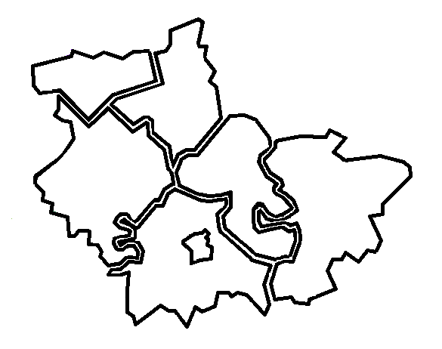
The Housing Board
Cambridgeshire | Peterborough | West Suffolk
10 January 2025: 10.00 am to 12.00 noon
Held online via Microsoft Teams
Meetings will be recorded. These recordings will be kept, in the event any point of detail needs re-visiting whilst we are not producing full minutes. Please let us know at the beginning of the meeting of any objections to recording.
Meeting notes
Present | Apologies
- Dan Horn (DH), Fenland DC chair  - Azma Ahmad-Pearce (AAP), CPCA  - Sue Beecroft (SB), Housing Board Coordinator  - Jon Collen (JC), Huntingdonshire DC  - Iain Green (IG), Public Health, Peterborough City  - Simon Hunt (SimonH), Cambridge City  - Ali Manji (AM), Cross Keys Homes  - Pamela Scott (PS), Huntingdonshire DC  - Lisa Sparks (LS), Adult Social Care, Cambs County  - Helen Tonks (HT), CHS  - Heather Wood (HW), South Cambridgeshire DC | - Elaine Field, South Cambridgeshire DC  - Julie Fletcher, South Cambridgeshire DC  - Alex Francis, Accent Housing  - Anna Hill, Cambridge City  - Chris Hill, Cambs and Peterborough ICS  - Stephen Hills, CHS  - Anne Keogh, Peterborough  - Karen Mayhew, Homes for Cambridgeshire & Peterborough (H4C&P)  - Matt Oliver, Peterborough City  - Jess Pickman, Cambs and Peterborough ICS  - Helen Reed, Cambridge City  - Sarah Scase, Peterborough City
Previous Notes
Previous meeting notes are available at https://cambridgeshireinsight.org.uk/housingboard/
Please note: This documents includes brief notes of the latest meeting, and action points.
Earlier meeting notes are found in previous action notes, but in the latest version only action notes of previous meetings are included. It may be helpful to refer to an older set of notes to see the context for the actions, but this approach helps us minimize the papers needed and keep an eye on previous actions and progress.
So only on the meeting notes when an item is presented, are brief notes (not full minutes) of the discussion. Actions for each item follow which are numbered.
These are then updated and progressed at the following meetings. Once actions are “done” they are removed. Key to the table:
- Bulleted points, brief notes, not full minutes. If more detail is needed, please contact elaine.field@scambs.gov.uk
- Numbered items = actions. When action is complete and reported back to the following meeting, it is removed from the table.

 | Items | Lead | To do | Doing | Done
 | 10 January 2025
 | Item 1: Safe Accommodation Strategies and IDVA service updates Danae Evans (DE)
Danae shared learning from October 2024 report on failings when tackling domestic abuse. Link to report here
“Being trauma informed can make the biggest difference to those escaping domestic abuse” – both for the person and for staff.
Specific questions:
- Single gender temporary accommodation is recommended – how to progress with this?
- Mentioned information sharing: for example a letter of support cannot be shared with other agencies, such as Home-Link, Jigsaw and the homelessness process. Can information be shared from DASH and DARA assessment tools (about managing risk) used by the Police, with temporary accommodation providers? Can we work on better information sharing, perhaps linking to Changing Futures trauma informed work, building a network and framework? Could this be an example area to look at?
 | Danae to share slides and links to trauma informed training (Shelter webinar) | DE
 | SB to add page of Cambs Insight showing which local partners are DAHA accredited | SB
 | All to review wording on websites making sure we refer to domestic abuse, not domestic violence, as it’s much broader than just physical violence.SB to review Cambs Insight housing pages. | All  SB
 | Danae does info collation for MHCLG and would like to share that info more widely – SB to assist  Also to explore the idea of info sharing for DA as a trauma -informed “mission” or project | SB/DA
 | Item 2: Preparations for our annual review meeting: Devolution white paper & Marmot BMJ article
Dan Horn & devolution: Place directors are working on local approach to devolution, letter to be submitted by end of March showing our plans for review of local govt. For a local growth plan, the key to governance is identifying where ethe gaps are, can we deal with these though existing structures.
KM highlighted he importance of including all players in this thought process, if it misses key facts and key partners we will miss each others’ issues.
 | Please ensure plans for growth include all key partners from the housing system – request to Place Directors via Dan Horn | DH?
 | Item 3: Update on housing board budget and finances for 2025/26
 | Note: Deferred to February
 | Sue to bring funding update to February Housing Board, for 2025/26 | SB
 | Item 4: AOB
Jon C: regulation of supported housing will affect Las in the licencing, providers in the provision. Lots of additional work.
Iain: Health and wellbeing strategy: HWBB next week will review the strategy/ In June will have a further discussion on whether the strategy is fit for purpose, will review priorities and will ensure CPCA is fully involved.
Iain: Chris Whitty is doing a report on health in cities, focussing on the wider determinants of health. OHID has asked Peterborough, Cambridge and Ely to replicate the data. Strengthens link / understanding of link between housing and health.
 | Sue to draft an agenda for March’s meeting / annual review session | SB
 | 6 December 2024
 | Item 1: Annual review of homelessness and related issues
 | LS to ascertain contacts who are developing gateways | LS
 | SB to invite a contact to a future Housing Board meeting – Birmingham suggested by LS. | SB
 | Item 2: Poverty Commission and housing: brief update
 | SB to investigate making this data (on unspent s106 monies) open or doing an annual update, in collaboration with planners | SB / PPF
 | Item 3: AOB
 | SB will look at costs of “Locarla” and if worth Housing Board subscribing. Taken to enablers group in Feb for views | SB
 | HW to take making information more SEND friendly, to Sub Regional Home-Link Board as a possibility for the future. | HW
 | SB to help Housing Board members to share plans, progress and documents to compare on housing requirement studies | SB
 | 8 November 2024
 | Item 1: Tackling serious organised crime
 | NS to deliver online bespoke SOC knowledge events for housing staff. Start with Housing Associations via KM. | KM/NS
 | Item 3: Adaptations Review
 | HR will liaise with Peterborough and others in the area around RP landlord vs tenant responsibility for works. | HR
 | AF will discuss with Accent Housing’s Adaptations Co-ordinator and update Helen as needed. | AF / HR
 | IG to help Helen link with ICS on their project on Digital enabled care. | IG / HR
 | 6 September 2024
 | Item 1: Show and Tell – capturing work done on income maximization & tenancy training
 | List to be collated of RP Income Maximisation contact names. | ?
 | DH will discuss Income Maximisation with Fenland colleagues. | DH
 | Item 3: Benefits up-take project
 | SB will be working on the Benefits Take Up Project and will discuss with DH to look at contacts. | SB
 | Item 4: AOB
 | Ask Jo Evans’ of County Housing Group to look at the issue relating to the Fire Service, to ensure that in each District there’s an understanding of the activity between the Fire Rescue service and the Councils, to gain connections. | Jo E
 | 12 July 2024
 | Item 1: Domestic abuse policies, support, and links
 | HW and IG to discuss data which DE might need for the Safe Accommodation Strategies; how different partners can help. | HW / IG
 | SB carrying out an audit of needs assessments, therefore any needs about DA or violence against women and girls, let SB know. | All
 | Item 2: Home-Link annual update
 | HW to look at turnover of older properties, and new builds meeting high level of demand comparison | HW
 | 10 May 2024
 | Item 1: End Furniture Poverty
 | Look to key housing provider forums to present to (includes own stock Cambridge City and South Cambs DC). | SB/DH

