**Children & Young People  
Joint Strategic Needs Assessment 2024   
Executive Summary**

Health and wellbeing in childhood is important in its own right. Childhood experiences also have a huge impact in shaping later outcomes across all aspects of life. While there have been improvements in child health over recent decades, childhood obesity is worsening, childhood immunisation rates have declined, and child development and early education outcomes have not recovered to pre-pandemic levels. Mental health disorders, autism and ADHD are increasing and follow children into adulthood.

This Joint Strategic Needs Assessment (JSNA) describes the needs of children and young people in Cambridgeshire and Peterborough, predominantly based on quantitative data available from open data sources (available in the accompanying CYP JSNA interactive dashboard[1]). There are time lags with some of the data, but nevertheless it highlights the growing diversity and complexity of children and young people’s needs. Some of these trends were emerging before the Covid-19 pandemic, but others were a direct impact of the pandemic response. The increasing levels of needs, alongside population growth for some local areas, have substantial implications for scale of demand, escalating costs, inequalities, and consequently, outcomes for children, young people and their families.

Within an increasingly challenging financial context, and with many poorer outcomes being driven by child poverty, there needs to be a concerted effort from all those who work with children and young people within a whole systems approach. For success, co-production with children, young people and their families to find solutions is vital as is the embedding of community development approaches to improve health and wellbeing.

To this end, this JSNA has five strategic recommendations which each have implementation actions associated with them. The recommendations are action oriented. The overarching recommendation is that the system explores the implementation actions associated with each strategic recommendation and develops clear delivery plans, that are responsive and reactive to social and cultural needs of our diverse population. This exploration should include consideration of the barriers and enablers, evidence of effectiveness, and with prioritisation and clear lines of accountability for delivery.

## Population growth, diversity and complexity

One of the main areas of change has been the increasing diversity and complexity of the children and young people’s population in Cambridgeshire and Peterborough. Population growth has not and will not be uniform – numbers of under 5s are expected to remain stable or reduce, whereas numbers of older children are likely to increase. New housing developments will mean larger scale changes in some local areas because they are more likely to attract families with children. These changes may have significant impact for some services, highlighting the importance of a good understanding of the needs of local communities, both now and for the future.

In 2023, one in five (139,131) residents in Cambridgeshire were under 18 – similar to the England average, and a quarter of residents (55,957) in Peterborough – higher than the England average. Across all of our areas, there are more children aged 10-14 years than aged 5-9 years, which in turn has more children than the youngest age group 0-4. Recent growth in children and young people has been concentrated in the cities of Cambridge and Peterborough, and among those aged 5-14 years. In contrast, due to declining birth rates, numbers of pre-school children (<5 years) have remained similar in Peterborough and reduced in Cambridgeshire.

Considerable growth of the 0-19 population is expected over the next 10-20 years in South Cambridgeshire due to housebuilding, with more moderate growth elsewhere – driven more by people moving into the area than by births to families already resident.

**Figure 1: Estimates population growth of 0-19 year olds (count and percentage), 2021 to 2041**

Bar Chart - Estimates Population growth of 0-19 year olds (count and percentage) 2021 to 2041
Cambridgeshire Districts including Cambridgeshire and Peterborough

Source: ONS 2021 Census and 2041 Cambridgeshire County Council population forecasts

There has been a marked increase in the diversity of children and young people, with proportionally more children (33%) than adults (26%) from minority ethnic backgrounds in the latest Census. School census data shows that 15.6% of Cambridgeshire schoolchildren and 34.3% of Peterborough schoolchildren have English as a second language.

As well as increasing diversity among our children and young people, the data points to increasing complexity and need, most notably mental health, neurodivergence, physical and/or learning disability and adverse childhood experiences. Increasing child poverty underpins the poorer outcomes for children and young people in some local communities. Other important dimensions of inequality that are likely to be experienced by children and young people locally are being a child in care or care leaver, being an asylum seeker, having a physical and/or learning disability, having other SEND needs, being a young carer, being from a service family, being from a Gypsy, Roma or Traveller background, being LGBTQ+, or being at risk of contact with the Youth Justice system.

## Strategic recommendations

|  |
| --- |
| **There are five strategic recommendations from this JSNA** |
| 1) Prioritise prevention to give our babies, children and young people the best start in life |
| 2) Address the wider determinants of health to reduce child poverty and health inequalities |
| 3) Improve children and young people’s life chances through a coordinated multi-agency approach to raising school attendance |
| 4) Take a whole systems approach to support children, young people and their families who are facing challenges from poor mental health, neurodivergence, disability, and adverse life experiences |
| 5) Strengthen and integrate place-based community services to enable equitable access to support, treatment and care in the most appropriate setting |

**STRATEGIC RECOMMENDATION 1:**   
Prioritise prevention to give our babies, children, and young people the best start in life

To thrive and flourish, children need to be given the best start in life. This begins at conception. There are established, evidence-based and cost-effective interventions and approaches to support this and we need to remain focussed on delivering these to a high standard and equitably across families in different communities, building upon established services and partnerships.

Smoking in pregnancy has well known detrimental effects for the growth and development of the baby and health of the mother but nearly one in ten mothers are smoking at the time of delivery in Cambridgeshire and Peterborough. More than half of women delivering at local hospitals are overweight or obese, increasing the risk of complications during birth. No good local data was available on the impact of alcohol in pregnancy, but estimates suggest that many children are likely to be affected locally. At 6-8 weeks, 56% of women in Cambridgeshire are breastfeeding (higher than national average) compared to 47% in Peterborough (similar to the national average), with differences across local areas (Figure 2). Breastfeeding is highest among Black, Asian, and ‘Other’ ethnic groupings, more affluent areas, and among older mothers. Where women do start breastfeeding, the ‘drop-off’ of breastfeeding between 10 days and 6-8 weeks is highest among younger parents.

Each year, 10-15% of new mothers experience postnatal anxiety and depression (around 1,000 women in Cambridgeshire and 400 women in Peterborough), with smaller numbers experiencing more severe postnatal mental health difficulties. Mental health challenges in the perinatal period can impact the parent-infant relationship which has a significant impact on early development and resilience, highlighting the importance of prevention and early intervention.

Routine childhood immunisation uptake is very low in Peterborough — 20% of children are not vaccinated for MMR at age 2, increasing to 25% for the MMR booster at age 5. Children and young people are at higher risk of dangerous infectious disease and some cancers as a result. Within Cambridgeshire there are differences in routine childhood immunisation rates by area. While immunisation uptake is better than for Peterborough, 10% of children in Fenland, Huntingdonshire and Cambridge City have not had their MMR booster at age 5.

**Figure 2: Breastfeeding rates at 10 days and 6-8 weeks, Cambridgeshire and Peterborough, 2022/23**

**Bar Chart 
Breastfeeding rates at 10 days and 6-8 weeks in Cambridgeshire and Peterborough 2022-2023**

Source: CCC Public Health analysis of Health Visitor data provided by Cambridgeshire Community Services (CCS), babies born 2022/23. *Please note that breastfeeding data analysis includes babies with unknown breastfeeding status in the denominator.*

Data on the weight of children at primary school shows that there is a longer-term trend of increasing overweight and obesity levels in Year 6 children (aged 10-11) in Cambridgeshire and Peterborough. Currently, in Cambridgeshire 30% of Year 6 children have excess weight (39% in Fenland) and 38% in Peterborough. Children in special schools were much more likely to be overweight or obese. In our secondary schools, large numbers of young people, particularly girls, are reporting that they would like to lose weight. Furthermore, being shy in front of others, or feeling worried about being seen is a key reason pupils reported for not doing as much exercise as they would like. Physical activity is low across our area, especially for girls.

Vaping is common among children – according to the 2024 Health Related Behaviour Survey (HRBS), more than a third of girls and a quarter of boys in Year 10 have tried vaping. Alcohol consumption remains high, especially in Cambridgeshire and is more common among girls than boys. Almost a quarter of children in Year 10 say they have been offered cannabis. One in four has reported negative behaviours from a boyfriend/girlfriend, and of those who report having sex, less than 40% reported that they ‘always’ use contraception. One in ten of our Year 8 and 10 pupils say they carry a weapon for protection (sometimes or more frequently). For the most part, behaviours that add health risk increase between Year 8 and Year 10, particularly for girls — so preventative intervention needs to be aimed at the younger secondary school years.

**Recommendations into action:**

**Action 1.1**: All services to continue to prioritise and promote childhood immunisation uptake and accessibility, particularly in Peterborough, Fenland and Cambridge City to achieve herd immunity.

**Action 1.2**: Through the Best Start in Life / Family Hubs Partnership, give infants the best start in life, by supporting pregnant women, pregnant people, and their families with adopting and maintaining healthy behaviours before, during and after pregnancy, and to initiate and continue breastfeeding. This must be underpinned by effective and simple information sharing between services to enable joined up support and with integration into Early Help.

**Action 1.3** *[shared with the Mental Health JSNA]*: Align ICS work and planning to deliver the 7 priorities for perinatal mental health that have been identified by The Cambridgeshire and Peterborough Perinatal and Infant Mental Health Network

**Action 1.4** *[shared with the Healthy Places JSNA]*: Create a healthy environment for children so that making healthy choices becomes easier. This should include embedding Healthier Streets principles into new and existing localities and developments and ensuring that Local Plans have policies around green spaces, opportunities for play and learning, active travel, fast food / takeaways and healthy food provision.

**Action 1.5**: Through the School Aged Health Improvement Partnership, deliver effective and evidence-based interventions and education for children and young people to promote healthy behaviour (oral health, healthy eating, physical activity, mental health and wellbeing, self-esteem and identity) and reduce risky behaviours (smoking/vaping, alcohol, drugs, unprotected sex) with an increased focus on those from more deprived backgrounds and those at risk of health inequalities.

## **STRATEGIC RECOMMENDATION 2:**

Address the wider determinants of health to reduce child poverty and health inequalities

Poverty and health inequalities are increasing across Cambridgeshire and Peterborough, and as elsewhere, children and young people are disproportionately impacted. Around one in five children in Peterborough and Fenland live in income deprived households, however, this is likely to be an under-estimate as the cost of living has continued to rise since this data was published. Other districts, including Cambridge City, have pockets of deprivation within them. The percentage of children eligible for free school meals has almost doubled in both Cambridgeshire and Peterborough in recent years.

Poverty is linked with higher infant mortality, low birthweight, and prematurity and child deaths (including from road accidents) are associated with higher levels of deprivation too. While Cambridgeshire and Peterborough are better or similar to the national average, there is some evidence that infant and child mortality has been increasing although this is not statistically significant. National data shows that inequalities linked to deprivation are widening, and that Black and Asian children have much higher mortality than White children.

Higher levels of tooth decay among children – which are entirely preventable, are found in areas of deprivation likely due to limited access to toothbrushes and fluoride toothpaste, more bottle feeding, greater consumption of high sugar foods, and fewer visits to the dentist. Oral health in young children (aged 5) is poorer overall in Peterborough: 30% of 5-year-olds in Peterborough had visible dental decay in 21/22 compared to 24% across England and 18% in Cambridgeshire. Rates for hospital admission for decay were also higher in Peterborough, though both areas have seen these admission rates rise over time.

Children from poorer households are less likely to be ready for school at age five, often driven by poorer language and communication skills, with lifelong impacts on educational attainment and employment opportunities. While two-thirds of Cambridgeshire children in reception had a good level of development (similar to England), only 40% of children receiving free school meals had a good level of development – one of the lowest levels in the country (Figure 3). In comparison, Peterborough had a lower level of achievement for all children (63%) but good levels of development among those on free school meals, while still low (48%), was similar to the England average (52%).

**Figure 3: Children achieving a good level of development in reception, by free school meal status, Cambridgeshire and Peterborough compared to regional and national averages, 2022/23**

Bar Chart
Children achieving a good level of development in reception, by free school meal status, Cambridgeshire and Peterborough compared to regional and national averages, 2022/23

Source: Department for Education

Teenage pregnancy is highly associated with poverty. It is more common among young women living in poverty and confines families in the cycle of poverty: children born to a teenage mother are at an increased risk of living in poverty. While there have been large reductions in teenage pregnancy, Peterborough has higher rates of teenage pregnancy than the national average, and pregnant under-18s in Peterborough are less likely to have a termination than the England average. Cambridgeshire’s teenage pregnancy rate is similar to the national average, and all districts have either similar or lower rates than England.

Improvements on the wider determinants of health, and especially employment, are vital to reduce child poverty and improve children’s outcomes. Supporting parents and carers to have ‘good jobs’ that pay a living wage is critical for household income. There need to be employment opportunities locally as well as transport to get there, particularly in rural areas, and educational opportunities to enable people to upskill to get work.

**Recommendations into action:**

**Action 2.1**: Address the wider determinants that can be influenced in the short-term and identify investment priorities to improve transport, education, employment and housing for children in poverty or at risk of health inequalities.

**Action 2.2**: Starting from conception and through the integrated services offered through our Family Hubs and Early Help offers, provide support to infants and children from low-income families to improve early language development and other skills to close the gap in school readiness (particularly in Cambridgeshire) between children on free school meals and all children.

**Action 2.3**: Develop shared approaches to reducing and mitigating the impacts of child poverty, which includes community engagement and coproduction of solutions, informed by Cambridgeshire’s Poverty Commission and in Peterborough’s Poverty Truth Commission and system-wide work addressing poverty with a place-based approach to maximise local provision.

**Action 2.4**: Promote better oral health and greater access to routine NHS dentistry for children and young people, with a focus on the most deprived communities.

**Action 2.5**: Maintain a focus on reducing teenage pregnancy, particularly in Peterborough, through availability of contraception, education, and sexual health advice. Ensure that teenage parents receive support to complete their education to improve their employment opportunities and life chances.

## **STRATEGIC RECOMMENDATION 3:**

## Develop a co-ordinated multi-agency approach to raising school attendance to improve life chances

National data shows that pupils who are persistently or severely absent (who missed more than 10% and 50% respectively of possible school sessions) have lower average attainment, with stark inequalities by deprivation and children with special educational needs and disabilities (SEND). Increasing numbers of children are also being electively home educated. Research has found that children and young people from the most deprived backgrounds experienced the worst impacts from the COVID-19 pandemic and school closures. The impact on social development, mental health and safeguarding risks are all concerns locally, as well as nationally. Attendance is a protective factor and being in education reduces the risk of children being vulnerable to other issues such as exploitation and radicalisation, and also becoming NEET (not in education, employment or training on reaching school leaving age).

While Cambridgeshire and Peterborough’s absence rates[2] (7.0% and 7.5%, respectively) were better or similar to the England average (7.4%) in 2022/23, the absence rate had increased from 4.4%-4.7% before the COVID-19 pandemic. School absence is variable across our area and worst in Fenland. ‘Persistent absenteeism’ has doubled (Figure 4) and the latest data shows that between one in four and one in three secondary school pupils are missing at least one school day a fortnight. A large part of the increases in absence are considered to be due to mental health and emotional wellbeing although it is not possible to quantify this with currently available statistics.

There are stark inequalities in absenteeism in children and young people with substantial impacts on future chances and health inequalities: over 40% of those who are severely or persistently absent in Cambridgeshire and Peterborough are eligible for free school meals. Thirty percent of children and young people in Cambridgeshire who are severely or persistently absent have SEN provision, and 21% in Peterborough.

**Figure 4: Persistent absentees – Secondary schools,** **Cambridgeshire, Peterborough, East of England and England, 2016/17-2021/22**

**A graph of different colored lines
Line Graph
Persistent absentees – Secondary schools, Cambridgeshire, Peterborough, East of England and England, 2022/23**

Source: Department for Education

Alongside the increases in absences, schools have seen a surge in the numbers of children identified as having additional needs requiring special educational needs (SEN) provision, including EHCPs. These children are more likely to be eligible for free school meals than their classmates. As well as creating overwhelming demand for services and significant long-term impacts for the health and wellbeing of children, young people and their families, the cost pressures for the public sector are unsustainable given current levels of funding. Cambridgeshire is in line with national trends for its children requiring SEN provision (17.9% vs. 18.4%). However, the percentage of children with an EHCP is higher than the national average (5.6% vs. 4.8%), which suggests more could be done earlier to prevent needs escalating. Peterborough has lower rates of children requiring SEN provision (15.4%) compared to England. The new Inclusion for All Framework aims to create inclusive settings and schools so that children are supported to have their needs met in mainstream settings were appropriate. This will drive a ‘needs led’ approach that identifies and meets need at the earliest point shifting the balance from a process driven approach.

Some Cambridgeshire and Peterborough children do not attend school in mainstream state provision. As well as the Independent School provision (which is particularly high in Cambridgeshire (11% of children)), there are Special Schools and alternative provision arranged by the local authority. In addition, 1,570 children in Cambridgeshire and 720 in Peterborough are now electively home educated. Around 2,600 children were reported as ‘missing from education’ at some point across the academic year in in 2022/23 in Cambridgeshire and Peterborough. These children are either not registered at a school or being electively home educated. A child missing from education is a potential indicator of abuse or neglect and is at an increased risk of underachieving, being a victim of abuse, being exploited and becoming NEET.

**Recommendations into action:**

**Action 3.1**: Undertake a deep dive into school absence (including persistent absence) and exclusions, in partnership with schools (including alternative provision), families and young people. This should include a review of existing local work and analyses to understand the drivers and root causes of absence and exclusions, alongside evidence around what works to improve attendance.

**Action 3.2**: Use findings of the deep dive to inform a whole systems approach early intervention approaches with children and families to tackle issues before they become entrenched and reduce the number of young people in alternative provision because of exclusion.

**Action 3.3**: In line with Department of Education expectations, develop a proactive, multi-agency response to attendance, including the expanded role of the virtual school, and embed approaches to inclusion to ensure that schools are safe, suitable places for all students to thrive in education.

**Action 3.4:** To support a reduction in emotion-based school non-attendance, strengthen the whole-school approach to mental health across Cambridgeshire and Peterborough and address the barriers to this being implemented effectively *[from the Mental Health JSNA]*

**Action 3.5:** Recognise the expertise of parents and carers in relation to the support needs of their children to increase school attendance and attainment, and ensure support is available for their own mental health and to maintain family resilience given their roles as parent carers.

**Action 3.6**: Ensure that the growing numbers of children who are electively home educated or in alternative provision are fully considered when designing and delivering child health services. This includes equitable access to school nursing and health improvement programmes (e.g. sexual health, substance misuse, immunisation services).

## **STRATEGIC RECOMMENDATION 4:**

## Take a whole systems approach to support children, young people and their families who are facing challenges from poor mental health, neurodivergence, disability, and adverse life experiences

More children and young people in Cambridgeshire and Peterborough are presenting with poor mental health or challenges with neurodivergence, and demand is growing at a pace that is outstripping supply for some services with wider impacts on education and family life. Children with physical or learning disabilities continue to have poorer outcomes, some of which could have been prevented. Those who have had adverse life experiences, including care experienced children and young people and those at risk of contact with the Youth Justice system have high levels of physical, mental and emotional health and wellbeing needs.

Mental health needs have grown substantially in the past few years, beyond what would be expected from population growth. Survey data (figure 5) of our young people shows high levels of poor mental wellbeing, low resilience and concerning levels of self-harm. More than one in three young people reported they were afraid (sometimes or often) of going to school because of bullying. In 2022/23, 3.5% of Cambridgeshire pupils had social, emotional and mental health needs as their primary SEN support need compared to 2.3% in 2015/16. Services are not keeping pace with demand. High thresholds for care and longer wait are likely to exacerbate children and young people’s poor mental health. A potentially lower spend per head on mental health services for children and young people in Cambridgeshire and Peterborough compared to other areas should be explored, but increased investment in treatment services alone is unlikely to be able to entirely meet the challenge. A population-level approach is necessary due to the complex drivers of poor mental health and the high numbers of children who are affected, including those who have had adverse childhood experiences and those living in poverty.

**Figure 5: Self-reported mental health and wellbeing among year 8 and 10 pupils in Cambridgeshire and Peterborough, 2024**

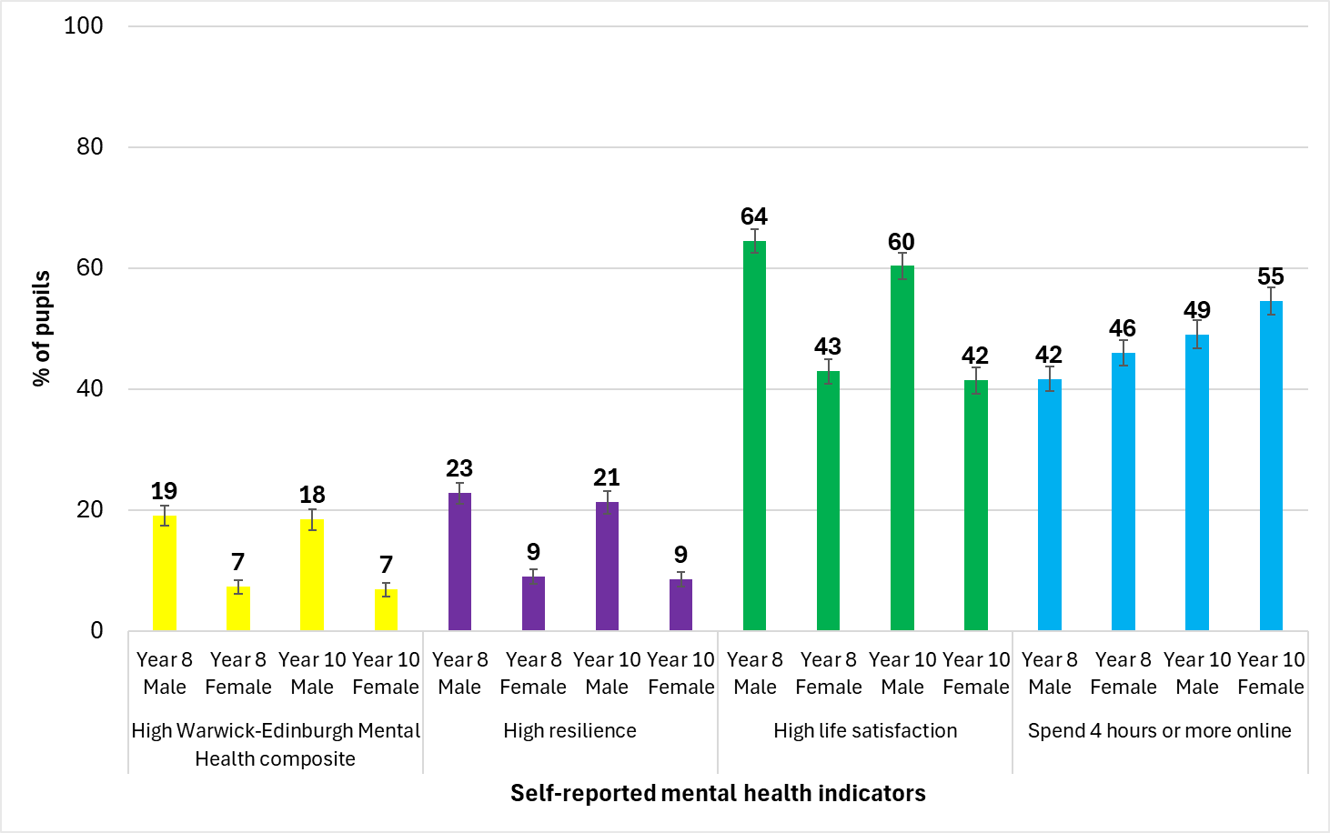

Source: Health Related Behaviour Survey (HRBS), Cambridgeshire and Peterborough, 2024

Estimates of autism and ADHD prevalence vary widely but it is clear there has been a huge rise in demand for diagnostic assessments for both these conditions, with very significant impacts on waiting times. As of October 2024, there are approximately 1,000 children and young people across Cambridgeshire and Peterborough awaiting an assessment for autism (this has doubled since January 2024). In January 2024 there were 1,500 awaiting a diagnostic assessment for ADHD. These children and young people need holistic care based on their needs including pre and post diagnosis. This should be provided through education (including early years and at home), through local communities and across NHS pathways.

There are estimated to be just over 3,000 children with a learning disability in Cambridgeshire and Peterborough. However, not all of them will have received a diagnosis. Children with a learning disability in Cambridgeshire and Peterborough are more likely to have a range of physical health, mental health and developmental comorbidities than children without a learning disability.

As children with SEND approach adulthood it is important that they are adequately prepared for employment, independent living, good health, and have friends, family and belong to a community. There have been growing needs to support young people to transition to adulthood. For example, over the past five years, the East of England has seen a 95% increase in Personal Independence Payment (PIP) claims among young people aged 16-24, with 80% of these claims linked to mental health conditions or autism. It is important that we understand this rise, and how young people with SEND can be best supported into adulthood as population level needs are changing.

Children in Care are those children in the care of the local authority. On 31st March 2023, 646 and 412 children were in the care of Cambridgeshire and Peterborough local authorities, respectively. Over that period, Cambridgeshire had a lower rate of children in care but more timely local data, suggests that there has been a recent increase. Peterborough’s rate for children in care has been similar to the national average. There has been an increase in complexity of need among children in care, some of whom consequently remain in care for a longer time and with additional requirement of complex support and specialist professional input. Being care experienced substantively impacts on a young person’s life chances.

In 2023, 86 young people aged 10-17 years entered the youth justice system for the first time in Cambridgeshire and 48 in Peterborough. While Cambridgeshire’s rate of first-time entry was similar to the national average, Peterborough’s rate was higher and the second highest rate in the East of England. Children and young people at risk of offending or within the youth justice system often have more unmet health needs than other children, and particularly for mental health. National and local studies have shown clear disproportionality in the young people in contact with the youth justice system, with rates higher for some ethnic minority groups and marginalised communities, and there are stark inequalities in outcomes.

**Recommendations into action:**

**Action 4.1:** Ensure that the proposed roadmap with system partners to extend services across the system meets the mental health needs of young people up to the age of 25, both with common mental health conditions and severe mental illness [MH JSNA recommendation]

**Action 4.2**: System partners across Cambridgeshire and Peterborough have co-produced an All-Age Autism Strategy that has identified 8 key priorities ranging from early identification to support with employment and accessing health care. These recommendations should be implemented.

**Action 4.3**: The children’s learning disability health needs assessment has highlighted system improvement actions around diagnosis, annual health checks, reasonable adjustments, support for physical health needs, data collection and special schools that should be implemented.

**Action 4.4**: Look at opportunities to strengthen local approaches to Preparing for Adulthood, including across organisational boundaries, between children’s and adults’ services (including PIP), and between physical health and mental health, to ensure that young people with SEND can gain employment, become independent and live long, fulfilling and healthy lives.

**Action 4.5**: All services should be aware of the increased complexity of children in care and where possible prioritise children who are care experienced, including unaccompanied Asylum seekers (UASC), to improve outcomes. This includes agreeing responsibility for access and response for physical, emotional health and learning needs; shared funding to access appropriate services; and having the right placement and provision.

**Action 4.6:** Strengthen our system-wide approach and the integration of preventative and targeted support for children and young people at risk of offending, exploitation or drug/alcohol use, to reduce the disproportionality of young people from minority ethnic groups and marginalised communities in contact with the justice system and to ensure equity of access to early support to improve their life chances.

## **STRATEGIC RECOMMENDATION 5:**

## Strengthen and integrate place-based community services to enable equitable access to support, treatment and care in the most appropriate setting

The Census data shows that between 5-7% of children aged under 15 (varying by area) had a physical or mental health condition or illness lasting or expected to last for a year or more in 2021.

**Figure 6: Percentage of children with a physical or mental health condition or illness lasting or expected to last for a year or more, Cambridgeshire and Peterborough, 2021 Census**

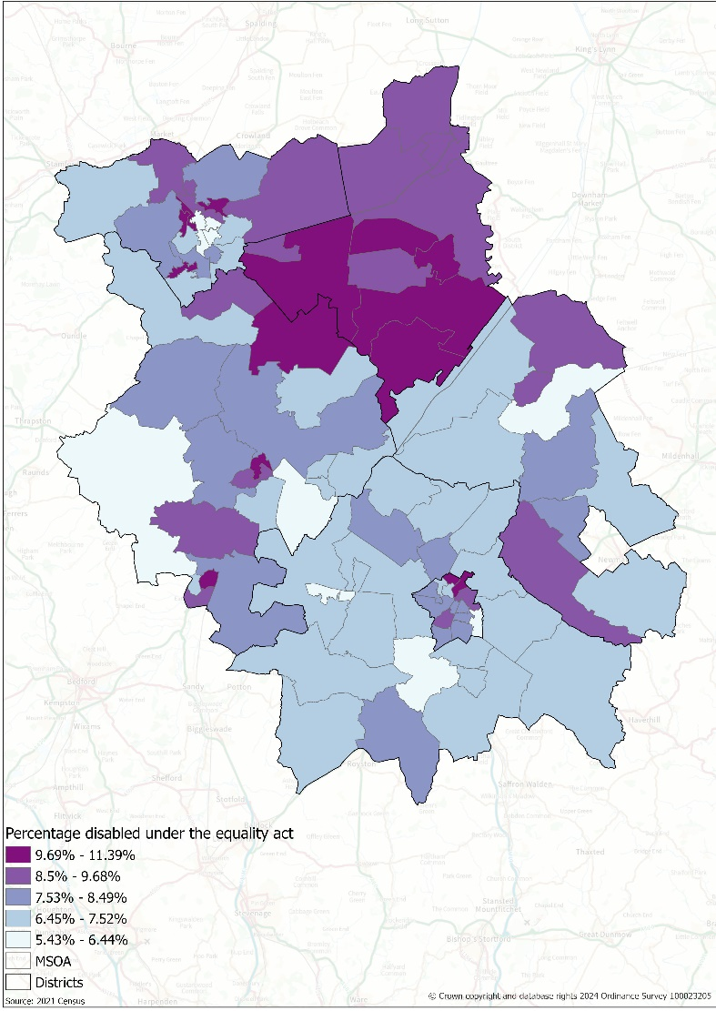

Source: 2021 Census

A&E attendances in children aged under five years are frequent but often preventable, and commonly caused by accidental injury or by minor illnesses which could have been treated in primary care. In 2022/23, rates of A&E attendance in Cambridgeshire and Peterborough are lower than the England average, but Fenland was a clear outlier with a much higher rate. Between October 2022 and September 2023, 8% of A&E attendances were from 898 patients aged 0-19 years (0.4% of the population). This disproportionately heavy use by a small number of children and young people requires further investigation.

Around 6,300 children in Cambridgeshire and 2,500 children in Peterborough have a diagnosed long-term condition. Asthma is the most common long-term condition among children and young people and is one of the top ten reasons for emergency hospital admission in the UK. Whilst in recent years emergency hospital admissions are beginning to fall, deprivation continues to be a risk factor for asthma admissions amongst children and young people.  Emergency hospital admission rates for asthma are higher in Peterborough than in Cambridgeshire, but no different to the England average.

While bringing care closer to home is the aspiration, some children will still need hospital treatment. The planned children’s hospital at the Addenbrookes’ site to the south of Cambridge has the potential to not only improve care for local children, but also to shift the demographics of the population. Families with children who require considerable specialist input may choose to relocate to the area in order to be closer to their child’s healthcare, which in turn is likely to create additional need for specialist educational provision, housing adaptations, and other support services. Similar smaller-scale impacts are likely when new special schools are built in Cambridgeshire and Peterborough.

**Recommendations into action:**

**Action 5.1**: Acute, specialist and community services should work together with existing local services (e.g. schools and GPs) so that children and young people’s needs can be met closer to home. Services should be person-centred, prevention-focussed and promote healthy behaviours.

**Action 5.2:** All services should maximise educational attendance which may include seeking opportunities to deliver care within a school setting or offering different appointment times so that children are not missing out on school. If children need multiple specialist appointments, these should be co-ordinated to minimise school absence.

**Action 5.3:** There should be promotion of family friendly policies across local employers so that parents and carers can take time off work to take children to medical appointments.

**Action 5.4:** To reduce health inequalities, services should routinely collect data on protected characteristics and undertake equity audits to ensure that they are providing equitable access and opportunity for all children and young people.

**Action 5.5:** As plans for the new children’s hospital progress, the implications for other services must be considered and likely changes in demand understood.

1. [Cambridgeshire & Peterborough Insight – Joint Strategic Needs Assessment (JSNA) – 2024 Children and Young People JSNA](https://cambridgeshireinsight.org.uk/jsna/2024-cyp-jsna/)).
2. Pupil Absence rates are the percentage of half days missed by pupils due to overall absence in the academic year (including authorised and unauthorised absence). 