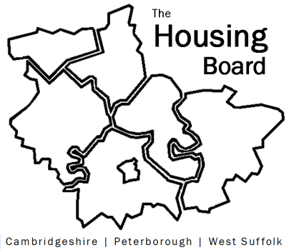
The Housing Board
Cambridgeshire | Peterborough | West Suffolk
Meeting from 10:00 to 12:00, Friday 8 November 2024
To be held online via Microsoft Teams: link can be found in the meeting invite
AGENDA
 | Item | Lead
 | Welcome/apologies  Actions of previous meeting to approve, and matters arising.  Meeting papers available at www.cambridgeshireinsight.org.uk/housingboard | Dan Horn  Chair
 | - Tackling serious organised crime | Neil Sloan  Cambs Police
 | - Housing Delivery stats 2023/24  Rob will talk us through the unpublished county-wide housing delivery stats which come through the planning annual monitoring reports for each district. Enablers will contribute info on the affordable housing programme, which may differ. | Rob Kemp form Cambs County with Frank Mastrandrea for housing enablers
 | - Adaptations Review | Helen Reed
 | - Poverty Commission and housing | Yannick Auckland
 | - Public health, JSNA and HWBB catch-up | Iain Green, Public Health Peterborough
 | - AOB  - Homelessness review to come to December meeting provided govt stats are available  - Adding housing board members to Changing Futures mailing list? | Sue Bee
2024 meeting dates (10am – 12 noon)
- 6 December
- 10 January 2025

