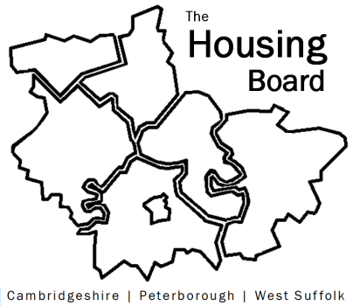
The Housing Board
Cambridgeshire | Peterborough | West Suffolk
Meeting from 10:00 to 12:00, Friday 6 December 2024
To be held online via Microsoft Teams: link can be found in the meeting invite
AGENDA
 | Item | Lead
 | Welcome/apologies  Actions of previous meeting to approve, and matters arising.  Meeting papers available at www.cambridgeshireinsight.org.uk/housingboard | Dan Horn  Chair
 | - Annual review of homelessness and related issues | Jon Collen HDC, Heather Wood SCDC
 | - Poverty Commission and housing: brief update | Sue B
 | - AOB  - Update form CPCA on planned partnership with Homes England  - RP stock info (annual surveys vs cost of national database)  - Quick check if members of HB can download the papers shared in the chat function of meetings. | Azma A-P  Sue B
Next meetings (10am – 12 noon)
- 10 January 2025
- 7 Feb 2025
- 7 Mar 2025

