|  |  |
| --- | --- |
|  | **Changing Futures Cambridgeshire & Peterborough**  **Impact Report**, October 2024 |

|  |  |
| --- | --- |
| **Brief Description** | **Changing Futures Cambridgeshire & Peterborough** (CFCP) is a partnership approach to improving outcomes for people who face multiple disadvantage. Multiple disadvantage means someone experiencing three of five of homelessness, mental health issues, substance misuse, domestic abuse and offending behaviour, at any one time. It does this by encouraging involvement of people with lived experience at all stages of our system and service design and looking at how our partnerships affect people. |
| **Funding Partnerships 2022-25** | Public Health, Cambridgeshire County Council (hosting), Probation, Combined Authority, Office of Police & Crime Commissioner, Cambridge City Council, Fenland District Council, South Cambridgeshire District Council, East Cambridgeshire District Council (year 1 only) |
| **Area covered** | All |
| **Status** | Year 3 of 3 year programme (2022 – 2025) |
| **Programme Contact** | Tom Tallon; Tom.tallon@cambridgeshire.gov.uk |
| **Context** | Changing Futures is a national programme. CFC&P sits alongside this but is not one of the 15 areas that receive national funding. The national evaluation partner has been used to evaluate the C&P programme. |
| **Purpose of Paper** | In response to the positive and encouraging findings of two independent evaluations of the national Changing Futures (CF) programme, the Ministry of Housing, Communities and Local Government (MHCLG) has [extended the CF programme](https://www.gov.uk/government/news/life-chances-of-vulnerable-adults-improved-as-government-extends-73-million-changing-futures-programme) funding for the 15 local areas. |

Contents

1. What is the MEAM Approach and why is it important? 2

2. Impacts 3

Homelessness Outcome Star 3

New Direction Teams Assessment 4

Accommodation 5

Service Use 6

National Changing Futures Outcomes 7

3. Testimonials of partners 7

4. Individual case studies 9

5. Project Plan Outcomes 10

System Learning 10

Co production and co design 11

Trusted Person approaches 12

Trauma Informed system 12

**Changing Futures Cambridgeshire & Peterborough impact report, October 2024**

### What is the MEAM Approach and why is it important?

The MEAM Approach is a non-prescriptive framework developed in 2012 by Making Every Adult Matter (MEAM), a coalition of the national charities Clinks, Collective Voice, Homeless Link and Mind. Its purpose is to help local areas to design and deliver better coordinated services for people experiencing multiple disadvantage. As of the most recent evaluation in late 2022, there are 32 MEAM Approach areas throughout the UK.

The MEAM Approach launched with three pilot areas, of which Cambridgeshire was one: Cambridgeshire has remained a MEAM Approach area for its entire duration, the only area to do so. Peterborough formally became a MEAM Approach area in 2020. Progress towards delivering better outcomes for those facing multiple disadvantage has been quantitatively evaluated throughout the Approach’s application, with half-yearly evaluations produced from March 2018 to October 2022, which is the final report of that evaluation cycle. As of September 2024, MEAM have renewed Cambridgeshire and Peterborough’s membership of the Approach network because our ‘local partnership are actively working towards systems change for people experiencing multiple disadvantage’. The evaluation provides an evidence-based assessment detailing how the application of the MEAM Approach in Cambridgeshire and Peterborough has stopped, slowed or reversed trajectories into multiple disadvantage in our areas.

The report presents results of the MEAM Approach evaluation for Cambridgeshire at October 2022 and Peterborough at September 2021. The analysis of the data was undertaken by Cordis Bright, who are also the evaluator for the national Changing Futures programme. The data is provided by Counting Every Adult, the operational element of Changing Futures C&P. Consequently, the data relates directly to those facing multiple disadvantage supported by Counting Every Adult and Changing Futures C&P. The importance and relevance of the MEAM Approach evaluation data is noted in most recent Changing Futures national programme report, which states: ‘Evaluations of both…the MEAM Approach have provided a significant evidence base on multiple disadvantage and we have supplemented findings from the Changing Futures evaluation with insights from these evaluations.’

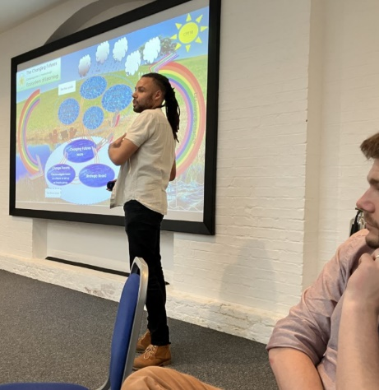

1 Carl Brown of MEAM talks through our Learning Ecosystem slides at the 2023 MEAM annual conference

The full versions of each report with more detail on methodology, assessment and data can be found [here](https://cambridgeshireinsight.org.uk/housing/changing-futures-cp/).

Finally, it should be noted that Changing Futures Cambridgeshire and Peterborough have procured the services of Cordis Bright and MEAM to create a bespoke, area specific evaluation framework and evidence baseline to iteratively assess the programme going forward. The framework will be ready in January 2025.

## Impacts

Since 2022 Changing Futures has supported **104** people facing multiple disadvantage. 74 of these people are still on the current caseload at October 2024 while 40 peoples’ cases have closed. The cohort assessed as part of the MEAM evaluation is a subset of those supported by the programme, so MEAM evaluated 28 people of our total cohort of 104.

Further detail on the whole Changing Futures caseload is provided in the *outcomes and proposals* report which accompanies this *impact* report.

#### Homelessness Outcome Star

The Homelessness Outcomes Star is a tool used to measure, track and support progress towards a range of identified goals. It is completed by the coordinator in consultation with the person they are supporting and with partner agencies also working with the person.

It measures a person’s increasing capability against key outcomes such as motivation, managing tenancy and accommodation, and offending over a period of 12 months for the assessed cohort (17 people facing multiple disadvantage in Cambridgeshire, 11 in Peterborough).

Key figures for Cambridgeshire, set out in Fig 1:

* A **70%** increase in capability managing **tenancies and accommodation**.
* A **47%** increase in capability managing **offending behaviour** and **47% reporting stability** in capability.
* A **47%** increase in capability managing **mental and emotional health** and **47% reporting stability** in capability.
* A **71%** increase in capability managing **money.**
* A **64%** increase in **motivation** and a **52% increase** in capability for exercising **self-care.**
* A **29%** increase in capability managing **alcohol and substance misuse** and **59% reporting stability** in capability.

Key figures for Peterborough are similar, with a **64%** increase in capability managing **mental health**, **90%** reportingincreased or stable capability in managing **drug and alcohol misuse**, **87.5%** reporting increased or stable capability in managing **tenancy and accommodation**, and **100%** increased capability in managing **offending behaviour** for the cohort.

1. Reported increase in capability over 12 months (Cambridgeshire)

#### New Direction Teams Assessment

The New Direction Teams Assessment was originally developed by a Southwest London mental health team for assessing adults facing chronic exclusion and is widely used by organisations working with people facing multiple disadvantage.

People are scored against 10 categories which are indicators of multiple disadvantage; these include engagement with frontline services, self-harm, risk to and from others, stress, social effectiveness, alcohol/drug use, impulse control, and housing.A **reduction** in score indicates a **reduction** in the indicators of multiple disadvantage and represents **positive progress.** Some key figures over 12 months of reporting for the assessed cohort (17 people facing multiple disadvantage in Cambridgeshire, 13 in Peterborough):

* **20% reduction** of indicators for **drug and alcohol misuse** for Cambridgeshire. (21% in Peterborough)
* **24% reduction** in indicators for **intentional self-harm** for Cambridgeshire. (48% in Peterborough)
* **25% reduction** of indicators for **unintentional self-harm** for Cambridgeshire (38%in Peterborough)
* **26% reduction** of indicators for **housing** for Cambridgeshire(28% in Peterborough)
* **32% reduction** of indicators for **stress** for Cambridgeshire(31% in Peterborough)
* **41% reduction** of indicators for **impulse control** for Cambridgeshire (52% in Peterborough)
* **24% reduction** of indicators for **posing a risk to others** for Cambridgeshire. (34% in Peterborough)

1. Reduction in indicators for Cambridgeshire & Peterborough

#### Accommodation

This section looks at the change in accommodation used by the assessed cohort (22 people facing multiple disadvantage in Cambridgeshire, 8 in Peterborough) between their first and fourth quarters of support over 12 months. Key figures for Cambridgeshire:

* A **75%** reduction in **rough sleeping**, a **60%** increase of people **in accommodation** (temporary or license i.e. no tenancy agreement) with **all** 100% in **supported accommodation (license)** by the fourth quarter.
* Additionally, there was a **300%** increase (from 1 to 4) of **people in accommodation** (own or shared tenancy), with three having a social housing tenancy and one privately renting.
* These changes also resulted in an average **71.1%** reduction in the mean number of nights **rough sleeping** (from 46.2 to 13.5)**.**

Key figures for Peterborough are a **100%** reduction in **rough sleeping** between the first and fourth quarter (from 2 to 0), and a **200%** increase in persons in **long term supported accommodation,** with one individual going on to live with family. The average number of nights in spent in different accommodation types is also accounted for in Cambridgeshire in Fig 3:

1. Change in average nights in spent in different accommodation types, Cambridgeshire

#### Service Use

This section looks at change in unplanned and emergency services use by people. The eligible cohort was assessed from pre-support to over eight quarters (2 years), with the below comparing pre-support service use with that at the end of the eighth quarter.

Key figures for Cambridgeshire:

* A **27% reduction** in mean number of interactions relating to **nights in prison**
* a **40% reduction** in mean number of interactions relating to **mental health admissions**
* a **37% reduction** in mean number of interactions relating to **arrest**.

Key figures for Peterborough, where assessment was from first quarter of support to fourth quarter of support:

* An **84% reduction** mean number of interactions relating to **mental health admissions** (sample size 9 people).
* A **9% reduction** in mean number of interactions relating to **arrests** (sample size 5 people).

1. Reduction in interactions

#### National Changing Futures Outcomes

The outcomes delivered throughout Cambridgeshire and Peterborough mirror those found within the national Changing Futures evaluation, such as:

* There has been a small but statistically significant reduction in the proportion of people who are homeless, from 59 per cent when people first join the programme to 52 per cent roughly three months later. There is also a significant reduction in people sleeping rough, from 33 per cent to 23 per cent over a similar timeframe.
* Early positive indications of improvements to physical health, with an increase in people reporting no or only slight problems with their physical health. The proportion of participants getting help to access a GP has also increased from roughly one quarter at baseline to about one third three months later.
* There has been a reduction in the proportion of people unable to manage debts or bills, from 37 per cent at baseline to 24 per cent about three months later.
* Working towards greater integration and collaboration across local services to provide a person-centred approach, and reduced demand on reactive services.

## Testimonials of partners

The following compiles assorted testimony regarding the impact Changing Futures Cambridgeshire & Peterborough has achieved:

**Making Every Adult Matter (MEAM)**

C&P are a long-standing and highly respected member of the MEAM Approach network, having been involved from the very start of MEAM’s work in 2010. The C&P partnership and its staff are known across the MEAM Approach network, both for the success they have had in driving change at the individual, service and system level across C&P, and for their willingness to share learning and provide peer support to other areas.

The recent move to develop the local Changing Futures work in C&P speaks to the area’s ability to tell a coherent and compelling story of change—a story that draws on lived experience, local context, and a shared vision for a more equitable system. This is not just about metrics and analysis; it’s about creating a narrative that weaves together diverse perspectives and partners into a cohesive journey of transformation.

Crucially, this wider systems approach has led to demonstrable improvements in outcomes for people facing multiple disadvantage. By building more coordinated, person-centred support, they have helped reduce instances of homelessness, improve engagement with services, and support people to achieve more sustainable, positive life changes[1]. In this way, Cambridgeshire and Peterborough not only inspire, but show how strategic systemic change directly benefits the individuals at the heart of this work.

**Campbell Tickell, evaluators of the Rough Sleeper Drug and Alcohol Treatment Grant for Cambridge and Peterborough**

‘Cambridgeshire and Peterborough Changing Futures programme operates a Trusted Person approach. This enables people who face multiple disadvantage to access all the support they need without repeating discussion of their experiences… We think there would be particular value in exploring this approach in Cambridge in relation to assessing the suitability of move-on options and ensuring tenancy support is provided’

‘We recommend utilisation of the Trusted Person approach developed by Changing Futures as a means of developing effective multi-agency working arrangements for this part of the cohort’

‘…the Changing Futures project [is] undertaking significant work on systems development across the Cambridge and Peterborough area in partnership with services and clients…The emerging model provides a useful map for a whole system to understand and analyse how it could work more effectively’

‘It is recommended that partners use the Changing Futures methodology to look again at strategic partnerships to ensure that the system and all organisations which are part of the partnership are working together in a learning ecosystem and trauma informed way’.

**It Takes a City** “It Takes a City is happy to see Changing Futures as an umbrella to come under, learn from and support. We are with you"

**Probation** “Honestly Counting Every Adult is the best thing ever - I’d never even know to suggest something like that. Thank you!”

**Commissioning Team Manager for Substance Misuse and Inclusion Health** “The Change Forum in Peterborough so far has really helped to advance partnership working by giving space for services to listen to each other as we try and address some of the key challenges we all face. Moving forward as Changing Futures develops and evolves, we have a really good platform to take work to the next level”

**Criminal Justice Coordinator, CGL** ‘I just want to say an enormous thank you for the life changing piece of work you instigated for DB. DB had been caught in a spiral for years, with nobody able to get DB the right help. Because of you, Dave from Housing First and Corryn CPN, DB got the support he needed and has now got his own flat for the first time in 22 years. He now has the foundation to have a better quality of life. So, thank you so very much.’

**Public Health Commissioner at Cambridgeshire County Council** Referring to the effectiveness of the Trusted Person Approach when supporting individuals with experience of multiple disadvantage in a presentation at 'Collaborative Working in the Criminal Justice system' event, said how, “How impactful it was and how it should be a consideration for any service in the system to work effectively with individuals’

**Cambridgeshire University Hospitals NHS Foundation Trust - Preventative and Personalised Care Board** ‘We have examples of the trusted person model for people facing multiple disadvantage in East Cambridgeshire where the person initially felt that they could no longer trust professionals so didn't want to work with them - after support they are now working together to make the changes that matter to them.’

**GP - Cambridge Access Surgery** ‘Thank you very much to the co-production group for spending time with the Mayor to highlight the work done at Cambridge Access Surgery’

**Donald, expert by experience** ‘Now I don’t have a trusted person, I have a trusted channel. Marie has gone from being my trusted person, to someone I consider to be my family, and her network has become my trusted channel. I now have a good future, all thanks to one encounter, with someone who cared for long enough, for me to put my trust in them. That trust is now rock solid, I am looking forward to building on it further’.

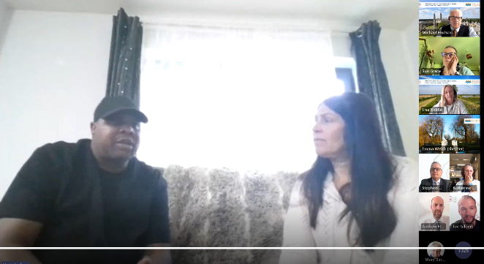

2 Donald and Marie in “Cambridgeshire Conversations with Stephen Moir,” Chief Executive, Cambridgeshire County Council, Aug 2024

**CGL** ‘Thanks to everyone (in the Changing Futures Team) who worked so hard to get all the arrangements in place for yesterday, it’s a great example of joint working. We are lucky, we had all of you, a brilliant team of support’

**Expert by experience after attending their first Coproduction group meeting** ‘I loved today. You’re always pushing me to do more and it’s good, it’s working, it’s nice to feel needed and helpful and useful and a part of something good. The small groups helped so much, it helped me get to know a few people at a time until I knew the whole room, what a great idea... I feel very happy and energetic now just wanna get stuck in to with more stuff. I’m going to brave the outdoors to get my meds and actually open all the curtains today’.

## Individual case studies

Case studies highlight issues to overcome, as well as the effectiveness of the Trusted Person approach, over the last 3 years. Here is a summary of a few, the links provided take you to a more detailed note:

[Mike](https://cambridgeshireinsight.org.uk/wp-content/uploads/2022/07/case-study-mike.pdf)’s story exemplifies the importance of working together in partnership to unlock systemic barriers and achieve better outcomes for people. Changing Futures Coordinators do this as part of their work and support others in the system to do the same

[Martin](https://cambridgeshireinsight.org.uk/wp-content/uploads/2022/10/case-study-martin.pdf)’s story reflects how positive communication and shared goals between services can break the cycle of homelessness and addiction. Changing Futures has created spaces to explore how Trauma Informed systems can help people and avoid them repeating their stories

[Molly](https://cambridgeshireinsight.org.uk/wp-content/uploads/2022/10/case-study-molly.pdf)’s story shows how bringing services and networks around a person and using Trusted Person approaches can help inform decision making to prevent long term homelessness and allow access to the right support services. Changing Futures support partnerships is applying Trusted Person Approaches

[Leon](https://cambridgeshireinsight.org.uk/wp-content/uploads/2023/09/case-study-leon-010923.pdf)‘s story highlights use of the Trusted Person approaches, including Leon building his circle of trust, and how other people across the system starting to adopt the Trusted Person approach and apply the lessons learned from Changing Futures to help other individuals.

## Project Plan Outcomes

This section outlines some of the key milestones for the Changing Futures programme and progress to date. For more detail on the project plan please visit [***Project Plan.xlsx***](https://cccandpcc.sharepoint.com/:x:/r/sites/ChangingFuturesProjectTeam/Shared%20Documents/Project%20Plan/Project%20Plan.xlsx?d=w4dc0631d041040aea31df7e86c8b6a5c&csf=1&web=1&e=FWiG3r&nav=MTVfezAwMDAwMDAwLTAwMDEtMDAwMC0xNTAwLTAwMDAwMDAwMDAwMH0)

#### System Learning

***A number of people from across the system have been identified and supported to be able to lead an enquiry into systemic issues that they are aware of.*** Completed: 6 people have undertaken systems leadership training, 4 of which have led or are leading enquiries. Further training soon to begin, with 48 people over three cohorts receiving it. The training will use action experiments, which essentially are enquiries into systemic issues being encountered by those trained, resulting in a potential 48 further enquiries from across the system to be explored.

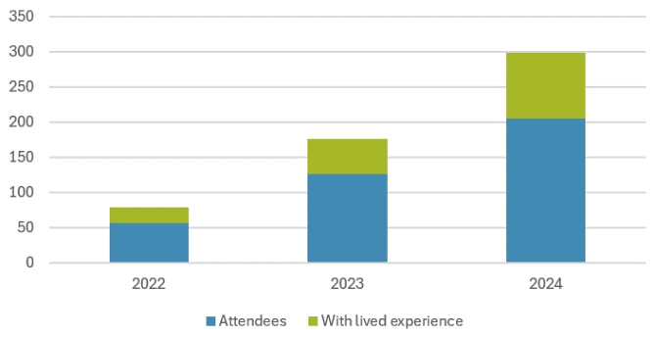

3 Learning events: in 2022 there were 57 attendees, of which 22 had lived experience. By June 2024 this had grown to 206 attendees, of which 93 had lived experience

***Improved awareness of what is a system barrier and system issue that can be addressed through the Changing Futures networks*.** Completed: Systems Leaders Group have undertaken a session specifically on the fundamentals of an effective system, focussing on structural impediments to healthy systems. Spaces have been created, maintained or supported where groups identify and work through systemic issues collectively (Change Forums, Co-pro groups, CoP), or to facilitate system leadership in tackling specific, concrete cases involving service users (PSGs).

***Establish a peer network for systems agents****.* Completed: at present, a group meets every 4-6 weeks as a Community of Practice for systems leadership and thinking, offering peer support, reflective practice, and offering a diagnostic space to troubleshoot difficult enquiries and drive forward action in tackling systemic issues. The intention is to nurture further CoPs for involving those attending the forthcoming systems leadership training.

***Systems leadership programme in place to train and support leaders across the network***. Completed: this has been procured. 48 people will be trained over three cohorts, with the first beginning in mid to late October.

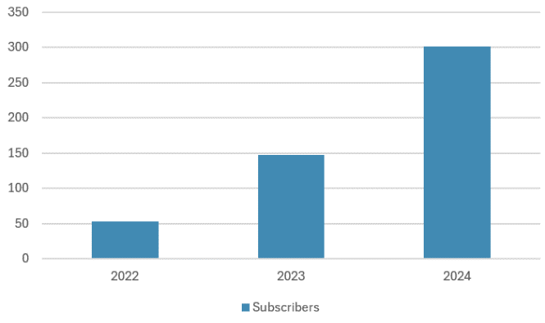

4 Newsletter subscribers: grown from 53 in 2022 to 302 in June 2024, from 83 different agencies

***Facilitate a space/forum for systems leaders to come together for peer support*.** Completed: this is the Systems Leaders Group, which convenes quarterly. Previous meetings have focussed on exploring the core pillars of Changing Futures’ practice, but the programme is looking to utilise the group as a network to explore, practice and mainstream systems leadership throughout the partnership and cultivate a more connected, effective system.

***Develop at least one system enquiry into system barrier action plans*.** In progress: work is underway to explore, within some the programme’s more mature enquiries, how a given enquiry’s particular barriers are examples of deeper systemic issues and to provide a ‘cheat sheet’ as first pass to inspire further action for people facing similar barriers. The intention is to use two enquiries for this, with a third having excellent potential but needing to progress slightly further.

Learning from case coordination: Case coordination forms the foundation for wider system change, as it enables recruitment of people with lived experience, fosters multi-agency working, and it enables up-to-date knowledge of local systems around the five “petals” of multiple disadvantage.

#### Co production and co design

***Wisbech Coproduction Group up and running and identifying potential system enquiries:*** By June 2024 Two Fenland Coproduction sessions had happened to scope the landscape and work on how we can progress as a partnership. After a hiatus due to change in staffing, the group will resume in the Autumn with key services in the Wisbech ecosystem keen to support participation.

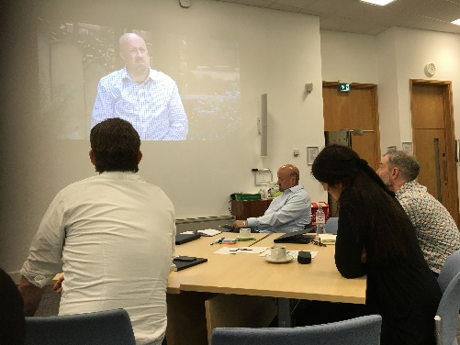

5 Paul explaining the importance of a “Handheld, not a handout” to System Leaders (Oct 2023)

***Ely Coproduction Group up and running and identifying potential system enquiries:*** By June 2024 Ely Coproduction well established and on the verge of identifying its first enquiry. The group has chosen to name itself ‘Our Voice’ to give it identity and be something to describe to others with lived experience who might want to participate. Changing Futures is working with the Lighthouse to conduct an evaluation of issues that face people who present at their food hub. We plan to enable skilled volunteers to interview up to 100 people to identify, theme and group ongoing needs. From this we plan to create a space where people can begin to access this support.

We are overseeing 9 systems enquiries and witnessing how some of these working groups are steering progress towards policy, commissioning and legislative change:

***Huntingdon Coproduction Group up and running and identifying potential systems enquiries:*** Some work has been done by Donald speaking with people with lived experience in the area. Great appetite to commence. Working to start a group, aiming for end of November. A number of services are keen to support and provide suitable venues

***Reflective work on the impact of those who contribute***including feedback loops and celebrating success - 'you said we did' approach: Enabling the voices of lived experience workshop held September 2023, Invented the Poster board that people can contribute, displaying celebration, organisation requested to give their views and inputs. Ely, Fenland and Peterborough has feedback loop from progress of group, more work to be done regarding the above, demonstrating the achievements of Coproduction. Celebrations to be put on website and find a way of bringing to all Coproduction groups. Aim is for all organisations working with LE agreeing to this feedback loop.

***Identify a network of coproduction leads within organisations across the system*:** Include as part of future funding proposal scope. 26/9/24 - extensive mailing list with individuals and services being made aware of coproduction activities across all hubs.

***Work to ensure that people with lived experience can be present in strategic spaces without it being tokenistic***: Develop the 'buddy' concept and check if it is achieving the intended outcomes. Buddy System in use in multiple spaces. Structure, guidance and oversight need to be developed further. Meeting with partners to develop. Some synergy with ICS. Links established.

#### Trusted Person approaches

***Review Trusted Person Model:*** TP approaches were reviewedin Summer 2023 and several case studies produced. New iterations need to be allowed to develop based on CEA feedback, feedback from the system, and LE and included in lessons learned. The TP approach has been reiterated again following learning from people with LE. Presented work at MEAM conference as 'innovative approach'. spoken with several other areas interested in learning the principles

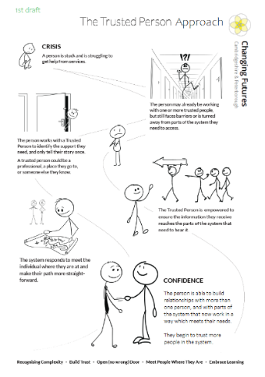

6 Note outlining the Trusted Person approach

**Promotion:** Several partnerships have expressed an interest in implementing TP approaches more formally including Streets to Home; Rough Sleeper Drug and alcohol partnership; Wisbech Housing Partnership; High Intensity Users; Acorn Project; Co-occurring Conditions partnership; Safer off the Streets); ICS City place. We are helping partnerships come together to explore it and do it themselves - videos, meet-ups, documentations etc.

The County Council including the Trusted Person approach in commissioning providers of adult Housing Related Support.

#### Trauma Informed system

***Build a collective understanding and shared ambition around what trauma informed practice mean*s** for Cambridgeshire and Peterborough community of practice: A trauma informed system group moving forward. The Trauma informed network attracted interest from all parts of the system and has started to include partners from outside of the multiple disadvantage sector. Three workshops have been held attracting around 40 professionals and people with lived experience each time. The most recent was held July 2024. We are currently working with Mental Health, Learning Disability & Autism partnership on establishing a senior level steering group. May need to review whether this continues to sit with CF or enlarges due to interest from partners working outside multiple disadvantage. Increasing partners on mailing list. Regular 'core group' meetings between workshops. Fieldwork groups starting to work separately in Oct 2024 then come together periodically to develop the network.

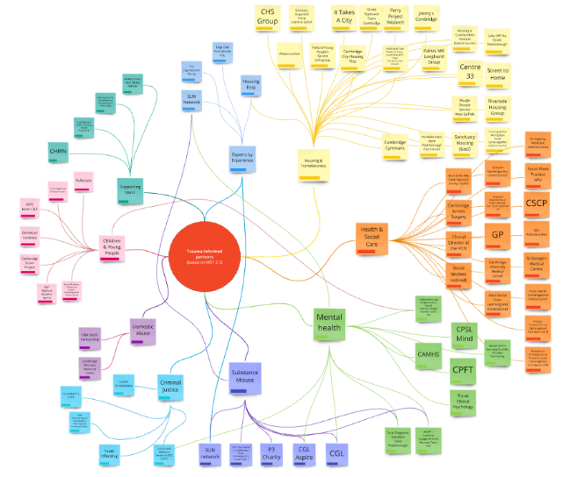

7 Trauma informed network includes 17 organisations – foundation for a system map (June 2024)

1. Cordis Bright’s [**MEAM Approach Final Evaluation Report** (Year 5)](https://meam.org.uk/publications/meam-approach-evaluation-final-report/) published in October 2022 offers a comprehensive overview of the impact of coordinated systems approaches in MEAM areas, including Cambridgeshire and Peterborough. It demonstrates improved outcomes for individuals facing multiple disadvantage, such as a 41-percentage point decrease in rough sleeping over two years, a 37% reduction in A&E attendances, and significant reductions in contact with the criminal justice system. These findings underscore how a systems-focused approach can drive positive change for people while also evidencing the wider service and cost benefits achieved​ ([MEAM](https://meam.org.uk/2022/10/20/a-step-change-in-the-evidence-base/)). Access to the full report and key findings is available [here](http://meam.org.uk/publications/meam-approach-evaluation-final-report/)​.