BBC summary:

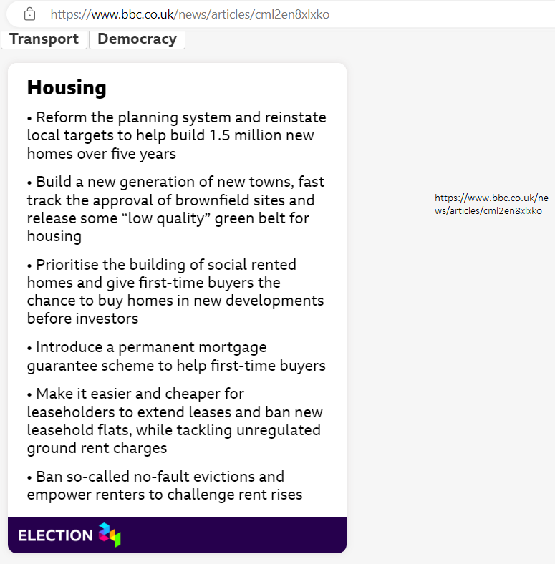

**ITV news**

**What are Labour’s plans for housing and how will they work?** By Rachel Reeves, Monday 8 July 2024 at 5:12pm

On Monday, Chancellor Rachel Reeves announced a variety of plans to build more houses across the UK.

In her first speech since the General Election, Ms Reeves reiterated a number of campaign promises, including freeing up planning restrictions and forcing local councils to build more homes.

She added she will reinstate compulsory housebuilding targets for local councils, as part of plans to build 1.5 million new homes within five years.

It follows former Levelling Up Secretary Michael Gove removing mandatory targets in 2023, which prompted councils across the country to revise their housebuilding plans.

Ms Reeves said Labour would reform the planning system to make it easier to build houses on less desirable parts of the green belt, which Prime Minister Sir Keir Starmer has dubbed the “grey belt”.

The Government will also prioritise building energy infrastructure projects, and lift a de facto ban on onshore wind projects across the UK.

A draft of the National Planning Policy Framework, which lays out the details of how this will work, is expected before Parliament rises for recess in August.

Angela Rayner, the deputy prime minister and levelling up secretary, and Matthew Pennycook, the planning minister, will lead the overhaul. Part of their jobs will be to lead a review of the boundaries of the green belt.

Ms Reeves said Labour will also set up a team of experts to “accelerate stalled housing sites”, starting with projects in Liverpool, Worcestershire and Sutton Coldfield.

The Chancellor did not give a date for the next Budget, where the Government is expected to lay out its spending plans - but she said it would be in the autumn.

**Why is Labour doing this?**

Experts agree that Britain is suffering from a chronic shortage of housing, while previous Governments have struggled to hit ambitious targets to build more homes.

In the year to March, about 135,000 homes started being constructed, a drop of more than one-fifth on the year before. Britain has not built 300,000 new homes a year - the amount needed to hit the 1.5 million target - since the 1950s.

Last month, average private rents in Britain climbed to record highs, in another sign that demand for housing is far outstripping supply.

**Are the targets realistic?**

They’re certainly difficult. Paul Maile, a senior planning partner at law firm Eversheds Sutherland, said obstacles include “supply chain constraints, and a shortage of skilled workers like construction personnel”.

Meanwhile, James Dunne, head of operational real estate at asset manager Abrdn, added that the Government’s targets “have never been reached in annual terms without significant direct development by Government or local authorities”.

“In the expected continued absence of this, the Government needs to go beyond the planning system and work in partnership and financially support the private sector to deliver significant volumes of housing across all tenures.”

Affordable housing is desperately needed, but there is a battle on between the builders and the blockers.

**What are businesses saying?**

In response to Ms Reeves’ speech, Rob Perrins, Berkeley Group chief executive, said he is “hugely encouraged to see the clear priority and focus on housing delivery”.

“Today’s announcements are a very positive start and we will continue to work closely with (the) Government to help unlock the potential of brownfield regeneration sites to deliver good green homes, both affordable and private.”

Barratt Homes, the UK’s largest housebuilder, already voiced support for Labour’s 1.5 million target on Friday after the party won the election.

The Builders Merchants Federation, a trade body, said that the involvement of smaller firms was “critically important to get anywhere near” the target.

**What about the Nimbys?**

And while there is certainly appetite from the business world, there will be significant opposition from so-called Nimbys (“not in my back yard” – a term for people who oppose new developments).

Ms Reeves was asked if Labour is “going to war” with Nimbys after the speech.

She said planning decisions will still “in the first instance” be up to local communities, but compulsory targets mean councils cannot always reject new developments.

The Chancellor said Ms Rayner will also write to planning authorities making clear “what is expected” of them.

Reeves added: “I know there will be opposition to this … trade-offs always exist.

“But we will not succumb to a status quo that … relegates the national interest below other priorities.”

From <https://www.itv.com/news/2024-07-08/the-plan-to-fix-a-country-wide-housing-crisis-that-has-lasted-for-decades>