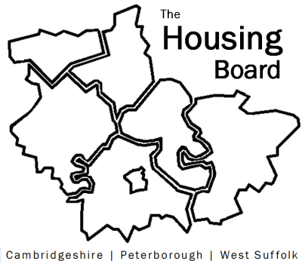
The Housing Board
Cambridgeshire | Peterborough | West Suffolk
Meeting from 10:00 to 12:00, Friday 10 May 2024
To be held online via Microsoft Teams: link can be found in the meeting invite
AGENDA
 | Item | Lead
10.00 | Welcome/apologies  Actions of previous meeting to approve, and matters arising.  Meeting papers available at www.cambridgeshireinsight.org.uk/housingboard | Dan Horn  Chair
 | - End Furniture Poverty  Slides will be circulated after the meeting | Claire Donovan, Head of Policy, Research & Campaigns, End Furniture Poverty
 | - Draft Housing Board Work Plan 2024/25  Draft plan circulated with agenda | Sue Beecroft
 | - Cambs County strategic commissioning intentions  email summary circulated | Lisa Sparks, Cambs County
 | - AOB
 | - Sub-regional Funding and Options  Item for funding partners only | Dan Horn, Sue Beecroft
2024 meeting dates (10am – 12 noon)
- 7 June
- 5 July
- 2 August

