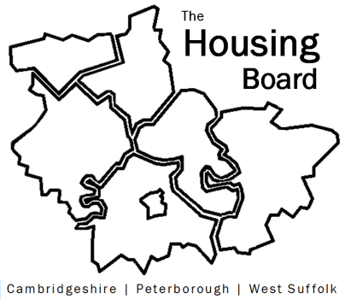
The Housing Board
Cambridgeshire | Peterborough | West Suffolk
Meeting from 10:00 to 12:00, Friday 1 March 2024
To be held online via Microsoft Teams: link can be found in the meeting invite
AGENDA
 | Item | Lead
10.00 | Welcome/apologies  Actions of previous meeting to approve, and matters arising.  Meeting papers available at www.cambridgeshireinsight.org.uk/housingboard | Chair  Dan Horn
 | - Update on Health and Wellbeing ‘audit of housing assessments’ project (note circulated) | Sue Beecroft, David Norton (public health)
10.30 | - Main item: Housing Board planning for 2024/25 – discussion note circulated | Dan Horn /Sue Beecroft
11.45 | - AOB  - Update on C&P ICS Housing Need Survey Evaluation Report (circ)  - Govt plans on asylum seeker housing  - Cambs County strategic commissioning intentions (email summary circulated) | Lead  - Chris Hill  - Sam Shimmon, Cambridge City  - Lisa Sparks to talk through in April
2024 meeting dates (10am – 12 noon)
- 5 April
- 3 May
- 7 June

