Notes of Strategic Board 12 October 2023

What is Changing Futures?
Changing Futures Cambridgeshire & Peterborough is about improving the outcomes for people with multiple disadvantage. Multiple disadvantage means someone experiencing three of five of homelessness, mental health issues, substance misuse, domestic abuse and offending behaviour.

Strategic Board 12 October agenda
Welcome and Introductions Robert Pollock (Cambridge City Council)
Programme Update Tom Tallon (Changing Futures)
Proposed changes to programme governance - Paper attached for consideration Lisa Riddle (Cambridgeshire County Council)
Current System enquiries - Feedback on first escalation Tom Tallon / Peterborough Change Forum
Involving people with lived experience of multiple disadvantage – lessons learned - Paper attached, note questions we will explore at the end of the paper Tom Tallon / The Cambridgeshire Coproduction Group
Involving Experts at strategic levels - The Buddy System - Outline attached Robert Pollock and Paul Knight (The Coproduction Group & SUN Network)
Reflections and Close

Attendees & apologies
Ciara Mole, Custody Prevention and DTOA Co-Ordinator, Cambridgeshire Police
Cristina Turner, Head of Policy, Office of the Police and Crime Commissioner
Dan Horn, Acting Assistant Director, Fenland District Council
Sam Shimmon, Assistant Director, Housing and Homelessness, Cambridge City Council
Donald Munyebvu, Expert by experience, The Coproduction Group
Eleanor Robinson, Trusted Persons Coordinator, Counting Every Adult
Elizabeth Whelan, Health and Justice Partnership Coordinator, Probation, East of England
Emily Sanderson, Countywide Coordination Hub, Cambridgeshire County Council
Joe Keegan, Commissioning Team Manager Substance Misuse, Joint Commissioning Unit, Public Health, Cambridgeshire County Council
Jon Bartram, Programme Director - Strategic Commissioning, Cambridgeshire & Peterborough Integrated Care System (ICS)
Keith Smith, Chief Executive, The Ferry Project, Wisbech
Kelly Storton, Trusted Persons Coordinator, Counting Every Adult
Lisa Barraclough, Senior Safeguarding Leader, DWP
Lisa Riddle, Assistant Director of Communities, Employment and Skills, Cambridgeshire County Council
Liz Watts, Chief Executive, South Cambridgeshire District Council
Marie Ludlam, Trusted Persons Coordinator, Counting Every Adult
Nicola Caffell, Commissioning & Partnership Manager, Probation
Paul Knight, Expert By Experience, SUN Network / The Coproduction Group
Peter Campbell, Head of Housing Options & Advice, South Cambridgeshire District Council
Robert Pollock, Chief Executive, Chair of Group, Cambridge City Council
Shelley Ward, Drugs and Alcohol Policy & Practice / Op Farmington Project Officer, Police
Sue Beecroft, Housing Coordinator, Housing Board
Tom Tallon, Counting Every Adult & Changing Futures Programme, Cambridgeshire County Council
Val Thomas, Deputy Director of Public Health, Cambridgeshire County Council
Khadeeja Bibi, Commissioning and Partnerships Officer, Probation
Beth Whelan (health & justice team, probation)
Nicola Cafell (health & justice team, probation)
Ciara Mole (Cambs Constabulary)
Gary Diggin (CGL)
Nick Sheppard (Cambs County)
Apologies
Sue Grace, Cambs County
Chris Jenkin, It Takes a City
Anne Taylor, Expert by Experience
Steve Smith, CGL
Paul Pescud, CGL

Proposed changes to programme governance
Note on governance was circulated before the meeting
In brief, the plan is to convene a new, small governance group to look at funding, outcomes, and mechanics of the programme, leaving more time for the Strategic Group to work on system-wide topics. The suggestion is that the Strategic Group will be re-named the System Leaders group.

Feedback about Strategic Board arrangements
Introductions round the table take (and need) time – want to allow at least 15 mins for this.
Could run a poll around the length of time and in person or virtual and ask for some suggestions and reflections about ideas
Meetings are really useful but try to get through too much, would rather extend the time to 2.5/3 hours

Programme update slide
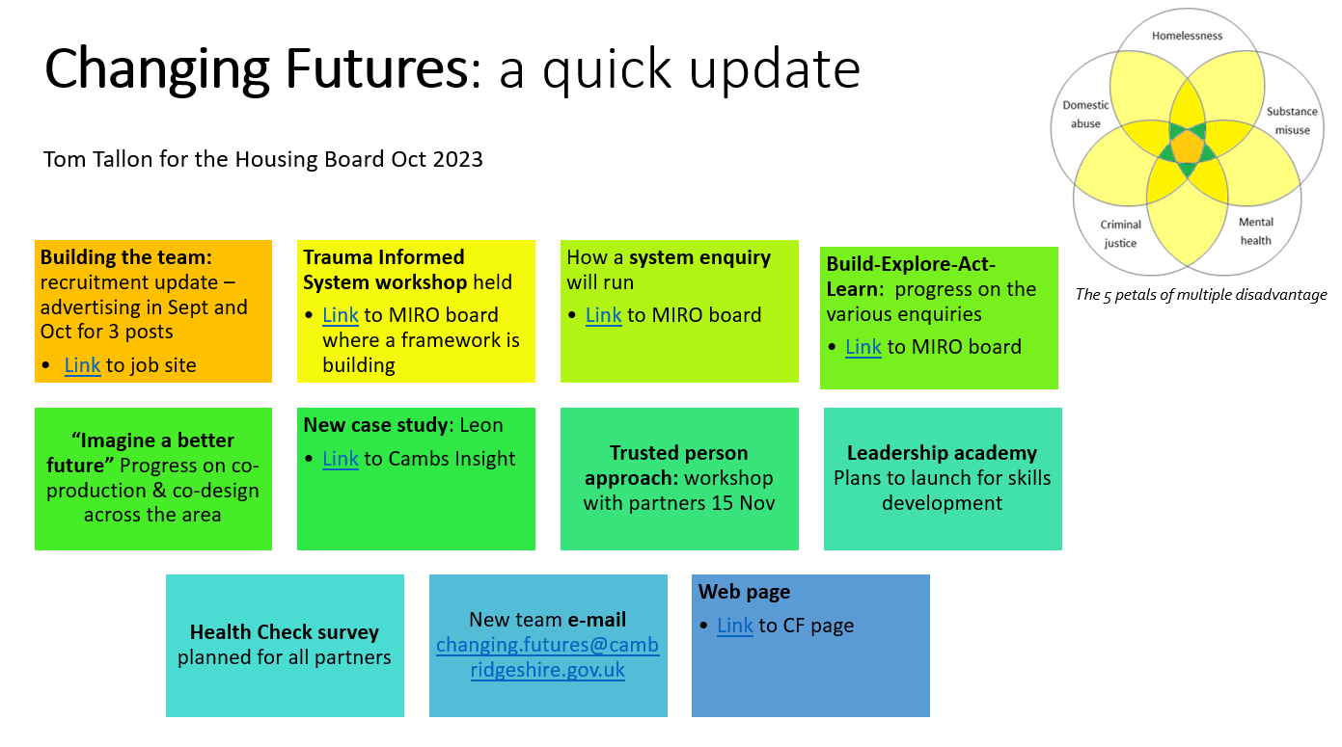
Future locations – found the Bourges Room difficult – the large table with everyone sat around it doesn't promote engagement, plus car parking restrictions meant that some people had to leave early
Plan to e-mail questions re the buddy system around and a request for reflections
Want to add the positive news stories into the forward agenda to bring to each strategic group
Need to clarify the relationship between the strategic group and the governance group – presumably governance group will feed up / report in to the strategic group.
View that it's important to do these meetings in person as you get much more from it
Reps:
  - For Probation, Nicky &/ Beth would probably come to the strategic group
  - Health Rep currently Jon Bartram - will look at who else will come to the strategic group
  - Val Thomas (public health) is keen to be involved in the governance group

Good news stories: things about system enquiries interest and emails
Lots of good news stories from Keith Smith of the Ferry Project, particularly around changing the relationship with the local GP surgery improving both attendance stats for the surgery, and the support people at the Ferry Project are getting.
Conversation about adding a widget to help get someone added to the mailing list
Jon Bartram noted the ICB has commissioned an overview of health provision for homeless people
Dan Horn asked for a system enquiry topic: how do we make it so trusted partners / groups get the same response as statutory services?
New system enquiry notice e-mail: confirmed received by most in the group, except for Nicky from Probation - can we double check the email lists
Suggestion to add a ‘poll’ to system enquiry emails, sent to strategic group giving quick respond options such as Seen / not relevant / Planning to respond need a little time / something else.
Dan Horn - the email has triggered some conversations in Fenland so is likely to continue to respond
Benefit from Changing Futures is that there is now a structure to take these things to
Joe Keegan added support for this as a route and the system approach is supporting this

Involving people with lived experience of multiple disadvantage – Co-production and Co-design progress & learning
Changing Futures aim to establish five co-production hubs, which will bring together people with lived experience of multiple disadvantage to identify systemic issues that are important to them. This note sets out learning across Cambridgeshire and Peterborough, and feedback form experts by experience, along with questions posed to the Strategic Group for exploration.
The ‘Ladder of Participation’ shows different levels of involvement and sharing decision making power with communities, citizens, residents and service users:
- Which level of the ladder is closest to the current practice in the way you/your service/sector works with people to design and introduce changes to the system and how it operates?
- What is your response to the feedback from the coproduction workshop?
- How can you use your influence to encourage your sector to take the next step up the coproduction ladder?

“Ladder” exercise
People were asked to stand in a line, aligned to the “ladder of co-production” graphic on page 5.

What is your response to the feedback from the coproduction workshop?
Language is a really important point - the way we speak shapes the way we think
Integrated neighbourhoods have worked well to translate between different languages - really believing that everyone's voice is valid and should be listened to
Exposure of people using services to people in senior leadership
Challenging the status quo - and accepted wisdom
Continuation of involvement of people with lived experience from the beginning
Change default policy around engaging people with lived experience
Continue the consultation and complete the feedback loop to people with lived experience
Important to think about the breadth of people who are involved with people with lived experience
Don't just engage but actually listen to what people are saying
Be clear about the decisions made as a result of engagement and why those decisions have been made
Cambridge City Housing First approach is strengths based, co-produced with the client, the organisation involving people with lived experience in recruitment and designing services
Part of the ladder is about redesigning the physical environment, not just services
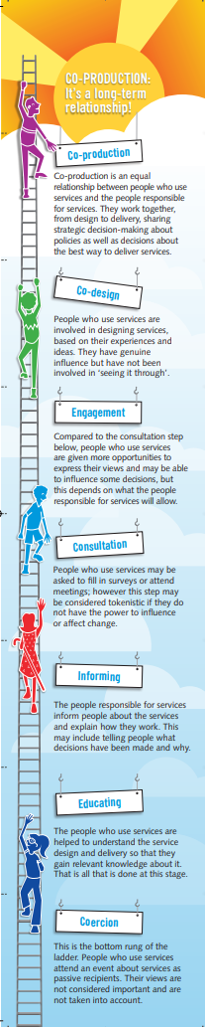
Human conversations at all levels are important
Sometimes people think they are doing coproduction but it's easily tokenistic and/or manipulative – summarized as 'tick box' coproduction
Probation have a lived experience team however some services are statutory/enforcement in nature
When you do consultation is important - open ask or selecting from options, codesign to create the consultation
Cambridge City has a system for engagement called CitizenLab - see https://engage.cambridge.gov.uk/en-GB/
A key question is 'whose agenda is being met through this exercise'
Active Listening is a key skill to support coproduction. Find your silence - listen to the quieter voices
Different types of coproduction - how do we do this? and the variety of approaches
Important to have these conversations widely to pick up the breadth of viewpoints - these types of meetings gather people who are coproduction inclined /empathic / human centred

How can you use your influence to encourage your sector to take the next step up the coproduction ladder?
Active listening is key
How do you facilitate ALL lived experience voices?
One way is to hold individual conversations
Recognize the difference the feedback makes
Feedback improves service AND makes the person feel positive
Listening to the quieter voices - 'find your silence'
Appropriate messages to appropriate feedback
Quick wins
Ways people prefer to be involved
Barrier can be how broad the experience 'feels' to people in power
The more you do it the more you see the need for individuality - need to use this to do system change on a broad level
Prompts for different types of coproduction
Important to encourage everyone to go 'up' one step on the ladder
Influence up the coproduction ladder
Community forums - ICS and Council - ICS summit
Joint working
Building trust / credibility
Incremental - small wins
Target areas can influence
Keep plugging away - in it for the long game
Increase/encourage sector to take the next step up the coproduction ladder
Using customer service accreditation as method to challenge services to co-produce and co-design
Challenge 'status quo' in public services - question 'why?'
Continuation of involvement from the beginning
Look to change policy/law to include lived experience consultation

Involving Experts at strategic levels - The Buddy System – Robert and Paul’s reflections
Really important to meet in a place where your buddy is comfortable
Having a friendly face in the meeting to help you interact in them is important
Can be a challenge finding time to support this
Robert reflected that he got a huge amount out of this
You can find a current note on the Buddy System here.

Commitments
Group members were asked to make a commitment at any scale, to take the Changing Futures work forward. Here are some of the commitments:
Regular attendance by DWP
Encourage / question 'expert by experience' involvement in policy writing in Probation
Support the governance group with probation's presence and take any actions forward especially around 'experts by experience'
Attend next meeting/networking/partnership working
Attend next meeting - Find out more strategies of getting more into society
Progress the outcomes framework
Keep driving forward the change forum agenda S Ward
Explore how coproduction and co-design can be utilised as part of homelessness and rough sleeping strategy and action plan Dan Horn
Bring co-production further and as far as possible into Peterborough Change Forum
Continue to ensure the voice of lived experience is heard.

Next meeting
18 January 2024, 2-4pm, changed from on-line to in-person, possibly in Huntingdonshire

