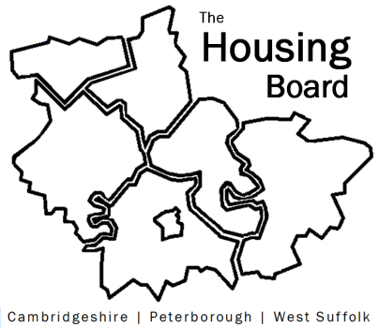
The Housing Board
Cambridgeshire | Peterborough | West Suffolk
Meeting from 10:00 to 12:00, Friday 6 October 2023
To be held online via Microsoft Teams: link can be found in the meeting invite
AGENDA
 | Item | Lead
 | Welcome/apologies  Actions of previous meeting to approve, and matters arising.  Meeting papers available at www.cambridgeshireinsight.org.uk/housingboard | Chair
 | Changing Futures | Tom Tallon, Cambs County
 | Housing Delivery numbers across the County | Rob Kemp, Cambs County
 | The new Supported Housing Act | Lisa Sparks
 | Housing/homeless referrals/enquiries coming through to Adult Early Help | Lisa Sparks
 | ICS Accommodation Needs Survey | Chris Hill, ICS
 | ICS Economic Modelling | Iain Green
 | Updating our priority “homes for wellbeing” based on recent housing and health work | Sue Beecroft
 | Updates
 | AOB
2023 meeting dates (10am – 12 noon)
- 3 November
- 1 December

