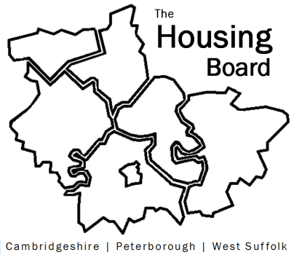
The Housing Board
Cambridgeshire | Peterborough | West Suffolk
Meeting from 10:00 to 12:00, Friday 3 November 2023
To be held online via Microsoft Teams: link can be found in the meeting invite
AGENDA
 | Item | Lead
 | Welcome/apologies  Actions of previous meeting to approve, and matters arising.  Meeting papers available at www.cambridgeshireinsight.org.uk/housingboard | Chair  Dan Horn
 | Homelessness Annual Review | Jon Collen  Heather Wood
 | Update from October Health and Wellbeing Board | Iain Green  Sue Beecroft
 | Updates around the table | All
 | AOB
2023/24 meeting dates (10am – 12 noon)
- 1 December
- 12 January
- 2 February

