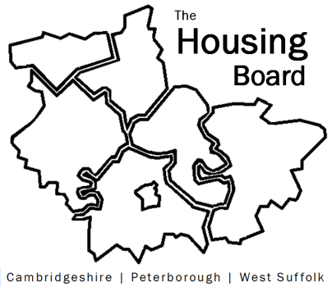
The Housing Board
Cambridgeshire | Peterborough | West Suffolk
Meeting from 10:00 to 12:00, Friday 1 September 2023
To be held online via Microsoft Teams: link can be found in the meeting invite
AGENDA
 | Item | Lead
 | Welcome/apologies  Actions of previous meeting to approve, and matters arising.  Meeting papers available at www.cambridgeshireinsight.org.uk/housingboard | Chair
 | Financial models for NHS staff accommodation | Ian Burden, NHS
 | The new Supported Housing Act – defer to Oct | Lisa Sparks, Cambs County
 | Piloting a checklist for Damp, Mould & Excess Cold: observations from frontline staff | Iain G, Sue B
 | Housing Board in-person meetings discussion | All
 | Updates  Key worker housing survey: update  Sub-regional budget proposal (has been circulated to funding partners) | All  Jess Pickman  Sue Beecroft
 | AOB
2023 meeting dates (10am – 12 noon)
- 6 October
- 3 November
- 1 December

