Children and Young People Mental Health Dashboard user guide
The Children and Young People Mental Health dashboard allows for an interactive way to present a wealth of data and information on Cambridgeshire and Peterborough from multiple sources. It was created to form part of the All-age Mental Health and Learning Disabilities Needs Assessment.
For any queries, please contact the team at PHI-Team@Cambridgeshire.gov.uk.

Examples of dashboard page layout:
Page navigation – Press the down arrow to see the list of pages, select the required page and press → to navigate.
Population (Count) and Population (%) - press these buttons to show numbers and proportion of population for the selected area.
Area name drop down slicer – press the down arrow to select the required area name.

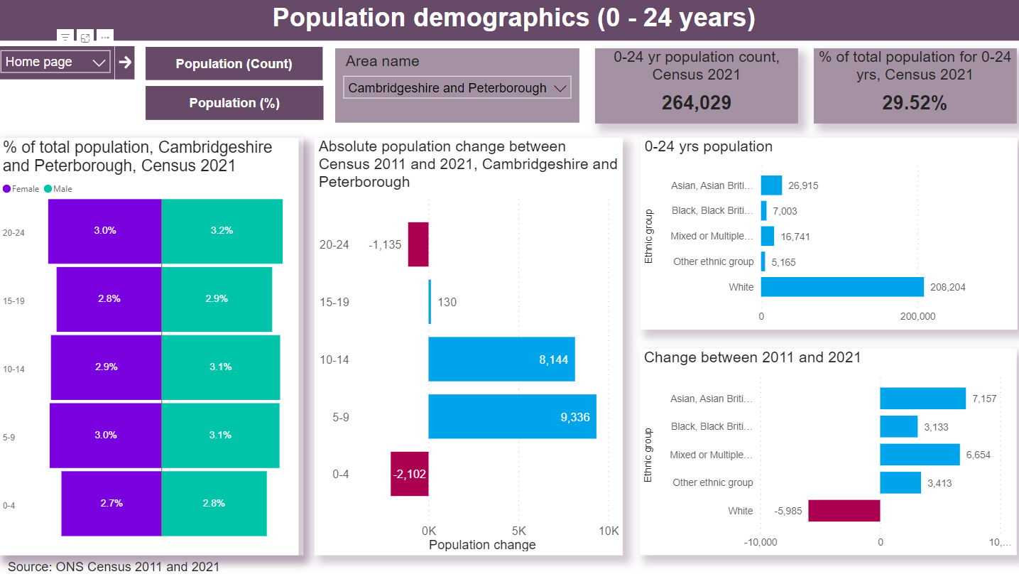

The title bar including the dashboard page name and some consistent buttons on the left for navigation.
The interactive area, where the user can make selections for the visualisations using the ‘slicers’.

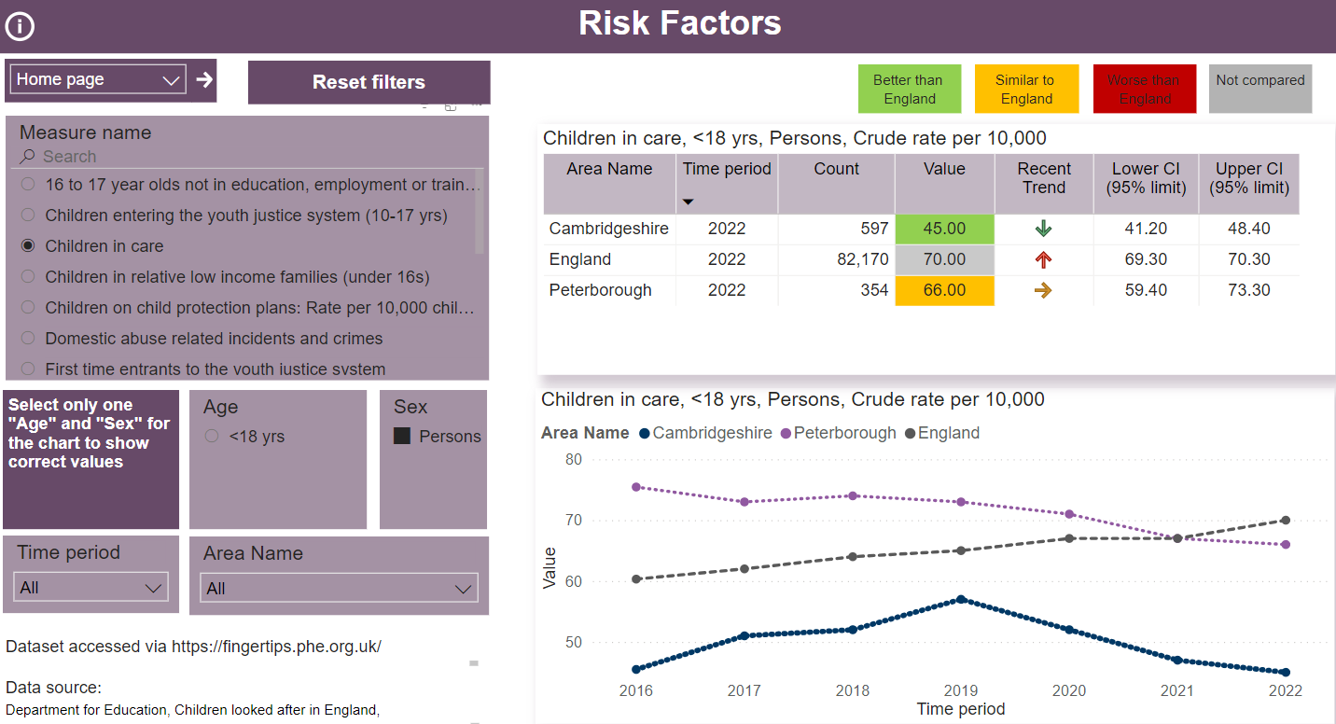

Important to read the instructions near the slicers to get correct values on the tables and charts.
The data source detailing which organisation produced the dataset.
The visualisation area, where the data is visualised in tables, charts, and maps, based on the data selections made.
Tool tips for using the dashboard:

Key ICONs on each dashboard page:

Information button

This opens an information (Metadata) page about the data displayed, including key definitions, sources and any caveats.
Back button

Press this button to return to the data visualisation page from information/metadata page.

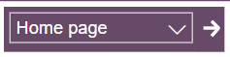 | Page navigation  It’s a drop-down menu. Use this to select the required page and press → to navigate to the required page on the Dashboard.
Reset filter button

Use this button to reset the page to its default filter settings or to clear the filter selections
Example of slicers in the dashboard pages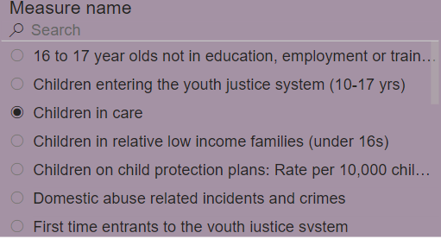  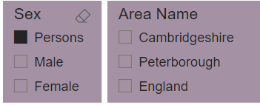  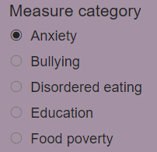 | Slicers:  By making selections in the slicers the user is able to select the required data to be displayed in the visualisations, (in this example the slicer selects the ‘Measure Name’).  It is important to read the instructions near the slicers to get correct values on the tables and charts.  Examples:  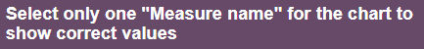  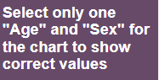
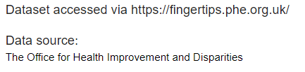 | Data Source.  Each dashboard page contains ‘Source’ information. In most cases the data Source is located on the bottom left side of a dashboard page. It may interact with the visualisations, so as different data is selected and displayed, the data source text will also change.

In-page tips

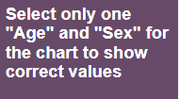 | Selections are important. Be clear about what data you have selected to be visualised. Follow the instructions mentioned near the slicers.  For example, some datasets are available for Males, Females and All Persons. If all 3 are selected the visualisations may combine all 3 datasets (Eg: triple count) so the user must make a selection of one Person type.
Hovering over a visualisation | Hovering over a visualisation provides additional figures and information included in the visualisation in some instances
Red-Amber-Green (RAG) rating | RAG rating indicates how an indicator compared to the England average with 95% confidence intervals.  Statistically significantly better than England  Statistically similar to England  Statistically significantly worse than England
Recent trend arrows | Trend calculations on fingertips data are carried out if at least five non-overlapping data points are available, and the value is a proportion or a rate.  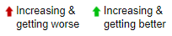  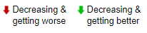  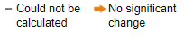
Show as a table | 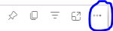  To see the values of the visualisation in a table, click the 3 dots at the top right corner of the visualisation (as shown above) and choose “Show as a table” option from the dropdown menu.

