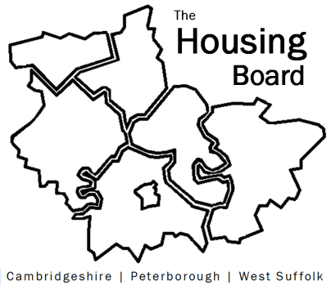
The Housing Board
Cambridgeshire | Peterborough | West Suffolk
Meeting from 10:00 to 12:00, Friday 7 July 2023
To be held online via Microsoft Teams: link can be found in the meeting invite
AGENDA
 | Item | Lead
 | Welcome/apologies  Actions of previous meeting to approve, and matters arising.  Meeting papers available at www.cambridgeshireinsight.org.uk/housingboard | Chair  Dan Horn, FDC
 | Rent Arrears Survey and Homes for Cambridgeshire & Peterborough update | Karen Mayhew, Homes for Cambs and Peterborough
 | Housing and Health actions as part of the Health and Wellbeing Strategy  Including update to Health and Wellbeing Board | Iain Green / Sue Beecroft
 | Brief update on Keyworker Accommodation Needs Survey | Jess Pickman, ICS
 | Updates around the room | All
2023 meeting dates (10am – 12 noon)
- 4 August
- 1 September
- 6 October

