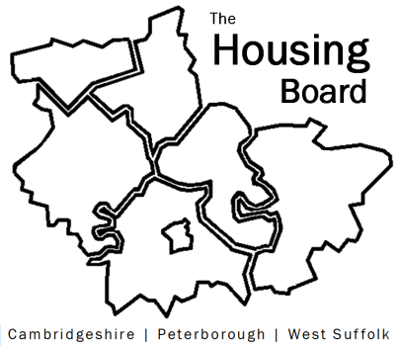
The Housing Board
Cambridgeshire | Peterborough | West Suffolk
Meeting from 10:00 to 12:00, Friday 5 May 2023
To be held online via Microsoft Teams: link can be found in the meeting invite
DRAFT AGENDA
 | Item | Lead
 | Welcome/apologies  Actions of previous meeting to approve, and matters arising.  Meeting papers available at www.cambridgeshireinsight.org.uk/housingboard | Chair
 | Update on DLUHC Supported Housing Needs Survey | Lisa Sparks
 | Cambridgeshire County demand profiles | Julie Fletcher/Sue Beecroft
 | Update on Changing Futures | Sue Beecroft
 | Reps for Strategic Infrastructure Framework Development | Sue Beecroft
 | Updates
 | AOB
2023 meeting dates (10am – 12 noon)
- 2 June
- 7 July
- 4 August
- 1 September

