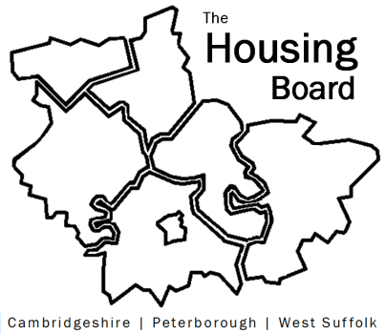
The Housing Board
Cambridgeshire | Peterborough | West Suffolk
Meeting from 10:00 to 12:00, Friday 4 August 2023
To be held online via Microsoft Teams: link can be found in the meeting invite
AGENDA
 | Item | Lead
 | Welcome/apologies  Actions of previous meeting to approve, and matters arising.  Meeting papers available at www.cambridgeshireinsight.org.uk/housingboard | Chair
 | Devolution Deal Part 2, relating to Affordable Housing | Paul Staines, CPCA
 | Update on ICS worker housing needs survey | Jess Pickman, NHS
 | Updates around the room | All
 | AOB
2023 meeting dates (10am – 12 noon)
- 1 September
- 6 October
- 3 November

