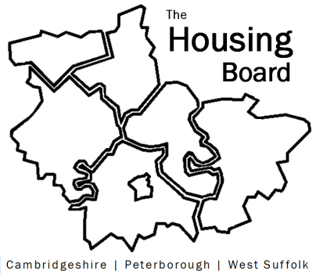
The Housing Board
Cambridgeshire | Peterborough | West Suffolk
Meeting from 10:00 to 12:00, Friday 2 June 2023
To be held online via Microsoft Teams: link can be found in the meeting invite
AGENDA
 | Item | Lead
 | Welcome/apologies  Actions of previous meeting to approve, and matters arising.  Meeting papers available at www.cambridgeshireinsight.org.uk/housingboard | Chair  Dan Horn
 | Update on Home-Link | Heather Wood
 | Supported Housing Regulatory Oversight bill going through parliament including survey submission | Dan Horn  Lisa Sparks
 | Changing Futures: A Trauma Informed System | Sue Beecroft
 | Updates around the room | All
2023 meeting dates (10am – 12 noon)
- 7 July
- 4 August
- 1 September

