# Update on co-production in Peterborough

## What is Changing Futures?

*Changing Futures* *Cambridgeshire & Peterborough* is about improving the outcomes for people with multiple disadvantage. This will be achieved by people with lived experience guiding professionals on how organisations across Cambridgeshire and Peterborough can work together more effectively and efficiently to tackle multiple disadvantage.

Multiple disadvantage means someone experiencing three of five of homelessness, mental health issues, substance misuse, domestic abuse and offending behaviour, at any one time

One of the action areas for *Changing Futures* is to support more co-production and co-design in our system. This note gives an update on co-production in Peterborough at July 2023.

## Background

There have been four co-production sessions across Peterborough since the beginning of 2023.

The sessions aim to give people with lived experience of multiple disadvantage an opportunity to have their voice heard and be involved in making positive changes to the system.

The sessions are held at a variety of venues, including the Salvation Army, CGL Aspire, The Garden House and Outside Links.

Each session has had varying numbers in attendance, with up to 20 people getting involved at any one time.

## Four key questions

The sessions initially focused on the following 4 questions:

What have been your positive experiences of services?

What would you change?

What are the issues/barriers you face at the moment?

How would you like to be involved to make change?

Working with some of the experts, responses to these questions were divided into the service or area they relate to, such as drug / alcohol, housing, mental health and so and labelled as

broadly positive: blue

broadly negative: red

neutral: yellow

From this, we were able to theme the issues that were arising (pink) leaving us with a list of potential inquiries for the Co-Production group to work on moving forward.

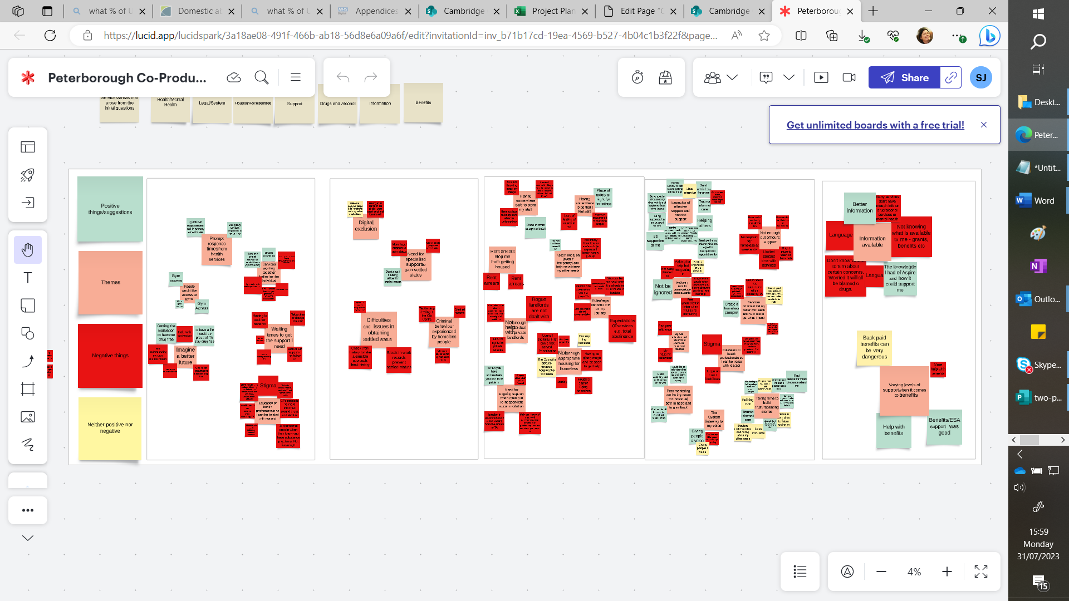

To access the full chart, please visit

<https://lucid.app/lucidspark/3a18ae08-491f-466b-ab18-56d8e6a09a6f/edit?viewport_loc=-9980%2C-6623%2C36220%2C19834%2C0_0&invitationId=inv_b71b17cd-19ea-4569-b527-4b04c1b3f22f>

## Emerging themes

Some of the emerging themes include

Services need to work better together for the benefit of the individual

Prompt responses from health services improves my situation

I need to be able to imagine a better future

Long waiting times to get the support I need

Digital Exclusion

Education for health professionals so I can be treated with respect

Need for ongoing support when I get moved to independent accommodation

Difficulty in obtaining settled status

Not enough help to deal with private landlords

Peer mentoring can be important both for an individual in need but also to give back

Rules and regulations can stop me in my journey

Having somewhere to go that I feel safe

Be unable to communicate my needs and wants

Encouragingly there was a lot of positive feedback on support provided individual services.

## Next steps

The next step is to test the arising themes with Experts by Experience and frame some topics they wish to pursue and what they want to see change.

We will need to include relevant stakeholders with this work, as well as in any inquiry or exploration of systemic issues.

We are hoping to reach even more people as the co-production group progresses and grows.

We have learnt that holding the sessions in an open space where people already feel comfortable has helped more people to get involved.

It is also great to have interest and encouragement from staff and volunteers at the service where the session is being held, to increase involvement and aid understanding of the benefits of co-production.

**Useful links to learn more**

🔿 The **5 principles** for Changing Futures are to:

* Recognise complexity
* Build trust
* Open doors (there is no wrong door)
* Meet people where they are
* Embrace learning

🔿 **Read** more at our [web page](https://cambridgeshireinsight.org.uk/changing-futures-cp/)

🔿 **Sign up** for 3-monthly newsletter using [sue.beecroft@cambridge.gov.uk](mailto:sue.beecroft@cambridge.gov.uk)

🔿 **Join in…** This is a learning process, so please ask if you have questions or suggestions. You can find some [FAQs](https://cambridgeshireinsight.org.uk/wp-content/uploads/2022/10/first-attempt-TP-QA.docx) here. Get your question added so others can benefit from your curiosity!