Qualitative findings from the TONIC report

This document summarises over 140 pages of a report of fieldwork undertaken by TONIC, looking at aspects of the drug and alcohol services and need across Cambridgeshire and Peterborough. Cambridgeshire and Peterborough’s Public Health Intelligence team have summarised the content and the recommendations from the fieldwork; some content is lifted directly from the original report but most is summarised.

Methodology
An online survey gathered 196 good quality responses from 129 professionals working in the area, 54 people with their own experience of substance use, and 13 people responding on behalf of someone with substance use. Another 104 people took part in a shorter version of the online survey.
More in depth work (interviews, focus groups and other types of engagement) gathered input from 252 people with lived experience, 11 family members and 70 professionals. It is not clear whether there was an overlap between this group and the group of people responding to the online survey.
The professionals who participated came from a wide range of organisations, including representatives from local government, the local NHS including mental health services, policing and criminal justice, housing and homelessness services, and other voluntary sector partners.
It is important to acknowledge the volume of work summarised here and, of course, the goodwill and honesty of professionals and people with lived experience who contributed their time and opinions to the work. While the work demonstrates very good engagement with professionals and service users (with the exception of very limited responses from professionals or service users from Peterborough’s children’s service), it is important to recognise that substance users who have not had a good experience of treatment or engagement with services are probably much less likely to complete treatment or to take part in qualitative research. As such, the most critical voices and people with the most complex backgrounds may be absent from this work.

Service users and types of substance use

Substances used
Both participants with lived experience and those with professional involvement agreed that the most commonly used substances are alcohol, heroin, crack cocaine, cocaine and cannabis. Spice was an additional issue mentioned by those working with the criminal justice system and prison leavers. It appears to be the preferred substance within HMP Peterborough, as well as for rough sleepers and homeless people, though it was apparently more of an issue in Peterborough than in Cambridgeshire.

Complex lives
Many of the participants in the research process reported substantial challenges across their lives in addition to their substance use. Mental health challenges (diagnosed or not) were common, as was a history of being subject to abuse, physical disability, homelessness and involvement with the criminal justice system.
Figure 1 shows responses from research participants with lived experience and is an insight into the complexity of the lives of people using drug and alcohol services (please note that this is based on small numbers and the proportions shown here should not be seen as representative of all service users, especially given that those with the most complex lives are probably least likely to engage with research.)

The service user journey
The ‘journey’ has four parts: referral, assessment, treatment, and then ‘step down support’ once the main treatment phase is complete.
Service users, those with lived experience, and stakeholders working in this field gave feedback on these four stages; summarised separately for Cambridgeshire and Peterborough in the tables shown in Figure 2. Of those service users who took part in the research, a majority were satisfied with their experience throughout these stages. It is notable that Peterborough’s satisfaction rates from service users were consistently higher than Cambridgeshire’s.

Figure 1: Experiences and ‘additional needs’ of survey respondents with lived experience

Figure 2: Visual summary of service user journeys in Cambridgeshire and Peterborough 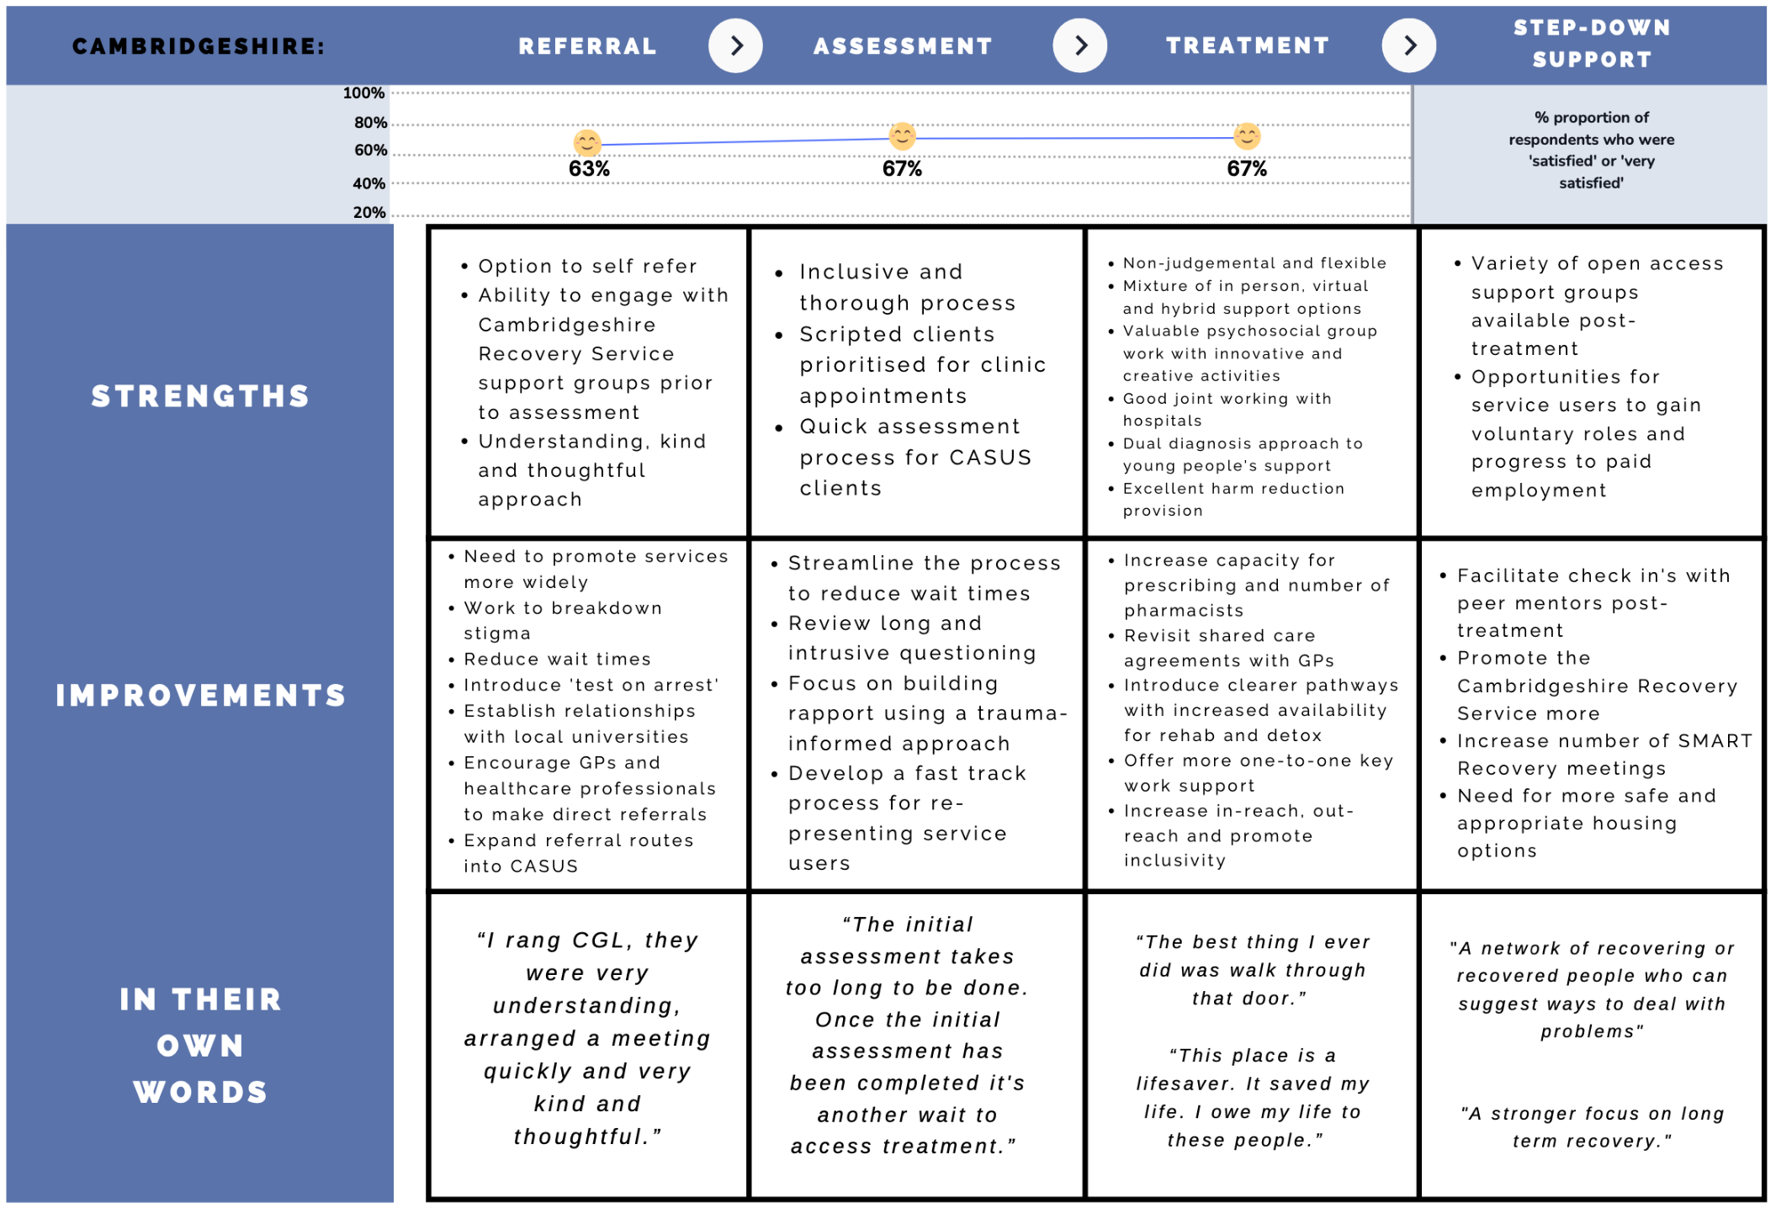

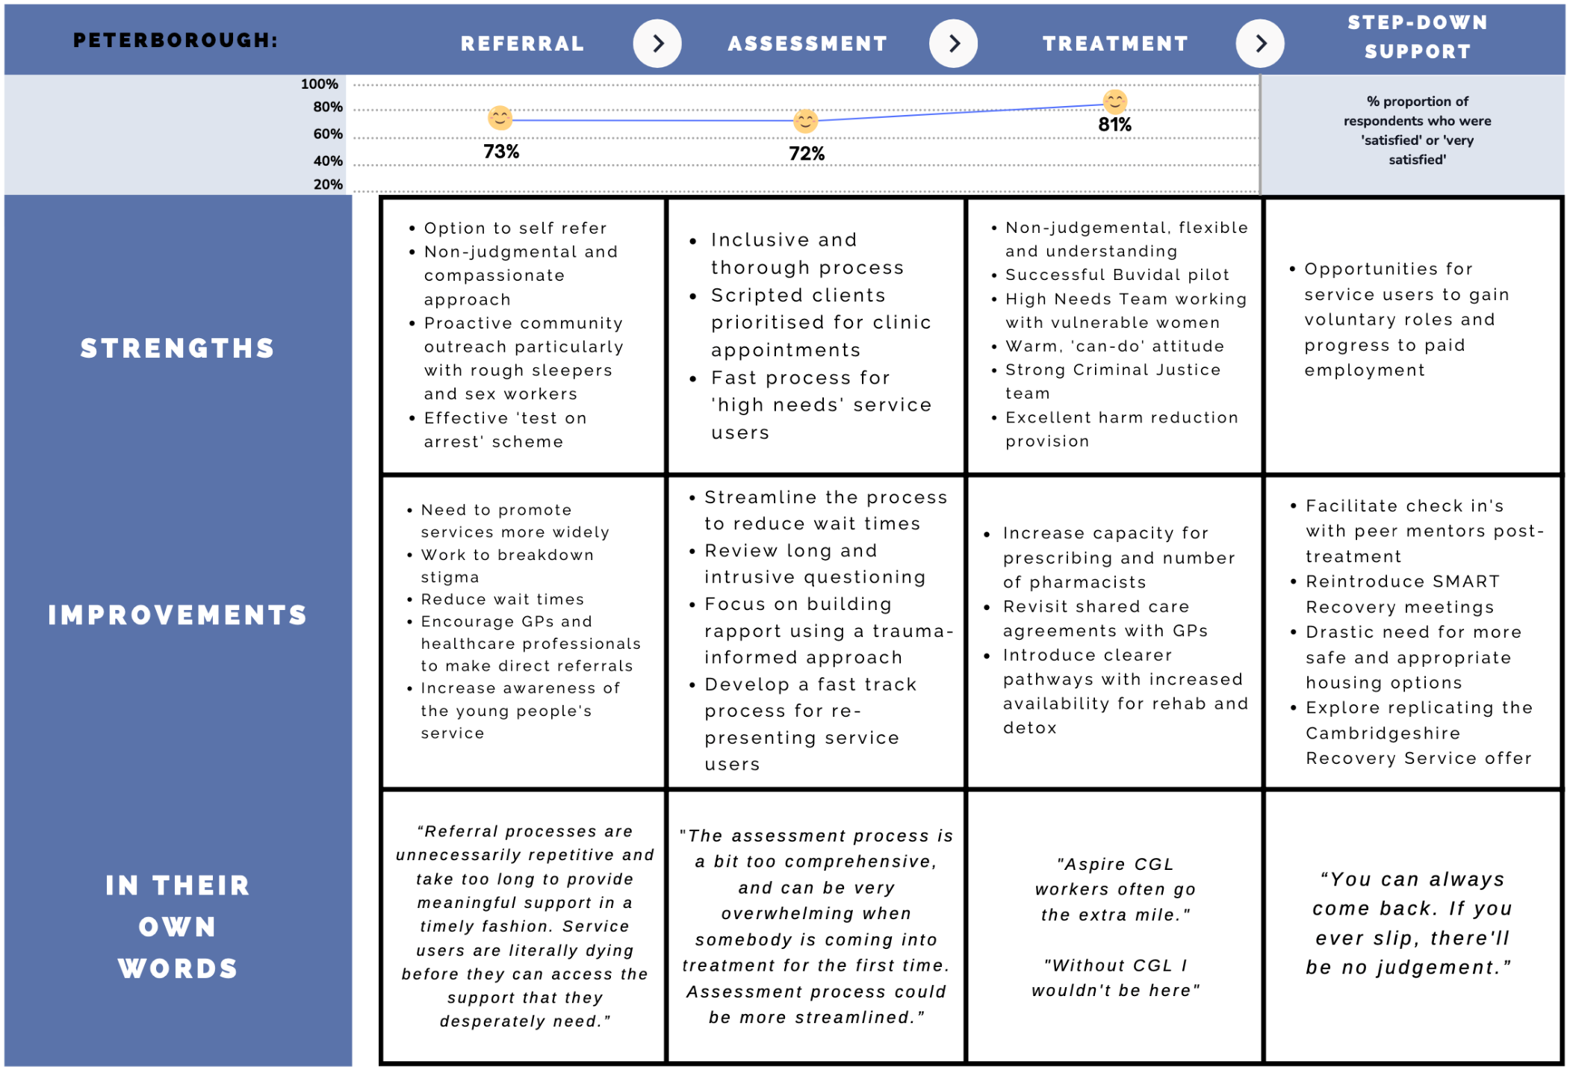

Recommendations arising from the qualitative work

Service commissioning and management
- Share positive feedback with frontline staff to boost team morale.
- Recruitment and retention of staff would support a more experienced workforce with reduced caseloads, improving the quality and quantity of support to clients. Approaches include:
  - Use of internships, apprenticeships, and pathways with colleges and universities.
  - Developing a robust induction package for new starters, that is not to be rushed, incorporating checklists of shadowing opportunities and training to be completed.
  - Ensuring practitioners are encouraged and given adequate provision for CPD
  - Clinical supervision for all staff and identifying staff experiencing vicarious trauma through work.
  - Improving the recognition of service time and experience through salary and terms and conditions and ensuring consistency in this.
  - Continuing to advertise opportunities for internal promotion, expanding this to national positions, and considering opportunities for secondments. At the same time, ensuring time to backfill posts is minimised to avoid disruption to service delivery.
- Consider the possibility of commissioning one adult substance misuse service to cover the entire county. This could allow flexibility for the service to move resources around in line with demand and ensure equitable access to all within Cambridgeshire and Peterborough.
- Professionals commented that the short term nature of much of the available funding was not ideal and that longer term funding would allow stability of services and staffing.

Improving the referral process and access to services
- A wide range of barriers to service access and engagement were described by research participants (the list is not included here). The services should review these and consider solutions, prioritising the most commonly raised barriers, which included lack of awareness of what help is available, issues around capacity and waiting lists, breaking down associated stigma, and promoting inclusivity to reach individuals from all backgrounds.
- Promote awareness amongst external partners and the public to drive direct referrals, to respond to areas where limited referrals have been identified. In particular, focus on health services such as GPs, and schools for the young people’s service, and work with Universities in the local area to ensure students can access appropriate support.
- Review the experience of accessing services (triage and assessment) with a view to reducing the wait before support is received and reducing duplication and the need to ‘tell your story’ several times. Consider assigning a ‘lead practitioner’ for people with multiple needs.
- Services should ensure that early discussions with service users should include an explanation of possible pathways and services and a discussion of their expectations.
- Commissioners and service providers to consider reviewing the assessment questions and processes. Specifically, shifting this to have a greater emphasis on relationship building, and exploring the most appropriate timing for this to be conducted within a trauma-informed approach.
- Improve staff awareness of learning disabilities, cognitive impairments, and brain damage and how to adapt support accordingly.

Group work and options for support
- Review the one-to-one offer for adults and consider increasing the availability of such sessions to people who are not able to engage with or benefit from group work.
- The range of group sessions in Cambridgeshire was well-received: the services should explore expanding this to cover Peterborough, as well as replicating Free-Flow Friday in all hubs across the county.
- The in-house psychology team within the Cambridgeshire service should continue to quality assure group programme content and promote consistency between group facilitators, ensuring all group work is of the highest quality. The Peterborough service does not have this quality assurance for group work at present; ways to implement this could be explored.
- Commissioned services could improve communication about group programmes, both in terms of what is on offer and any cancelled or postponed sessions. It is vital that group work timetables are visible and available to all, and feedback from service users should be sought about ways to promote and communicate more effectively.
- Services should consider how best to make support as flexible as possible for service users, including a range of options such as face-to-face, telephone, video calls via Teams or Zoom.

Service design
- Consider whether current premises and capacity are sufficient: services should allow for safe and welcoming waiting environments and services must be accessible to all, including those with disabilities or who face other barriers (such as travel) to engaging with support.
- Explore the possibilities of additional outreach to rural communities, and of introducing more out of hours provision to the current offer.
- Review the provision of residential rehabilitation and inpatient detoxification programmes, particularly for homeless people, and the ‘pre-rehab’ support available prior to undertaking these programmes as well as aftercare.
- The SUN Network should aim to raise awareness of their role in Cambridgeshire and ensure any change they influence is advertised widely so that people can see the impact feedback is having on the system and service delivery. The SUN Network does not cover Peterborough and so there is a gap here in terms of listening to the voices of people with lived experience.
- Wherever possible, commissioned services should consult with service users, as well as those not in treatment – from a variety of backgrounds and with a range of protected characteristics – to gain their feedback and facilitate co-design and co-production with these individuals and communities to ensure services are responsive, meeting their needs, and driving improvements.
- When service users were asked about gaps in service provision, the most common answers identified a need for more mental health support including counselling. Housing support was also identified as a key unmet need in Peterborough. Service leads and commissioners should consider ways to extend support available in these areas.

Harm reduction and prescribing
Harm reduction was felt to be a key strength of Cambridgeshire and Peterborough’s provision.
- Consider expanding the provision of naloxone kits to friends and family, and enabling anonymity to encourage greater take up. Work to encourage people to carry their naloxone kits with them more frequently rather than leaving them at home.
- Evaluate the impact of the Buvidal (long-lasting buprenorphine injection) pilot and then if deemed to be a success, explore expansion in terms of the number of service users who can access this treatment option.
- Commissioners should explore what can be done to increase capacity of pharmacies in the local area to ensure dispensing provision can meet the demand for those requiring opioid substitution treatment. The possibility of electronic prescribing should be considered to streamline the process by eliminating some of the paperwork and removing the need to physically deliver prescriptions to pharmacies.
- Consider reintroducing shared care arrangements for opioid substitution treatment with GPs, so that GPs can manage prescribing for users who are maintaining on low levels of methadone or buprenorphine and not actively engaging with commissioned support services.
- Commissioned services could deliver more training to GPs, hospital staff, and other appropriately placed healthcare professionals to raise awareness of substance misuse and harm reduction advice and encourage them to conduct more alcohol intervention and brief advice with patients. GP brief advice and brief interventions can be very effective at averting future problems.
- Professionals felt that a key improvement for the clinical offer would be to increase the number of staff who are able to prescribe to service users.

Dual diagnosis
- The feedback from lived experience participants suggests that the pathways between substance misuse services and mental health services are not working well to deliver the appropriate support to patients. Reviewing the pathway, joint working agreements and protocols would identify areas for improvement.
- There are several learning opportunities at present: skills and knowledge exchange between mental health and substance misuse colleagues, and evaluation of the in-house psychology service and the ‘Co-Occurring Conditions Lead’ in Cambridgeshire with a view to possible extension to Peterborough.
- As mentioned above, access to sufficient mental health support was felt by service users to be poor and this should be a focus for service design review.
- There was good feedback about the recent additions of the psychology team in Cambridgeshire and the Dual Diagnosis Outreach Team; the impact of these should be reviewed to see how they can be most effective given limited staff capacity.
- The system across Cambridgeshire and Peterborough was noted to lack a clear shared definition of ‘dual diagnosis’ and services should consider developing clear agreed criteria.

Groups with particular needs
- Ensure that services are able to work with the full range of clients who need services by working with local LGBTQ+ and ethnic minority organisations to identify unmet need in these groups and consider how services can meet those needs. Continue working across homeless and rough sleeper and sex worker services across Cambridgeshire and Peterborough, sharing learning across the two areas.
- Criminal justice teams within the commissioned services should continue efforts currently being made to ensure effective joint working with other agencies in the criminal justice system, including improving working with Peterborough prison and associated agencies including the RECONNECT programme.
- On leaving prison, people are at high risk of relapse into substance misuse and overdose deaths. Criminal justice teams within the commissioned services should review their support offer to prison releases who are not scripted, to ensure they are able to continue to access support in the community should they wish to do so or be mandated to via licence conditions and facilitating their access to naloxone kits where appropriate. Services should also explore expanding their ‘prison in reach worker’ roles so that individuals are supported ‘through the gate’ by a consistent worker who is involved during their time in prison and is able to assist with conducting pre-release work.
- Feedback highlighted a gap in the support available to family and friends of substance misuse clients and there were several suggestions around how to improve this.
- Children’s support has different models in Cambridgeshire and Peterborough; the CASUS service in Cambridgeshire had good feedback from young people and professionals alike but there was little input from Peterborough to this research. There may be some more work required in this area to recommend combining different strengths to ensure a holistic child-centred approach in both areas that does not just focus on substance misuse.

Step-down and long-term recovery support
- Review longer term support available to service users in both Cambridgeshire and Peterborough, with consideration of increasing the number of SMART recovery group and ‘Free Flow Friday’ sessions
- Commissioned services should continue to promote the pathway from service user to volunteer and later into paid employment and encourage other services to offer a similar route into work.

Other
- Review and extend work around housing for service users, in particular exploring the possibility of work with housing providers to establish ‘dry’ and ‘transitional’ accommodation.
- There is potential to improve joint working and communication across the multiple organisations working with this client group. In particular, the system should work with police to monitor trends in substance use across Cambridgeshire and Peterborough.
- There is considerable work underway with new programmes or pilots in conjunction with Addenbrookes and Peterborough hospitals; these should be kept under review to assess benefits and share learning.

