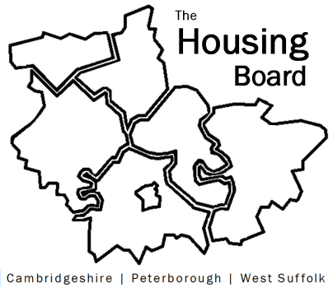
The Housing Board
Cambridgeshire | Peterborough | West Suffolk
Meeting from 10:00 to 12:00, Friday 3 March 2023
To be held online via Microsoft Teams: link can be found in the meeting invite
DRAFT AGENDA
 | Item | Lead
 | Welcome/apologies  Actions of previous meeting to approve, and matters arising.  Meeting papers available at www.cambridgeshireinsight.org.uk/housingboard | Chair  Dan Horn
 | Update on  - Adult social care restructure  - Cambs County and Peterborough City split  - Preparing for Adulthood workshop | Lisa Sparks
 | Keyworker housing, and staff housing needs survey | Jess Pickman, ICS (workforce planning)
 | Working with the Combined Authority – update following recent Place Directors meeting | Dan Horn
 | Planning for 2023/24:  - Issues of concern & good practice to share in coming year (brainstorm) under our 6 priorities  - Meeting planner (att.)  - Keeping our Terms of Reference up to date (recent version att.) | Sue Beecroft
 | Updates
 | AOB
2023 meeting dates (10am – 12 noon)
- 14 April
- 5 May
- 2 June

