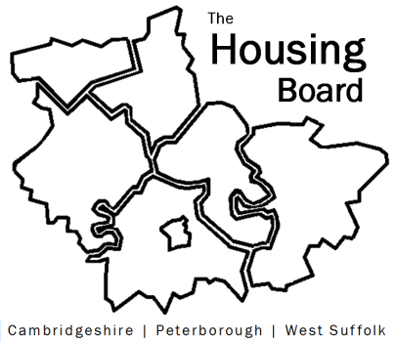
The Housing Board
Cambridgeshire | Peterborough | West Suffolk
Meeting from 10:00 to 12:00, Friday 14 April 2023
To be held online via Microsoft Teams: link can be found in the meeting invite
AGENDA
 | Item | Lead
 | Welcome/apologies  Actions of previous meeting to approve, and matters arising.  Meeting papers available at www.cambridgeshireinsight.org.uk/housingboard | Chair  Dan Horn
 | DLUHC Supported Housing survey | Lisa Sparks
 | Private sector housing group activities including HMO guide for landlords (draft to be circulated) | Jo Evans (FDC) from countywide (private sector) housing group
 | Health and wellbeing strategy and action planning for housing theme | Emmeline Watkins, Asst. Director Public Health
 | Migrant / refugee working group - proposal to link this countywide group into the Housing Board network | Sue Beecroft, Ray McCappin (Cambs County)
 | Diamond affordability analysis (slides) | Sue Beecroft
 | Updates  - Update on keyworker housing, and staff housing needs survey (one slide)  - Draft meeting planner for 2023/24 (attached with agenda) | Jess Pickman, ICS  Sue Beecroft
 | AOB
2023 meeting dates (10am – 12 noon)
- 5 May * 2 June * 7 July
- 4 Aug * 1 Sept *6 Oct
- 3 Nov * 1 Dec

