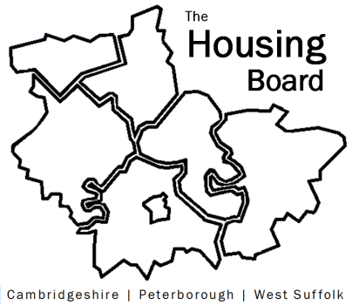
The Housing Board
Cambridgeshire | Peterborough | West Suffolk
Meeting from 10:00 to 12:00, Friday 3 February 2022
To be held online via Microsoft Teams: link can be found in the meeting invite
DRAFT AGENDA
 | Item | Lead
 | Welcome/apologies  Actions of previous meeting to approve, and matters arising.  Meeting papers available at www.cambridgeshireinsight.org.uk/housingboard | Chair  Dan Horn
 | Domestic abuse focussing on familial abuse | Danae / Vickie
 | Progress to update from ICS / keyworker workstream  • review of housing strategies in C&P  • progressing initiatives that are being adopted elsewhere to help tackle the accommodation issues  • conduct a Health and Care Housing Needs Survey across C&P – results, analysis and report providing evidence to support discussions around housing provision for key workers | Chris Hill / Anna Palutek
 | Update on Health and Wellbeing Strategy and Summit  Link to draft strategy here https://www.cpics.org.uk/hwb-icp-meetings-2022-23?media_folder=299&root_folder=Health%20&%20Wellbeing%20ICS%20Strategy | Iain Green & Sue B
 | Local Authority Refugee Funding (brief note circulated) | Led by Dan Horn
 | Updates  - Update on HRS re-commissioning and related, and any update on county funding for additional DFGs?  - Preparing for Housing Board’s year-end (March meeting);  - finding a rep for the Suicide Prevention Group  - draft year planner for the Board (circ)  - 2023/24 budget note (circ) | Lisa Sparks  Sue Beecroft
 | AOB
2023 meeting dates (10am – 12 noon)
- 3 February
- 3 March
- 14 April
- 5 May
- 2 June

