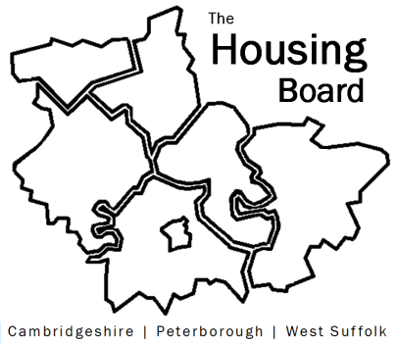
The Housing Board
Cambridgeshire | Peterborough | West Suffolk
Meeting from 10:00 to 12:00, Friday 2 December 2022
To be held online via Microsoft Teams: link can be found in the meeting invite
DRAFT AGENDA
 | Item | Lead
 | Welcome/apologies  Actions of previous meeting to approve, and matters arising.  Meeting papers available at www.cambridgeshireinsight.org.uk/housingboard | Chair  Dan Horn
 | Draft Health and Wellbeing Housing Strategy (attached) | Iain Green  Sue Beecroft
 | Homelessness Update | Heather Wood  Jon Collen
 | Future accommodation needs for specialist housing | Lisa Sparks
 | Verbal update on County additional funding contribution to DFG works | Lisa Sparks
 | Updates  - Any Covid related issues to highlight  - Update on HRS re-commissioning and related | All  Lisa Sparks
 | AOB  - Housing Board Budget 2023/4 | Sue Beecroft
2023 meeting dates (10am – 12 noon)
- 13 January (2nd Friday)
- 3 February
- 3 March

