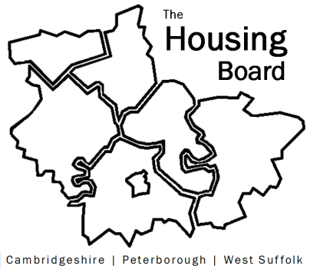
The Housing Board
Cambridgeshire | Peterborough | West Suffolk
Meeting from 10:00 to 12:00, Friday 7 October 2022
To be held online via Microsoft Teams: link can be found in meeting invite
A G E N D A
 | Item | Lead
 | Welcome/apologies  Actions of previous meeting to approve, and matters arising.  Meeting papers available at www.cambridgeshireinsight.org.uk/housingboard | Chair  Heather Wood (TBC)
 | 24/7 living and Macquarie presentation on:  - Offer from 24/7 living and Macquarie Capital on local Passive Housing  - Development funding solution which works with the Affordable Housing Programme, as a solution to significantly reducing heating costs  - Homes save ~75% in heating costs as highly insulated passive house standards & build in reduced water waste with grey water recycling | Christine Hynes, Chief Executive Officer 24/7 living and colleagues
 | Emerging public health strategy, leading on the housing theme  Involving the Housing Board | Liz Watts, SCDC and Jo Lancaster, HDC
 | County additional funding contribution to Disabled Facilities Grant (DFG) works | Lisa Sparks, Cambs County
 | Co Production Inquiry Update  “Ensure everyone has access to support when accommodated – not just in the first few weeks, but ongoing and when they need it.” | Tom Tallon, Changing Futures Cambridgeshire & Peterborough / CEA team
 | Updates  - Any Covid related issues to highlight  - Update on HRS re-commissioning and related | - All  - Lisa Sparks
 | AOB
2022 meeting dates (10am – 12 noon)
- 4 November
- 2 December
2023
- 13 January (2nd Friday, TBC at October meeting)
- 3 February
- 3 March

