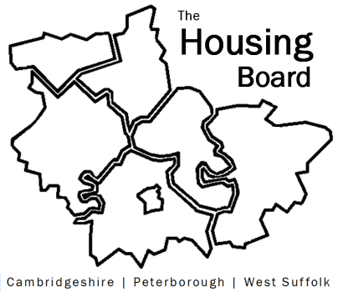
The Housing Board
Cambridgeshire | Peterborough | West Suffolk
Meeting from 10:00 to 12:00, Friday 4 November 2022
To be held online via Microsoft Teams: link can be found in the meeting invite
DRAFT AGENDA
 | Item | Lead
 | Welcome/apologies  Actions of previous meeting to approve, and matters arising.  Meeting papers available at www.cambridgeshireinsight.org.uk/housingboard | Chair  Dan Horn
 | Update on CAS3 accommodation  This is temporary accommodation for people on release from prison with no alternative housing options. | Matthew Ryder, Probation
 | ICS accommodation project  (Relates to key worker housing, slides to follow) | Chris Hill & Anna Palutek, Cambridgeshire & Peterborough Integrated Care System
 | Additional Funding Contribution to Disabled Facilities Grants | Lisa Sparks, County
 | Update on rent arrears / financial hardship reporting | Karen Mayhew H4C&P and Sue Beecroft
 | Update on Health and Wellbeing Strategy work (note circulated) | Sue Beecroft (tbc)
 | Update on Housing Board budget for 2023/24 (note to follow) | Sue Beecroft
 | Updates  - Any Covid related issues to highlight  - Update on HRS re-commissioning and related | All  Lisa Sparks
 | AOB
 | Please note: homelessness update to come to December 2022 meeting
2022 meeting dates (10am – 12 noon)
- 2 December
2023
- 13 January (2nd Friday)
- 3 February
- 3 March

