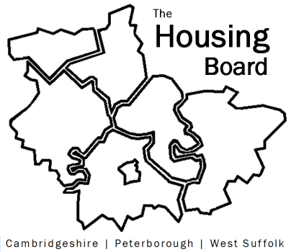
The Housing Board
Cambridgeshire | Peterborough | West Suffolk
Meeting from 10:00 to 12:00, Friday 2 September 2022
To be held online via Microsoft Teams: please open the meeting invite to click on the link
A G E N D A
 | Item | Lead
 | Welcome/apologies  Actions of previous meeting to approve, and matters arising.  Meeting papers available at www.cambridgeshireinsight.org.uk/housingboard | Chair  Dan Horn
 | Update on asylum dispersal consultation | Dan Horn
 | Diamond affordability analysis  - Slides focussing on Greater Cambridge to give an outline (link)  - Summary report (being amended so just to give a flavour) (link)  - Worksheets containing all the data (link)  - Plan for final report structure: exec summary, method, fundings (a) area-wide and (b) for each district covered | Sue Beecroft
 | Updates  - Any Covid related issues to highlight  - Update from Lisa Sparks on HRS re-commissioning and related  - Terms of Reference for Housing Board (att to email) | - All  - Lisa Sparks  - Sue B
 | AOB
2022 meeting dates (10am – 12 noon)
- 7 October
- 4 November
- 2 December

