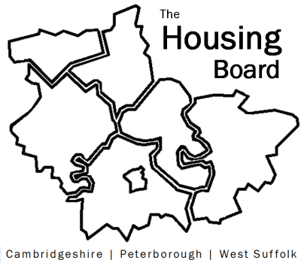
The Housing Board
Cambridgeshire | Peterborough | West Suffolk
Meeting from 10:00 to 12:00, Friday 10 June 2022
To be held online via Microsoft Teams: please open the meeting invite to click on the link
A G E N D A
 | Item |  | Lead
 | Welcome/apologies  Actions of previous meeting to approve, and matters arising.  Meeting papers available at www.cambridgeshireinsight.org.uk/housingboard |  | Chair  Heather Wood
 | Asylum dispersal consultation |  | Heather Wood, David Greening, Matt Oliver (?)
 | Ukrainian update |  | All
 | Updates  - Any Covid related issues to highlight  - HRS re-commissioning and partner update  - ADASS new regional best practice guide – text submitted Thurs 9 June is attached  - Update on “new diamonds” – to be circulated via email before next meeting  - Terms of Reference to follow |  | All  Lisa Sparks  Sue Beecroft  Sue Beecroft  Sue Beecroft
 | AOB
 | 2022 meeting dates (10am – 12 noon)  1 July  5 August  2 September | 7 October  4 November  2 December

