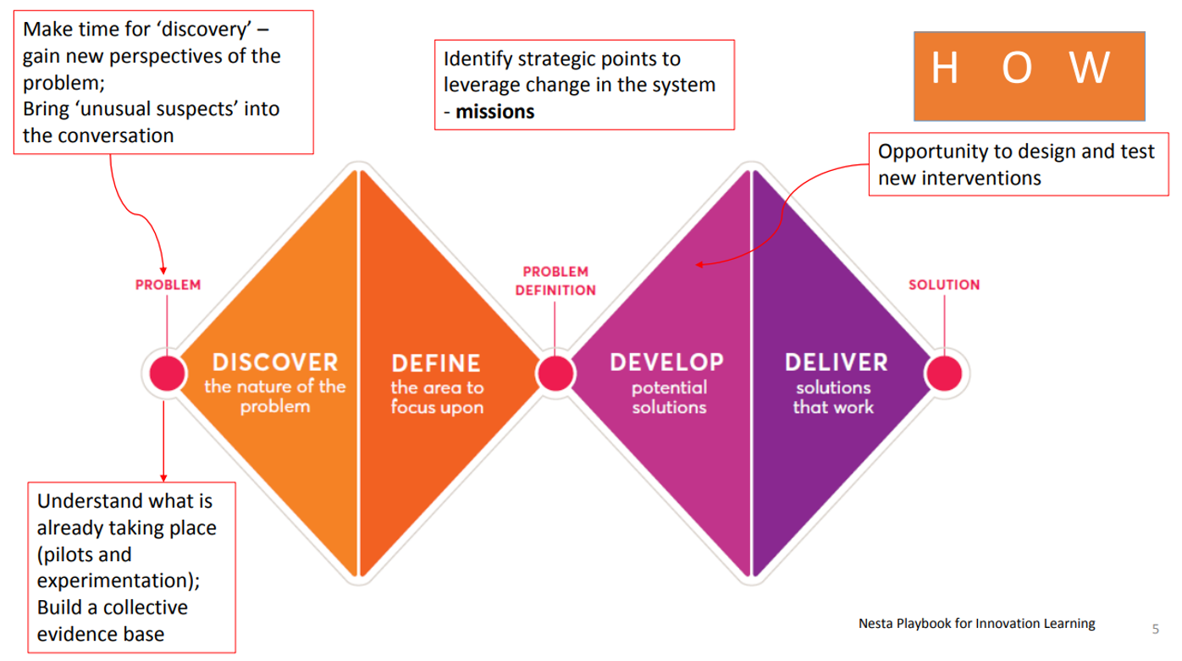
Post CSHG: suggested edits to points on slides, plus suggested categorization under the double diamond structure.
Discover
- Explore ways to improve / increase access to mental health support as witnessed by housing / homelessness teams, and to expand the options where a person does not reach a ‘threshold’ for support but will fall into crisis without it. Earlier intervention will cost less both financially to services and personally to individuals.
- Discover ways to support new GP practices in relation to housing; housing partners could work with health partners to devise ways to offer a home to a new GP for a fixed term enabling a smooth arrival into a new area. Links to action (x)
- As part of (x) can also explore use of assets / land in public ownership for social, affordable, key worker and Gypsy Traveller Roma housing
- Discover reasons for delays to the planning process and to delivering new homes; and explore the information we could share between housing and health to help promote delivery of accessible and adaptable homes
- Discover ways to learn from / about innovators in relation to housing and health, particularly in preventing homelessness which can have some of the worst health outcomes
- Discover ways to calculate cost savings from up-stream housing (and other) interventions, helping avoid hospital admission, slips and falls and people living in cold or otherwise unsafe or unsuitable accommodation, or indeed homelessness – in order to properly assess the value and cost-benefits of small scale and low cost interventions across the “system”.
- Discover links and benefits of “step up and step down” care through schemes like intermediate care, linking supported housing with early days after hospital discharge, the costs and benefits linking these models can bring
- Discover ways we can work together to improve our joint intelligence and data, linking housing and health activities and outcomes, so all our joint projects are properly informed.
- Discover the views and needs of health partners on our review of the county-wide adaptations policy for existing homes, making homes safe and suited to the resident’s needs, which may link to the hospital discharge process where the home is not suitable for the person to return.
Define
- We know that pathways from hospital to supported services aren’t always clear and multi-disciplinary teams often do not include districts so can miss the housing element, which can cause delays. We would like to define the issues better as a collective to help all players
- (x) We know there are difficulties recruiting and retaining key heath and social care workers. There is also a lack of robust evidence on the need for key worker housing – Addenbrookes has a good evidence base; could others follow their approach to help define the issues. If we create robust evidence this can feed into local plans for new build, and into housing policies for other interventions; Housing colleagues can’t secure the health data so key worker housing is lost – need a ‘housing link’.
Develop
- Hoarding: no clear pathway to mental health support for people who hoard. This is a growing problem with serious health implications. We need to develop long term, trauma-informed support to enable people (and their neighbours and visitors) to escape hoarding and live safely
- Develop health input to housing needs profiles for people with learning disabilities and autism, and older people. New profiles being created by county council working with district housing, due to launch by end December 2022. Health and social care partners could help as these develop in future, and work with the team to help discover people not already in the system.
- New housing developers (including new “for profit” developers) are cherry picking tenants for new affordable housing areas due to their governance and business models, which reduces ability to house those in most extreme housing need. We need to develop new approaches to overcome this barrier to access.
- Use the experience of the Healthy New Towns programme and the good evidence to develop healthy homes according to the New housing developments & the built environment JSNA 2016
- Develop ways to promote and make best use of extra care housing - can there be a triage person in the GP surgery
- Develop links to new regional approaches to health screening for socially excluded groups
Deliver
- Need to work closer as a system especially for those experiencing barriers to access, helping deliver the Changing Futures programme across the whole system over the next 3 years. Within this programme, support, contribute to and act on the findings of co-production group inquiries which looks at issues being faced by people facing multiple disadvantage.
- Delivering on a review of Home Improvement Agencies, which enable grants to owner occupiers so they can stay in safe, warm homes, with reduced energy use, improved security etc. funded via Better Care Fund. A joint review of pathways over the covid period has led to two HIAs adopting the new process and a third coming on board over winter 2022. Would like to help health partners to remain aware of the work of HIAs, the process and about related services (e.g. handypersons and mobile wardens) and how to access, in a ways which allows for staff change and turnover in health and social care.
- Deliver? Improving low quality homes including HMOs, and can GPs ‘spot’ where these are and talk to housing teams? (Sue contacted Ian to clarify – is this at the deliver stage now?)
- Deliver a brief guide for health colleagues on standards of housing which relate to health needs such as visitability, accessibility and adaptability for new homes, and any housing quality standards teams work to secure in existing homes (disrepair, warmth, facilities, condition etc).

http://cambridgeshireinsight.org.uk/wp-content/uploads/2017/08/New-Housing-Developments-and-the-Built-Environment-JSNA-2015.pdf
Some districts underspend the grant, others are over committed depending on how the government formula works out. This can affect customer waiting times significantly. We are waiting to hear outcomes of a national review of this formula.

