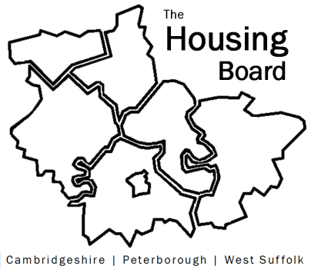
The Housing Board
Cambridgeshire | Peterborough | West Suffolk
Meeting from 10:00 to 12:00, Friday 5 August 2022
To be held online via Microsoft Teams: please open the meeting invite to click on the link
A G E N D A
 | Item | Lead
 | Welcome/apologies  Actions of previous meeting to approve, and matters arising.  Meeting papers available at www.cambridgeshireinsight.org.uk/housingboard | Chair  David Greening
 | Domestic Abuse Safe Accommodation work | Danae Evans,  Safe Accommodation Programme Manager, Cambs & Pet IDVA Service
 | Outcome of housing paper to CPCA Board | Sue Beecroft (HB) & Azma Ahmad-Pearce (CPCA)
 | Modern Day Slavery | Sarah Gove, FDC
 | Updates  - Any Covid related issues to highlight  - Changes to County teams including Lisa’s; HRS re-commissioning and partner update and update on needs profile work  - Update on “new diamonds” affordability analysis | - All  - Lisa Sparks  - Sue Beecroft
 | AOB
 | (Pause so people can leave now, if not part of the Cambridgeshire asylum dispersal conversation)
 | Asylum Dispersal (estimate need around 45 mins) | David Greening with Paul Fox & Rebecca Harris from Cambs County
2022 meeting dates (10am – 12 noon)
- 2 September
- 7 October
- 4 November
- 2 December

