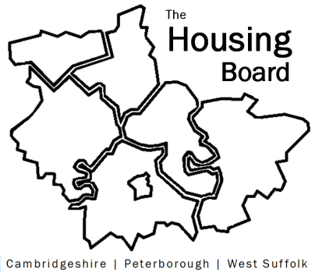
The Housing Board
Cambridgeshire | Peterborough | West Suffolk
Meeting from 10:00 to 12:00, Friday 4 March 2022
To be held online via Microsoft Teams: please open the meeting invite to click on the link
A G E N D A
 | Item |  | Lead
 | Welcome/apologies  Actions of previous meeting to approve, and matters arising.  Meeting papers available at www.cambridgeshireinsight.org.uk/housingboard |  | Chair  Dan Horn
 | Update on local and national strategic work around substance misuse:  The development of local action plan and linked outcomes framework  The new National Strategy  New funding which is becoming available |  | Joe Keegan
 | Update on housing involvement in the new delirium pathway |  | Sue Beecroft
 | Updates  - MAIC stats and any Covid issues to highlight  - HRS re-commissioning and partner update  - DA accommodation update (if anything to bring) |  | All  Lisa Sparks
Planning for the Housing Board in 2022
  - Review of our current 4 priorities: Is anything missing?
    - What is coming “at us” in 2022? Any areas we should be expanding into?
  - Do we have the right people round the table, and the right links?
    - Who should we invite or link with?
    - Any key collaborations we want to be a part of?
  - Are there any specific projects we want to
    - Start
    - Stop
    - Continue?

 | AOB
 | 2022 meeting dates (10am – 12 noon)  1 April  6 May  10 June  1 July | 5 August  2 September  7 October  4 November  2 December

