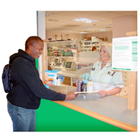 | Have your say on local pharmacy services (chemists) and dispensing doctors in Cambridgeshire and Peterborough  June 2022  Consultation survey – Easy Read version
The Cambridgeshire and Peterborough Health and Wellbeing Board wants to know your views about pharmacy services in Cambridgeshire and Peterborough.

A Health and Wellbeing Board is a group where leaders from the health and care system work together to improve the health and wellbeing of their local population.

We want to know how easy it is for you to use pharmacy services and get the medicines and medical equipment (such as incontinence and stoma devices) you need from pharmacies.
 | Also, we are looking at whether we have enough pharmacy services for the population of Cambridgeshire and Peterborough.
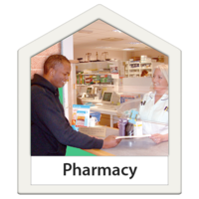 | Pharmacy services mean things like prescriptions, selling medicines that don’t need to be prescribed by a doctor, giving advice about medicines, supporting people to quit smoking, providing medical equipment, etc.  A dispensing doctor means a GP practice that also gives out medicines (also known as a GP dispensary).
We have written a draft report called a Pharmaceutical Needs Assessment.

A Pharmaceutical Needs Assessment is a report which looks at the current needs for pharmacy services in an area.

Our report is based on information about local health needs and existing services and the results of a survey with local pharmacies and GP dispensaries.

This report will be used by NHS England when making decisions on whether to open new pharmacies and commission services from new and existing pharmacies.

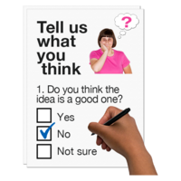 | You can take part in the consultation by completing a survey.
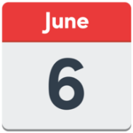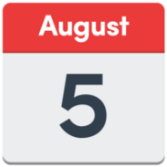 | The consultation runs from 6 June to 5 August 2022.
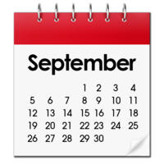 | We will use the consultation feedback to write a report for the Health and Wellbeing Board meeting in September 2022.
You can e-mail your completed survey to:

pna@cambridgeshire.gov.uk

If you need help to complete the survey and there is no one that can help you, please call:
01223 703259
Monday – Friday between 9am – 5pm
and leave your contact details.
We will then contact you within seven working days and will help you with the survey.

Data Protection Statement

- This survey is about local pharmacy services (chemists) and GP dispensaries in Cambridgeshire and Peterborough.

- You do not have to give us any personal information.

- We will keep your information confidential and safe in line with the Data Protection Act 2018.

Thank you for taking part in this survey.

Information about key findings from the draft Cambridgeshire and Peterborough Pharmaceutical Needs Assessment for 2022

What does it say?

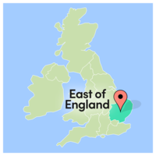 | Local pharmacy services  It says:  - Currently there are enough pharmacy services across Cambridgeshire and Peterborough.  This is because there are 148 pharmacies and 40 GP dispensaries across Cambridgeshire and Peterborough.  This is like the East of England average number of pharmacies and GP dispensaries for the size of population in the area.
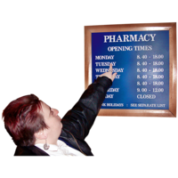 | - However, there has been a reduction in the opening hours of many pharmacies.  Despite this, there appears to be enough pharmacies open for most days of the week.  Some pharmacies have long opening hours, and 16 pharmacies are open for 100 hours a week.

What is recommended:

- The draft report recommends that no new pharmacy services are needed for Cambridgeshire and Peterborough.

- The Health and Wellbeing Board will continue to monitor increases in the population and will then decide if more pharmacies are needed.

The role of pharmacy services in improving the health of the local population

It says:

- Pharmacy services have an important role to play in improving the health of local people.

What is recommended:

- That local services continue to be commissioned in pharmacies to promote health and wellbeing.

1) How did you find out about this survey?

Please tick () one box.

Pharmacy
GP surgery
Cambridgeshire County Council website
Peterborough City Council website
Library
Child and Family Centre
Other (please give details in the box below)

2) Who are you?

Please tick () one box.

A member of the public
A person replying on behalf of somebody who uses pharmacy services
A health or social care staff member
A pharmacist or medical equipment provider
A person replying on behalf of an organisation

If you are a member of the public or a person replying on behalf of somebody who uses pharmacy services, then please complete all the questions.

If you are a health and social care staff member, a pharmacist or medical equipment provider, or replying on behalf of an organisation, then please complete questions 12-18 only.

3) How often do you use a pharmacy or a GP dispensary in Cambridgeshire and Peterborough, or use an online pharmacy?

Please tick () any boxes that apply to you.

 | Never | Less than 3 times a year | 3 – 12 times a year | More than 12 times a year
Pharmacy
GP dispensary
Online pharmacy

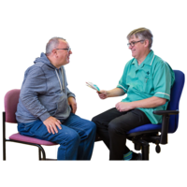 | 4) How often do you do each of the following?  Please tick () any boxes that apply to you.  Never Less than 3 times a year 3 – 12 times a year More than 12 times a year  Collect prescribed medicines or equipment  Buy non-prescription medicines  Give back old or unwanted medicines  Ask a pharmacist for advice  Use a medical equipment provider  If you would like to add any other comments about the service, please write them in the box below.
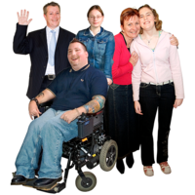 | 5) Who would you normally visit the pharmacy for?  Please tick () any boxes that apply to you.  Yourself  A family member  Neighbour / friend  Someone you are a carer for  All of the above  Other (please give details in the box below)
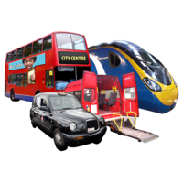 | 6) If you usually travel to a pharmacy, how would you normally travel?  Please tick () one box.  Car  Taxi  Public transport  Walk  Bicycle  Other (please give details in the box below)
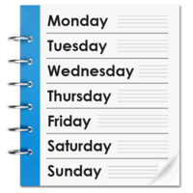 | 7) Considering your current use of pharmacies, what is the most convenient day for you to visit?  Please tick () one box.  Monday to Friday  Saturday  Sunday  Varies  No preference
8) If your pharmacy was open more often, what would be the most convenient day for you to visit?

Please tick () one box.

Monday to Friday
Saturday
Sunday
Varies
No preference

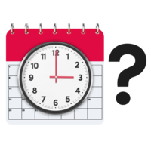 | 9) Considering your current use of pharmacies, when do you prefer to visit?  Please tick () one box.  Morning (8am – 12pm)  Lunchtime (12 – 2pm)  Afternoon (2 – 6pm)  Early evening (6 – 8pm)  Late evening (after 8pm)  Varies  No preference
10) If your pharmacy was open more often, when would you prefer to visit?

Please tick () one box.

Morning (8am – 12pm)
Lunchtime (12 – 2pm)
Afternoon (2 – 6pm)
Early evening (6 – 8pm)
Late evening (after 8pm)
Varies
No preference

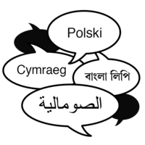  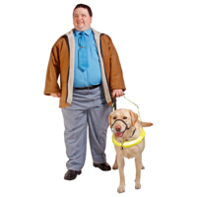 | 11) Do you have any problems in using your local pharmacy or GP dispensary? For example, language barriers, sight issues, hearing issues.  Yes  No  If yes, please let us know what in the box below:
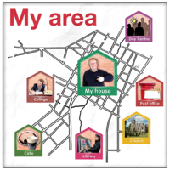 | 12) Do you think that pharmacy services are available at convenient locations?  Yes  No
13) Do you think that pharmacy services are available at convenient opening hours?

Yes
No
If no, please let us know why in the box below.

14) Do you feel that the purpose of the Pharmaceutical Needs Assessment has been explained enough in the draft report?

Yes
No
If no, please let us know why in the box below:

15) Do you agree with our conclusion that we have enough pharmacies and GP dispensaries across Cambridgeshire and Peterborough, and we do not currently need any more?

Yes
No
If no, please let us know why in the box below:

16) Do you agree with the key findings about pharmacy services in Cambridgeshire and Peterborough?

Yes
No
If no, please let us know why in the box below:

17) Are there any services you would like pharmacies to provide that are not described in the draft report?

Yes
No
If yes, please let us know why in the box below:

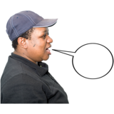 | 18) Do you have any other comments?  Yes  No  If yes, please let us know why in the box below:

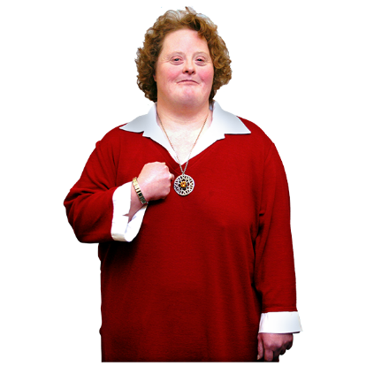 | Information about you  Please can you tell us more about yourself. You do not have to answer these questions, but it will help us to understand how replies may be different across different groups of people or in different areas of Cambridgeshire and Peterborough.
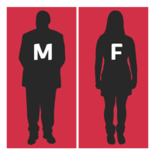 | 19) How would you describe your gender?  Please tick () one box.  Male  Female  Other  Prefer not to say
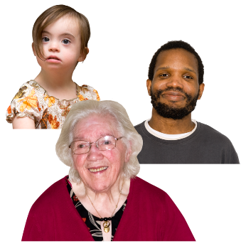 | 20) How old are you?  Please tick () one box.  Under 15 years  15-24 years  25-34 years  35-44 years  45-54 years  55-64 years  65-74 years  75 or over
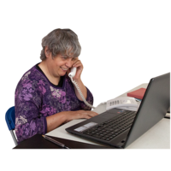  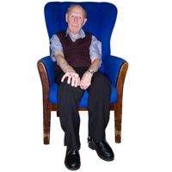 | 21) What is your employment status?  Please tick () any boxes that apply to you.  In education (full or part time)  In employment (full or part time)  Self-employed (full or part time)  Unemployed  Retired  Stay at home parent/carer or similar  Other, please say in the box below
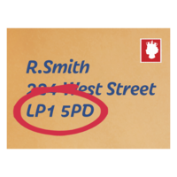 | 22) What is your postcode?  This will be used to look at common concerns by location, not to identify you personally.
23) How would you describe your ethnic background?

Please tick () one box.

White
British
Irish
Gypsy and Traveller
Eastern European
Other
Mixed
White and Black African
White and Black Caribbean
White and Asian
Other
Black or Black British
African
Caribbean
Other
Asian or Asian British
Indian
Pakistani
Bangladeshi
Chinese
Other
Other Ethnic Group
Prefer not to say

