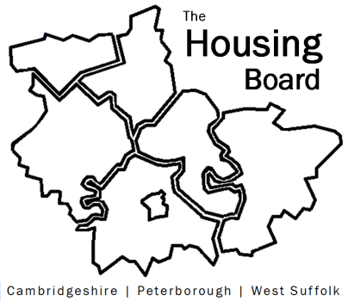
The Housing Board
Cambridgeshire | Peterborough | West Suffolk
Meeting from 10:00 to 12:00, Friday 6 May 2022
To be held online via Microsoft Teams: please open the meeting invite to click on the link
A G E N D A
 | Item |  | Lead
 | Welcome/apologies  Actions of previous meeting to approve, and matters arising.  Meeting papers available at www.cambridgeshireinsight.org.uk/housingboard |  | Chair  Dan Horn
 | Modern Day Slavery |  | Sarah Gove tbc
 | National Asylum Accommodation Dispersal Scheme
 | Initial findings of Accommodation Needs Assessment and Discussion |  | Fiona Smitton, Cambs and Peterborough
 | CPCA Housing Direction update |  | Dan Horn / All
 | New Cambridgeshire & Peterborough Private Sector Housing Group |  | Dan Horn / Sue Beecroft
 | Ukrainian update |  | All
 | Updates  - Any Covid related issues to highlight  - HRS re-commissioning and partner update  - DA accommodation update: tender for dispersed accommodation is live –and looking for Registered Housing Providers to provide up to 12 units of accommodation  - ADASS new regional best practice guide – housing board and Toolkit submitted as good practice examples (FYI)  - Update on “new diamonds”  - Draft County Build Figures  - Terms of Reference |  | All  Lisa Sparks  Sue Beecroft  Sue Beecroft  Sue Beecroft
AOB
- Inviting a new Registered Provider representative since Damian’s departure
 | 2022 meeting dates (10am – 12 noon)  10 June  1 July  5 August  2 September | 7 October  4 November  2 December

