Agenda Item No:

Report title: TB Health Needs Assessment 2019/20 overview and current recommendations

To: Health Protection Steering Group

Meeting Date: 11th November 2021

From: Emmeline Watkins, Deputy DPH Peterborough

Tiya Balaji, Senior Public Health Manager .

Outcome: Update on the findings of the 2019/20 TB Health Needs Assessment and the current recommendations

Recommendation: What is the HPSG being asked to agree?
- To agree the current TB recommendations based on the draft 2019/20 TB Health needs assessment
- To agree the organisational leads/named leads for each recommendation.
- To review progress against the recommendations.

Officer contact:
Name: Emmeline Watkins
Post: Deputy DPH
Email: Emmeline.watkins@peterborough.gov.uk

Member contacts:
Names: Councillors
Post: Chair/Vice-Chair
Email:
Tel: 01223 706398

1. 2019/20 TB Health Needs Assessment plan and progress

  - A TB Health Needs Assessment was initiated in 2019 for Cambridgeshire and Peterborough. Public health and system work on this was halted due to the Covid-19 pandemic.
  - The original project plan and proposed time frame are below. The majority of the work was completed, with interim findings being taken to the Housing Board, Harm Reduction Group and Social Care Managers group in early 2020.
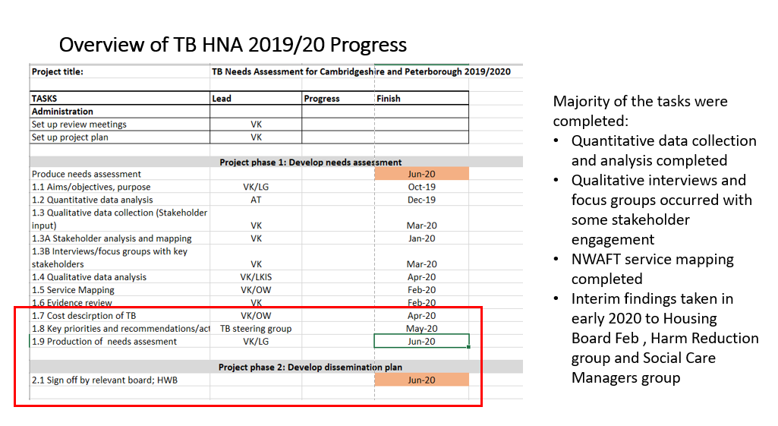

  - The quantitative data collection and analysis was completed by EFEU and an update to key information including incidence of TB and complexity of patients has been requested in 2Q 2021.
  - Qualitative interviews and stakeholder engagement occurred with interviews with key individuals across the system as well as engagement around preliminary findings and recommendations with key groups. Examples of the issues highlighted are below.
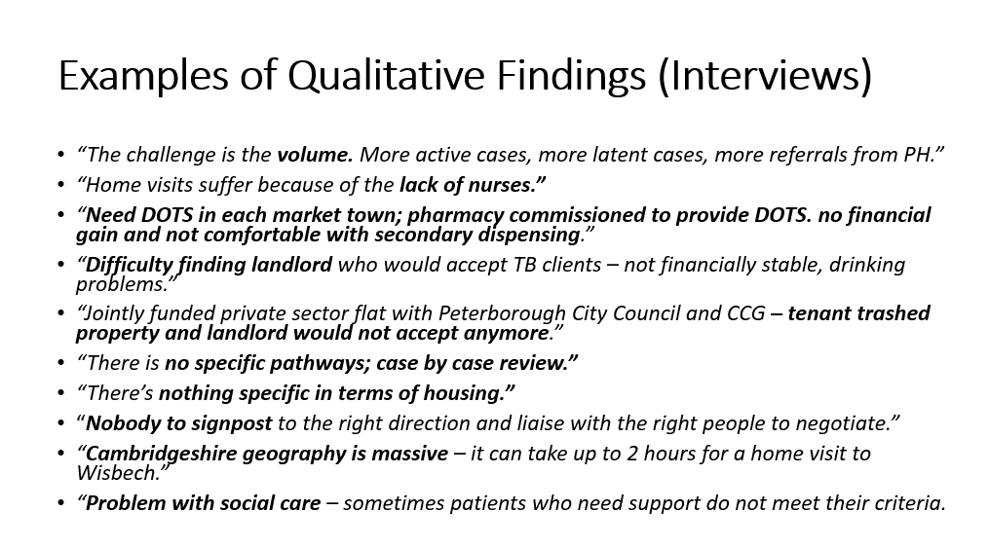

2. Current position
2.1 The TB situation in Peterborough is currently escalating with The Peterborough TB service seeing an increasing number of patients diagnosed with Tuberculosis (TB), with more having Enhanced Care Needs (ECN) due to the complex issues that can go with TB such as homelessness and alcohol misuse. There are several ongoing TB clusters of concern especially in the Peterborough homeless/rough sleeper community with ongoing and escalating screening activity and concerns regarding a case with extremely drug resistant TB, also in this community.

2.2 UKHSA and the Peterborough TB service have highlighted concerns regarding the ongoing workforce capacity issues as well as a need for clear integrated clinical and wider pathways for TB.

2.3 A TB Health Needs Assessment refresh meeting was held in late July 2021, with representation from Public Health, CCG, NWAFT and PCC housing to understand the level of refresh needed and if the issues highlighted in the needs assessment and the recommendations still stood. Since then these recommendations have been taken to the Cambridgeshire and Peterborough Respiratory Network, and the Safer Peterborough Partnership and have had input from UKHSA.

2.4 There is also a new TB Action Plan for England 2021-2026 which highlights the key need for system wide actions and areas for action.

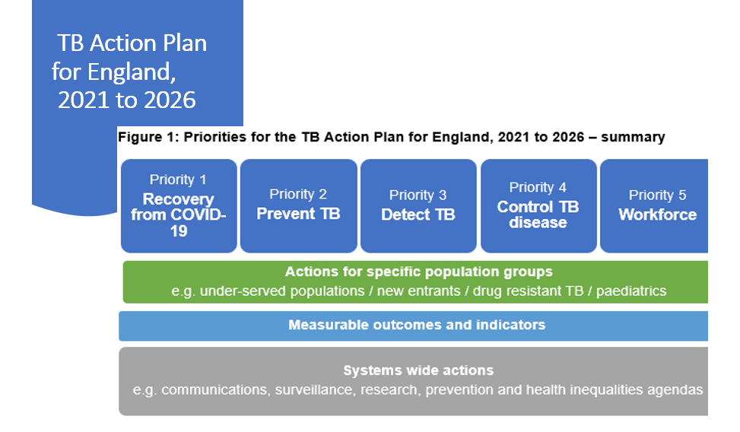

3. Recommendations
2.1 The TB recommendations below are based on the recommendations developed during the 2019/20 TB Health Needs Assessment but have been updated based on input provided by stakeholders and based on the TB Action Plan for England 2021-2026.

2.2 The HPSG are asked to approve the recommendations and identify organisational leads for each recommendation, as well as to track future progress.

 | TB Needs Assessment Recommendations 2021 – for approval
1 | Raise awareness / education of TB among frontline staff in health and care services. In addition, raise awareness of TB in the community and especially in vulnerable/hard to reach groups and the organisations that support them.
2 | Enable prevention, early identification and consistent follow-up of contacts and cases that have risk factors for non-compliance to treatment
3 | Ensure clear pathways and arrangements are in place to meet the needs of TB patients with complex social care needs AND/OR no recourse to public funds, including housing pathways.
4 | CCG/ICS and other organisations should identify a named lead to work with their local TB services, UKHSA and other partners to develop and agreeing effective pathways and service specifications for TB services, including outreach Directly Observed Therapy (DOT) services where needed.
5 | Address the workforce capacity in current services. Every TB service should have appropriate clinical leadership and workforce (including dedicated administrative support) for the size of the service and the needs of the population.
6 | Clarify the role and responsibility (including financial) of each team and organisation, especially in the management of difficult TB cases and TB situations.
7 | To consider development of an integrated approach to service delivery for vulnerable groups enabling effective prevention and treatment of TB and other conditions and diseases such as HIV.

