Media pack for the Housing, Mental Health and Substance Misuse Toolkit

Location on the web | Full URL:  https://cambridgeshireinsight.org.uk/housing/priority-themes/housing-need/h-mh-sm-toolkit/  Shortened URL for sharing:  https://cambridgeshireinsight.org.uk/h-mh-sm-toolkit/
Email address for feedback | toolkit@cambridge.gov.uk
Link direct to the Toolkit document (pdf) | https://cambridgeshireinsight.org.uk/wp-content/uploads/2022/02/housing-mh-substance-misuse-toolkit-v1.0.pdf
Link to slides (powerpoint)  These talk you through the content of the Toolkit and tips on using it | https://cambridgeshireinsight.org.uk/wp-content/uploads/2022/02/toolkit-launch-slides.pptx
Link to narrated slides (MP4 video) | https://cambridgeshireinsight.org.uk/wp-content/uploads/2022/02/toolkit-launch-video.mp4
Branding (png)
Logo | Cogs only
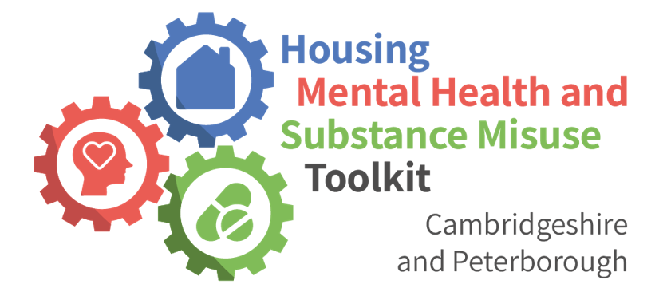
Link to media file:  https://cambridgeshireinsight.org.uk/wp-content/uploads/2022/01/Final-Logo.png | Link to media file:  https://cambridgeshireinsight.org.uk/wp-content/uploads/2022/02/cogs-only.png
Suggested text
Feel free to modify, this is just a suggestion If you are sharing the Toolkit on your website or other platform:
The Housing, Mental Health and Substance Misuse Toolkit has been developed by a wide range of teams and agencies across Cambridgeshire and Peterborough, with the inspiration and help of experts by experience. It sets out the process to follow when housing, mental health and substance misuse issues occur in ten different scenarios.
The Toolkit was produced in response to a workshop help in November 2019, which highlighted that teams need to work better together to help secure the outcomes needed by people experiencing housing, mental health and substance misuse problems; informed by the lived experience of people who have been through it themselves.
The aim of the Toolkit is to make it easier for each team to find out what to do and who to contact, particularly in services or organisations they may be less familiar with. In addition to the three “main” areas of focus on the toolkit, this includes partners in voluntary and charitable agencies, social care, police, fire and rescue and probation services.
You can find the toolkit at https://cambridgeshireinsight.org.uk/h-mh-sm-toolkit/
We welcome feedback which will help build on and improve version 1.0 which was launched in Feb 2022. Please send feedback to toolkit@cambridge.gov.uk
Social media | - If you tweet about the Toolkit, please tag @CambsHsgSubReg  - Twitter profile link https://twitter.com/CambsHsgSubReg  - The hashtag to use is #h-mh-sm-toolkit
Contact information | sue.beecroft@cambridge.gov.uk  07715 200 730

