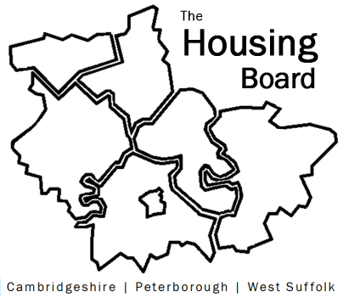
The Housing Board
Cambridgeshire | Peterborough | West Suffolk
Meeting from 10:00 to 12:00, Friday 4 February 2022
To be held online via Microsoft Teams: please open the meeting invite to click on the link
A G E N D A
 | Item |  | Lead
 | Welcome/apologies  Actions of previous meeting to approve, and matters arising.  Meeting papers available at www.cambridgeshireinsight.org.uk/housingboard |  | Dan Horn
 | Homes for Wellbeing Tuberculosis needs assessment, draft priorities and learning from recent experiences in Peterborough |  | Emmeline Watkins  Tiya Balaji  Public Health
 | Suicide Prevention Strategy link in suicide prevention work to services working with vulnerable people, such as housing, debt, employment. |  | Joseph Davies  Adult Mental Health,  Cambs County Council
 | Launch of Toolkit (celebratory item!) |  | All
 | Our “annual review” meeting in March – thinking about how we’d like to approach the meeting  Circulating our Terms of Ref to consider |  | All
 | Updates  - Any Covid issues to highlight  - Leaving prison and Covid  - HRS re-commissioning and partner update  - DA accommodation update (if anything to bring) |  | All  Matthew Ryder  Lisa Sparks
 | AOB
 | 2022 meeting dates (10am – 12 noon)  4 March  1 April  6 May  10 June  1 July | 5 August  2 September  7 October  4 November  2 December

