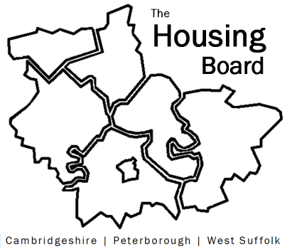
The Housing Board
Cambridgeshire | Peterborough | West Suffolk
Meeting from 10:00 to 12:00, Friday 14 January 2022
To be held online via Microsoft Teams: please open the meeting invite to click on the link
A G E N D A
 | Item |  | Lead
 | Welcome/apologies  Actions of previous meeting to approve, and matters arising.  Meeting papers available at www.cambridgeshireinsight.org.uk/housingboard |  | Chair  Dan Horn
 | Housing Needs Assessment which will be focusing on learning disabilities, autism, mental health, and physical disability in under 65s. |  | Fiona Smitton  Jamie Aprigliano  Guy Fairbairn  Cambridgeshire County Council
 | Progress on Hoarding: Feedback from Housing Board on idea of a Hoarding project, and on Hoarding Champions |  | Stuart Brown  Cambridgeshire County  Council
 | Update on ‘cut down’ Changing Futures proposal |  | Sue Beecroft
 | GTANA |  | Julie Fletcher
 | Updates  - Any Covid issues to highlight and work on vaccination uptake in homeless accommodation  - HRS re-commissioning and partner update  - DA accommodation update (if anything to bring) |  | All  Lisa Sparks
 | AOB
 | 2022 meeting dates (10am – 12 noon)  4 February  4 March  1 April  6 May  10 June  1 July | 5 August  2 September  7 October  4 November  2 December

