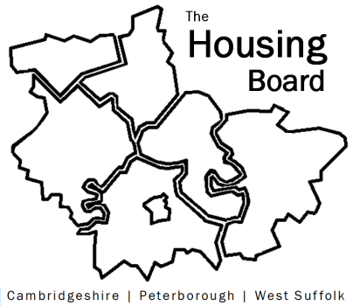
The Housing Board
Cambridgeshire | Peterborough | West Suffolk
Meeting from 10:00 to 12:00, Friday 5 November 2021
To be held online via Microsoft Teams: please open the meeting invite to click on the link
A G E N D A
 | Item |  |  | Lead
 | Welcome/apologies  Actions of previous meeting to approve, and matters arising.  Meeting papers available at www.cambridgeshireinsight.org.uk/housingboard |  |  | Dan Horn
 | Homelessness: annual focus  Review of our “end rough sleeping plans”  Update on homelessness stats |  |  | Heather Wood and Jon Collen
 | Hoarding – P3’s 6-month evaluation report (has been circulated)  Next actions on Hoarding (further discussion needed in Dec) |  |  | Lisa Sparks / Sue Beecroft
 | Mention social housing and broadband provision |  |  | Sue / Nigel Howlett / David Greening
 | Updates  - Any covid issues  - HRS re-commissioning and partner update  - DA accommodation update  - Update on hardship metrics – more info to December meeting |  |  | All  Lisa Sparks  Heather W / Jon C  (SB for DR)
 | AOB
 | 2021 meeting dates (10 – 12)  3 December | 2022 (appointments sent, 10-12)  14 January  4 February  4 March  1 April  6 May  3 June | 1 July  5 August  2 September  7 October  4 November  2 December

