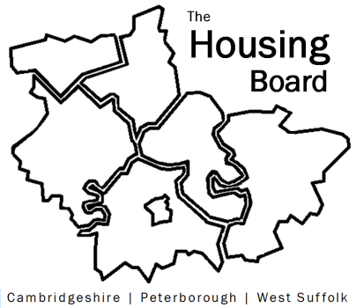
The Housing Board
Cambridgeshire | Peterborough | West Suffolk
Meeting from 10:00 to 12:00, Friday 3 December 2021
To be held online via Microsoft Teams: please open the meeting invite to click on the link
A G E N D A
 | Item |  | Lead
 | Welcome/apologies  Actions of previous meeting to approve, and matters arising.  Meeting papers available at www.cambridgeshireinsight.org.uk/housingboard |  | Vice Chair  Heather / Damian
 | Update on Hardship Metrics work / future plan (paper to follow) |  | Damian Roche
 | Mental health, substance misuse and housing: final document for approval (document to be circulated by close of play 30 Nov) |  | Sue Beecroft
 | GTANA update (TBC) |  | Julie Fletcher, if needed
 | Output of number of homes built 2020/21 (verbal only) |  | Sue Beecroft
 | Updates  - Any Covid issues to highlight  - HRS re-commissioning and partner update  - DA accommodation update (if anything to bring) |  | All  Lisa Sparks
 | AOB
 | 2022 meeting dates (10am – 12 noon)  14 January  4 February  4 March  1 April  6 May  10 June | 1 July  5 August  2 September  7 October  4 November  2 December

