Crisis Care Concordat Mental Health Delivery Board
This Concordat is about how we, as signatories, can work together to deliver a high quality response when people – of all ages – with mental health problems urgently need help. Mental illness is a challenge for all of us. When a person’s mental state leads to a crisis episode, this can be very difficult to manage, for the person in crisis, for family and friends, and for the services that respond. All may have to deal with suicidal behaviour or intention, panic attacks or extreme anxiety, psychotic episodes, or behaviour that seems out of control, or irrational and likely to endanger the person or others. - Mental Health Crisis Care Concordat - Improving outcomes for people experiencing mental health crisis, DoH, 18 February 2014
Terms of Reference
Introduction
The Crisis Care Concordat, launched in February 2014, is an England-wide national agreement between the different agencies and services involved in the care of people experiencing, or at risk of experiencing, a mental health crisis. The focus of the Concordat is on improving the quality and availability of help and support, with a focus on acute mental health crises, although it also recognises the importance of prevention and recovery.
The four main aims of the Concordat are:
- Access to support before crisis point – making sure people with mental health problems can get help 24 hours a day and that when they ask for help, they are taken seriously
- Urgent and emergency access to crisis care – making sure that a mental health crisis is treated with the same urgency as a physical health emergency
- Quality of treatment and care when in crisis – making sure that people are treated with dignity and respect, in a therapeutic environment
- Recovery and staying well – preventing future crises by making sure people are referred to appropriate services
It is evident that mental health crisis care services will not be sustainable or fit for purpose for the next decade without change and without support. The transformation in the way crisis services are commissioned needs to be locally-led and therefore local areas have been tasked to engage with local communities, CCGs, area teams and other stakeholders to develop action plans for bridging the gap between physical and mental health services, with the aim of creating a seamless multi-organisational pathway for individuals in mental health crisis.
Purpose
The purpose of the Mental Health Delivery Board is:
- To drive actions and improvements towards meeting the commitment of the National Crisis Care Concordat and the local declaration
- To support the development of the local crisis care concordat action plan and transformation programmes within it, ensuring a future mental health crisis care system that is fit to support the new care models, pathways and workforce requirements that are fundamental for service delivery
- To support action to transform services in local communities and to stimulate debate as to how we can best support further development of mental health crisis care services, as described in the Five Year Forward View for Mental Health and new Cambridgeshire and Peterborough Joint Mental Health Strategy which supports our Sustainability and Transformation Programme plan and work to implement the Care Act
- To develop and implement innovative crisis care solutions to overcome the challenges faced by all partner agencies who are signatories to the Crisis Care Concordat action plan and declaration
- To respond to the urgent need to develop inter-organisational approaches for the mental health crisis care system that utilise best practice and implement appropriate changes at both scale and pace
- To provide strategic leadership pertaining to the Mental Health Act (MHA), the Mental Capacity Act (MCA) and their respective Codes of Practice
- To monitor, provide challenge and seek assurance on compliance with external standards relating to Mental Health legislation.
Aims and objectives
The overall aim of the Mental Health Delivery Board is to oversee the implementation of the updated Crisis Care Concordat Action Plan with specific emphasis on securing delivery of improved outcomes for people in mental health crisis at a local level.
It will oversee an ambitious, but realistic, series of initiatives to transform crisis care services across Cambridgeshire and Peterborough, ensuring that organisations work together collaboratively to address the challenges and deliver the solutions. The Board will also ensure that the work undertaken by all partner organisations is well aligned to avoid duplication and increase efficiency.
Scope
The group will agree and define the programme work streams as per the five main aims of the local Crisis Care Concordat Action Plan:
- System wide collaborative working and relationship building to improve outcomes for those in MH crisis
- Access to support before crisis point
- Urgent and emergency access to crisis care
- Quality of treatment and care when in crisis
- Recovery and staying well / preventing future crisis
Operating principles
Any specific work streams developed as part of the action plan will be led by the dedicated action leads and overseen by the Programme Manager.
The Mental Health Delivery Board will:
- act as an expert reference group, to share experience and best practice for crisis care transformation
- oversee the successful delivery of programme milestones
- work collaboratively with other partner organisations to support local solutions
- provide professional and strategic leadership
- ensure robust links with the Sustainability and Transformation Programme (STP), Health and Wellbeing Boards and CCG Clinical Executive group
Local governance structure
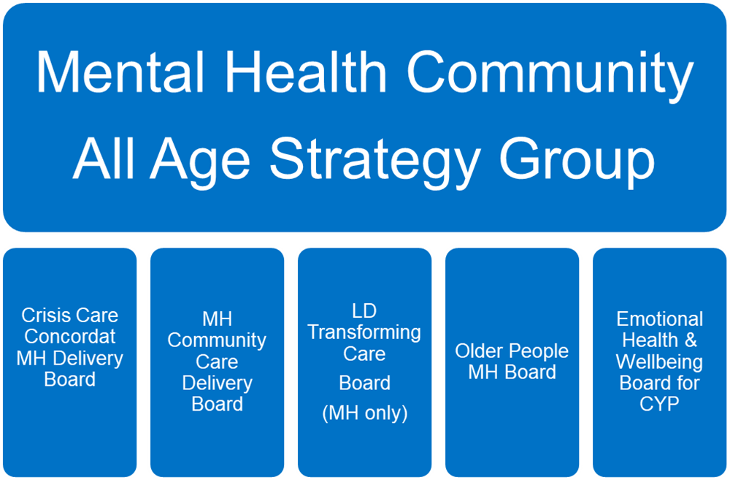
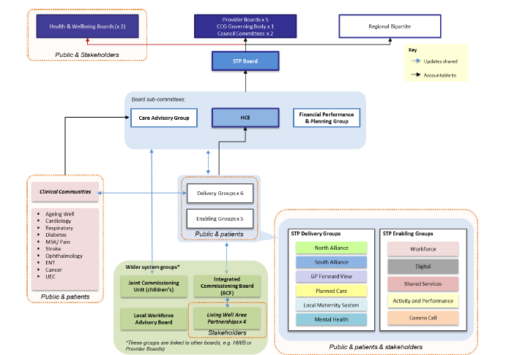
Membership
Mental Health Delivery Board is co-chaired by Cambridgeshire Constabulary, CCG, Local Authority and CPSL Mind.
Membership consists of local crisis care concordat declaration signatories and will include senior representation from the following organisations:
- Peterborough and Cambridgeshire Clinical Commissioning Group
- Cambridgeshire and Peterborough NHS Foundation Trust
- North West Anglia NHS Foundation Trust
- Cambridge University Hospitals NHS Foundation Trust
- East of England Ambulance Service NHS Trust
- Peterborough City Council/Safer Peterborough Partnership
- Cambridgeshire County Council
- Cambridgeshire Constabulary
- British Transport Police
- Cambridgeshire, Peterborough and South Lincolnshire Mind
- Health Watch Cambridgeshire & Peterborough
- Lifecraft
- Cambridgeshire Office of the Police and Crime Commissioner
- Rethink
- SUN network
- Third Sector representatives
Meetings and attendance
The meetings will be held on a bi-monthly basis with Task and Finish Group meetings arranged as and when necessary agreed by the membership.
The representatives should make every effort to attend; in exceptional circumstances when this is not possible deputies will be allowed.
Roles and responsibilities
The main function of the Mental Health Delivery Board is to ensure the delivery of the aims and objectives. Each area of work will be overseen by the Programme Manager and dedicated action leads that are responsible for delivering the components of the local Crisis Concordat action plan.
Information flows and reporting
The programme progress reporting will be in accordance with the meeting frequency. Individual projects will be reported to the Programme Manager who is tasked with monitoring overall progress and who will provide a summary report for the Mental Health Delivery Board. However, should any risk or issue need to be escalated for immediate attention then these will be reported as they arise through an appropriate route.
Review and approval
Date of review and approval by Board members: September 2017
Next review date: March 2019

