P3 update
Note for housing board, 01 Oct 2021

The main message from P3 at present is that they have seen a surge but are manging to hold the fort and keep all the referral portal areas open.

Currently have
- 360 receiving tier 2 support (full support)
- And a further 41 receiving tier 1 support (drop-in type support).
- Have FTE of 20 support workers working with up to 20 cases each.

There’s been an increase in referrals for people
- In private rented / owner occupiers
- Who have long term support needs / may always need some support due to Autism, learning needs / disabilities
- Not able to manage independently / requests for support with viewing properties due to hearing or sight loss
- Who are new to this county or have a language barrier or who need help navigating the processes around immigration status
- Who have experienced Domestic Abuse.

For some of the above it has been tricky to work out if there is a housing related support need or if they are struggling to manage because of the other factors e.g. language barrier, autism slight loss etc.

Referrals
 | Q1 2020-21 | Q2 2020-21 | Q3 2020-21 | Q4 2020-21 | Q1 2021-22
Cambs
New referrals this month | 100 | 249 | 267 | 270 | 252
% of referrals contacted by service | 97% | 95% | 96% | 94% | 89%
Peterborough
New referrals this month | 19 | 36 | 42 | 40 | 24
% of referrals contacted by service | 100% | 100% | 98% | 100% | 100%

Referral numbers by district Sept 2020 to Aug 21
Area | Referral numbers | % of referrals
Cambridge City | 222 | 19%
East Cambs | 109 | 10%
Fenlands | 172 | 15%
Huntingdonshire | 309 | 27%
Peterborough | 147 | 13%
South Cambs | 188 | 16%
Total | 1147

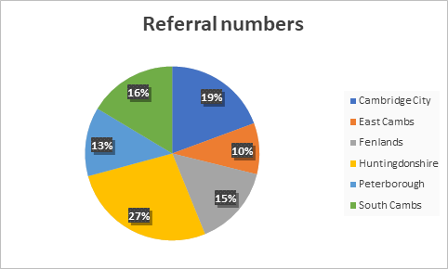

The following pie charts show sources of referrals.

For both Cambs and Peterborough, in this time period, there were NO referrals from PRISM teams, Prison, DWP / Job Centre, HIAs

Caseload Information (average for each quarter)
 | Q1 2020-21 | Q2 2020-21 | Q3 2020-21 | Q4 2020-21 | Q1 2021-22
Number currently being supported across the whole service | 257 | 222 | 247 | 294 | 309
Number being supported:  in Cambridge | 71 | 69 | 61 | 69 | 74
in East Cambridgeshire | 20 | 19 | 29 | 33 | 29
in Fenland | 47 | 24 | 26 | 29 | 32
in Huntingdonshire | 83 | 59 | 76 | 108 | 113
in South Cambridgeshire | 36 | 51 | 56 | 56 | 60
In Peterborough | 23 | 18 | 27 | 31 | 25
Number currently on the waiting list (C & P) | 49 | 10 | 17 | 21 | 22

Outcome data
 | Q1 2020-21 | Q2 2020-21 | Q3 2020-21 | Q4 2020-21 | Q1 2021-22
Cambs
Number of clients exiting the service this month | 185 | 102 | 169 | 186 | 195
% of exits that were planned | 84% | 86% | 82% | 88% | 88%
Peterborough
Number of clients exiting the service this month | 25 | 6 | 19 | 23 | 22
% of exits that were planned | 84% | 83% | 95% | 87% | 86%

Housing Outcomes
 | Q1 2020-21 | Q2 2020-21 | Q3 2020-21 | Q4 2020-21 | Q1 2021-22
Cambs
Clients for whom eviction or repossession action was prevented | 60 | 44 | 53 | 61 | 64
Clients supported to set up a new home / tenancy | 38 | 36 | 50 | 61 | 50
Clients assisted to move to more suitable accommodation | 48 | 42 | 67 | 79 | 83
Clients evicted in period | 2 | 2 | 1 | 1 | 0
Peterborough
Clients for whom eviction or repossession action was prevented | 7 | 4 | 12 | 10 | 10
Clients supported to set up a new home / tenancy | 3 | 2 | 5 | 5 | 5
Clients assisted to move to more suitable accommodation | 3 | 2 | 9 | 6 | 7
Clients evicted this month | 0 | 0 | 0 | 1 | 0

