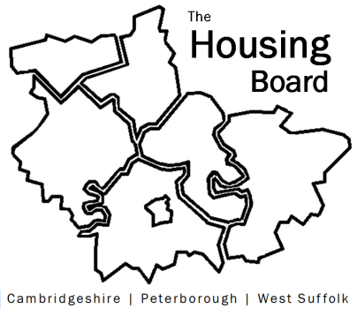
The Housing Board
Cambridgeshire | Peterborough | West Suffolk
Meeting from 10:00 to 12:00, Friday 3 September 2021
To be held online via Microsoft Teams: please open the meeting invite to click on the link
A G E N D A
 | Item |  | Lead
 | Welcome/apologies  Actions of previous meeting to approve, and matters arising.  Meeting papers available at www.cambridgeshireinsight.org.uk/housingboard |  | Dan Horn
 | Evidence base for Local Plans including update on GTANA  Summary slides on GLHearn report  Verbal update on GTANA |  | Sue Beecroft  Julie Fletcher
 | First Homes update |  | Julie Fletcher / Helen Reed
 | Update on Afghan LES Scheme including RP response |  | David G / Karen M
 | Update on P3 support position |  | Sue with Lisa’s notes
Output of number of homes built in 2020/21
Deferred to October meeting when county-wide housing figures should be available
Updates
- MAIC stats and Covid issues
- HRS re-commissioning and partner update
 | AOB
2021 meeting dates (10am – 12 noon):
1 October
5 November
3 December

