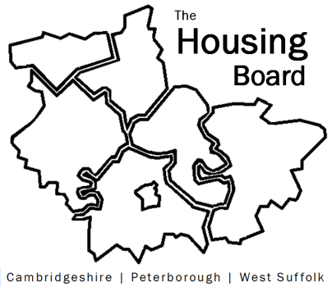
The Housing Board
Cambridgeshire | Peterborough | West Suffolk
Meeting from 10:00 to 12:00, Friday 1 October 2021
To be held online via Microsoft Teams: please open the meeting invite to click on the link
A G E N D A
 | Item |  | Lead
 | Welcome/apologies  Actions of previous meeting to approve, and matters arising.  Meeting papers available at www.cambridgeshireinsight.org.uk/housingboard |  | Dan Horn
 | P3 update and statistics |  | Jennifer Kralj (P3) & Lisa Sparks
 | Overview of Prof Dame Carol Black independent drugs review (TBC) |  | Joe Keegan / Susie Talbot (County)
 | Update on Mental Health, Substance Misuse and Housing Protocol |  | Sue Beecroft
 | Developing older persons' housing (TBC) |  | Lynne O’brien (county)
 | Housing Completions – deferred to November
 | Updates  - MAIC stats and Covid issues  - HRS re-commissioning and partner update  - Update on accommodation for Domestic Abuse and coverage across our area |  | All  Lisa Sparks  All
 | AOB
2021 meeting dates (10am – 12 noon):
5 November
3 December

